Results

Daniel Reyes

6/3/2021

Table of Contents

# Results

# Univariate analysis: trait ~ group + year

## Model 1: Mainland/Island

### Mericarp

We found that mericarps in island populations are larger but less spiny than mericarps in mainland populations. Mericarps on islands are 7% longer, 5% wider, 12% deeper than mainland populations (X^2(1)=[14.10], p = <0.001; X^2(1)=[12.43], p = <0.001; X^2(1)=[52.33], p = <0.001). Their upper spines are 6% more separated between them on island populations than on mainland (X^2(1)=[5.85], p = 0.015). However, lower spines are more common on mainland populations than on island populations (X^2(1)=[76.74], p = 0.001).

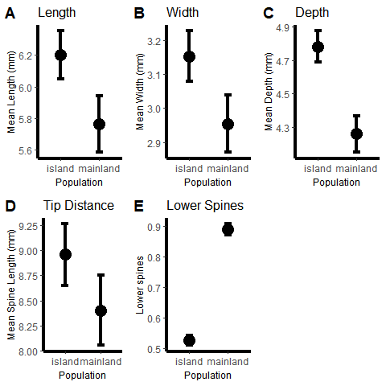

Estimated means of mericarp traits between island and mainland populations.

ANOVA Length (mm)

|  |  |  |  |
| --- | --- | --- | --- |
|  | Chisq | Df | Pr(>Chisq) |
| mainland_island | 14.101389 | 1 | 0.0001732 |
| year_collected | 8.619226 | 1 | 0.0033263 |

ANOVA Width (mm)

|  |  |  |  |
| --- | --- | --- | --- |
|  | Chisq | Df | Pr(>Chisq) |
| mainland_island | 12.437551 | 1 | 0.0004208 |
| year_collected | 8.160411 | 1 | 0.0042815 |

ANOVA Depth (mm)

|  |  |  |  |
| --- | --- | --- | --- |
|  | Chisq | Df | Pr(>Chisq) |
| mainland_island | 52.33355 | 1 | 0.0e+00 |
| year_collected | 19.54242 | 1 | 9.8e-06 |

ANOVA Tip Distance (mm)

|  |  |  |  |
| --- | --- | --- | --- |
|  | Chisq | Df | Pr(>Chisq) |
| mainland_island | 5.8539558 | 1 | 0.0155421 |
| year_collected | 0.0915133 | 1 | 0.7622621 |

ANOVA Lower Spines

|  |  |  |  |
| --- | --- | --- | --- |
|  | Chisq | Df | Pr(>Chisq) |
| mainland_island | 76.74445 | 1 | 0 |

### Flower

We found no significant differences between mainland and island populations on petal length (p = 0.299). However, there was a significant result for year (X^2(1)=[15.89], p = <0.001) between mainland and island populations.

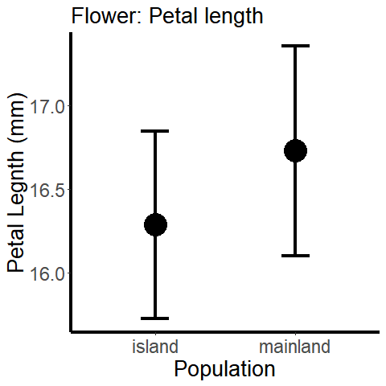

Estimated means of petal length between island and mainland populations.

ANOVA Petal Length (mm)

|  |  |  |  |
| --- | --- | --- | --- |
|  | Chisq | Df | Pr(>Chisq) |
| mainland_island | 1.077345 | 1 | 0.2992922 |
| year_collected | 15.899451 | 1 | 0.0000668 |

### Leaf

We found that leaves in island populations are longer, and have more leaflets than leaves in mainland populations. Leaves on islands are 20% longer, their leaflets are 7.5% larger and they have approximately 11% more leaflets than mainland populations (X^2(1)=[21.86], p = <0.001; X^2(1)=[4.86], p = 0.027; X^2(1)=[39.61], p = <0.001).

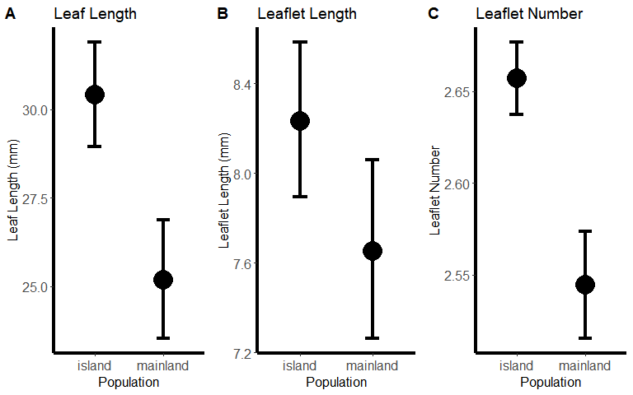

Estimated means of leaf traits between island and mainland populations.

ANOVA Leaf Length (mm)

|  |  |  |  |
| --- | --- | --- | --- |
|  | Chisq | Df | Pr(>Chisq) |
| mainland_island | 21.861875 | 1 | 0.0000029 |
| year_collected | 6.502476 | 1 | 0.0107724 |

ANOVA Leaflet Length (mm)

|  |  |  |  |
| --- | --- | --- | --- |
|  | Chisq | Df | Pr(>Chisq) |
| mainland_island | 4.865144 | 1 | 0.0274045 |
| year_collected | 8.692819 | 1 | 0.0031947 |

ANOVA Leaf Number

|  |  |  |  |
| --- | --- | --- | --- |
|  | Chisq | Df | Pr(>Chisq) |
| mainland_island | 39.61924 | 1 | 0 |

## Model 2: Galapagos/Other Islands

### Flower

We found that *Tribulus* flowers in the Galapagos are smaller than flowers of populations from other islands. Petal length of *Tribulus* on the Galapagos is 46% shorter than petal length from other islands (X^2(1)=[156.39], p = <0.001).

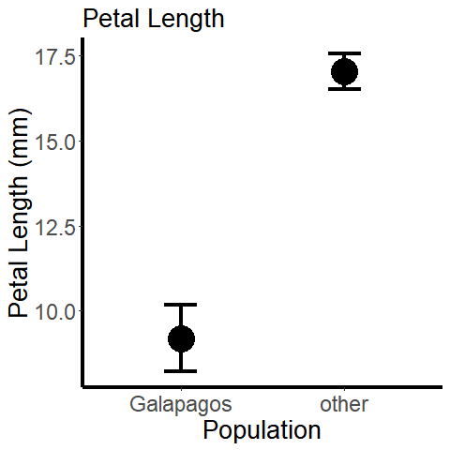

Estimated means of petal length between the Galapagos and other islands populations.

ANOVA Petal Length (mm)

|  |  |  |  |
| --- | --- | --- | --- |
|  | Chisq | Df | Pr(>Chisq) |
| galapagos_other | 156.39806 | 1 | 0.000000 |
| year_collected | 10.13346 | 1 | 0.001456 |

### Leaf

We found that leaf length of population from the Galapagos are smaller than populations from other islands. Leaves are 22% shorter, leaflets are 18.5% shorter compared to other island populations (X^2(1)=[20.39], p = <0.001; X^2(1)=[17.20], p = <0.001). However there were not significant differences for the number of leaflets between Galapagos and other island populations (p = 0.17).

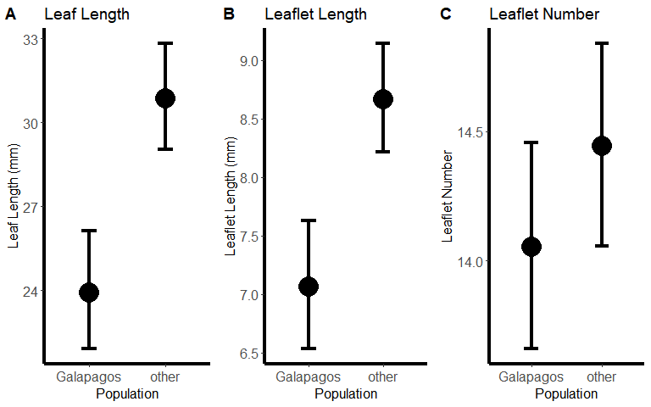

Estimated means of leaf traits between the Galapagos and other island populations.

ANOVA Leaf Length (mm)

|  |  |  |  |
| --- | --- | --- | --- |
|  | Chisq | Df | Pr(>Chisq) |
| galapagos_other | 20.3974384 | 1 | 0.0000063 |
| year_collected | 0.5726341 | 1 | 0.4492141 |

ANOVA Leaflet Length (mm)

|  |  |  |  |
| --- | --- | --- | --- |
|  | Chisq | Df | Pr(>Chisq) |
| galapagos_other | 17.2063072 | 1 | 0.0000335 |
| year_collected | 0.8816053 | 1 | 0.3477624 |

ANOVA Leaf Number

|  |  |  |  |
| --- | --- | --- | --- |
|  | Chisq | Df | Pr(>Chisq) |
| galapagos_other | 1.864473 | 1 | 0.1721094 |

## Model 3: Finch Beak

### Mericarp

The presence of large beak finch species, *Geospiza magnirrostris* and *Geospiza cornirostris* was significantly associated with the presence of lower spines (X^2(1)=[125.47], p = <0.001). However, mericarp length, width, depth and spine tip distance were not significant (p = 0.08, p = 0.58, p = 0.37, p = 0.25).

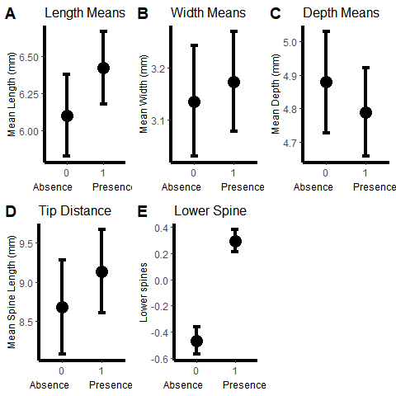

Estimated means of mericarp traits between finch beak communities. 1 = Presence of large finch species, *Geospiza magnirrostris* and *Geospiza cornirostris*. 0 = Absence of large finch species.

ANOVA Length (mm)

|  |  |  |  |
| --- | --- | --- | --- |
|  | Chisq | Df | Pr(>Chisq) |
| finch_beak | 3.0175412 | 1 | 0.0823683 |
| year_collected | 0.1566561 | 1 | 0.6922540 |

ANOVA Width (mm)

|  |  |  |  |
| --- | --- | --- | --- |
|  | Chisq | Df | Pr(>Chisq) |
| finch_beak | 0.2771715 | 1 | 0.5985612 |
| year_collected | 0.9632845 | 1 | 0.3263607 |

ANOVA Depth (mm)

|  |  |  |  |
| --- | --- | --- | --- |
|  | Chisq | Df | Pr(>Chisq) |
| finch_beak | 0.7951283 | 1 | 0.3725539 |
| year_collected | 2.4684788 | 1 | 0.1161503 |

ANOVA Tip Distance (mm)

|  |  |  |  |
| --- | --- | --- | --- |
|  | Chisq | Df | Pr(>Chisq) |
| finch_beak | 1.3132890 | 1 | 0.2518000 |
| year_collected | 0.0048628 | 1 | 0.9444054 |

ANOVA Lower Spines

|  |  |  |  |
| --- | --- | --- | --- |
|  | LR Chisq | Df | Pr(>Chisq) |
| finch_beak | 125.47933 | 1 | 0.00e+00 |
| year_collected | 17.41415 | 1 | 3.01e-05 |

### Flower

There was no statistically significant difference for petal length between islands with large beak finches present and absent (p = 0.55)

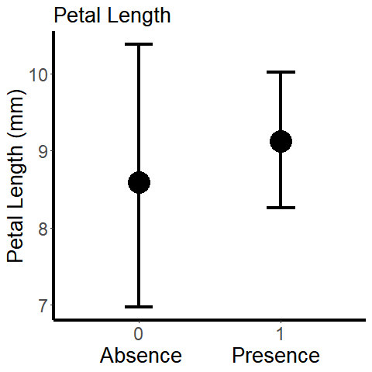

Estimated means of petal length between finch beak communities. 1 = Presence of large finch species, *Geospiza magnirrostris* and *Geospiza cornirostris*. 0 = Absence of large finch species.

ANOVA Petal Length (mm)

|  |  |  |  |
| --- | --- | --- | --- |
|  | Chisq | Df | Pr(>Chisq) |
| finch_beak | 0.3459436 | 1 | 0.5564184 |
| year_collected | 6.7203092 | 1 | 0.0095321 |

### Leaf

There is not statistically significant difference between islands with large finch beak species present and absent for all three leaf traits, leaf length, leaflet length and leaf number (p = 0.17; p = p = 0.15; p = 0.73).

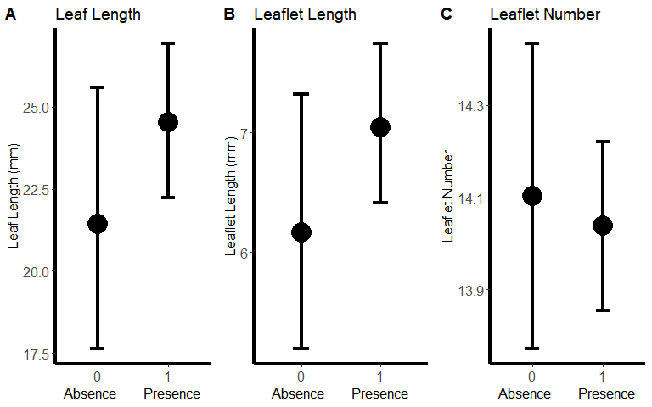

Estimated means of leaf traits between finch beak communities. 1 = Presence of large finch species, *Geospiza magnirrostris* and *Geospiza cornirostris*. 0 = Absence of large finch species.

ANOVA Leaf Length (mm)

|  |  |  |  |
| --- | --- | --- | --- |
|  | Chisq | Df | Pr(>Chisq) |
| finch_beak | 1.878735 | 1 | 0.1704780 |
| year_collected | 12.856477 | 1 | 0.0003363 |

ANOVA Leaflet Length (mm)

|  |  |  |  |
| --- | --- | --- | --- |
|  | Chisq | Df | Pr(>Chisq) |
| finch_beak | 2.027993 | 1 | 0.1544244 |
| year_collected | 3.709110 | 1 | 0.0541162 |

ANOVA Leaf Number

|  |  |  |  |
| --- | --- | --- | --- |
|  | LR Chisq | Df | Pr(>Chisq) |
| finch_beak | 0.1126053 | 1 | 0.7371973 |
| year_collected | 11.9862382 | 1 | 0.0005359 |

# Multivariate analysis: trait ~ group + condition(year)

## Model 1: Mainland/Island

### Mericarp

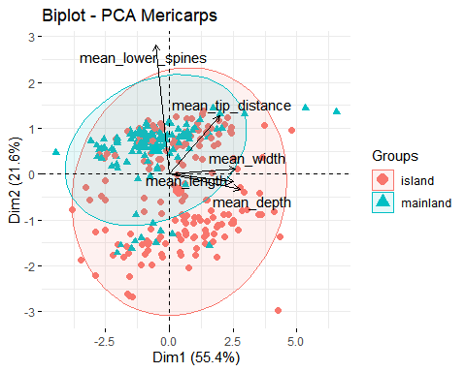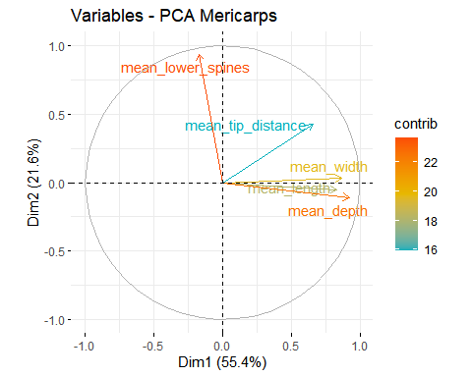

### Leaf

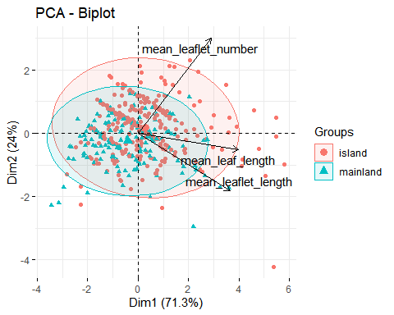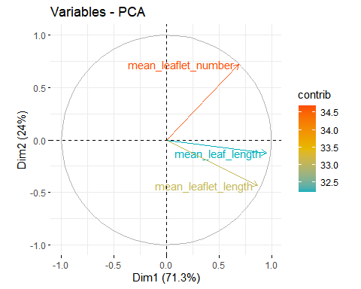

## Model 2: Galapagos/Other

### Leaf

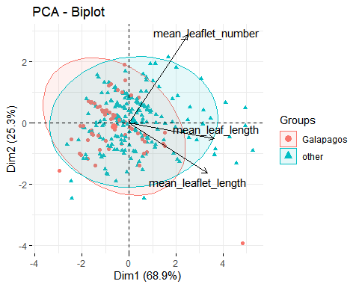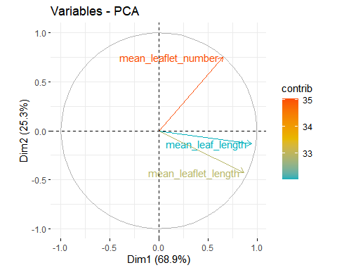

## Model 3: Finch Beak

### Mericarp

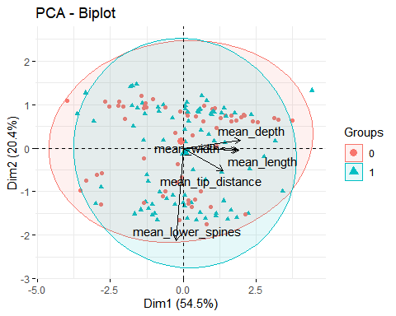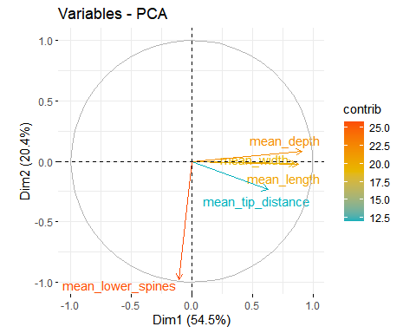

### Leaf

