Name: Nguyễn Phước Nguyên Phúc

Student’s id: 2053342

Computer Architecture Report

1. Game’s instruction
2. Click “Assemble” to run the game
3. Click “Run the current program” to play
4. On “Mars Messages” you will see a square board 3x3 , each small square contains numbers from 1-9
5. The first player is X, second one is O. Input a number according to the position you choose. Then you can see your symbol (X) or (O) will be on that square
6. First player who have 3 of their symbol on consecutively vertical, horizontal or diagonal will be the winner.
7. Click Assemble -> Run if you want to play again

*Attention: please don’t remove or change you move unless you play again and the game will stop after 9 turns.*

1. Algorithm / Idea

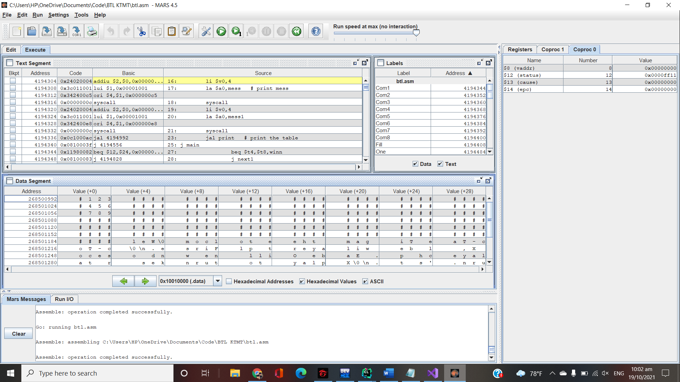First, I created a string from address 268500992 to 268501187 (choose ASCII to see)

Specially, I put 9 numbers from 1-9 to create the game board (look at the picture at address 268500992 , 268501024 and 26851056)

Now I just print out this part of the string, adjust a little bit to create the board.

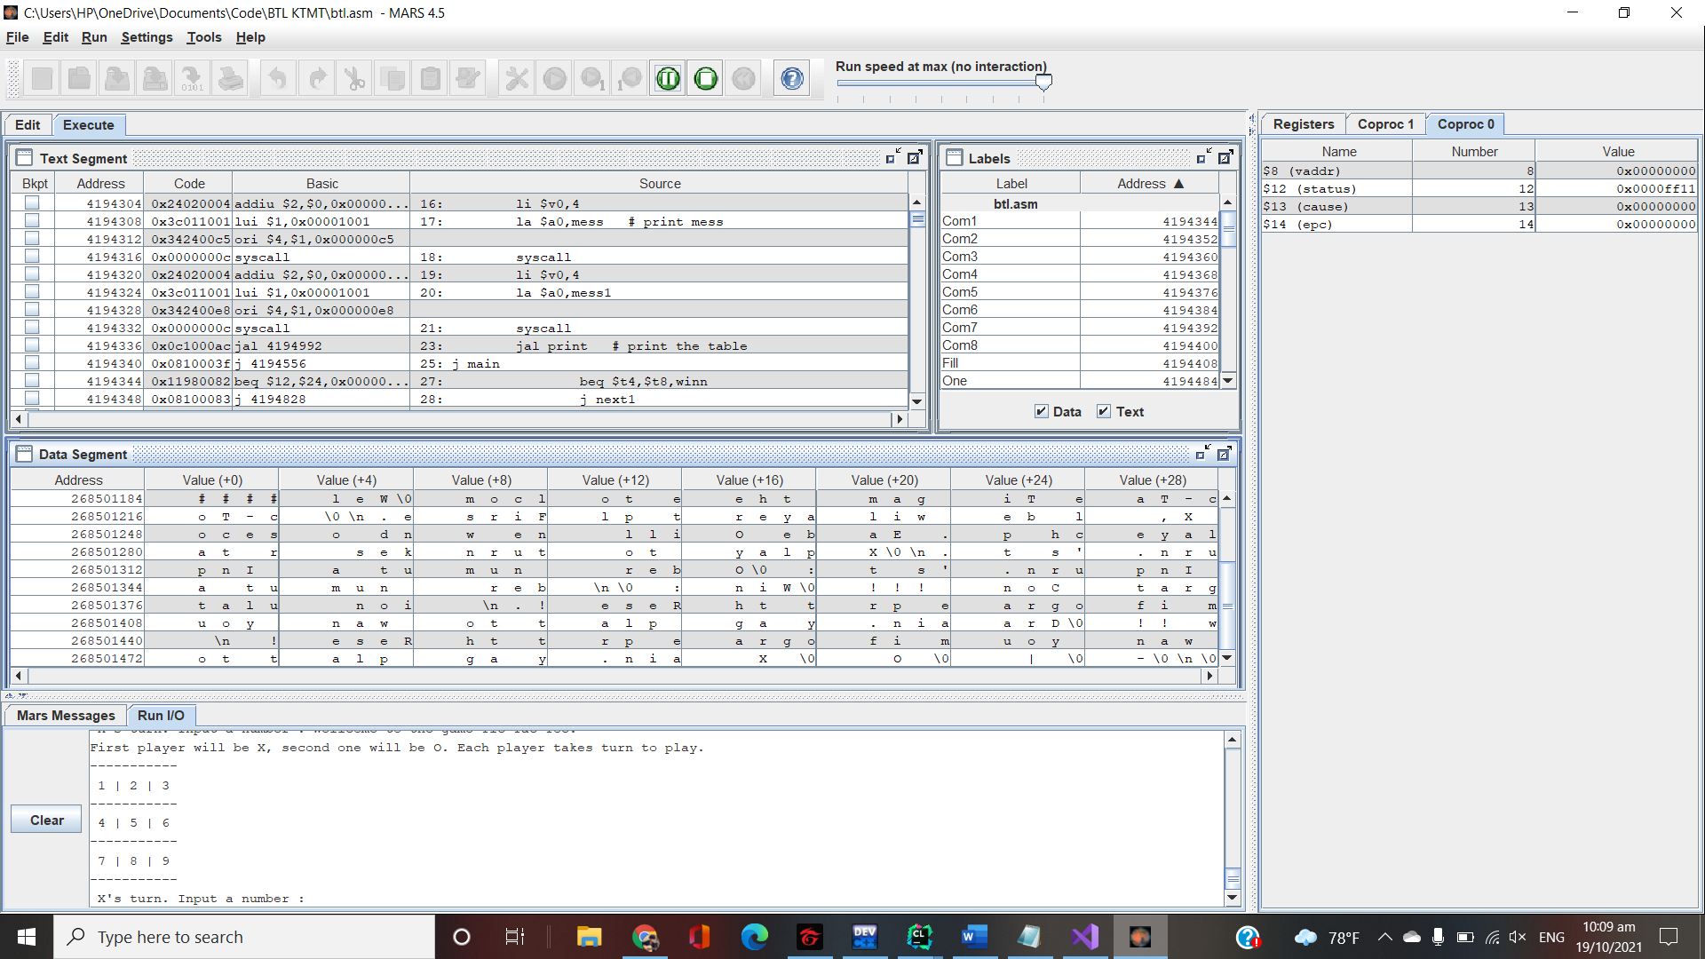

Because now I have exactly address of each square, so I created 9 labels, whenever player input a number, for example, if 1 is input then I use beq to jump to the label number1. At this, I store byte the ASCII code of the symbols in to address 268500995 (which is number 1).

After each turn, I will check is there 3 symbols on consecutive positions yet by checking each pair first, for example, I check 5-1, 5-2, 5-3, 5-6, if one of these pair have to same symbol, for example, if I check 5-1 and it true, then I check 5-9 next (because they make a diagonal line), if this also true, the game will stop and print out the winner, if not, it will continuously check other pair and so on. (If 5-2 is true, then check 5-8, if 5-6 is true, then check 5-4).

If the condition to win isn’t satisfied, then other player’s turn.

After 9 turns, the game stop, if there is no winner, “Draw” will be print out.