# Exercise 3

Question1:  What is the status code and phrase returned from the server to the client browser?

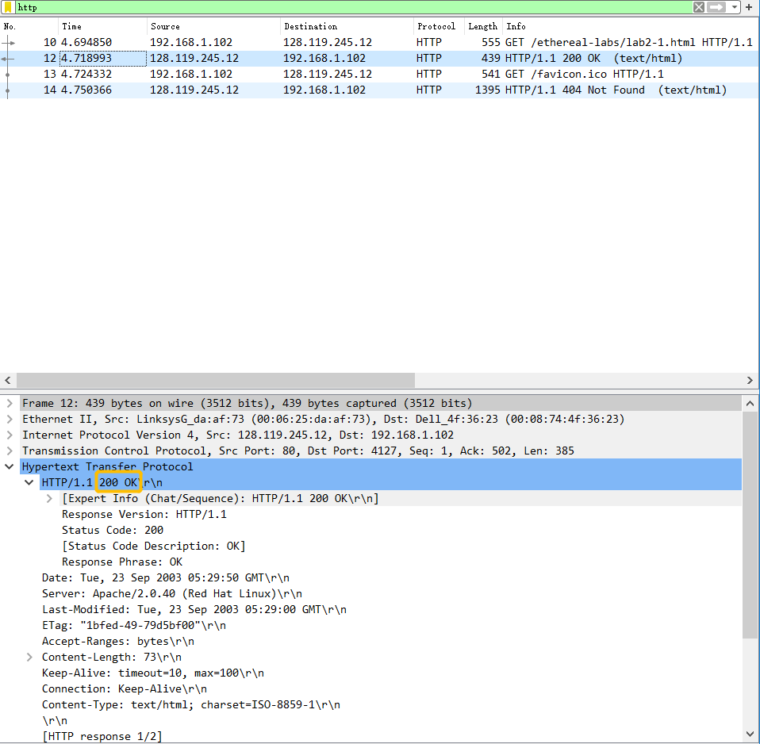

The status code is 200 and the phrase is HTTP/1.1 200 OK\r\n.

Question2: When was the HTML file that the browser is retrieving last modified at the server? Does the response also contain a DATE header? How are these two fields different?

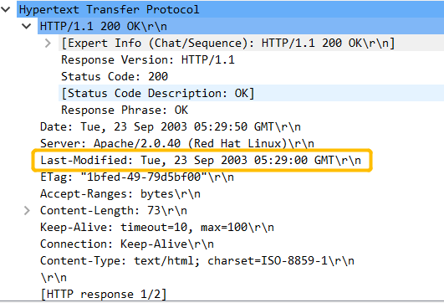

The last modified is Tue, 23 Sep 2003 05:29:00 GMT.



Yes, the response also contains a Date header. The definition of Date HTTP header is which contains the date and time at which the message was generated.

Date is different with Last-Modified, because it’s not the time when the object was created or last modified, but the time when the server retrieved the object from his file system, the object inserted the response message, and sent the response message.

Question 3: Is the connection established between the browser and the server persistent or non-persistent? How can you infer this?



Both the client and server are configured for using persistent HTTP connections. As the above picture, because it is *keep-Alive* rather than *close.*

Question 4: How many bytes of content are being returned to the browser?



There are 73 bytes of content.

Question 5: What is the data contained inside the HTTP response packet?

The file being returned to the browser is an HTML file with the following content:

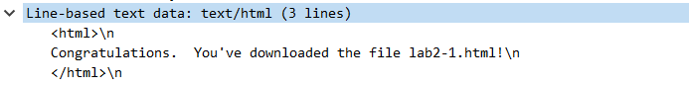

# Exercise 4

Question 1: Inspect the contents of the first HTTP GET request from the browser to the server. Do you see an “IF-MODIFIED-SINCE” line in the HTTP GET?

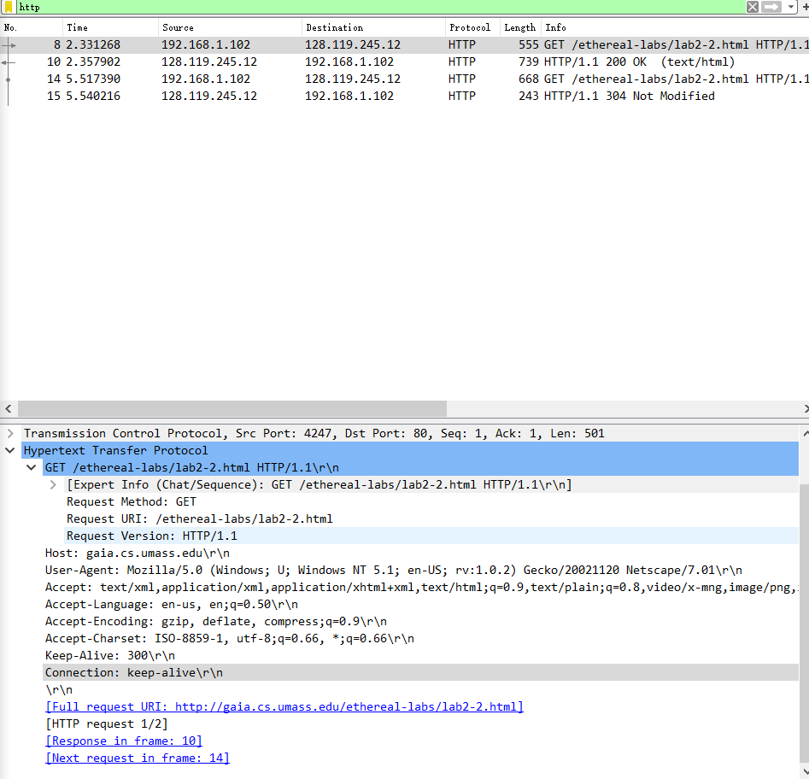

There is no “IF-MODIFIED-SINCE” line in the HTTP GET.

Question 2: Does the response indicate the last time that the requested file was modified?



Yes, we can see *Last-Modified*.

Question 3: Now inspect the contents of the second HTTP GET request from the browser to the server. Do you see an “IF-MODIFIED-SINCE:” and “IF-NONE-MATCH” lines in the HTTP GET? If so, what information is contained in these header lines?

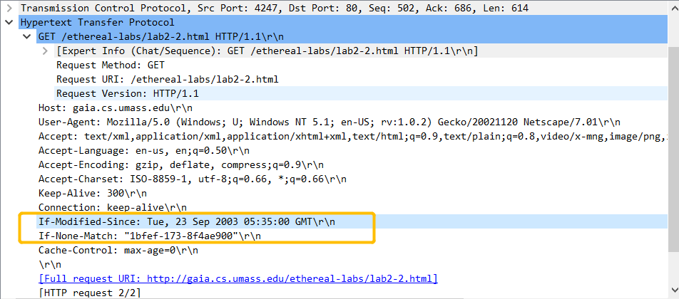

Yes. This information: Tue, 23 Sep 2003 05:35:00 GMT\r\n, is the date of the last modification of the file from the previous get request.

Question 4: What is the HTTP status code and phrase returned from the server in response to this second HTTP GET? Did the server explicitly return the contents of the file? Explain.



The status code is 304 and the phrase is HTTP/1.1 304 Not Modified\r\n.

Question 5: What is the value of the Etag field in the 2nd response message and how it is used? Has this value changed since the 1 stresponse message was received?



The value of the Etag is “1bfef-173-8f4ae900”\r\n. An ETag is an opaque identifier assigned by a Web server to a specific version of a resource found at a URL. If the resource representation at that URL ever changes, a new and different ETag is assigned.

However, this value hasn’t changed due to “not modified”.

# Exercise 5

The program:

(It is also included in ***tar*** )

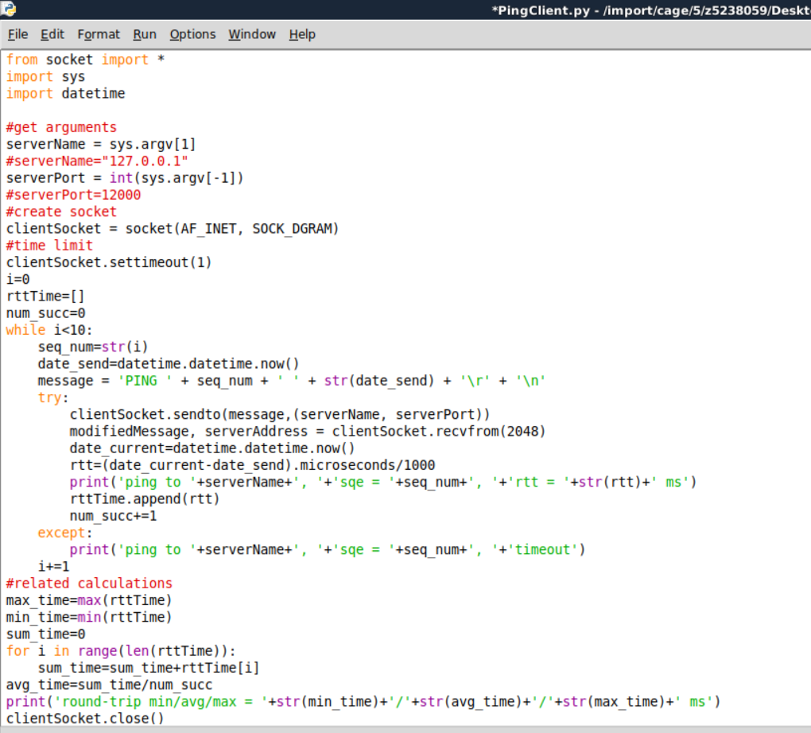

The test result:

