加载底图与标记
<!DOCTYPE html>
<html>
<head>
<meta charset="UTF-8">
<title>我的第一张地图</title>
<link rel="stylesheet" href="https://unpkg.com/leaflet@1.9.4/dist/leaflet.css" />
<style>
body { margin: 0; padding: 0; }
#map { height: 100vh; width: 100%; }
</style>
</head>
<body>
<div id="map"></div>
<script src="https://unpkg.com/leaflet@1.9.4/dist/leaflet.js"></script>
<script>
var map = L.map('map').setView([23.0288, 113.1226], 13);

// 高德底图（国内可用）
L.tileLayer('https://webrd0{s}.is.autonavi.com/appmaptile?lang=zh_cn&size=1&scale=1&style=8&x={x}&y={y}&z={z}', {
subdomains: ['1', '2', '3', '4'],
attribution: '高德地图'
}).addTo(map);

L.marker([23.0288, 113.1226]).addTo(map).bindPopup("佛山").openPopup();
// 广州标记
L.marker([23.1291, 113.2644])
.addTo(map)
.bindPopup("广州");

// 深圳标记
L.marker([22.5431, 114.0579])
.addTo(map)
.bindPopup("深圳");
</script>
</body>
</html>
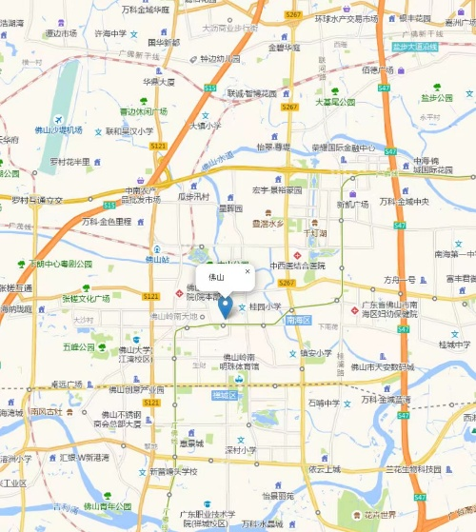

<!DOCTYPE html>
<html>
<head>
<meta charset="UTF-8">
<title>Leaflet 进阶</title>
<link rel="stylesheet" href="https://unpkg.com/leaflet@1.9.4/dist/leaflet.css" />
<style>
body { margin: 0; padding: 0; }
#map { height: 100vh; width: 100%; }
</style>
</head>
<body>
<div id="map"></div>
<script src="https://unpkg.com/leaflet@1.9.4/dist/leaflet.js"></script>
<script>
// 初始化地图（广佛深中心）
var map = L.map('map').setView([22.9, 113.5], 9);

// 底图1：高德街道图
var gaode = L.tileLayer('https://webrd0{s}.is.autonavi.com/appmaptile?lang=zh_cn&size=1&scale=1&style=8&x={x}&y={y}&z={z}', {
subdomains: ['1', '2', '3', '4'],
attribution: '高德地图'
}).addTo(map);

// 底图2：高德卫星图（备用）
var gaodeSat = L.tileLayer('https://webst0{s}.is.autonavi.com/appmaptile?style=6&x={x}&y={y}&z={z}', {
subdomains: ['1', '2', '3', '4'],
attribution: '高德卫星'
});

// 添加多个标记
var cities = [
{ name: "佛山", lat: 23.0288, lng: 113.1226 },
{ name: "广州", lat: 23.1291, lng: 113.2644 },
{ name: "深圳", lat: 22.5431, lng: 114.0579 },
{ name: "东莞", lat: 23.0489, lng: 113.7448 }
];

for (let i = 0; i < cities.length; i++) {
let c = cities[i];
L.marker([c.lat, c.lng])
.addTo(map)
.bindPopup(`<b>${c.name}</b><br>纬度: ${c.lat}<br>经度: ${c.lng}`);
}

// 画线：连接佛山-广州-深圳
var line = L.polyline([
[23.0288, 113.1226], // 佛山
[23.1291, 113.2644], // 广州
[22.5431, 114.0579] // 深圳
], { color: 'red', weight: 3 }).addTo(map);

// 画圆：佛山50公里范围
var circle = L.circle([23.0288, 113.1226], {
color: 'blue',
fillColor: '#30f',
fillOpacity: 0.2,
radius: 50000 // 50公里，单位米
}).addTo(map).bindPopup("佛山50公里范围");

// 底图切换控件
var baseMaps = {
"街道图": gaode,
"卫星图": gaodeSat
};
L.control.layers(baseMaps).addTo(map);

// 添加比例尺
L.control.scale().addTo(map);

console.log("地图加载完成，标记数量：" + cities.length);
</script>
</body>
</html>
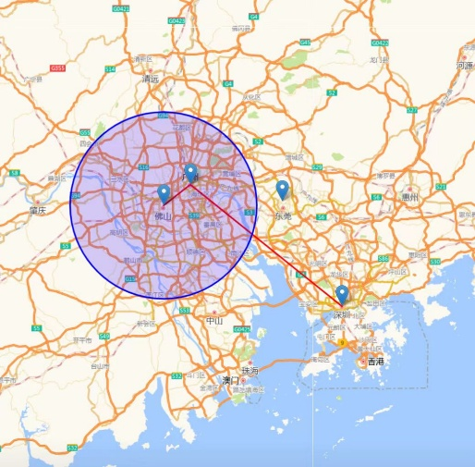

<!DOCTYPE html>
<html>
<head>
<meta charset="UTF-8">
<title>GeoJSON 数据加载</title>
<link rel="stylesheet" href="https://unpkg.com/leaflet@1.9.4/dist/leaflet.css" />
<style>
body { margin: 0; padding: 0; }
#map { height: 100vh; width: 100%; }
</style>
</head>
<body>
<div id="map"></div>
<script src="https://unpkg.com/leaflet@1.9.4/dist/leaflet.js"></script>
<script>
// 初始化地图
var map = L.map('map').setView([23.0288, 113.1226], 9);

// 高德底图
L.tileLayer('https://webrd0{s}.is.autonavi.com/appmaptile?lang=zh_cn&size=1&scale=1&style=8&x={x}&y={y}&z={z}', {
subdomains: ['1', '2', '3', '4'],
attribution: '高德地图'
}).addTo(map);

// ===== GeoJSON 数据（内嵌）=====
var citiesData = {
"type": "FeatureCollection",
"features": [
{
"type": "Feature",
"geometry": {
"type": "Point",
"coordinates": [113.1226, 23.0288]
},
"properties": {
"name": "佛山",
"population": 950,
"gdp": 12156
}
},
{ "type": "Feature",
"geometry": {
"type": "Point",
"coordinates": [113.2644, 23.1291]
},
"properties": {
"name": "广州",
"population": 1881,
"gdp": 28839
}
},
{ "type": "Feature",
"geometry": {
"type": "Point",
"coordinates": [114.0579, 22.5431]
},
"properties": {
"name": "深圳",
"population": 1768,
"gdp": 34606
}
}
]
};

// ===== 加载 GeoJSON =====
var geoJsonLayer = L.geoJSON(citiesData, {
// 点样式
pointToLayer: function(feature, latlng) {
return L.circleMarker(latlng, {
radius: feature.properties.population / 100, // 人口决定大小
fillColor: "#ff7800",
color: "#000",
weight: 1,
opacity: 1,
fillOpacity: 0.8
});
},

// 每个要素的弹窗
onEachFeature: function(feature, layer) {
var props = feature.properties;
var popupContent = `
<b>${props.name}</b><br>
人口: ${props.population}万<br>
GDP: ${props.gdp}亿元<br>
人均: ${(props.gdp / props.population * 10000).toFixed(0)}元`;
layer.bindPopup(popupContent);
}
}).addTo(map);

// 缩放到数据范围
map.fitBounds(geoJsonLayer.getBounds());

console.log("加载了 " + citiesData.features.length + " 个城市");
</script>
</body>
</html>

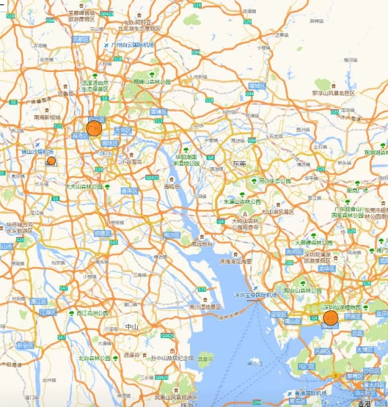

<!DOCTYPE html>
<html>
<head>
<meta charset="UTF-8">
<title>加载外部 GeoJSON</title>
<link rel="stylesheet" href="https://unpkg.com/leaflet@1.9.4/dist/leaflet.css" />
<style>
body { margin: 0; padding: 0; }
#map { height: 100vh; width: 100%; }
#info {
position: absolute;
top: 10px;
right: 10px;
background: white;
padding: 10px;
z-index: 1000;
}
</style>
</head>
<body>
<div id="map"></div>
<div id="info">加载中...</div>

<script src="https://unpkg.com/leaflet@1.9.4/dist/leaflet.js"></script>
<script>
// 初始化地图
var map = L.map('map').setView([23.0288, 113.1226], 9);

L.tileLayer('https://webrd0{s}.is.autonavi.com/appmaptile?lang=zh_cn&size=1&scale=1&style=8&x={x}&y={y}&z={z}', {
subdomains: ['1', '2', '3', '4'],
attribution: '高德地图'
}).addTo(map);

// ===== 异步加载 GeoJSON =====
async function loadData() {
try {
// 1. 获取数据（等待网络请求完成）
let response = await fetch('https://geo.datav.aliyun.com/areas_v3/bound/440000_full.json');

// 2. 检查是否成功
if (!response.ok) {
throw new Error('网络请求失败');
}

// 3. 解析 JSON（等待解析完成）
let geojsonData = await response.json();

// 4. 显示在地图上
L.geoJSON(geojsonData, {
style: {
color: '#0066cc',
weight: 2,
fillColor: '#99ccff',
fillOpacity: 0.3
},
onEachFeature: function(feature, layer) {
layer.bindPopup(feature.properties.name || '无名称');
}
}).addTo(map);

// 5. 更新信息
document.getElementById('info').innerHTML = '加载完成';
console.log('加载了', geojsonData.features.length, '个要素');

} catch (error) {
// 6. 错误处理
console.error('加载失败:', error);
document.getElementById('info').innerHTML = '加载失败: ' + error.message;
}
}

// 调用函数
loadData();
</script>
</body>
</html>

<!DOCTYPE html>
<html>
<head>
<meta charset="UTF-8">
<title>加载本地 GeoJSON</title>
<link rel="stylesheet" href="https://unpkg.com/leaflet@1.9.4/dist/leaflet.css" />
<style>
body { margin: 0; padding: 0; }
#map { height: 100vh; width: 100%; }
</style>
</head>
<body>
<div id="map"></div>
<script src="https://unpkg.com/leaflet@1.9.4/dist/leaflet.js"></script>
<script>
var map = L.map('map').setView([23.0288, 113.1226], 9);

L.tileLayer('https://webrd0{s}.is.autonavi.com/appmaptile?lang=zh_cn&size=1&scale=1&style=8&x={x}&y={y}&z={z}', {
subdomains: ['1', '2', '3', '4'],
attribution: '高德地图'
}).addTo(map);

// ===== 加载本地 GeoJSON 文件 =====
async function loadLocalData() {
try {
// 本地文件路径（相对路径）
let response = await fetch('./data/cities.json');

if (!response.ok) {
throw new Error('文件加载失败: ' + response.status);
}

let geojsonData = await response.json();

// 根据 type 属性设置不同颜色
var typeColors = {
"制造业": "#ff7800",
"商贸": "#0066cc",
"科技": "#00cc66"
};

L.geoJSON(geojsonData, {
pointToLayer: function(feature, latlng) {
var color = typeColors[feature.properties.type] || "#999";
return L.circleMarker(latlng, {
radius: 12,
fillColor: color,
color: "#000",
weight: 1,
opacity: 1,
fillOpacity: 0.8
});
},
onEachFeature: function(feature, layer) {
layer.bindPopup(`
<b>${feature.properties.name}</b><br>
类型: ${feature.properties.type}
`);
}
}).addTo(map);

console.log('加载了', geojsonData.features.length, '个城市');

} catch (error) {
console.error('错误:', error);
alert('加载本地文件失败，请使用 Live Server 运行');
}
}

loadLocalData();
</script>
</body>
</html>

// 本地路径（开发时用）
// let response = await fetch('./data/cities.json');

// GitHub raw 链接（部署后用）
let response = await fetch('https://raw.githubusercontent.com/你的用户名/GIS-Learning-Log/main/data/cities.json');

<!DOCTYPE html>
<html>
<head>
<meta charset="UTF-8">
<title>Leaflet 事件交互</title>
<link rel="stylesheet" href="https://unpkg.com/leaflet@1.9.4/dist/leaflet.css" />
<style>
body { margin: 0; padding: 0; font-family: "SimSun", serif; }
#map { height: 100vh; width: 100%; }
#info { position: absolute; top: 10px; left: 10px; background: white; padding: 10px; z-index: 1000; border: 2px solid black; }
.btn { margin: 3px; padding: 5px 10px; border: 1px solid black; background: white; cursor: pointer; }
#coords { font-family: monospace; font-size: 11px; display: block; margin: 5px 0; padding: 3px; border: 1px dashed #999; }
@media print { #map, .btn { display: none; } #info { position: static; width: 100%; border: 1px solid black; } }
</style>
</head>
<body>
<div id="info">
<b>Leaflet 事件交互</b>
<span id="coords">纬度: --, 经度: --</span>
<button class="btn" onclick="startDrawPoint()">画点</button>
<button class="btn" onclick="startDrawLine()">画线</button>
<button class="btn" onclick="clearDraw()">清除</button>
</div>
<div id="map"></div>

<script src="https://unpkg.com/leaflet@1.9.4/dist/leaflet.js"></script>
<script>
// 初始化
var map = L.map('map').setView([23.0288, 113.1226], 13);
L.tileLayer('https://webrd0{s}.is.autonavi.com/appmaptile?lang=zh_cn&size=1&scale=1&style=8&x={x}&y={y}&z={z}', { subdomains: ['1','2','3','4'], attribution: '高德地图' }).addTo(map);

// 图层与状态
var coordLayer = L.layerGroup().addTo(map), drawLayer = L.layerGroup().addTo(map);
var drawMode = '', linePoints = [], currentLine = null, clickTimer = null;

// 点击事件
map.on('click', function(e) {
if (drawMode) { if (clickTimer) clearTimeout(clickTimer); clickTimer = setTimeout(function() { handleDraw(e); }, 200); return; }
var lat = e.latlng.lat.toFixed(6), lng = e.latlng.lng.toFixed(6);
document.getElementById('coords').innerHTML = '纬度: ' + lat + '<br>经度: ' + lng;
L.circleMarker([lat, lng], { radius: 5, color: 'red', fillColor: 'red', fillOpacity: 1 }).addTo(coordLayer).bindPopup(lat + ', ' + lng).openPopup();
});

// 双击结束画线
map.on('dblclick', function() { if (clickTimer) { clearTimeout(clickTimer); clickTimer = null; } if (drawMode === 'line') { drawMode = ''; console.log('线条:', JSON.stringify(linePoints)); currentLine = null; } });

// 绘制处理
function handleDraw(e) {
if (drawMode === 'point') { L.marker(e.latlng).addTo(drawLayer).bindPopup('标记'); drawMode = ''; }
else if (drawMode === 'line') { linePoints.push(e.latlng); if (currentLine) drawLayer.removeLayer(currentLine); currentLine = L.polyline(linePoints, { color: 'blue', weight: 4 }).addTo(drawLayer); document.getElementById('coords').innerHTML = '画线中: ' + linePoints.length +
' 个点（双击结束）'; }
}

// 按钮控制
function startDrawPoint() { drawMode = 'point'; }
function startDrawLine() { drawMode = 'line'; linePoints = []; currentLine = null; }
function clearDraw() { drawLayer.clearLayers(); coordLayer.clearLayers(); linePoints = []; currentLine = null; drawMode = ''; document.getElementById('coords').innerHTML = '纬度: --, 经度: --'; }
</script>
</body>
</html>

