James Chhun

T/TH -- 530 - 645pm

Homework 4

**Chapter 10 - # 2 and #3**

**Problem 4**

Starter graph

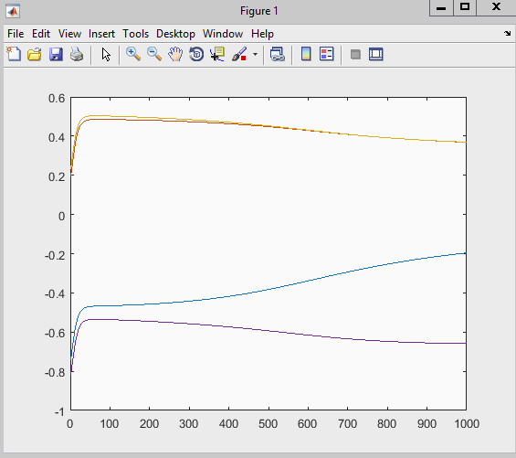

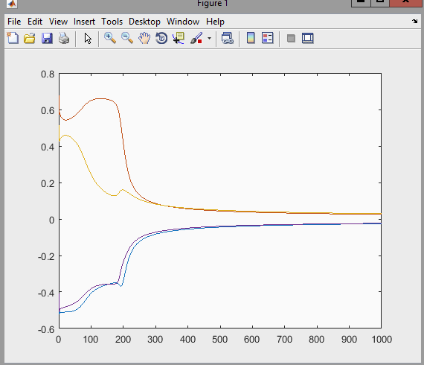

After increasing step size to 10.1

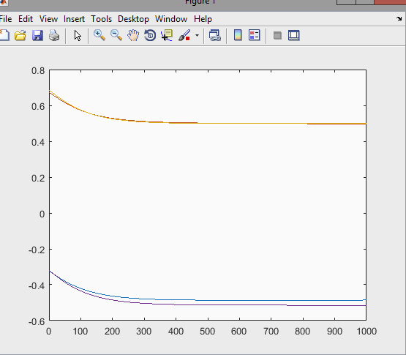

After decreasing step size to 0.1

**Problem 5**

5_1_LDA

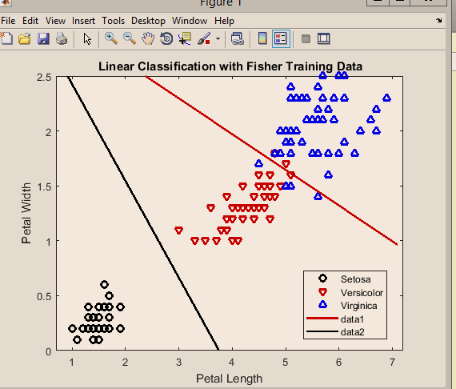

Initial LDA plot with fisher iris data.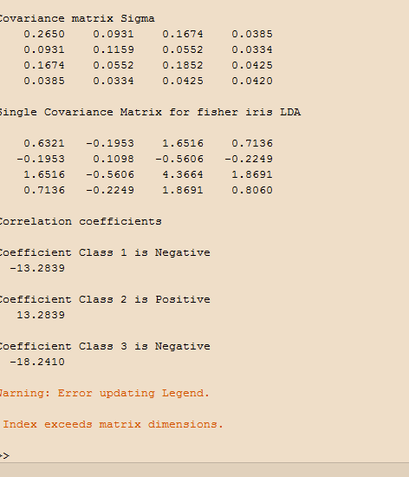

Covariance matrices after change and correlation coefficient.

5_2 LDA_2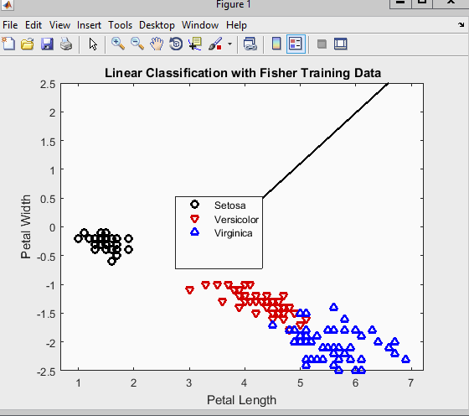

Initial LDA plot with fisher iris data.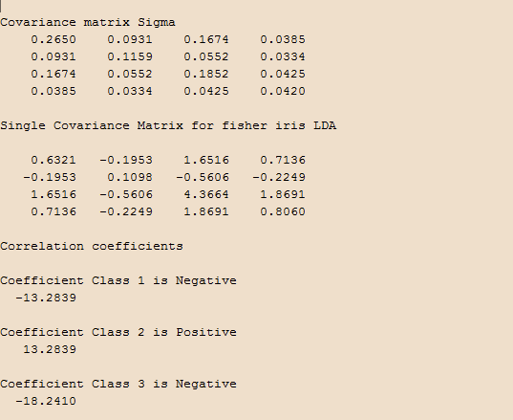

Covariance matrices after change.

5_3 - QDA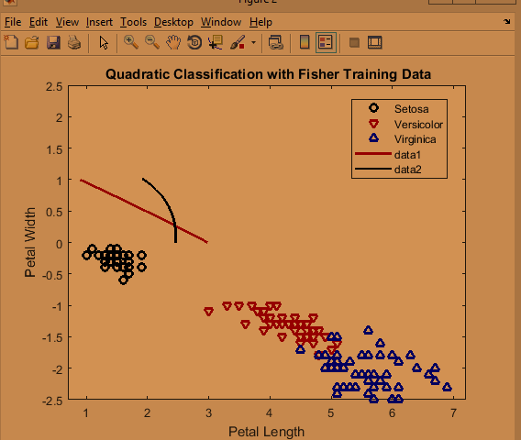

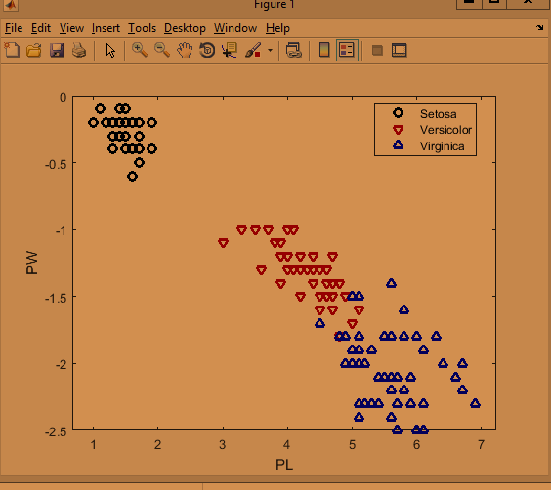

Initial QDA Plots.

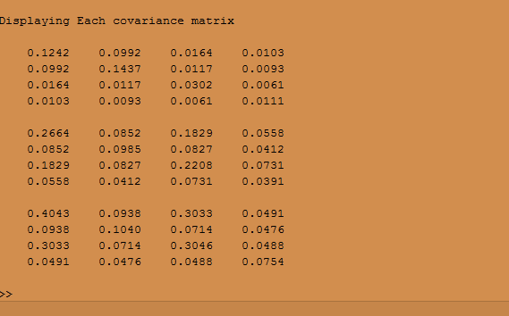

Covariance Matrices for QDA