This project is modified from [pp4fpga] Matrix Multiplication

Original source URL: <https://github.com/KastnerRG/pp4fpgas/tree/master/examples>

**HLS Screenshots**

Synthesis

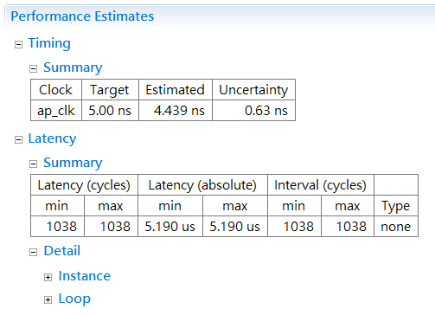

Cosim

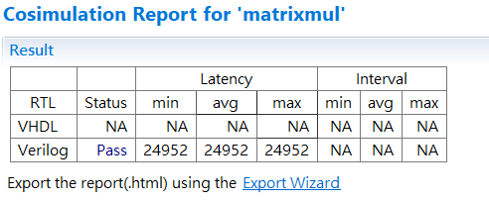

**System level bring-up**

The system is implemented on Pynq

Screenshot of Pynq running result

