This project is modified from [xhls] Squared_difference_accumulate

**HLS Screenshots**

Synthesis

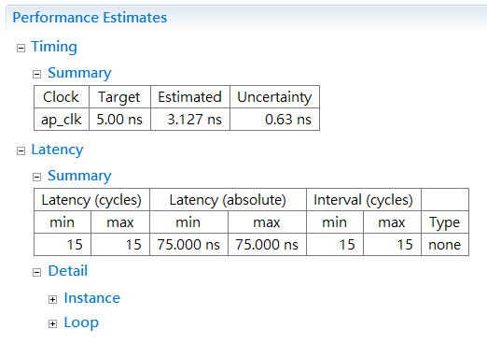

Cosim

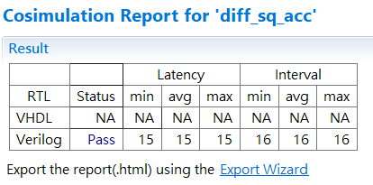

**System level bring-up**

The system is implemented on Pynq

Screenshot of Pynq running result

