This project is modified from [xhls] reed_solomon_erasure(xapp1273)

**Improvement**

Since both size of array c (size=4) and d (size=12) are small, use array_partition directive to partition both arrays.

Latency is improved from 1994 cycles to 25 cycles.

**HLS Screenshots**

Synthesis original

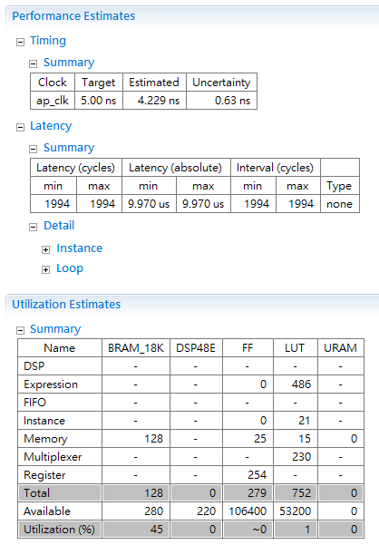

Synthesis improved

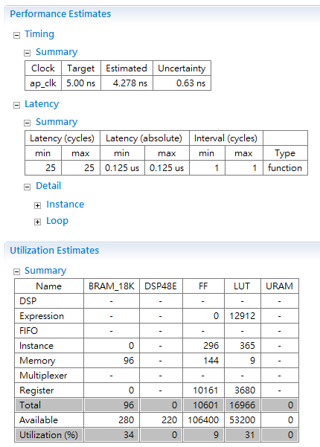

Cosim

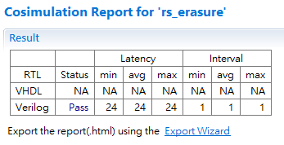

**System level bring-up**

The system is implemented on Pynq

Screenshot of Pynq running result

