**Lab4 Report**

1. **Project Introduction**

This project aims to develop a navigation system for the 4th floor of the Jishi Building, enabling users to virtually browse and access detailed information about each room. Through this system, users can gain comprehensive insights into the floor layout, including the purpose of each room and its assigned personnel. The user interface is designed to be intuitive, allowing users to easily select a target room from an overview map of the floor or quickly locate specific rooms or individuals using the keyword search function. This greatly enhances the efficiency of navigation and overall user experience.

1. **Project Layout**

The project is divided into the following sections:

**1. Homepage**

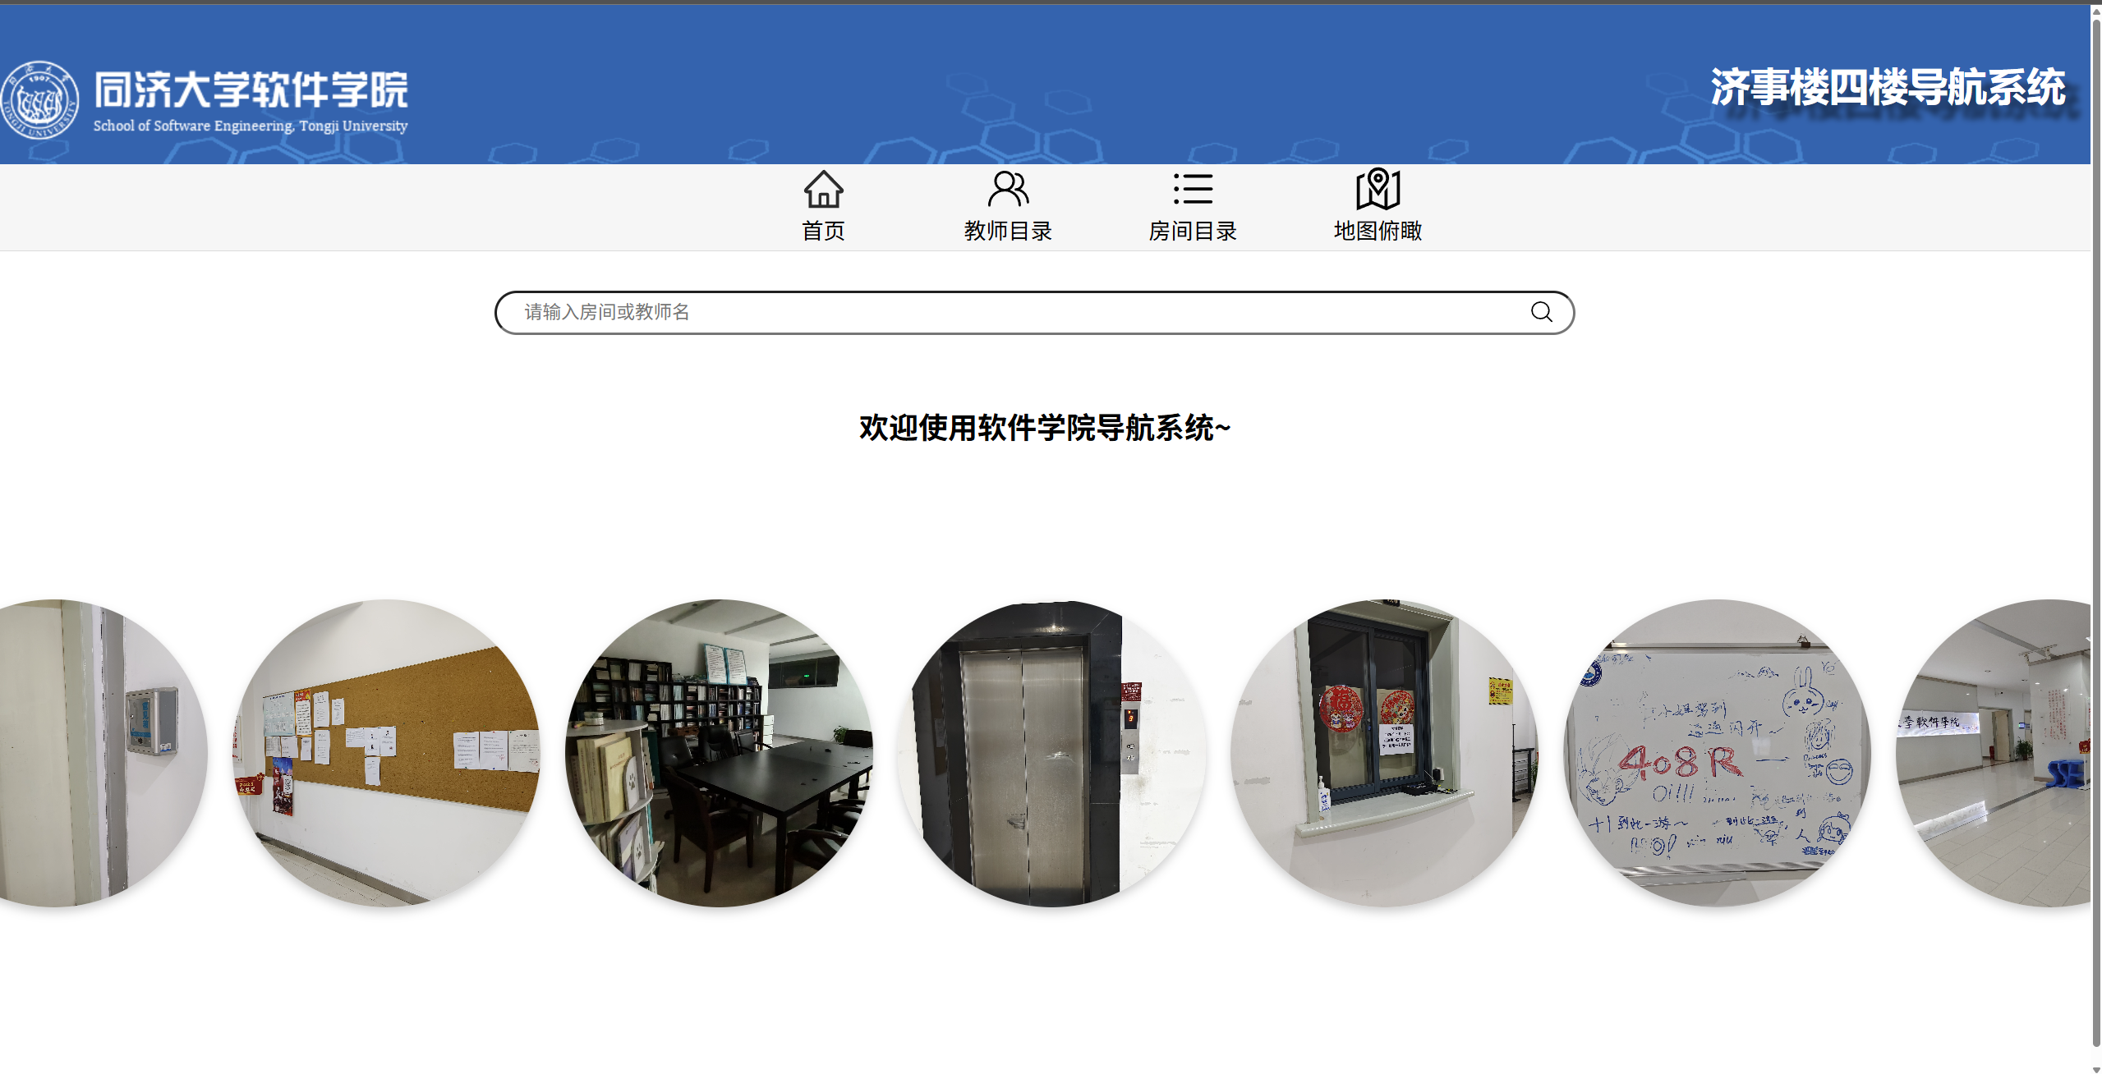

The homepage provides a search bar where users can enter relevant information, such as a teacher’s name, position, or room-related details, to find the corresponding room. After the search results are displayed, users will be redirected to the introduction page of the target room.

**2. Teacher Directory**

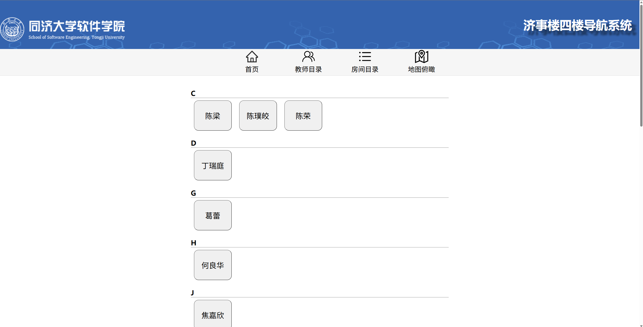

On the Teacher Directory page, teachers from each office on the 4th floor of the Jishi Building are listed in alphabetical order. When a user clicks on a teacher’s button, they will be redirected to the detailed introduction page of the room associated with that teacher.

**3. Room Directory**

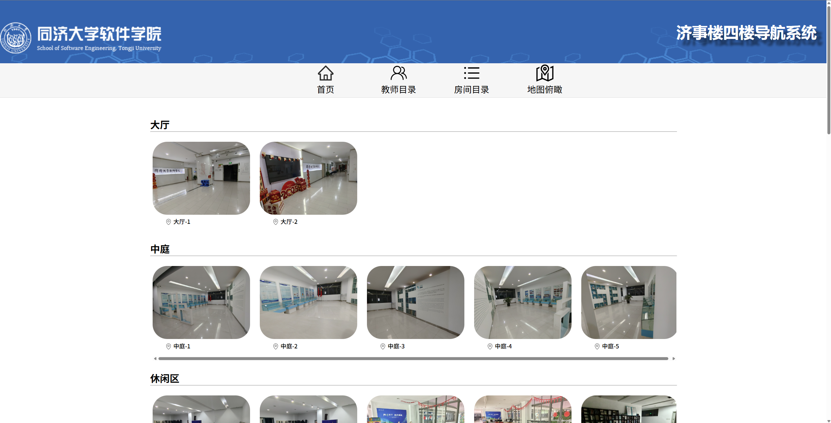

In the Room Directory interface, all rooms and areas on the 4th floor of the Jishi Building are listed, allowing users to preview relevant information for each room. When a user clicks on a room’s label, they will be redirected to the detailed page of the selected room.

**4. Map Overview**

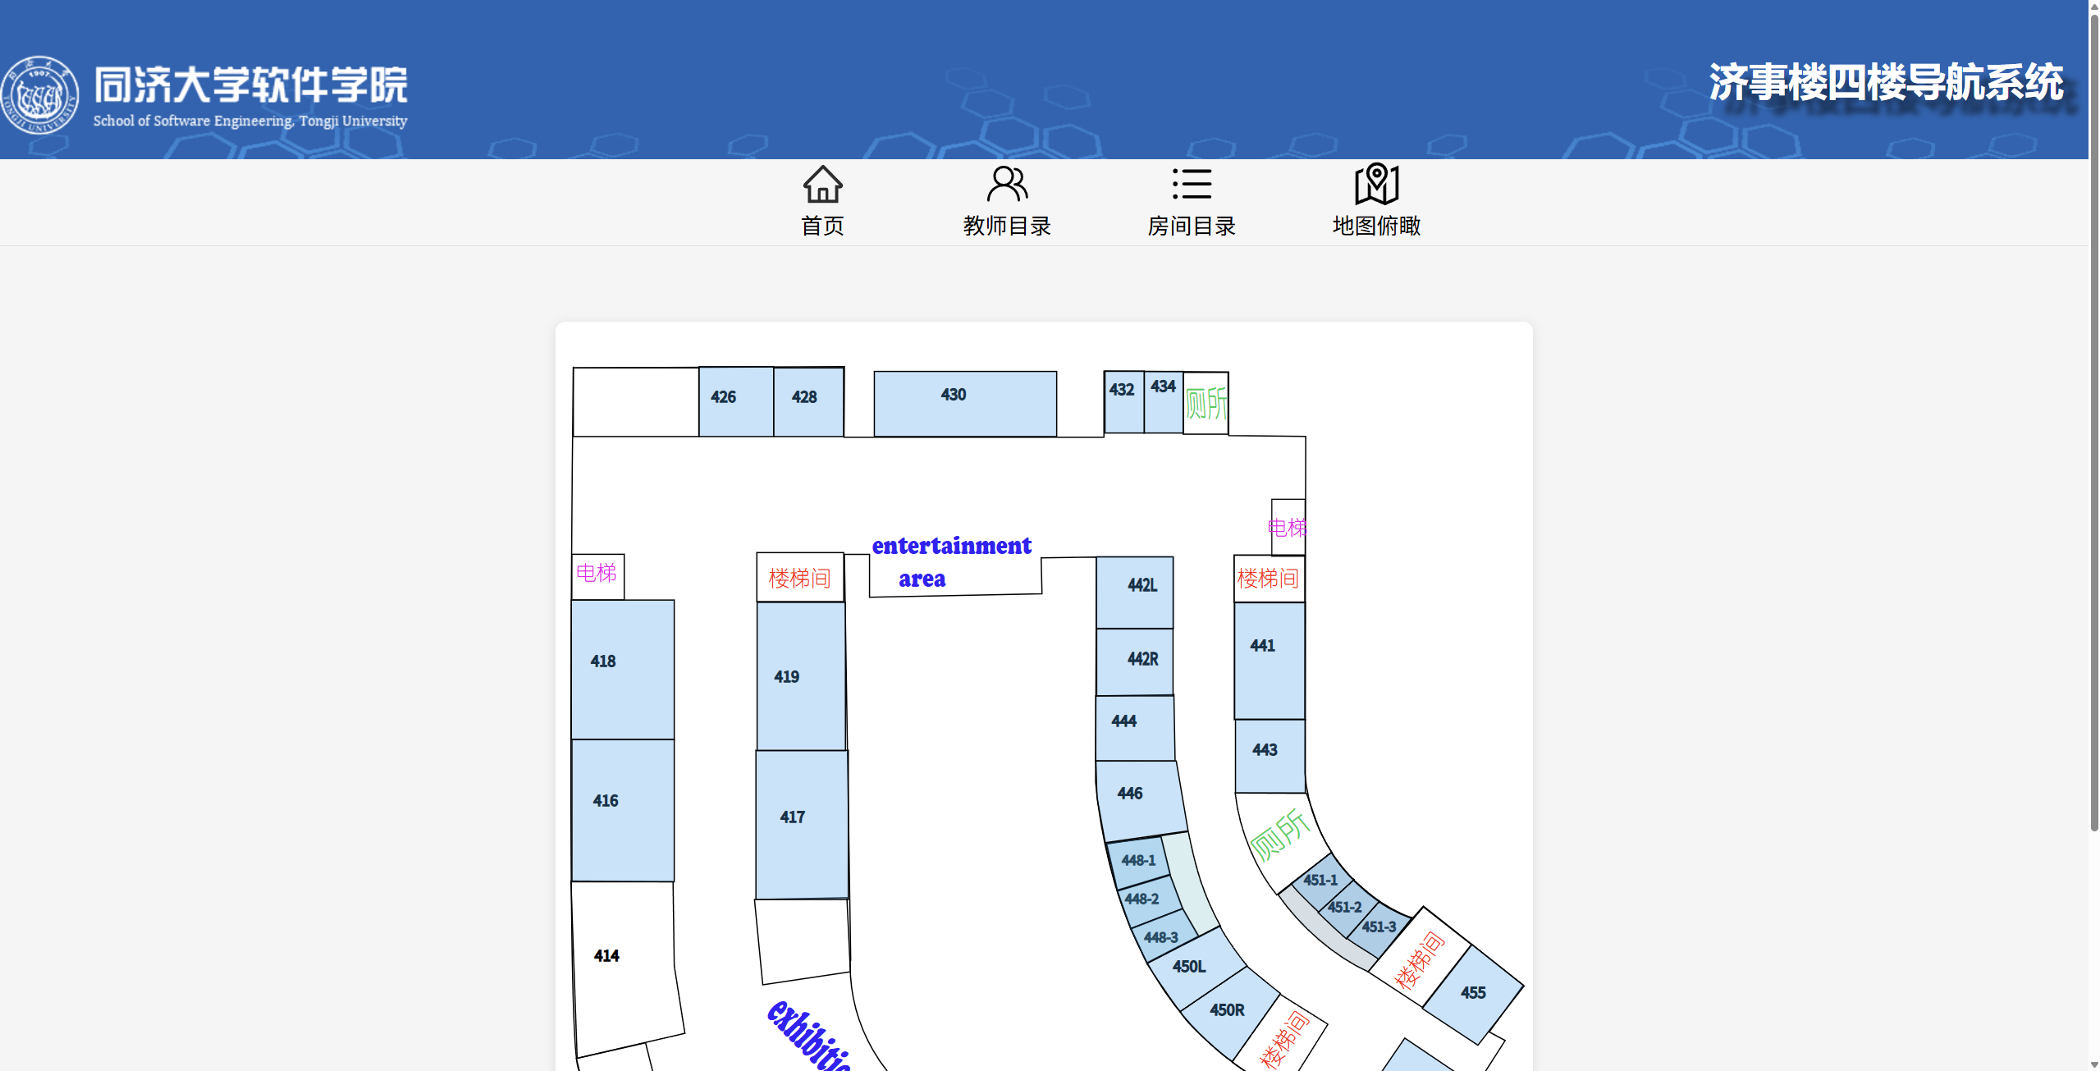

The Map Overview page features a bird’s-eye view of the 4th floor of the Jishi Building, allowing users to see the overall layout of the floor as well as the arrangement of individual rooms. Users can also click the room to see it in detail.

1. **Interactive Design**

Based on the design concept of "Fluid Navigation," the main goal is to enhance the usability and interaction efficiency of the user interface, ensuring that users can enjoy a smooth and seamless experience when using the software, application, or website. The design approach for this project is as follows:

1. Intuitive Visual Guidance Design

The project’s front-end interface is highly intuitive. Upon entering the homepage, users can immediately see various functions organized under different tabs, allowing them to easily identify and select the features they need.

1. Dynamic Interaction

All interactive areas in the project provide clear feedback during user interaction. For example, when the user’s mouse moves over an input box or button, the area’s color or size changes noticeably compared to its normal state. This approach actively engages users and provides strong positive feedback.

1. Consistency

Interface consistency is a key aspect of the project design. Inconsistent designs can cause discomfort and resistance among users. This project maintains consistency in elements such as colors, sizing, and layout, resulting in a more harmonious and cohesive interface.

1. Logical Categorization of Options

Grouping components with vastly different relevance together can cause inconvenience for users. This project places closely related options together, thereby enhancing the ease of use and convenience for users.

1. **Summary**

Through the development of the Jishi Building 4th Floor Guide System, we gained a deep understanding of how to apply the Vue framework in real-world projects. From component division and page design to route configuration and interactive logic implementation, each step provided us with a more systematic grasp of front-end development. During the development process, we not only improved our programming skills but also became more attentive to user experience (UX) and interface design (UI) details. In particular, we gained valuable experience in handling issues such as room information display, scroll adaptation, and image aspect ratio.

In addition, this project strengthened our problem-solving and independent thinking abilities. For example, when facing issues like inconsistent image rendering or malfunctioning scrollbars, we referred to documentation, debugged styles, and optimized logic to gradually find effective solutions. These real-world development challenges helped us better understand the principle that “code serves people”—it’s not only about functionality but also about usability and visual appeal.

Overall, this project gave us a deeper insight into interaction design and boosted our confidence in developing small-scale systems for practical applications. In the future, we hope to expand the system further by adding features such as map-based positioning and dynamic data loading, to enhance the system’s usability and intelligence.