00.01
AMOS application configuration
Process Design & AMOS Configuration Document
Purpose
This Process Design document is provided to Key-Users to record their key decisions regarding the AMOS Process design and the required AMOS configuration.
It is updated throughout the Project Definition Phase and used as the baseline for the Final Acceptance prior to Go-Live
Revision
Author, Name | Date | Notes
JPER, Faye Jaspers | 15.05.2024 | First Version

Table of Contents
1. Process Overview & Objectives 3
2. Regulatory References 3
3. Definitions & Glossary 3
4. Process Tasks 3
5. Process Dependencies 6
6. Process Flow 7
7. Process Design Questions 8
8. Data (Source) Mapping 9
9. Other Software Used 9
10. AMOS Configuration 10
a. Basic Data 10
b. Parameters 10
c. Workflows 15
d. Scheduled Tasks 15
e. API’s & Interfaces 15
11. Annex – Additional Info 15

Process Overview & Objectives

Process General Description:
This process is used for the creation, adjustment and alteration of AMOS behaviour, functions and pre-existing data within AMOS modules.
Main Process Objective (Outputs & Outcomes) :
The AMOS Competence Center (ACC) is in charge of configuring the AMOS applications as described in this process, as users usually have no user rights to change- or create basic data and parameters. However, the key users are needed to give input to the ACC, so the ACC can configure AMOS according to the user’s needs. After completing this business process, all necessary AMOS applications have been configured.

Regulatory References

N/A

Definitions & Glossary

Key-Words | Explanation
Maintenance key | Maintenance keys are used in AMOS to allow users to run the system as specified in the contract.
UOM | Unit of Measure

Process Tasks
Main Process Task / Actions / Activities:
The following actions are performed in this Business Process:
Setting up a maintenance key (APN 1500)
- Maintenance keys in AMOS contain the following information:
  - Hardware data: server name, IP, port and database name
    - Maintenance keys are defined per database, for each productive database, a valid maintenance key is needed.
    - It is possible to define up to two servers in one maintenance key, with the second one defined as a standby server.
  - Aircraft data: number of managed and non-managed aircraft
  - User data: number of users
  - Customer-specific access rights to modules and licences.
- The number of aircraft and users is always the amount of data in the database at the time the maintenance key is requested. It is not checked in a running system if these numbers are exceeded.
- In Maintenance Key Admin (APN 1500), a maintenance key request can be generated. After that, the key file can be saved, loaded, and imported, or a web request can be sent.

Configuring the Server (APN 10)
- With this tool, every setting of the AMOSserver configuration such as database and client communication, client installation defaults, database access, server update handling, interface data or statistics can be managed.
- This program should be restricted to be used only by the AMOS System Administrator.
- The AMOSserver can be configured to hide or disable some features, this needs to be done using the critical_features.cfg file, located under the /cfg directory of the AMOS installation folder.
- The following tabs within Configure Server (APN 10) will be further explained:
  - Application Server
  - Other Servers
  - Database Servers
- The Application Server tab is divided into five different sections:
  - Connection: this tab contains the primary settings for the application server, such as:
    - Address: the server address/name on which the AMOSserver runs
    - Port: the port that is used for the AMOSclient – AMOSserver communication
    - Max. Users: the maximum number of users who can be logged in at the same time. If this limit is reached, any further user who tries to connect gets a message that connection is impossible because too many users are logged in. System Administrators are always able to log in, even if the maximum limit is reached.
    - Security: Contains security settings for all AMOSclients.
  - Appearance: this tab is used to customise the appearance of the AMOS client, namely:
    - Client title
    - Client background colour
    - Client title colour
  - Systemwide compression: in this tab, the compression data exchanged between the AMOSclient and the AMOSserver is configured. The following fields can be used:
    - Compression mode – the following options are available:
      - Automatic Compression: must be selected to activate the rest of the fields in this section.
      - Compression Off
      - Compression On
    - Bandwidth Analysis – Set the options to analyse the bandwidth.
  - Logging: this section covers the handling of log files for the AMOSserver, and the configuring of the backends and filters. The log files will be located under <AMOSserver>/logs.
  - User-Observer: in this section, two thresholds can be defined to limit the access time of a user:
    - Kill user session after [HH:MM] logged in
    - Kill user session after [HH:MM] doing nothing
- In the Other Servers tab, all other servers which are used by the application server are defined, for example the SMTP Email Server.
- In the Database Servers tab, all details related to the database servers can be configured, such as:
  - Address: the server name or the IP-address of the server on which the database server is running. In almost every case, this is the same server that the application server is running on.
  - Port: the port that the database is using.
  - Database: the database to which the AMOSserver is connected.
  - Privileged user: the user which AMOS treats as a privileged user, so a user having extended rights on the database.
Setup basic data administration (APN 18)
- Basic-Data Administration is one of the core tools for using AMOS. In this program, the AMOS System Administrator together with key users, complete the tables with the codes used in the different AMOS programs. Without these codes the various AMOS programs cannot be used. Some examples are:
  - ATA chapters
  - Aircraft types
  - Countries
  - Material types
  - Bill types
  - Document types
  - Fuel types
  - Order types
- Users can:
  - Create a new entry in a table
  - Delete an entry in a table
  - Edit an entry in a table
Setup parameters (APN 1442)
- Parameter Setup is one of the core tools for using AMOS where the AMOS System Administrator sets the different parameters, together with key users.
- There are around 1175 internal parameters in AMOS, so they are not listed here. To view the internal parameters and their setup information, follow these steps:
  - Open Parameter Setup.
  - Click the Internal Parameters tab.
  - Filter/search for the parameter.
Edit UOM conversion (APN 973)
- UOM Conversion Editor is used to define the conversion factors used in UOM Converter to convert measurements. All units of measurement must be defined in Basic-Data Administration > Basic Tables > Measure Unit table.
Labeling (APN 880)
- Labeling is used to customise existing phrases or to translate those phrases into another language.
- Labeling is also used to set hints for labels and buttons. If defined, users see these tooltips if they hover the mouse over the component. HTML code can also be used to format the hints.
Setup workflow administration (APN 612)
- Workflow Administration is a tool for AMOS administrators and key users to create and manage messages, warnings and other means of communication and to steer the behaviour of programs and data.
- A workflow is triggered by a specific trigger point, e.g. clicking the Save button in a program. Once the workflow is triggered, the action defined for this workflow is performed. It is possible to define one or more actions for a single workflow. It is also possible to define different workflows for different scenarios and to customise their actions based on defined conditions.
Form configuration (APN 1444)
- Form Configuration allows the administrator to configure several AMOS forms/modules according to the needs of the company. Some possibilities are:
  - Setting a field to be mandatory or not.
  - Setting a field to be visible or not.
  - Setting a default value for a field.
  - Setting the Input Mode to: ANY_VALUE, ONLY_EXISTING_VALUES or ONLY_NEW_VALUES.
  - Activating a process or not.
After configuring the modules above, the application configuration is completed.

Process Dependencies

N/A

Process Flow

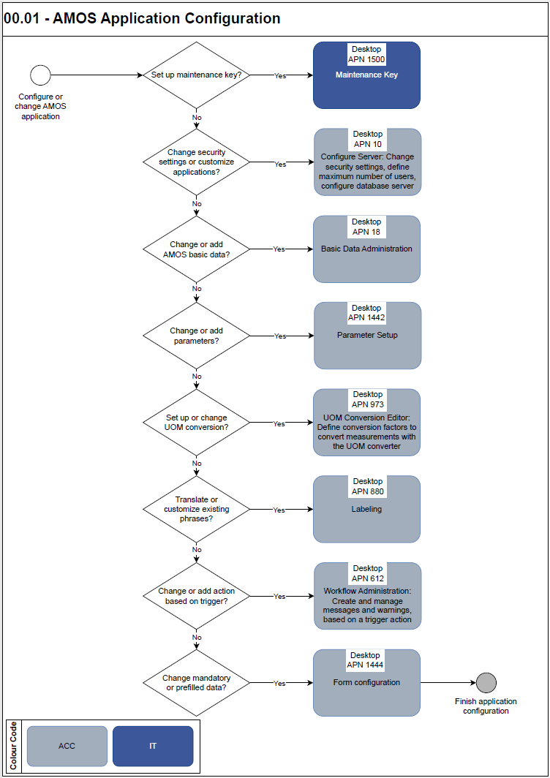

Process Design Questions

# | Question | Answer
1 | Why is the remark “AMOS Environment not maintained” shown in the AMOS Title Bar? | This message occurs due to a missing Maintenance Key in the environment.
2 | How long before the maintenance key expires will I receive a new one? | The Maintenance Key Check Job requests a new certificate ten days before the current one expires.  The existing key is set to inactive in the environment but will not be blacklisted.
3 | How can I set up who can receive the Maintenance Key Warning email? | The email is sent to the email address defined for the Admin group.
4 | In Configure Server, why do the MessageQueue configurations no longer store logins and encoded passwords? | To enhance security, starting with AMOS V19.6, in Configure Server > Other Servers tab > MessageQueue Configuration section, you will need a keystore area name.  A migration script was created to automatically convert old configurations into new ones.  New configurations should use the "amos.server.interface.mq" keystore area to register logins and passwords.
5 | How can I change the numbers in the date from Arabic to English numbers? | Some regions may use numbers other than 0-9. This might be set as the default settings for local computer environment, and might influence the AMOS date format.  This can be overridden in the setting: Configure Server>Application>Server>Connection>Locale>Overrule Locale.

Data (Source) Mapping

N/A

Other Software Used

N/A

AMOS Configuration

Basic Data

Since this process is related to application configuration, technically all basic tables are affected.

Basic Data Table | Notes

Parameters

Parameter Code | Parameter Name | Notes | Settings
1472 | MaintenanceKeyWebservice | This parameter contains the URL for requesting license keys using the web service. | Amount [Int] – 1 to activate automatic requests  Amount [String] – Maintenance Key Request URL
1462 | Enable the SPEC2000 HTTP web service | This parameter enables/disables the SPEC2000 HTTP service in AMOS. | Amount [Int] – 0 or below disables the SPEC2000 HTTP service. 1 or above enables the SPEC2000 HTTP service.
1463 | Configure external Electronic signature | Define the URL for external e-signature solutions | Amount [Int] – Set this to define the type of external service:  0 = RIT Single Sign Client  1 = Safran web service  Amount [String] –  Defines the location/URL of the configured service/interface.
1477 | Message poll interval | This parameter defines the interval in seconds. Every n^{th} second the AMOSclient polls for new messages on the AMOSserver side.  It is not advised to change this parameter unless Swiss-AS advises to do so. | Amount [Int] - Update interval in seconds
1478 | Update latency interval | Controls how often the AMOSclients send connection latency information to the AMOSserver for global statistics. This is done with every n^{th} AMOSclient request.  It is not advised to change this parameter unless Swiss-AS advises to do so. | Amount [Int] - 0: turned off
1492 | E-sign timestamp URL | URL of a time stamp authority server, used for requesting a valid time stamp for an Electronic signature. | Amount [String] - Empty: no authorised, valid time stamp will be added but the local AMOSserver will stamp the signature which will cause a warning in Acrobat Reader.  The String value should be filled with the URL and the port of the time stamp service
1493 | E-sign timestamp policy | Policy used for requesting a time stamp for Electronic signatures. The policy should be defined by the time stamp authority (if the authority does not define a special policy, leave this parameter empty). | Amount [String] - policy definition
1496 | MAX DBFS TRANSACTION SIZE | This parameter defines the maximal size of a transaction when storing binary files in the database. | Amount [Float] – maximum size in megabytes of the transaction object  Amount [Int] – maximum number of entries a transaction can have
1520 | Maximum parallel threads | Maximum amount of update threads | Amount [Int] - maximum number of parallel worker threads that are used by the AMOS server to perform background tasks.
1643 | E-sign password complexity | Specifies a minimum complexity for e-signing certificate passwords. | Amount [Float] – value larger than 0: settings of this parameter are used. Value equal to 0: default password settings of APN 10 are used.  Amount [Int] – Minimum number of characters in the password.  Amount [String] – Type of complexity:  PIN: allows only numbers in the password.  MIXED: requires numbers and letters.  Other values will not check the characters
1644 | E-sign different password policy | If this parameter is enabled, AMOS will not allow the use of the user's password for his or her e-signing certificate. | Amount [String] – Y = enforces the use of a different password for the e-signing certificate.
1710 | SOL Cache Statistics DB | Defines which data should be collected about updates and queries to the database. | This parameter is filled out automatically by the DB request content statistics setting, accessible through APN 10 via Statistics – Tracking Information, and should not be changed manually.
1714 | Exit client that has been logged out | This parameter controls how an AMOSclient reacts on an AMOSserver shutdown message or server message with logout indication. | Amount [Int] - Number of seconds > 0 after which a forcefully logged-out AMOSclient automatically exits.
1788 | Signoff Clock-in check | This parameter enables Clock-in checks for Sign-off events.  If enabled, a Sign-off field can be configured to check if the user is currently clocked-in. This feature rejects a user who has not clocked in. | Amount [String] – Y: switch clocked-in check functionality on.  N: switch clocked-in check functionality off.
1820 | Enable E-Sign for Administration/Service Task and/or Qualification Check for Admin Close | This parameter defines if e-signing check should be enabled when closing events classified as "Administration/Service Task" or using the "Administrative Close" action.  This parameter also defines if Qualification Check (Signoff-Settings) should be enabled when using the "Administrative Close" action. | Amount [String] – Y: E-signing and is enabled for "Administration/Service Task".  Qualification check (Signoff-Settings) is enabled for "Administrative Close" action.  N: E-signing is not enabled for "Administration/Service Task".  Qualification check (Signoff-Settings) is not enabled for "Administrative Close" action.  Y;N:  E-signing and is enabled for "Administration/Service Task".  Qualification check (Signoff-Settings) is not enabled for "Administrative Close" action.  N;Y  E-signing is not enabled for "Administration/Service Task".  Qualification check (Signoff-Settings) is enabled for "Administrative Close" action.
1885 | Maintenance Calendar Time Zone | This parameter is used to define the time-zone of the Maintenance Calendar Entries defined in the Program "Basic-Data Administration". Use Program "Time Zone Selection" to pick the time-zone and copy/paste it in this parameter field.  If the time-zone entered in this parameter field does not match with an existing time-zone, the AMOS Server’s time-zone will be used instead. | Amount [String] - default = empty = AMOS Server’s time-zone
1740 | AMOS server mail size limit | The Integer value specifies the maximum message/attachment size limit for mail in MB. | Amount [Int] – maximum message/attachment size for mail in MB
1808 | Configure linked document size limit | With this parameter, the AMOS Administrator can limit the size of the sent documents via Send E-Mail Action.  If the size limit is reached, then the link for documents will be provided as attachment. | Amount [Float] – Upper limit (in MB) for the files that can be attached to the email.  This value has to be less than the value defined for the maximum size of an email in Parameter 1740.  Amount [Int] – Expiration period. Number of days the downloaded URLs will be valid for the bigger files.  If the value is set to 0, the links won’t expire.  Amount [String] – Decides whether AMOS token links will be attached instead of documents, if the document size limit is exceeded (Y/N).

Workflows

Workflow Number | Workflow Name | Notes
155 | Basic Data Changed | Workflow gets triggered when saving in program Basic-Data Administration (APN 18).

Scheduled Tasks

Scheduled Task Reference | Frequency | Notes

API’s & Interfaces

Reference | Direction | Trigger | Frequency

Annex – Additional Info

