00.02
Users and Roles
Process Design & AMOS Configuration Document
Purpose
This Process Design document is provided to Key-Users to record their key decisions regarding the AMOS Process design and the required AMOS configuration.
It is updated throughout the Project Definition Phase and used as the baseline for the Final Acceptance prior to Go-Live
Revision
Author, Name | Date | Notes
JPER, Faye Jasperse | 15.05.2024

Table of Contents
1. Process Overview & Objectives 3
2. Regulatory References 3
3. Definitions & Glossary 3
4. Process Tasks 3
5. Process Dependencies 4
6. Process Flow 5
7. Process Design Questions 6
8. Data (Source) Mapping 7
9. Other Software Used 7
10. AMOS Configuration 8
a. Basic Data 8
b. Parameters 8
c. Workflows 10
d. Scheduled Tasks 10
e. API’s & Interfaces 10
11. Annex – Additional Info 10

Process Overview & Objectives

Process General Description: In AMOS, every login and role can be configured to define which actions and features are available for a given user and which ones are not. On top of that, deactivated logins can be reactivated.
Main Process Objective (Outputs & Outcomes) : The goal of this business process is to define and manage user rights. The need to know principle should be enforced, so the access for users should be restricted as much as possible and only rights that are needed should be granted. However, a team of key users or supervisors should be established with extended access rights. System critical modules should be limited to a small group of AMOS administrators or the AMOS Competence Center.
To grant rights for specific tasks or projects, it is advised to create new roles for this purpose, limit the role and assign and de-assign users to this role on demand. This helps to keep track of these users.
Additionally, AMOS offers the possibility to define an expiry date when assigning a user to a given role. This allows to grant access rights only for a given time period, and reduces the risk to forget to de-assign the user later again.
It is also recommended to regularly review, at least once a year, the access rights assignments of all users and to adjust them as needed. Experience has shown that after some years of AMOS usage, too many access rights are granted to users that only needed these rights for a given time or a specific project.
Furthermore, we recommend to regularly review the list of logins and to deactivate old logins that are no longer in use. We recommend doing this automatically (See Configure Server: Disable user after x days of inactivity. Swiss-AS recommends disabling user account after 60 days of inactivity).
If the login of a user has been deactivated, this login can also be reactivated again.

Regulatory References

N/A

Definitions & Glossary

Key-Words | Explanation
Sign | The sign in AMOS is the unique identifier of the AMOS user.
SSO | Single Sign On – System access solution

Process Tasks

There are two main options in this process, either the ACC needs to define or change user rights, or the ACC needs to reactivate a user login.
Defining or changing user rights
When defining or changing user rights, the ACC again has two options: either the change is applicable for a group of users, or for specific users. These two options are elaborated upon below:
- Change to group of users: the ACC needs to check if the relevant role already exists. If it does not, the role needs to be created in the program Admin Roles (APN 15). This program is used to assign programs to roles, assign users to roles or create a new role. If the role already exists, the ACC needs to decide whether the role needs to be assigned to a program (or more), or the other way around, so a program is assigned to a role. If a program needs to be assigned to a role, the ACC can again use the same program that was used to create a role, the program Admin Roles (APN 15). If a role needs to be assigned to a program, the program Admin Programs (APN 16) should be used.
- Change to a specific user: the ACC needs to check if the user already exists. If the user does not, a new user should be created in the program Admin Logins (APN 14) and the user should be assigned to one or more roles. If the user already exists, but their access should be changed, the programs Admin Logins and Admin Roles both can be used to assign the user to another role.
Reactivating a user login
If a user has been deactivated, the login can be reactivated again in the program Login Reactivation (APN 606). This program is used to reactivate logins and to monitor login changes.

Process Dependencies

N/A

Process Flow

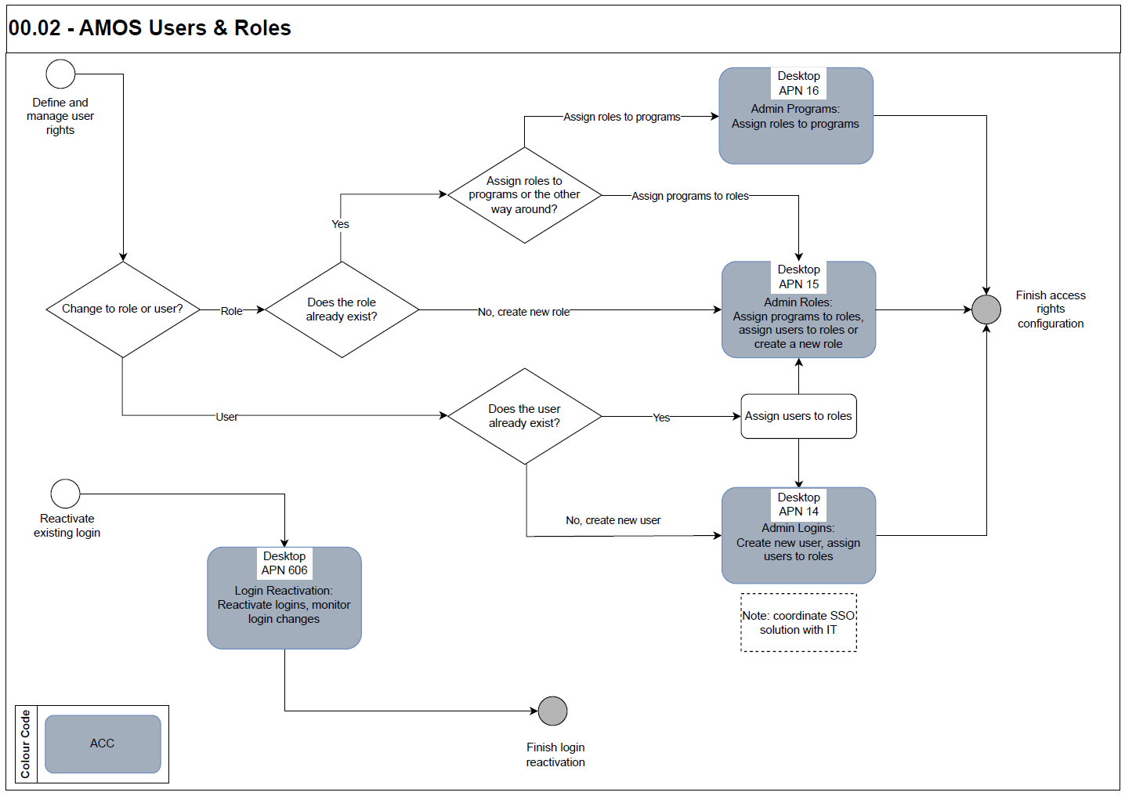

Process Design Questions

# | Question | Answer
1 | A user cannot log into the system, why? | Possible reasons:  - The check box Login activated is not selected. If this flag was not removed manually, it may have been disabled automatically if the user has entered the wrong password too many times, or because an expiry date has been reached.  - The user tries to log in from an external subnet and is not allowed to.  - The user login has been deleted.
2 | What is the difference between “Expiry Date” in Admin Logins and “Leaving Date” in Staff Administration? | The expiry date in Admin Logins is the date when the login expires. When this date is reached, the user will no longer be able to login. If you set the leaving date in Staff Admin, the user would still be able to log into AMOS but would be limited in using his or her 3LC/4LC or Sign in AMOS, for example only signing of workorders.
3 | A user cannot login, the error message is "Login has expired" but the user is set active. What can I do? | The most common error is another expiry date entered in Staff Management and parameter 1480 is set to "Y" - then there is an additional check against the license "valid until" date of the user. If parameter 1480 is activated to log out mechanics with expired licences, there are 4 possibilities:  - Deactivate parameter 1480 and then the CRS fields in Staff Management will not be checked during login for all users.  - Clear the "Valid until" field for the user in Staff Management so it will not be verified for that particular user.  - Enter a date in the future in the "Valid until" field for the user in Staff Management.  - Enter a date in the future in the "Extended to" field for the user in Staff Management.
4 | There are problems logging in using LDAP, why? | If there is more than one LDAP server, specify multiple URLs separated by a blank.

Data (Source) Mapping

N/A

Other Software Used

- SSO solution to connect external sign-on / access systems.

AMOS Configuration

Basic Data

Basic Data Table | Notes

Parameters

Parameter Code | Parameter Name | Notes | Settings
994 | Default email format | This parameter describes the default email format of your company and is used in all programs that deal with email addresses of employees. This parameter has the following syntax: | Amount [String] – CODE@CUSTOMER.COUNTRY  The CODE can be a combination of:  - Any characters that are displayed “as they are”.  - “Place holders” starting with “#” followed by three characters that define the appearance.  These “place holders” must contain the following four characters:  - Start-Token “#”.  - Field that should be displayed: “S“ for user-sign, “F” for first name, “L” for last name.  - The maximum number of characters that should be displayed (“0”-“9”) or “A” for all characters.  - “U” for upper case, “L” for lower case or “N” for normal – without a change.
995 | Phone number prefix | Default Phone-Prefix of the customer. | Amount [String] – The value entered here is used as default-value in the phone- and fax-fields.
1000 | Authentication-server path | If the string-value of this parameter is filled, an external authentication for the password is possible. In Admin Logins you will see a new option to turn on the external authentication for a certain user. After that, AMOS will ask that server for checking the password instead of using the internally stored password. As a side-effect, the user will not be able to change his password inside of AMOS anymore. | Amount [String] – LDAP servers  The string value should have the following format:  ldap://ldap-server.company.com:389/cn=?,ou=Users,ou=XXX,dc=swiss-as,dc=com  IMAP servers  Use the following format:  imap://imap-server.company.com  For more information, see the program Parameter Setup (APN 1442).
1179 | Default user-password | If something is entered in the String value, a Reset button will be available in the Admin User program to reset the User password to the text entered in the String value.  The date of the last Password change will be set to 1971 so that the user will be forced to change his password after his first login. | Amount [String] – if filled out with any character(s), a Reset button will be available in the Admin User program.
1480 | VERIFY LOGIN VALIDITY WITH PQS | This parameter is used to verify the validity of a Login according to the value defined for the Valid Until Date field in PQS. | Amount [String] – If this parameter is set to Y (default value) and if the Login is also defined in PQS, then the Valid Until Date will be checked to verify the validity of the login.  If this parameter is set to N, then the validity of the Login will not be verified according the value defined for the Valid Until Date in PQS.
1629 | NUMBER OF old passwords not allowed | This parameter controls the number of old password hashes that are stored and not allowed to be reused when a user changes their password. This value can also be changed in Configure Server > Application Server tab > Connection section. | Amount [Int] – A value of 0 will not store old password hashes but will also not allow to reuse the last password when it is changed.  A value of 10 would store up to 10 password hashes for a user and will not allow these to be reused later.
1630 | Defaults for new login | Specify the default settings used for a new Login. | Amount [String] – Specifies the Authentication Mode used for a new Login, i.e. if “LDAP” is specified this will be preselected if a new login is created. AMOS “Password” Authentication is the default if the field is blank.  Amount [Int] – 0: Block multiple connections will not be checked for new logins (default).  1: Block multiple connections will be checked for new logins.
1739 | Specify default settings for the multiple session handling | Set a default for the multiple session handling when a new login is created. | Amount [String] –  - N: Only one session is allowed.  - A: One session per IP is allowed.  - B: One session per type per IP is allowed.  - C: One session per type from one IP is allowed.  - D: Different sessions from one IP are allowed.  - Y: Different sessions from different Ips are allowed (no restriction for multiple sessions).

Workflows

N/A

Scheduled Tasks

Scheduled Task Reference | Frequency | Notes
PqsExpiryCheckService | Daily | This task is used to check the users’ validity date and their qualifications. Shift Groups assignments are updated as well.

API’s & Interfaces

N/A

Annex – Additional Info

