00.04
Scheduler Tasks
Process Design & AMOS Configuration Document
Purpose
This Process Design document is provided to Key-Users to record their key decisions regarding the AMOS Process design and the required AMOS configuration.
It is updated throughout the Project Definition Phase and used as the baseline for the Final Acceptance prior to Go-Live
Revision
Author, Name | Date | Notes
VEAN, Angel Vega | 14.05.2024 | First version

Table of Contents
1. Process Overview & Objectives 3
2. Regulatory References 3
3. Definitions & Glossary 3
4. Process Tasks 4
5. Process Dependencies 4
6. Process Flow 5
7. Process Design Questions 6
8. Data (Source) Mapping 7
9. Other Software Used 7
10. AMOS Configuration 8
a. Basic Data 8
b. Parameters 8
c. Workflows 8
d. Scheduled Tasks 9
e. API’s & Interfaces 9
11. Annex – Additional Info 9

Process Overview & Objectives

Process General Description:
With AMOS Scheduler, the user can define tasks that should automatically be executed at a certain point in time. The process of defining, configuring, disabling, and removing scheduler tasks is usually performed by the AMOS Competence Centre team.
The full adoption of this process includes the constant monitoring of the logs generated by the tasks. The ACC should review the tasks that have errors or warnings and relay the information to the relevant stakeholders.

Main Process Objective (Outputs & Outcomes) :
The main benefits, for the organisation, of properly following this process are the following:
- Task automation: repetitive tasks can be configured to run with a given frequency, without any manual action from the user.
- Data quality: certain system tasks are recommended to be executed in a daily basis, this keeps the data up to date and allows to timely detect possible errors.
- Process monitoring: by constantly reviewing the outcome of the scheduled tasks, gaps in the adoption of other process can be identified. For instance, frequent errors in the forecast tasks can point to an engineering process not being followed.

Regulatory References

Definitions & Glossary

Key-Words | Explanation
ACC | AMOS Competence Centre

Process Tasks

Business Process Task / Actions / Activities :
- Create a new scheduler task: The user can select from a wide range of options of scheduled tasks. Each task may have different parameters and frequency.
- Create a new sequence: AMOS Scheduler has a function to group Scheduler Tasks that are mandatory or critical to be run together or in a specific order. In this case the frequency is defined at the sequence level.
- Monitor scheduled tasks: to keep a healthy AMOS system, the ACC should keep an eye in tasks that display errors or warnings after the execution.

Process Dependencies
N/A

Process Flow
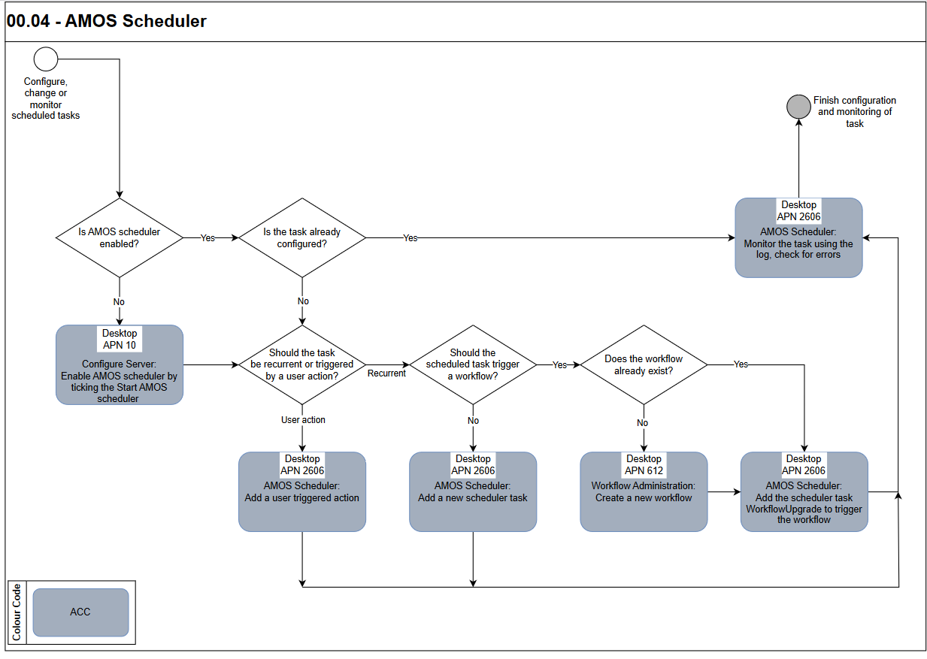

Process Design Questions

# | Question | Answer
1
2
3
4
5
6

Data (Source) Mapping

Data Sources | Description | Volume / Manual / Automatic / Static / Dynamic
N/A

Other Software Used

Other Softwares | Used by: | Description
N/A

AMOS Configuration

The AMOS scheduler can be enabled in Configure Server (APN 10).
- Go to Application Sever tab > Connection section > Misc. field.
- Tick / untick the box Start AMOS Scheduler to start/stop the scheduler (a server restart is required for changes to be taken).

Basic Data

Basic Data Table | Notes
Scheduler Groups | Table with groups that are used to classify Scheduler actions.

Parameters

Parameter Code | Parameter Name | Notes
1672 | Scheduler task output logged in scheduler tasks log files | Defines the log levels which are logged from AMOS scheduler to the scheduler tasks log files
1673 | Scheduler task output logged according to Amos logger rules | Defines the log levels which are logged from AMOS scheduler according AMOS logger rules to the standard log files
1706 | Activate/Deactivate the notifications for the Scheduler | Enables notifications for the scheduler
1716 | AMOS Scheduler Notifications | This parameter allows to push notifications related to the number of concurrent actions executed using the AMOS Scheduler

Workflows

Workflow Number | Workflow Name | Notes
12 | Scheduler Task Message | This workflow will be triggered when a scheduler task is finished. With a rule you can access the output of Java Scheduler Tasks defined in Scheduler Task Editor and inform users about the outcome

Scheduled Tasks

All scheduled tasks.
Scheduled Task Reference | Frequency | Notes

API’s & Interfaces

All AMOS AIM interfaces can be triggered through scheduled tasks.
Reference | Direction | Trigger | Frequency

Annex – Additional Info

