09.03
Ordering
Process Design & AMOS Configuration Document
Purpose
This Process Design document is provided to Key-Users to record their key decisions regarding the AMOS Process design and the required AMOS configuration.
It is updated throughout the Project Definition Phase and used as the baseline for the Final Acceptance prior to Go-Live
Revision
Author, Name | Date | Notes
Daniele Musella | 01.06.2024 | First version

Table of Contents

1. Process Overview & Objectives 3
2. Regulatory References 3
3. Definitions & Glossary 3
4. Process Tasks 3
5. Process Dependencies 6
6. Process Flow 7
7. Process Design Questions 11
8. Data Source Mapping 13
9. Other Software Used 13
10. AMOS Configuration 13
a. Process specific configuration programmes 13
b. Basic Data 13
c. Parameters 13
d. Workflows 15
e. Scheduled Tasks 16
f. API’s & Interfaces 16
11. UAT Guidance 17
12. Annex – Additional Info 17

Process Overview & Objectives
Process General Description
This Business Process explains, depending on the use case in subject, how to procure material and services for your organization from external vendors and how to provide material and service to your customers.

Main Process Objective (Outputs & Outcomes)
The main objective of Ordering is to:
- Fulfil the material and services demand of your organization putting in place the most appropriate procurement strategy to maximize the effectiveness and to reduce cost.
- Respond to material and service request of your customers, putting in place the most appropriate strategy to maximize the effectiveness and increase your revenue.

Regulatory References
There is no worldwide authority regulation applicable to this process.

Definitions & Glossary
Key-Words | Explanation
CLP | Catalog List Price
Q-order | Quotation Order
Single-Source | Default Supplier of the Good or Service
SPEC2000 | Aviation industry standard for procurement and repair transactions for aircraft maintenance
S-File | Specific file format defined by SPEC2000
AWB | Air Waybill
BFE | Buyer Furnished Equipment Order
CP | Customer Provision (external provisioning)
PCF | Parts Consumption Forecast
Loan (L-Order) | When you need to borrow part/tool from another airline/supplier you are loaning in AMOS by issuing a Loan Order (L-Order) to the selected loaner. During goods receiving a loan return (LU-)order is automatically created as a reminder and as form to send the part/counterpart back.
Customer Loan (C-order) | Lending a component to a customer is done via a customer loan order (C-order). Ones the part is shipped and the C-order booked a customer loan return (CU-)order is automatically created as a reminder and open order to be able to book the return part back into your system (Goods Receiving).
Loan Cost Calculator | The loan cost calculator helps you to find out if it is financially still worth to loan or if you should rather convert the loan order into a purchase order.

Process Tasks
The main business processes and related AMOS APNs are the following:
Procuring Material and Services for your Organization
Depending on the different use cases it is possible to procure material and services in the following ways:

Material | Services
Through Purchasing process (P-order, B-Order) | Through Purchasing of service process (S-Order)
Through Borrow process (L-order)
Through Exchange in Advance process (Y-order)
Through Pooling process see process 09.06 Pooling & Consignment
Through Consignment process see process 09.06 Pooling & Consignment

Best practice is to have, for the material/service to procure, either the relevant contract/CLP in AMOS with all contractual conditions (unit price, lead time minimum qty and so on) or, when not applicable, to require a quotation to the selected vendor(s) through Q-order (Quotation order), for the searched type of procuring use case (Purchasing, Exchange in Advance, Borrow, Service).

Providing Material to your customers and returning material to your vendors
Depending on the different use cases it is possible to procure material and services in the following ways:

Provide Material to your customers | Return Material to your vendors | Provide Services to your customers
Through Sales process (V-order) | Through Return Delivery process (D-order) | Through Sale of services process (V-Order)
Through Loan process (C-order)
Through Exchange process (X-order)
Through Exchange process (Y-order)
Through Pooling process see process 09.06 Pooling & Consignment
Through Consignment process see process 09.06 Pooling & Consignment

Main APNs concerned.
- Price Book (APN 325). Used to enter (also via massive upload via X-files) CLP both if you are the customer or if you are the provider.
- Order Management (APN 2015). It is the main APN where all the mentioned order type are created, issued and booked (for the bookable order types).
- Advanced Reorder Proposal (APN 899). From this APN it is possible to trigger the order creation for all those part numbers in status “Reorded required” see also process 09.01 Material Planning
- PCF (Part Consumption Forecast, APN 204). From this APN it is possible to trigger the order creation for all those part numbers whose status is “Unavailable”
- Approval Control Board (APN 2110). From this APN it is possible to approve those orders that need an approval according to the company policy set in then Approval Control Configuration (APN 2111) see process 04.04 Approval Control

Form Configuration
The Form Configuration (APN 1444) allows the administrator/key-user to configure forms, modules and certain program rules according to the needs of the company. Define mandatory fields which must be filled with data by your users or hide entry fields completely, etc. for Order Management, Goods Receiving, Component Inspection & Records and Shipment.

Generic Event
The Parts Consumption Forecast (APN 204) displays all part requests which are associated to a maintenance event; additionally, possibility given to create a generic event to which associated part requests can be manually added, e.g. phase-in of a new fleet. Generic events can be created in reference to a due date, project number, and cost center. Generic events can be created as a temporary event until real maintenance event is created or to indicate needs no maintenance event covers. These manually created generic events are also controlled completely manually, meaning if a real maintenance requirement is raised the generic event needs to be manually closed.

Order Approval
The Order Approval process is activated via Parameter 1440. If activated, an Order cannot be printed until it is approved within the Approval Control Program (APN 1337). The maximum ordering amount is defined in Logistics Administration (APN 1014). The maximum order amount can be defined per Order-type. The Workflow “Approval Control-ID91” should be activated to communicate the Approval requests. In urgent cases, a Buyer may “By-pass” an Order max-amount, but this Order will also flow through the approval control process.

Unknown Part Numbers
Unknown part numbers can be entered as part requests, but unknown part numbers cannot be ordered. Therefore, a process must be defined that will communicate to the responsible department to validate the created part number and if valid to create the unknown part numbers in Part Administration (APN 59). The workflow “Unknown Part Number Entered-ID197” can be activated to communicate this information.

Order Tracking
All Orders are searchable in Order Tracking (APN 1328). This report can be filtered by order state, order responsible, and order vendor. As in all table-views in AMOS, this table can be exported to Excel. The financial value of open Orders can be reviewed in the Financial Reports (APN 1355) “Value on Open Orders” report. An automatic “Order Reminder” service can be activated via the Scheduler Task “OrderReminderService”.

Order Reports
All order reports forms are stored in the Report Designer (APN 966), customizable to your own needs. Please note that Swiss-AS/AMOS does not support and maintain customized reports. After each AMOS version upgrade customized forms in the Report Designer need to be tested.

SPEC2000
In case SPEC2000 messaging is used, the SPEC2000 response can trigger emails (workflow 58).

Process Dependencies

INPUT | CONCURRENT | OUTPUT
- 09.02 Supplier Management: Address Administration (APN 53)  - 09.02 Supplier Management: Contract Management (APN 780)  - 09.04 Material Planning, Stock Replenishment process: ARP - Advanced Reorder Proposal (APN 899)  - 09.04 Material Planning, fulfilment of part request in status “unavailable”: PCF Part Consumption Forecast (APN 204)  - 09.04 Material Planning: Initial Provisioning, Scrap Replacement, increase of stock level (Rotables): through generic event in PCF (APN 204)  - 09.04 Repair & Exchange: Administration of the US parts to be returned to vendors via X/YU/LU orders | - 04.04 Approval Control – to monitor the approval of the order issued. | - 10.01 Logistics  - 12.01 Financial Accounting  - 12.02 Invoice Checking  - 12.03 Fixed Asset and Depreciation  - 12.04 Commercial Pricing and Billing  - 12.05 Customer Quotations

Process Flow
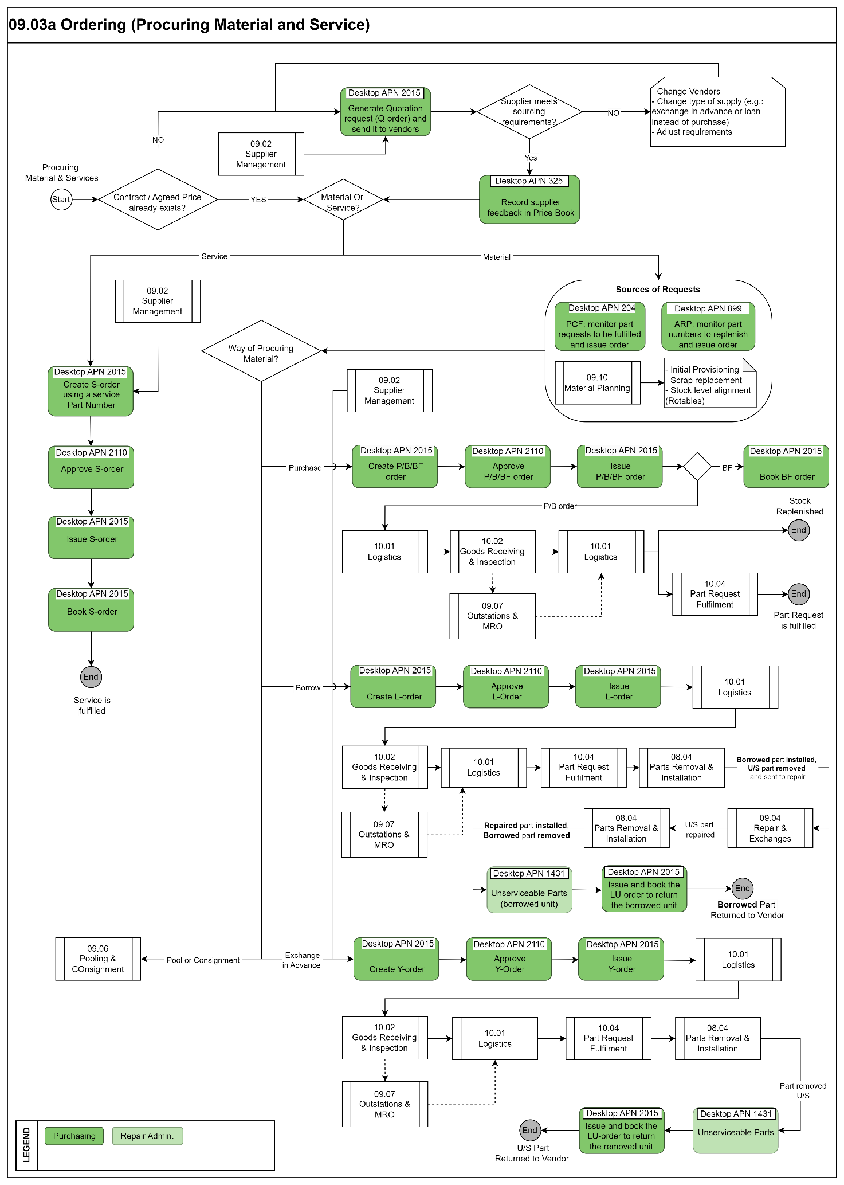
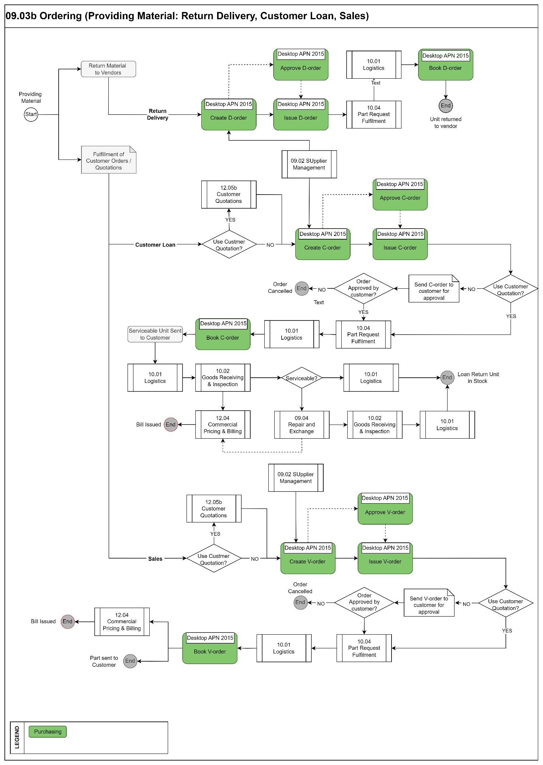
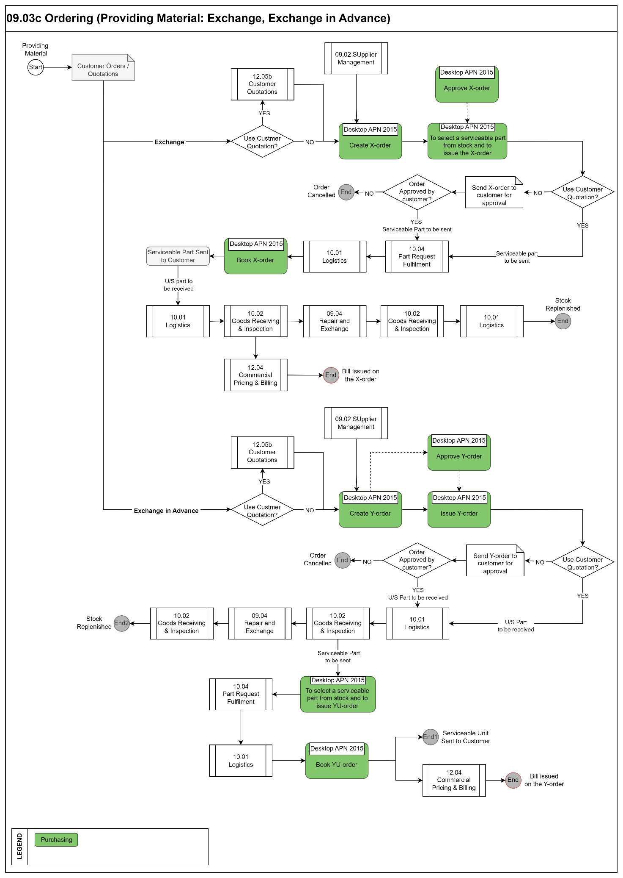

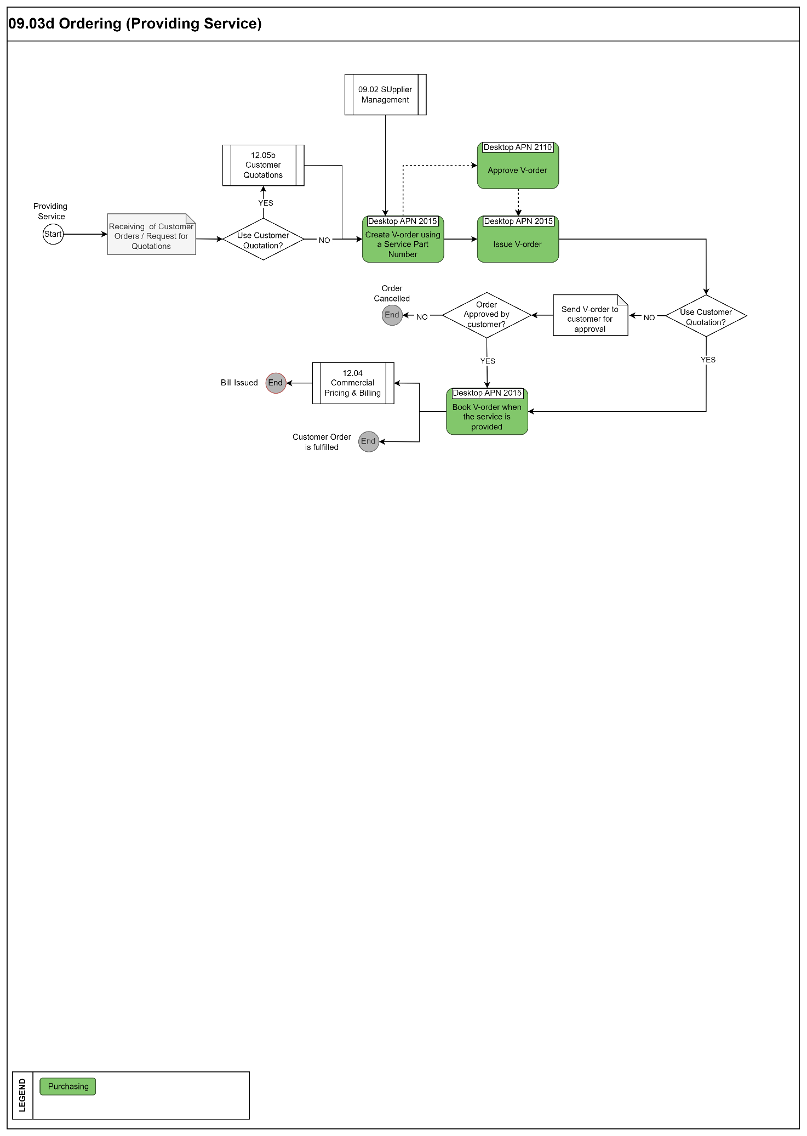

Process Design Questions
# | Question | Answer
1 | How will the Part Consumption Forecast (APN 204) responsibilities be separated? (E.g. per Fleet Type, per ATA chapter)
2 | Who will have access to the creation of Generic Event directly from the PCF (APN 204)? (Use License APN 1727).  Generic Event allows you to see in the parts consumption forecast a part not linked to a maintenance event (no aircraft material, e.g.).
3 | Which process has been defined to create the “Unknown” Part Numbers? Who will create them?
4 | How will Orders be approved? With a paper signature process or will the AMOS Order Approval Control logic be activated? (Parameter 1440)
5 | Is there a company policy in accordance with the separation of duties?  Define user-Roles accordingly in Admin Roles (APN 15).
6 | Who will control the maximum order price levels in AMOS?  Refer to Logistics Administration (APN 1014)
7 | Hint: The PCF has a column “Issue Order”. This value indicates the date before which the Order must be issued to ensure that the Material can be delivered before the Planned Date of the Maintenance Event.  This logic is based on the Lead-Time value in the Price Book for the Default Supplier. Will the Price Book (APN 325) be used?
8 | Hint: Orders created from the Parts Consumption Forecast (APN 204) should be linked to the associated Maintenance Event.
9 | What fields on the Order Management (APN 2015) will be defined as mandatory? E.G. Price, Quantity, Cost Center.  Note: Use Basic Table (APN 18) “Order Type” to load defaults.
10 | Define the process and responsibilities for each order type. - Repairs, Purchases, Loans, Exchanges, Sales.
11 | Define if any Special Order-type will be used; PR- Pool Requests, CP- Customer Provision, MP–Material Production, SI – Consignment.
12 | Will AMOS Quotation Orders be used and integrated with the Price Book (APN 325)?
13 | Will there be any integration with suppliers?

Data Source Mapping

Data Sources | Description | Volume / Manual / Automatic / Static / Dynamic
-/- | -/- | -/-

Other Software Used

Other Software | Used by: | Description
-/- | -/- | -/-

AMOS Configuration

Process specific configuration programmes
AMOS APN | Notes
-/- | -/-

Basic Data
Basic Data Table | Notes
Condition | Indicates the condition of a rotable relative to its traceability as it moves through its life cycle process.
Order Priority | Priorities used on every order. Codes like AOG, CRITICAL etc. is entered here.

Parameters

Parameter Code | Parameter Name | Notes
1163 | RESTRICTION LEVEL OF PARTS: FORECAST
1336 | MAX. AMOUNT TO RECALCULATE MANUALLY
1417 | USE NEW STOCK ACCESS LOGIC
1546 | CHECK PROJECT NUMBER OF STORE ENTRIES
1556 | PART REQUEST UPDATE
1565 | STORE BYPASS MODE
1582 | MFT Issue Transfer Date
1589 | PCF Restriction Settings
1611 | PCF Allocation Calculation
1662 | PART REQUEST UPDATE SETTINGS
850 | FISCAL-YEAR (OPTIONAL)
1157 | USE ONLY INTERNAL APPROVED VENDORS
1285 | FOCUS FIRST TO MANDATORY FIELDS
1288 | USE NEW SHIPMENT LOGIC
1295 | REMARK POPUP WHEN ISSUE A NEW ORDER
1325 | REORDER PROPOSAL INFORMATION
1438 | ENABLE CREDIT LIMIT CHECK
1440 | USE ORDER APPROVAL LOGIC
1574 | EXTERNAL PURCHASE RECEIVING SURCHARGE MARKUP
1608 | Default Order Management version
1639 | Use single source logic
1669 | Activate Buyer Furnished Equipment impact on stock valuation
1163 | RESTRICTION LEVEL OF PARTS: FORECAST
1336 | MAX. AMOUNT TO RECALCULATE MANUALLY
1417 | USE NEW STOCK ACCESS LOGIC
1546 | CHECK PROJECT NUMBER OF STORE ENTRIES
1556 | PART REQUEST UPDATE
1565 | STORE BYPASS MODE
1582 | MFT Issue Transfer Date
1589 | PCF Restriction Settings
1611 | PCF Allocation Calculation
1662 | PART REQUEST UPDATE SETTINGS
850 | FISCAL-YEAR (OPTIONAL)
1157 | USE ONLY INTERNAL APPROVED VENDORS
1285 | FOCUS FIRST TO MANDATORY FIELDS
1288 | USE NEW SHIPMENT LOGIC
1295 | REMARK POPUP WHEN ISSUE A NEW ORDER
1325 | REORDER PROPOSAL INFORMATION
1438 | ENABLE CREDIT LIMIT CHECK
1440 | USE ORDER APPROVAL LOGIC
1574 | EXTERNAL PURCHASE RECEIVING SURCHARGE MARKUP
1608 | Default Order Management version
1639 | Use single source logic
1669 | Activate Buyer Furnished Equipment impact on stock valuation

Workflows

Workflow Number | Workflow Name | Workflow Setup Notes
2 | Booking an order (ID:2)
39 | Closed WO due to Repair Order (ID:39)
53 | Partno change on order (ID:53)
58 | SPEC2000 Order Notification (ID:58)
92 | Order Export (ID:92)
104 | LHT Material Request status changed (ID:104)
191 | Order Modification (ID:181)
214 | Order Confirmation received (ID:214)
237 | ATA106 Form Printed (ID:237)
242 | Book Order Detail (ID:242)
302 | Issue Order (ID:302)
352 | Issue Order Detail (ID:352)
358 | SRT Request message received (ID:358)
91 | Approval Control-ID91
197 | Unknown Part Number Entered-ID197
181 | Modify an Order / Before
455 | Check Export Control for Orders / Before
459 | Check Export Control for order details
474 | Modify an Order Detail / After
497 | Execute an Order action / Before
498 | Save an Order / Before
499 | Issue an Order Detail / After
500 | Book an Order Detail / After
518 | Save an Order / After
519 | Book an Order / After
600 | Modify an Order / Before
638 | Book Order Detail / Before

Scheduled Tasks

Scheduled Task Reference | Frequency | Notes
PartForecastService | Nightjob | Active to recalculate part requests (based on Parameter 1589)
PartRequestDataCorrectionService | Nightjob | Active to clean up un-used part requests
PickslipEventTransferService | Nightjob | Active to create Part Requests and Generic Events for all Pickslip Requests without Events. Necessary for the Material Allocation to work
AdvancedReorderProposalService | N/A | Not Active: Calculation is currently reworked. Updates the Reorder Data
CalcStoreQtyService | Nightjob | Active to calculate Store Quantities for Station Parts Alert
AutomaticStationSupplyService | Nightjob or, depending on the volumes, up to every 2-3 hours | Scheduler task to check all station stores having the Automated Station Supply flag (in “scheduled” mode) and to automatically create T-order in case of need (If such a store has an active list defined in Station Parts Alert, the list gets checked for parts requiring a re-supply)
AlternatesGroupCreator | Nightjob/Weekly | Creates Alternate Groups of 2-way Alternates and stores them in a part special

API’s & Interfaces

Reference | Direction | Trigger | Frequency
TRANSFER ORDER | Export | Order created / Issued / Booked / received /cancelled /modified (Export order information from AMOS) | As required
EXPORT AEX REPAIR ORDER | Export | Order created / Issued / Booked / received /cancelled /modified (Export order information from AMOS) | As required

UAT Guidance

1 | To create a P-order from APN 899 for those parts in status “reorder required”
2 | In APN 899, to check if there are part number with status “NO Vendor found” and fix it
3 | In APN 204, select a part request in status “not available”, and create a P-order for it without linking the part request to the order. Then observes the AMOS behaviour in PCF from the issuing of the order until the receiving of the part
4 | In APN 204, select a part request in status “not available”, and create a P-order for it linking the part request to the order. Then observes the AMOS behaviour in PCF from the issuing of the order until the receiving of the part
5 | Create Approval Control rules and check AMOS behaviour for different Order types /amount and so on
6 | To create a price book for some part numbers and different order type, both when you are vendors and when you are provider
7 | Create, issue and approve a P/B-order in APN 2015
8 | Configure “Single Source” for a given entry in APN 325 and check the AMOS behaviour in AON 2015
9 | Create, issue and approve a Y-order in APN 2015. With/without Price Book.
10 | Create, issue and approve a L-order in APN 2015. With/without Price Book.
11 | Create, issue, approve and book an X-order in APN 2015. With/without Price Book.
11 | Create, issue, approve and book a C-order in APN 2015. With/without Price Book.
12 | Create, issue, approve and book a V-order in APN 2015. With/without Price Book.
13 | Create, issue, approve and book a S-order in APN 2015. With/without Price Book.
14 | Try to approve/not approve vendors (APN 53) and see the AMOS behaviour in APN 2015

Annex – Additional Info
-/-

