09.04
REPAIR & EXCHANGE
Process Design & AMOS Configuration Document
Purpose
This Process Design document is provided to Key-Users to record their key decisions regarding the AMOS Process design and the required AMOS configuration.
It is updated throughout the Project Definition Phase and used as the baseline for the Final Acceptance prior to Go-Live
Revision
Author, Name | Date | Notes
Swiss-AS, Consulting | 01.06.2024 | Initial revision

Table of Contents

1. Process Overview & Objectives 3
2. Regulatory References 3
3. Definitions & Glossary 3
4. Process Tasks 3
5. Process Dependencies 4
6. Process Flow 5
7. Process Design Questions 6
8. Data Source Mapping 8
9. Other Software Used 8
10. AMOS Configuration 8
a. Configuration APNs 8
b. Basic Data 8
c. Parameters 8
d. Workflows 9
e. Scheduled Tasks 10
f. API’s & Interfaces 10
11. UAT Guidance 10
12. Annex – Additional Info 11

Process Overview & Objectives

Process General Description:
This Business Process explains how an unserviceable part can be handled in AMOS. It provides the basis to manage the replenishment or replacement of rotable (and consumable repairable) parts that have been deemed unserviceable from different means.

Main Process Objective (Outputs & Outcomes):
The main objective of this Business Process is to allow for correct and timely management of the unserviceable parts. It also ensures:
- a high quality of repair information is available for the unserviceable parts going to repair/exchange,
- timely tracking and processing of parts which are on hold (from troubleshooting removal) thereby ensuring fast replenishment,
- any scrap part is checked for reselling or salvaging option.

Regulatory References

There is no worldwide authority regulation applicable to this process.

Definitions & Glossary

Key-Words | Explanation
Rotable label | This is a component tag; either Serviceable tag, or Unserviceable tag.
Label booking | This is the action of removing and/or installing a component in AMOS.
Electronic Pending Shelf (EPS) | This is an AMOS system location which corresponds to a physical store location to hold rotables that are removed as part of troubleshooting.
Repair Admin | APN where further actions related to unserviceable components are initiated.

Process Tasks

The main business process tasks / actions / activities are the following.
- Control and monitor all the unserviceable parts coming into the unserviceable area of the Stores. These may be from aircraft, internal shops, customer aircraft, customer store or returned from external repair.
- Process the unserviceable parts as per the respective business decisions.
- Initiate component workpackages (CMWP) to be routed to internal shops.
- Create and track external orders. Ensure necessary approvals are taken for ensuing costs.
- Ensure timely recertification of parts in EPS in coordination with MCC/Engineering.
- Scrap parts that have been approved for the same.
- Evaluate if any part that is due for scrap can be salvaged or not.

Process Dependencies

INPUT | CONCURRENT | OUTPUT
- 08.04 Parts Removal & Installation – parts are removed as U/S or for troubleshooting.  - 10.06 Inventory and Shelf-Life Control – shelf life expired parts and/or parts quarantined from stock declared as U/S.  - 10.02 Goods Receiving and Inspection – items declared as U/S during the receiving process for various reasons, and/or U/S parts received from customer for internal repair. | - 04.04 Approval Control – to monitor the approval of the order issued. | - 11.03 Shop Planner – to schedule and scope the CMWP for internal repair.  - 11.04 Component Maintenance – for performing the CMWP internal repair.  - 10.01 Logistics – to manage the movement of parts in (receive) and out (dispatch) of the company.  - 10.02 Goods Receiving & Inspection – to perform the receiving of a part returning after repair.  - 11.06 Component Release – to be able to perform the release of component either from EPS or from the CMWP.  - 10.06 Inventory & Shelf-Life Control – in case parts need to be sold.  - 01.07 Reliability – update failure confirmation and other relevant reliability information.

Process Flow

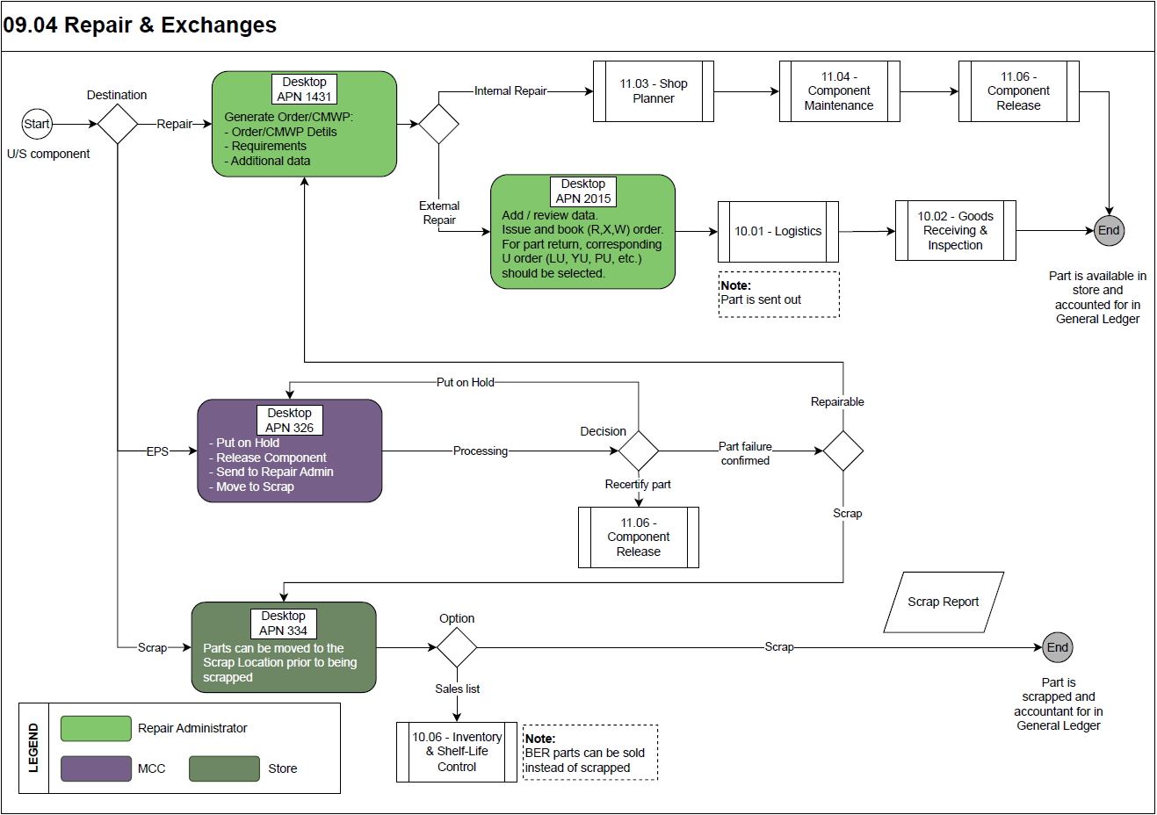

Process Design Questions

# | Question | Answer
1 | How is the routing of un-serviceable parts removed at outstations? Are all removed components returned from outstations to main base, or are those parts directly sent to the repair station?
2 | Are there components that have an internal shop as the default repair station?  Is the repair admin process same for internal and external repair vendors?
3 | Is the repair order creation process centralized? Are there different groups responsible for different components?  Will this user select the requirements and the modifications to be performed at the vendor?
4 | Will the removal reason confirmation be recorded in AMOS?  If yes by who? Is there a process defined?
5 | Will there be any integration with repair vendors? Eg., LHT, SRT, Aeroxchange, Spec-2000.
6 | Are repair-orders only one-part-one order, or are there as well orders with multiple order details (orders with more than one part)?
7 | What are your TAT points?
8 | Is there an Electronic Pending Shelf (EPS) process for components that are removed during troubleshooting?  Who is responsible for the parts in EPS? Who decides which parts are going to repair and which parts will be re-certified?
9 | Will you move all parts removed to EPS, or only parts with “U/S” and “Troubleshooting” ticked on the label? (parameter 969 and 1176)
10 | What is the re-certifying process for parts that are on the EPS?  Who has the qualification to release a removed component?
11 | What is the policy for parts that are put on hold?  Is there a time period within which the part needs to be processed?
12 | One or two step scrapping process?
13 | Which areas/teams are allowed to start the scrap process?

Data Source Mapping

Data Sources | Description | Volume / Manual / Automatic / Static / Dynamic

Other Software Used

Other Softwares | Used by: | Description

AMOS Configuration

Configuration APNs

APN | Notes
1444 – Form Configuration | Under the order management section, configure the repair and exchange forms according to the company needs.
1014 – Logistics Administration | Define various options/features/conditions relevant to Order Management, Order Tracking and Shipment modules.

Basic Data

Basic Data Table | Notes
Condition | Indicates the condition of a rotable relative to its traceability as it moves through its life cycle process.
Reason | Specifies the removal/perform reason.
Order Priority | Priorities used on every order. Codes like AOG, CRITICAL etc. is entered here.

Parameters

Parameter Code | Parameter Name | Notes
969 | Only U/S troubleshooting removals | Depending on the set up of parameter 1176, this parameter can finetune the handling of unscheduled removals.
1176 | Label booked removal parts | Strategy for further processing of parts removed by label booking.
1233 | Repair Administration Tabsheets | Here you can set which tabsheets in Repair Administration have to be checked.
1273 | Upper case in order text | To define if the text in order info tab should be in upper case or not.
1298 | Set default filter in repair admin | Set default filter in ´Repair Admin´.
1522 | Repair Administration - Copy W/O Txt | Copies the WO text into a field in the order info tab. Provides more information which is shown on the order.

Workflows

Workflow Number | Workflow Name | Workflow Setup Notes
157 | Part Transfer | Workflow triggered before the movement of parts between store locations.
228 | Repair station selected | This workflow is triggered when a repair station is selected.
236 | Order Created | This workflow is triggered when an order is generated in Repair Administration.
342 | Kit detail | This workflow is triggered in Kit Management 2.0 when a part from the kit is sent to scrap or sent to repair.
357 | After Part Transfer | Workflow triggered after the movement of parts between store locations
487 | Consignment Stock Decrease | This workflow is triggered after the consignment stock has been decreased.
502 | Pressing button 'Process selected Item' | This workflow is triggered when button "Process selected item" is pressed in APN 326 "Electronic Pending Shelf"
503 | Pressing button 'Repair'/'Send to RA' | This workflow is triggered when button "Repair" or "Send to RA" is pressed in APN 359 "Shelf Expiry Control" or APN 221 "Stock Information" or APN 326 "Electronic Pending Shelf" or APN 334 "Scrap Material".
515 | Order created with Document Modifications | This workflow is triggered when an Order is generated with Document Modifications in Repair Administration.

Scheduled Tasks

Scheduled Task Reference | Frequency | Notes
CalculateAvgTatFromTatTask | daily night job | Calculates the average TAT (turnaround time) from the "Order Flow and TAT" functionality for each part number and vendor/shop combination. All average TAT values will first be deleted and again stored where applicable for the current calculation.
SpecificTatCalculationTask | daily | Calculates the actual time for the specific TATs defined in the rule Engine.

API’s & Interfaces

Reference | Direction | Trigger | Frequency
EXPORT AEX REPAIR ORDER | Export | New or cancelled repair orders to AeroRepair (no update) | as required
TRANSFER ORDER | Export | Creation and/or updation of orders | as required
AMOS to AMOS – Exchange Repair Order Information | Export, Import | Creation and/or updation of orders | as required
AMOS to AMOS – Exchange Repair Order Acceptance | Export, Import | Acknowledgement of orders | as required
AMOS to AMOS – Exchange Repair Exchange Notes | Export, Import |  | as required
External Services - AeroRepair | Export, Import | Creation and/or updation of orders | as required

UAT Guidance

1 | Select any U/S item in repair admin and fill all the necessary information. Check if your needs are met by the available fields.
2 | Generate external repair and exchange orders from repair admin.
3 | Complete the order in order management. Check for completeness as per your requirement and issue the order.
4 | Complete the repair and exchange cycle by receiving.
5 | Generate internal repair workpackage from repair admin.
6 | Complete the internal repair process by executing the workpackage and receiving the item back into stock.
7 | Test any scenario specific to your repair/exchange process.
8 | From repair admin, send few parts to EPS and some to scrap. These may also come from other processes as well
9 | In EPS, put one part on hold and follow the parts on-hold policy.
10 | Recertify one part from the EPS to bring it back to stock.
11 | Test the scenario of confirmed failure of the part in EPS.
12 | Process the scrapping of part that is in scrap location.
13 | Review the generated forms, orders, reports to ensure that your requirements are met.
14 | Ensure workflows and interfaces are triggered correctly.

Annex – Additional Info
-/-

