09.05
Warranty
Process Design & AMOS Configuration Document
Purpose
This Process Design document is provided to Key-Users to record their key decisions regarding the AMOS Process design and the required AMOS configuration.
It is updated throughout the Project Definition Phase and used as the baseline for the Final Acceptance prior to Go-Live
Revision
Author, Name | Date | Notes
Swiss-AS, Consulting | 01.06.2024 | Initial revision

Table of Contents

1. Process Overview & Objectives 3
2. Regulatory References 3
3. Definitions & Glossary 3
4. Process Tasks 3
5. Process Dependencies 4
6. Process Flow 5
7. Process Design Questions 6
8. Data Source Mapping 7
9. Other Software Used 7
10. AMOS Configuration 7
a. Configuration APNs 7
b. Basic Data 7
c. Parameters 7
d. Workflows 8
e. Scheduled Tasks 8
f. API’s & Interfaces 8
11. UAT Guidance 8
12. Annex – Additional Info 8

Process Overview & Objectives

Process General Description:
This Business Process explains how to define various type of warranties in AMOS and raise and track the warranty claims.

Main Process Objective (Outputs & Outcomes):
The main objective of this Business Process is to manage and take benefit of the warranties provided by the suppliers, vendors, OEMs with respect to aircraft, component, and modifications. It also helps to track and maintain a record of all claims generated with their respective decisions/outcomes. Once properly administered, the risk of incurring additional expenditure arising from an otherwise FOC repair or replacement is eliminated.

Regulatory References

There is no worldwide authority regulation applicable to this process.

Definitions & Glossary

Key-Words | Explanation
-/- | -/-

Process Tasks

The main business process tasks / actions / activities are the following.
- Administer warranty terms and conditions pertaining to addresses (suppliers, vendors, OEMs), documents (SBs, ADs, SILs, etc.) and components (delivered with aircraft or procured separately).
- Review all events captured under warranty and collect all the necessary supporting documents to substantiate the warranty claims.
- Submit warranty claims and follow up to ensure timely collection of warranty benefits.

Process Dependencies

INPUT | CONCURRENT | OUTPUT
- 09.02 Supplier Management – define supplier, vendor, and OEM addresses.  - 01.01 Aircraft Definition – define aircraft registration and add/upload rotables delivered with the aircraft.  - 01.04 SB & AD Assessment – define documents.  - 10.02 Goods Receiving & Inspection – receive serviceable parts with valid warranty terms. | - 12.06 Budgeting & Cost Controlling – define project to capture warranty events.  - 08.02 Performing Maintenance – accomplishment of a document with warranty or an unscheduled work on aircraft under warranty.  - 08.04 Parts Removal & Installation – removing components that are under warranty and failed during operation. | - 12.05 Commercial Pricing & Billing – generate and close warranty claims to the supplier, vendor, OEM.  - 09.04 Repair & Exchange – generate warranty order for the parts qualified for warranty repair or replacement, and, process internal CMWP and claim the corresponding costs.

Process Flow

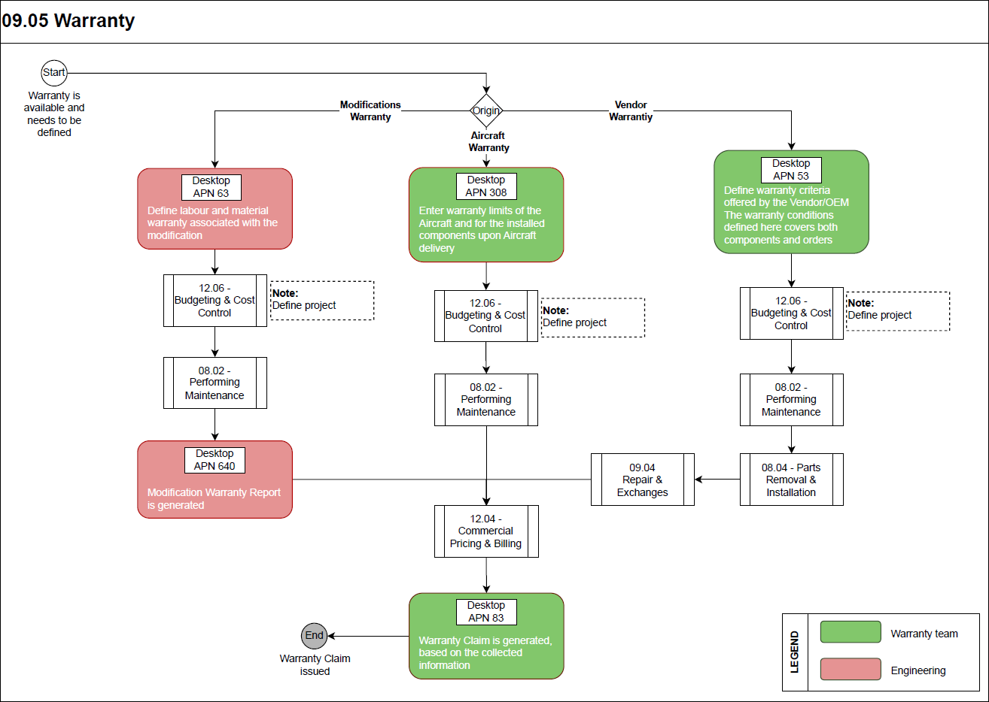

Process Design Questions

# | Question | Answer
1 | What kind of warranties do your vendors provide to you?
2 | Do you perform warranty related repairs in-house?
3 | Do your vendors provide you warranty agreement for all or some of the parts you purchase from them?
4 | Do you have any special practise to capture all warranty driven events being performed?

Data Source Mapping

Data Sources | Description | Volume / Manual / Automatic / Static / Dynamic

Other Software Used

Other Software | Used by: | Description

AMOS Configuration

Configuration APNs

APN | Notes
1444 – Form Configuration | Under the workorder section, using the ‘IS_AC_UNDER_WARRANTY’ validation rule will force to check if aircraft is under warranty and mark the unscheduled workorders with a warranty flag.  Also, configure the warranty form according to the company requirement.

Basic Data

Basic Data Table | Notes
-/- | -/-

Parameters

Parameter Code | Parameter Name | Notes
1510 | Activate Warranty Check in Repair Administration | To set the default type of order to warranty ‘W’ in the dropdown list in Repair Administration (APN 1431), when a valid warranty is detected for the selected item.

Workflows

Workflow Number | Workflow Name | Workflow Setup Notes
164 | Closed Bill/Claim | This workflow is triggered after the closing of a Bill/Claim.
635 | Cancelled Bill/Claim | This workflow is triggered after the cancellation of a Bill/Claim.

Scheduled Tasks

Scheduled Task Reference | Frequency | Notes
-/- | -/- | -/-

API’s & Interfaces

Reference | Direction | Trigger | Frequency
EXPORT WARRANTY CLAIM | Export | Closing of warranty claims | as required

UAT Guidance

1 | Define all known type of warranty conditions on addresses, documents and components.
2 | Define a warranty project.
3 | Perform the warranty document on an aircraft and check if it is captured under the warranty project with all the details correctly.
4 | Perform removal of a component with a valid warranty and check if it is captured under the warranty project with all the details correctly.
5 | Send the unserviceable component on warranty order.
6 | Perform an unscheduled maintenance on an aircraft under warranty and check if it is captured under the warranty project with all the details correctly.
7 | Mark a scheduled or any non-warranty workorder with the warranty flag and check if it is captured under the warranty project with all the details correctly.
8 | Generate warranty claim.
9 | Receive the component back after warranty repair and update the component warranty.
10 | Process the completion of warranty claims and check different settlement options.
11 | Receive a component back after chargeable repair and update the component repair warranty.
12 | Review the generated forms, orders, reports to ensure that your requirements are met.
13 | Ensure workflows and interfaces are triggered correctly.

Annex – Additional Info
-/-

