10.01
Logistics
Process Design & AMOS Configuration Document
Purpose
This Process Design document is provided to Key-Users to record their key decisions regarding the AMOS Process design and the required AMOS configuration.
It is updated throughout the Project Definition Phase and used as the baseline for the Final Acceptance prior to Go-Live
Revision
Author, Name | Date | Notes
Don Sunny | 01.06.2024 | First version

Table of Contents

1. Process Overview & Objectives 3
2. Regulatory References 3
3. Definitions & Glossary 3
4. Process Tasks 4
5. Process Dependencies 4
6. Process Flow 5
7. Process Design Questions 6
8. Data Source Mapping 8
9. Other Software Used 8
10. AMOS Configuration 8
a. Configuration APNs 8
b. Basic Data 8
c. Parameters 9
d. Workflows 9
e. Scheduled Tasks 10
f. API’s & Interfaces 11
11. UAT Guidance 12
12. Annex – Additional Info 12

Process Overview & Objectives

Process General Description:
This Business Process replicates the physical movement of parts into, out of and within a store and company in AMOS and, records any information associated with the movement. The execution of the process enables accurate tracking of parts.
Additionally, you can also track parts independently from other AMOS tracking programs, such as Parts Tracking, using Material Flow Tracking modules. It can assist to track the flow of material in the company, identify potential pain points, compare the movement of the material with defined routes – all of which contributes towards developing efficient store management.

Main Process Objective (Outputs & Outcomes):
The main objectives of this process are:
- Track, receive and consolidate inbound shipments from external suppliers. Perform physical incoming shipment of delivered goods and record customs relevant information.
- Transfer serviceable and unserviceable material within and between stores.
- Track, receive and consolidate outbound shipments to external suppliers.
- Define customs regions, commodity codes and generate reports for shipments.
- Analyse/control material flow in complex business environments.

Regulatory References

- Customs procedures and rules of the region
- Procurement regulations of the region

Definitions & Glossary

Key-Words | Explanation
Station | A physical place where the company has a maintenance facility (or not) defined in Address Administration (APN: 53). (Note: Address Property=SA).
Store | Within a defined station multiple stores can be defined in Address Administration (APN: 53). (Note: Address Property=SO).
Location | Within a defined store, all the physical locations within the store (eg., shelf, area, rack, counter, etc.) defined in Store Management (APN: 2409).
Consumable (Barcode) Label | Sticker label which can be printed for consumables, consumable repairables and rotables, containing P/N, batchnumber, S/N, expiry date, location, and other information.
Putaway | Process of placing a part on a temporary/intermediate store location after receiving.
IATA/DGR | IATA Dangerous Goods Shippers Declaration for Air Transport.

Process Tasks

The main business process tasks / actions / activities are the following.
- Setup customs administration and define part attributes (like DG material, commodity codes, etc.).
- Create incoming shipments corresponding to various orders for which parts are expected to be received at the store.
- Create outgoing shipments corresponding to various orders for which parts are expected to be shipped out of the store.
- Control, monitor and track all shipments generated from the store.
- Communicate delays/discrepancies/update of shipments to concerned for timely resolutions/actions.
- Create and execute transfers (for location to location move) and transfer pickslips (for store-to-store move).
- Setup material flow tracking routes and check points.
- Assess the flow of material within the organization for process improvements.

Process Dependencies

INPUT | CONCURRENT | OUTPUT
- 09.03 Ordering – incoming and outgoing orders creation.  - 09.04 Repair & Exchange – incoming and outgoing orders creation.  - 09.06 Pooling & Consignment – incoming and outgoing orders creation.  - 09.01 Material Planning – advises where the material should be to satisfy the part request. | - 09.07 Outstations & MRO’s – transfer of parts between stations. | - 10.02 Goods Receiving & Inspection – to perform the receiving of incoming order.  - 10.04 Part Request Fulfilment – the part request is satisfied.

Process Flow

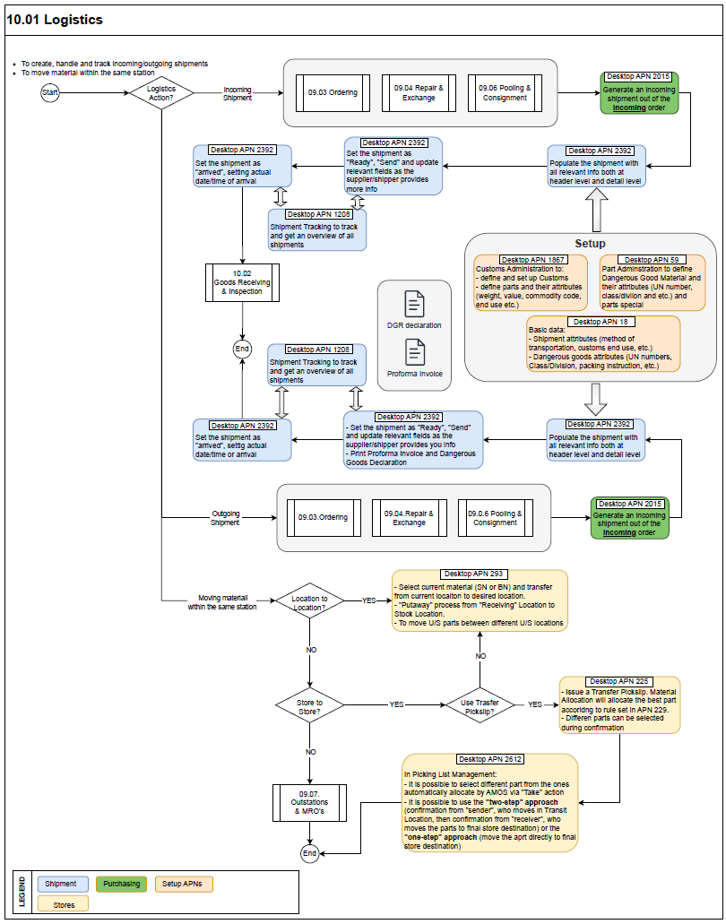

Process Design Questions

# | Question | Answer
1 | Do you have a centralized receiving location or do all stations have capabilities to perform receiving’s?
2 | Do you track incoming and outgoing shipments?
3 | Do you have consolidated shipments?
4 | Do you use forwarders?
5 | Will Customs Declarations be performed in AMOS?
6 | If parts are transferred between stores of the same station, is it done by one person or is there a handover of responsibilities?
7 | Are temporary locations used for receiving or directly stored to final location?
8 | Are shipments shipped from all Stations/Stores or is there a centralized shipping department?
9 | Will Dangerous Goods Shippers Declarations be generated from AMOS? (IATA, ADR, RID, ADN, IDMG?)
10 | Are package weight/size recorded?
11 | What kind of AWB tracking is currently in place? How will this be reflected in AMOS?
12 | Do you regularly generate customs report to your local custom office? Who controls the custom declaration in your company?
13 | Do you have any custom warehouse or logistic partner who performs the custom clearance for you? How do you get the information from them?
14 | Do you have any group of parts, vendors which have the same custom procedures?
15 | Are the store locations labeled with barcodes?
16 | Are mobile devices used in stores?
17 | Do you currently monitor specific material flow within your company?
18 | Which tracking points and predefined tracking routes do you want to setup?

Data Source Mapping

Data Sources | Description | Volume / Manual / Automatic / Static / Dynamic
-/- | -/- | -/-

Other Software Used

Other Software | Used by: | Description
-/- | -/- | -/-

AMOS Configuration

Configuration APNs

APN | Notes
1868 – Customs Regions | To create customs regions which contain groups of countries that have similar customs requirements.
1867 – Customs Administration | Define groups of vendors associated to a customs address and link to parts which will prefill the data in shipments.
1240 – DG Shippers Declaration | To print standard DG declaration forms.
2257 – AWB Tracking Configuration | To setup link with the carrier’s website that will allow tracking of AWBs.
1841 – Material Flow Setup | Define material flow tracking points and routes.
1014 – Logistics Administration | Define customs type to be printed for end-use authorization purposes and other shipment related features.
1444 – Form Configuration | Under the shipment section, configure the incoming and outgoing shipment forms according to the company needs.

Basic Data

Basic Data Table | Notes
Customs End Use | The end-use authorization text that is displayed on the proforma invoice.
Customs State | Different states for defining the customs clearance process.
Customs Types | It is related to the end-use authorization text that is displayed on the proforma invoice and the order detail text. Stored on receiving detail level.
Method of Transportation | Define the method used to ship.
Type of Service | It is typically a code used by Freight Forwarders and shipping companies to indicate the guaranteed Type of Service that is being paid for.
Class Division | Dangerous goods classes.
Dangerous Goods Transport Regulations | Standard DG transportation forms.
Packing Instructions | Codes (defined by customer) to identify packing instructions for associated P/Ns.
UN Numbers | Codes identifying different DG items in the framework of international transport.
Commodity Code | Standard system of numbers that are used to identify the goods and services that are being procured.
Customs Classification | Can be used as Export Control Classification Number (ECCN).
Hardware Workplace | Used to assign a computer to an address with the property "Workplace (WP)". Allows you to link a physical work station to a tracking point.

Parameters

Parameter Code | Parameter Name | Notes
1150 | Create history (VM = T) for parts transfer | Enables the creation of history records for transferred parts.
1288 | Location types in shipment | Defines the location types to be displayed in shipment module.
1524 | AWB number sequence | Used to generate an own AWB Number sequence in IATA Shippers Declaration.
1549 | Default customs addressno | Define the default customs address to be used.

Workflows

Workflow Number | Workflow Name | Workflow Setup Notes
154 | Change a shipment state / before | This workflow is triggered every time the shipment state changes before the data saved in the DB.
157 | Part transfer | Workflow triggered before the movement of parts between store locations.
357 | After part transfer | Workflow triggered after the movement of parts between store locations.
446 | Shipment detail saved | This workflow is triggered every time a shipment detail is saved/updated.
454 | Export control check trigger for shipments | This workflow is triggered every time an export control is performed when an outgoing shipment is sent.
485 | After changing the location of a part (part movement) | Workflow triggered after the movement of parts between store locations.
501 | Delete a shipment detail / after | This workflow is triggered after a shipment detail has been deleted.
517 | Merging of consumable batches | Useful in situations in which contents of consumable batches are being merged (completely or partially).
641 | Detail added to shipment / after | This workflow is triggered after a detail is added to a shipment.
393, 624 | Change a shipment state / after | This workflow is triggered every time the shipment state changes after the data saved in the DB.
473, 625 | Modify a shipment / after | This workflow is triggered when a shipment is modified.
643, 644 | Save shipment detail / before | This workflow is called before the shipment detail was saved.
645, 646 | Save shipment detail / after | This workflow is called after a shipment detail was saved.

Scheduled Tasks

Scheduled Task Reference | Frequency | Notes
LhtMaterialDeliveryInfoService | as required | Sends outgoing shipment notifications to LHT.
SRTSendRequestUpdateTask | as required | Sends shipment information to SRT
CloseOldOpenIncomingShipmentsTask | daily/weekly | Checks orders, with ‘open’ linked shipments, received more than n days and change the status to ‘arrived’.
CloseOldOpenOutgoingShipmentsTask | daily/weekly | Checks orders, with ‘open’ linked shipments, booked more than n days and change the status to ‘send’.
ShipmentProformaCurrencyCheckTask | daily | Checks consistency of currencies between all the shipment details of a same shipment.
ShipmentStateConsistencyCheckTask | daily | Processes a shipment state consistency check based on calculation of shipment states from details and packages. Reports the list of shipments which may generate error when trying to open from APN 2392.
IssueAutomaticPickslipsService | as required | To be used if Pickslips should be issued automatically

API’s & Interfaces

Reference | Direction | Trigger | Frequency
External Services - LHTConnect | Export, Import | Creation and/or updation of shipment | as required
External Services - SRT | Export | Creation and/or updation of shipment | as required
External Services - WMS | Export, Import | Creation and/or updation of shipment | as required
Import Boeing IMM | Import | Creation and/or updation of shipment | as required
External Services - AeroComponent | Export, Import | Creation and/or updation of shipment | as required
External Services - Fedex | Export | Creation and/or updation of shipment | as required
Transfer Shipment | Export, Import | Creation and/or updation of shipment | as required
Transfer Shipment Status | Export, Import | Creation and/or updation of shipment | as required
AMOS to AMOS – Exchange Shipment | Export, Import | Creation and/or updation of shipment | as required
AMOS to AMOS – Exchange Shipment Status | Export, Import | Creation and/or updation of shipment | as required
AMOS to AMOS – Exchange Shipped Order | Export, Import | Creation and/or updation of shipment | as required
Import MDS Parts Transfer | Import | Parts transfer performed | as required
Export MDS Parts Transfer | Export | Parts transfer options | as required

UAT Guidance

1 | Define customs authority and assign in para 1529.
2 | Define customs and DG related data on P/Ns.
3 | Create an outgoing shipment linked to an order.
4 | Create an incoming shipment linked to an order.
5 | Check the steps to create a shipment and consider options available in APN 1014 to automate as much as possible.
6 | Move parts within a store
7 | Move parts between 2 stores in the same station.
8 | Review the generated forms, orders, reports to ensure that your requirements are met.
9 | Ensure workflows and interfaces are triggered correctly.

Annex – Additional Info
-/-

