10.02
Goods Receiving & Inspection
Process Design & AMOS Configuration Document
Purpose
This Process Design document is provided to Key-Users to record their key decisions regarding the AMOS Process design and the required AMOS configuration.
It is updated throughout the Project Definition Phase and used as the baseline for the Final Acceptance prior to Go-Live
Revision
Author, Name | Date | Notes
Don Sunny | 01.06.2024 | First version

Table of Contents

1. Process Overview & Objectives 3
2. Regulatory References 3
3. Definitions & Glossary 3
4. Process Tasks 3
5. Process Dependencies 4
6. Process Flow 5
7. Process Design Questions 6
8. Data Source Mapping 7
9. Other Software Used 7
10. AMOS Configuration 7
a. Configuration APNs 7
b. Basic Data 7
c. Parameters 7
d. Workflows 10
e. Scheduled Tasks 11
f. API’s & Interfaces 12
11. UAT Guidance 12
12. Annex – Additional Info 12

Process Overview & Objectives

Process General Description:
This process explains how a part that is delivered to the organization is taken into stock, and the procedure to address any anomalies (with respect to policy or regulation) observed during the same.

Main Process Objective (Outputs & Outcomes):
The main objective of this process is to ensure that the material received into the organization’s stock is airworthy and documented accordingly in AMOS. Any deviations will be appropriately separated and addressed for the concerned to resolve.

Regulatory References

- National Aviation Authority
- MOE

Definitions & Glossary

Key-Words | Explanation
Station | A physical place where the company has a maintenance facility (or not) defined in Address Administration (APN: 53). (Note: Address Property=SA).
Store | Within a defined station multiple stores can be defined in Address Administration (APN: 53). (Note: Address Property=SO).
Location | Within a defined store, all the physical locations within the store (eg., shelf, area, rack, counter, etc.) defined in Store Management (APN: 2409).
Physical Receiving | Step where the physical inspection of the part is done and basic details (P/N, S/N, condition, certificate, etc.) are confirmed.
Component Inspection | Step where the technical inspection is performed (for rotables only), which reviews and updates the requirements, tree components, modifications, etc.
Putaway | Process of placing a part on a temporary/intermediate store location after receiving.
Technical Query | Can be used as communication tool between involved parties to exchange concerns, solutions, etc.
Rotable Label | Equivalent of serviceable tag, for rotables.

Process Tasks

The main business process tasks / actions / activities are the following.
- Receive parts into stock following the physical receiving and component inspection steps, depending on the material class of part delivered.
- Check for regulatory compliance and adherence to company policies in terms of documentation and physical state.
- Flag discrepancies or deviations observed via technical query, and ensure they are resolved in time.
- Scan and attach delivered documents to the receiving entry.
- Track and monitor pending receiving.
- For the quarantined parts, take appropriate action (return, cancel or scrap) as per the decision agreed.

Process Dependencies

INPUT | CONCURRENT | OUTPUT
- 09.03 Ordering – expect a part to be received on an order.  - 10.01 Logistics – incoming shipment to be processed. | - 10.03 Major Assemblies – for technical inspection of rotables with sub-components in its configuration.  - 00.03 Technical Assistance – to issue technical query informing about the quarantine. | - 10.04 Part Request Fulfilment – received part available for part requests.  - 09.04 Repair & Exchange – to scrap or repair part after unsuccessful quarantine decision.  - 10.01 Logistics – process an outgoing shipment.

Process Flow

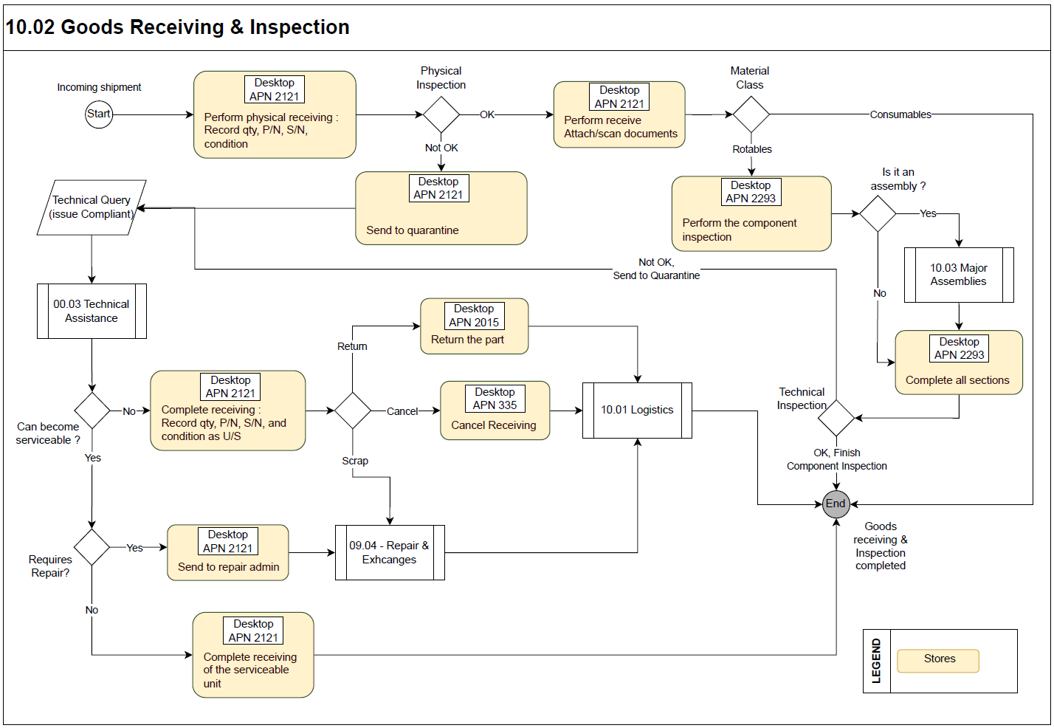

Process Design Questions

# | Question | Answer
1 | Does anybody other than Store Inspectors perform receiving?
2 | Will the receiving process of a rotable be split between departments (eg. Stores for physical receiving + Engg. for technical inspection)? Who will do the final validation?
3 | Will the split in rotables receiving process be applicable for all rotables or only certain P/Ns?
4 | Do you have a quarantine policy?
5 | Is the quarantine process handled by a different responsible team?
6 | How are quarantine rejects from receiving handled?
7 | Should the Customs Declaration Number field be mandatory during receiving?
8 | Do you track Rotables with shelf expiry? (form config)
9 | Do you intend to scan and attach the documents to the receiving?
10 | Should the data from the order be displayed at the time of receiving?
11 | When do you want to print the rotable label? Should the goods receipt note also be printed?
12 | For consumables, AMOS generated batch numbers will be used, or want to customize?
13 | Will there be a temporary receiving location, or receive directly to final location?

Data Source Mapping

Data Sources | Description | Volume / Manual / Automatic / Static / Dynamic

Other Software Used

Other Software | Used by: | Description

AMOS Configuration

Configuration APNs

APN | Notes
1444 – Form Configuration | Under the goods receiving section, configure the goods receiving and, component inspection & records forms according to the company needs.
1014 – Logistics Administration | Define various options/features/conditions relevant to receiving for Order Management and Shipment modules.
2409 – Store Configuration | Define required locations for receiving and quarantine.

Basic Data

Basic Data Table | Notes
Part Rejection Reason | Rejection reasons for pre-receiving.

Parameters

Parameter Code | Parameter Name | Notes
824 | Print barcode/certificate (Y/N) | Define whether you want to print additional Certificate/Barcode labels or not.
852 | Rec.-good: set delivered qty to zero | Define if quantity (for consumables only) should be set to zero.
917 | Default label printer | Defines the default matrix printer for the label form printout.
936 | Special codes to print on label | Define print requirement of location, approval number and other codes.
1001 | Force user to check doc-status | This parameter has an effect only if workflow 320 is activated.
1162 | Label layout consumables | Define whether you want to print consumable labels or not.
1168 | Print goods receipt note | Define whether you want to print a receipt note after receiving or not.
1191 | Use manufacture-date in Receiving | For calculation of expiry date, only refers to consumable parts.
1193 | Use def. Location for inhouse repair | If this parameter is activated, only shop locations (with restriction STANDARD or RESTRICTED) will be displayed during the release rotable process.
1196 | Receiving / inspection: certificate(s) required | Define if certificate is required for receiving/inspection of parts.
1220 | Receiving: displayed locations | Define which locations are shown in the drop down list in program Goods Receiving.
1251 | Force user to type in condition for receiving | Define if the condition needs to be automatically set.
1331 | Enable "scan to link" | Possible to scan images and append them directly to an AMOS internal item as link. Webdrive folder to be defined in APN 1672.
1341 | Batchno Generation | Allows to customize the automatic batch number generation for consumables during the receiving.
1355 | Default receiving report | Define the default receiving report.
1362 | Normalize serialnumbers | Do not allow spaces when entering new rotables.
1411 | Print consumable labels via client | Decide to print consumable-labels (sticker) via the amos-client or server.
1433 | Open scan dialog after receiving | Automatically opens after receiving, allowing to scan and link documents to the receiving detail.
1469 | Enable save removed in service condition report as pdf | Define if "Removed in Serviceable Condition" report will be showed at the end of release rotable.
1512 | Goods Receipt Note: show open pickslips | Define if information regarding open pickslips should be shown on the Goods Receipt Note or not.
1538 | Automatic batchno | Set number of batch for consumables to 1 and generate automatically a batch number.
1545 | Manage logic of component inspection tab nodes | Define behaviour of component modification and status nodes when opening an inspection.
1558 | Shelf life behavior for consumable in goods receiving | Define the shelf life behaviour of consumables
1587 | Display panel to set time/cycle/date since overhaul, repair or modification during inspection process | Can be activated for a rotable during inspection process.
1614 | Open Component Inspection | Define if APN 2293 should be opened automatically after physical receiving is performed.
1635 | Label Printing at Receiving/Inspection | Define when a label should be printed.
1698 | Tree Receiving behavior in case of exchange of top part | Define the behaviour at tree receiving in case a top part has been exchanged at physical receiving.
1721 | Activate cloned part logic | An existing part coming back on customer`s orders (RC or CP) count as customer`s part.
1723 | Activate Tree Receiving with Config Management | Define the tree receiving method available in Component Inspection.
1727 | Requirements review at Tree Receiving | Define the behaviour of reviewing requirements during inspection.
1754 | Pre-receiving configuration | Define if a technical query should be automatically created for each error during pre-receiving.
1766 | Goods Receiving - Receivings checks on configurations | Allows to define if the pre-receiving checks should raise an error or a warning.
1782 | Create external rotable during successful pre-receiving | Define if external rotable is automatically created after successful pre-receiving.
1787 | Serialno Generation | Allows to customize the automatic serial number generation for rotables during the receiving.
1904 | FastCI activation criteria | Define criteria to automate the component inspection process (possible only of a spec 2500 shop file is available).

Workflows

Workflow Number | Workflow Name | Workflow Setup Notes
195 | Duplicate FaCounterPart record at receiving | This workflow is triggered at the receiving of a rotable when the parameter 1481 is active and an active financial counterpart already exists for the rotable received.
315 | Physical Receiving | This workflow is triggered during a physical receiving.
316 | Send to quarantine | This workflow is triggered when a receipt is put under quarantine.
317 | Select Order for Receiving | This workflow is triggered when an order is selected.
318 | Select Order Detail for Receiving | This workflow is triggered when an order detail is selected.
320 | Show modifications after inspection | This workflow is triggered after an inspection is done to show modifications on the received part.
323 | Pre-release rotable | This workflow is triggered before a rotable release.
324 | Post release rotable | This workflow is triggered after a rotable release.
362 | Process a Receiving / Before | This workflow is triggered when a receiving is processed.
383 | Inspected Rotable Loaded | This workflow is triggered when rotable is loaded.
391 | After Inspection | This workflow is triggered when the inspection is finished.
427 | Save a Pre-Receiving / Before | This workflow is triggered after a pre-receiving is saved.
442 | "Finish Component Inspection" button pressed | This workflow is triggered when the button "Finish Component Inspection" is pressed.
443 | "Move to RA" button pressed | This workflow is triggered when the button "Move To RA" is pressed.
463 | Process a Receiving Action / After | This workflow is triggered after the available actions in Goods Receiving (Receive Physically, Save Pre-Receiving, Send to Quarantine), just before the whole transaction is saved into the database.
483 | MM Mobility - When receiving parts that can't be linked to the part request | This workflow is triggered when a received part can't be linked to the part request initially planned.
486 | Consignment Stock Increase | This workflow is triggered after the consignment stock has been increased.
495 | Save a Pre-Receiving / After | This workflow is triggered after a pre-receiving is saved.
516 | Send to quarantine / After | This workflow is triggered when a receipt is put under quarantine, after the transaction is executed.
640 | Scan Dialog / After
642 | Automated CI | This workflow is triggered after the automated inspection is done.
319, 617 | Process a Receiving / After | This workflow is triggered after a receiving (once).
322, 620 | Receive Dangerous goods / After | This workflow is triggered after the receiving of a dangerous good. The wildcard 'receiving station' contains the station where the part was received.
321, 622 | Receive a part with an open loan return / After | This workflow is triggered if an open loan return order is found.
462, 619 | Process a Receiving Action / Before | This workflow is triggered before the available actions in Goods Receiving (Receive Physically, Save Pre-Receiving, Send to Quarantine).
475, 621 | Remove a material from quarantine / After | Triggered when material is removed from quarantine.

Scheduled Tasks

Scheduled Task Reference | Frequency | Notes
PreReceivingsEvaluationTask | as required | This task evaluates all pre-receivings if parameter 1754 is activated.
ReceivingMissingHistoryDataCorrectionService | rarely | This task will find and add missing B1 histories for receiving details. This task should be run in really specific context, as may have otherwise financial impacts.

API’s & Interfaces

Reference | Direction | Trigger | Frequency
TRANSFER RECEIVING | Export | Creation of new receiving or quarantine | as required
IMPORT PRE RECEIVING | Import | Receivings initiated in external systems | as required
External Services – LHT Connect | Export, Import | Creation of receiving and completion of component inspection | as required
External Services - WMS | Export | Creation, cancellation of receiving | as required
External Services - SRT | Import | Creation of receiving | as required

UAT Guidance

1 | Perform physical receiving (APN 2121) of a rotable and consumable.
2 | Consumable receiving with multiple quantity on order.
3 | Perform technical inspection (APN 2293) of a rotable without sub-components (configuration).
4 | Perform technical inspection (APN 2293) of a rotable with sub-components (configuration).
5 | Send item to quarantine from APN 2121.
6 | Send item to quarantine from APN 2293.
7 | Test various scenarios of quarantine decision – return, scrap and any other business case.
8 | Review the generated forms, orders, reports to ensure that your requirements are met.
9 | Ensure workflows and interfaces are triggered correctly.

Annex – Additional Info
-/-

