10.03
Major Assemblies
Process Design & AMOS Configuration Document
Purpose
This Process Design document is provided to Key-Users to record their key decisions regarding the AMOS Process design and the required AMOS configuration.
It is updated throughout the Project Definition Phase and used as the baseline for the Final Acceptance prior to Go-Live
Revision
Author, Name | Date | Notes
Don Sunny | 01.06.2024 | First version

Table of Contents

1. Process Overview & Objectives 3
2. Regulatory References 3
3. Definitions & Glossary 3
4. Process Tasks 3
5. Process Dependencies 4
6. Process Flow 5
7. Process Design Questions 6
8. Data Source Mapping 7
9. Other Software Used 7
10. AMOS Configuration 7
a. Configuration APNs 7
b. Basic Data 7
c. Parameters 7
d. Workflows 8
e. Scheduled Tasks 8
f. API’s & Interfaces 9
11. UAT Guidance 9
12. Annex – Additional Info 9

Process Overview & Objectives

Process General Description:
This process addresses the technical inspection aspect of rotables that have sub-components, and multiple requirements and documents. Some rotables may have a simple assembly configuration for which the technical inspection is relatively easier to complete, while assemblies like engines, landing gear and APUs may require an expert review.

Main Process Objective (Outputs & Outcomes):
The main objective of this process is to impart focus on the detailed review of technical inspection of the assemblies being received and to ensure that they are compliant with, not only the regulatory and airworthy compliance, but also the CAMO requirements.

Regulatory References

- National Aviation Authority
- MOE

Definitions & Glossary

Key-Words | Explanation
Physical Receiving | Step where the physical inspection of the part is done and basic details (P/N, S/N, condition, certificate, etc.) are confirmed.
Component Inspection | Step where the technical inspection is performed (for rotables only), which reviews and updates the requirements, tree components, modifications, etc.
Putaway | Process of placing a part on a temporary/intermediate store location after receiving.
Technical Query | Can be used as communication tool between involved parties to exchange concerns, solutions, etc.
Rotable Label | Equivalent of serviceable tag, for rotables.

Process Tasks

The main business process tasks / actions / activities are the following.
- Complete the technical inspection of assemblies.
- Update the requirements, document status, configuration details of the main and sub-components.
- Ensure the CAMO requirements are satisfied.
- Flag discrepancies or deviations observed via technical query, and ensure they are resolved in time.
- Track and monitor pending inspections.
- For the quarantined parts, take appropriate action (return, cancel or scrap) as per the decision agreed.

Process Dependencies

INPUT | CONCURRENT | OUTPUT
- 10.02 Goods Receiving & Inspection – physical receiving of the major assy is completed. | - 00.03 Technical Assistance – to issue technical query informing about the quarantine. | - 10.04 Part Request Fulfilment – received part available for part requests.  - 09.04 Repair & Exchange – to scrap or repair part after unsuccessful quarantine decision.  - 10.01 Logistics – process an outgoing shipment.

Process Flow

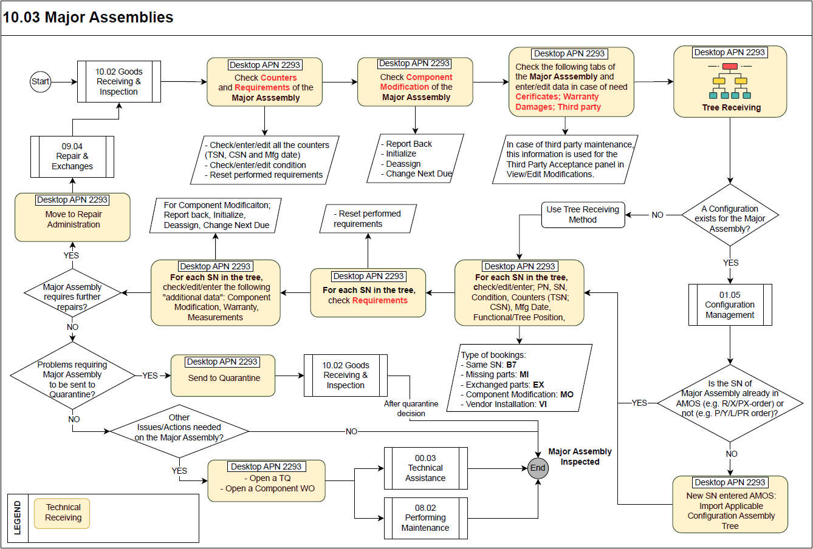

Process Design Questions

# | Question | Answer
1 | Who is responsible for technical inspection? Is the final validation done by this responsible?
2 | Will the split in rotables receiving process be applicable for all rotables or only certain P/Ns?
3 | Do you have a quarantine policy?
4 | Is the quarantine process handled by a different responsible team?
5 | How are quarantine rejects from receiving handled?
6 | What items do you consider as Major Assemblies?

Data Source Mapping

Data Sources | Description | Volume / Manual / Automatic / Static / Dynamic
-/- | -/- | -/-

Other Software Used

Other Softwares | Used by: | Description
-/- | -/- | -/-

AMOS Configuration

Configuration APNs

APN | Notes
1444 – Form Configuration | Under the goods receiving section, configure the component inspection and records forms according to the company needs.

Basic Data

Basic Data Table | Notes
-/- | -/-

Parameters

Parameter Code | Parameter Name | Notes
1001 | Force user to check doc-status | This parameter has an effect only if workflow 320 is activated.
1469 | Enable save removed in service condition report as pdf | Define if "Removed in Serviceable Condition" report will be showed at the end of release rotable.
1587 | Display panel to set time/cycle/date since overhaul, repair or modification during inspection process | Can be activated for a rotable during inspection process.
1545 | Manage logic of component inspection tab nodes | Define behaviour of component modification and status nodes when opening an inspection.
1614 | Open Component Inspection | Define if APN 2293 should be opened automatically after physical receiving is performed.
1698 | Tree Receiving behavior in case of exchange of top part | Define the behaviour at tree receiving in case a top part has been exchanged at physical receiving.
1723 | Activate Tree Receiving with Config Management | Define the tree receiving method available in Component Inspection.
1727 | Requirements review at Tree Receiving | Define the behaviour of reviewing requirements during inspection.
1904 | FastCI activation criteria | Define criteria to automate the component inspection process (only if a spec 2500 shop file is available).

Workflows

Workflow Number | Workflow Name | Workflow Setup Notes
320 | Show modifications after inspection | This workflow is triggered after an inspection is done to show modifications on the received part.
324 | Post release rotable | This workflow is triggered after a rotable release.
383 | Inspected Rotable Loaded | This workflow is triggered when rotable is loaded.
391 | After Inspection | This workflow is triggered when the inspection is finished.
442 | "Finish Component Inspection" button pressed | This workflow is triggered when the button "Finish Component Inspection" is pressed.
443 | "Move to RA" button pressed | This workflow is triggered when the button "Move To RA" is pressed.
642 | Automated CI | This workflow is triggered after the automated inspection is done.

Scheduled Tasks

Scheduled Task Reference | Frequency | Notes
-/- | -/- | -/-

API’s & Interfaces

Reference | Direction | Trigger | Frequency
-/- | -/- | -/- | -/-

UAT Guidance

1 | Perform technical inspection (APN 2293) of a rotable with sub-components (configuration).
2 | Send item to quarantine from APN 2293.
3 | Try replacement of sub-components in tree.
4 | Update documents, requirements and other sections of the main part and the sub-components as well.
5 | Test various scenarios of quarantine decision – return, scrap and any other business case.
6 | Review the generated forms, orders, reports to ensure that your requirements are met.
7 | Ensure workflows and interfaces are triggered correctly.

Annex – Additional Info
-/-

