10.05
Tools
Process Design & AMOS Configuration Document
Purpose
This Process Design document is provided to Key-Users to record their key decisions regarding the AMOS Process design and the required AMOS configuration.
It is updated throughout the Project Definition Phase and used as the baseline for the Final Acceptance prior to Go-Live
Revision
Author, Name | Date | Notes
Marcel Moser | 01.06.2024 | First version

Table of Contents
1. Process Overview & Objectives 3
2. Regulatory References 3
3. Definitions & Glossary 4
4. Process Tasks 4
5. Process Dependencies 5
6. Process Flow 6
7. Process Design Questions 7
8. Data (Source) Mapping 8
9. Other Software Used 8
10. AMOS Configuration 9
a. Basic Data 9
b. Parameters 9
c. Workflows 9
d. Scheduled Tasks 10
e. API’s & Interfaces 11
11. Annex – Additional Info 11

Process Overview & Objectives

Process General Description:
This process covers the definition of Tools in AMOS. It is beneficial if one department handles and maintains tools – from the creation of new tools in the system, inserting requirements, reserving tools for planned maintenance as well as hand out/return.

Main Process Objective (Outputs & Outcomes):
The main objective is the creation and management of Tools part numbers.
- Tool Logic in AMOS: With parameter 1397 you must set the logic which shall be applicable regarding tools and picking lists. If you do not activate the AMOS tool logic, tools and the required (normal) parts are printed on one picking list. If the AMOS tool logic is activated two pickslips/separate tooling picking lists are printed, one for (normal) parts and one for tools. Another option is that tools are automatically removed from pickslips. In any case tools can be handed out with APN410/Tool Registration. The parameter can be set up in the following applications:
  - APN 1442, Parameter Setup
  - APN 2365, Financial Configuration
  - APN 2605, Store Configuration
- Issue of Tools out of stores: the hand-out of tools usually follows the procedure of the parts handout and parts return. In a more special way, the Tool Handover (APN 1507) is used to reproduce the usage of tools and toolboxes between the technicians. Thereby the distribution as well as the return of tools is tracked through Tool Registration (APN 410). The administration of tools is handled within Tool Registration. Tools can either by registered by coins or tags and to facilitate the hand-out and hand-over, tools can be tagged as well by a barcode sticker or a RFID chip.
- Calibration of Tools: To calibrate tools and / or to reset the calibration requirement (Part Requirement Administration, APN 2773) within the AMOS system the module Shelf Expiry (APN359) is used. Tools can be either calibrated on the shelf (Perform Rotable, if Requirement setup is as "On Shelf") or via Repair Administration via the internal repair shop (Component Workpackage) or sent to an external repair shop, to reset the calibration requirement in the AMOS system.

Regulatory References

There is no worldwide authority regulation applicable to this process.

Definitions & Glossary

Keywords | Explanation
Part Administration | Definition of Part numbers including Tools (tick box)
Requirements | Setup of Requirements for parts including Tools (APN 2773)
Tool User | Personal code of the person. First and last name.
Receiver | Personal code of the person. First and last name.
Coin / Tag | Coin, personal Coin Number of Mech/Tag like a Batch Number on tool
Store Management | Create Tool Store and tool location and their access rights.

Process Tasks

Business Process Task / Actions / Activities:
- Define location type tool.
- Carry out the creation of Tool Part Numbers.
- Identify the necessity of tools, driven primarily by scheduled maintenance events, as well as by unscheduled ones.
- Issue tools to Technicians.
- Control tool movement. Monitor the return of tools.
- Assess the serviceability of tools, sending them to repair/calibration as applicable.
- Check serviceability of tools

Process Dependencies

INPUT | CONCURRENT | OUTPUT
- 01.02 – Parts Definition: Primary process responsible for the creation of all Part Number in AMOS, including Tools  - 09.01 – Material Planning: Here, the demand for tools is established. Primarily by scheduled maintenance events, as well unscheduled ones. | - 08.02 – Performing Maintenance: This process covers the employment of tools eventually issued out of stores  - 01.06 – Inventory & Shelf-Life Control: Monitors the state of Tools, in regards its requirements  - 09.04 – Repair and Exchange: Driven by the necessity to repair tools | - N/A

Process Flow
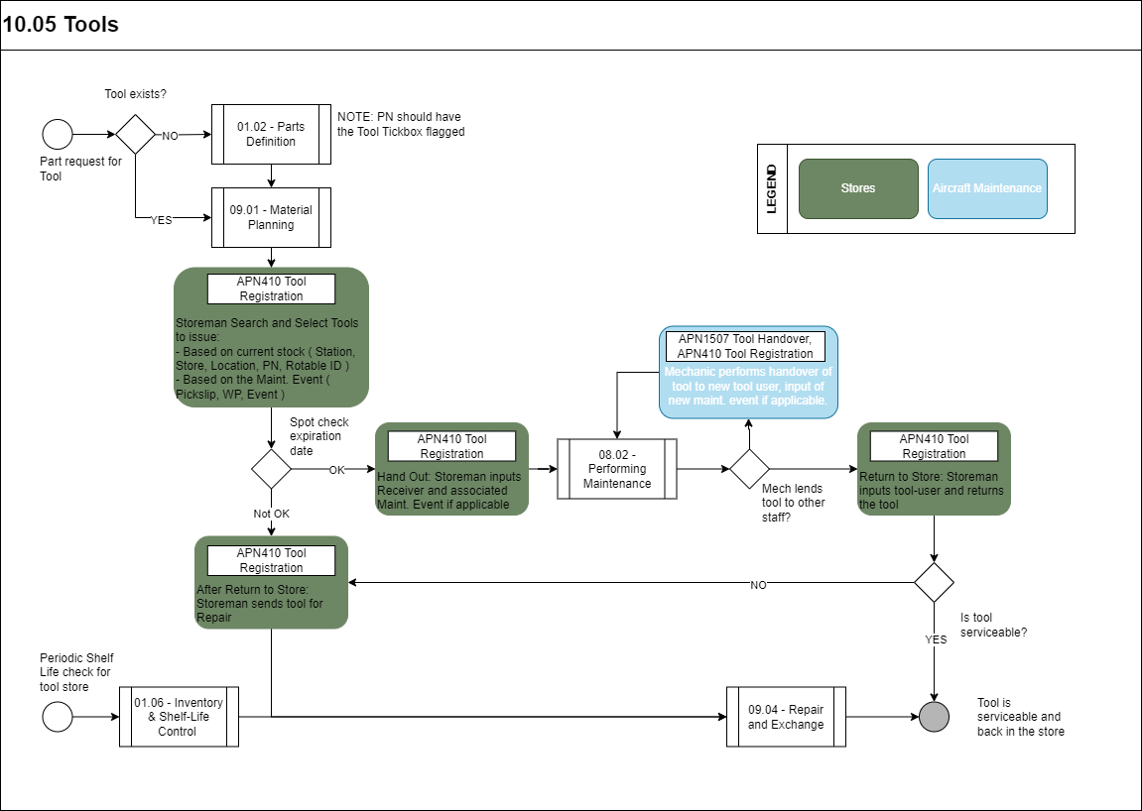

Process Design Questions

# | Question | Answer
1 | Who defines tools in the system?
2 | Who manages and tracks tools in the current system?
3 | Who defines tool requirements in the system (e.g., Calibration), using Part Requirements Administration, APN 2773
4 | Who determines tool serviceability and tracks requirements
5 | Who orders tools and initiate repair / calibration?
6 | Any system in place to observe and track tools returns?
7 | Who orders tools and initiate repair / calibration?
8 | Who determines tool serviceability and tracks requirements?
9 | How are tools calibrated (internal or external shop)?
10 | Do you highlight the next due date on the tool (tool sticker)?
11 | What the current procedure is regarding tool calibration?
12 | Will you scan barcodes/RFIDs to handout, return tool?
13 | Shall tools be added on a separate pickslip?
14 | Are you using Picking Lists?
15 | Are tools reserved and prepared for planned maintenance?

Data (Source) Mapping

Data Sources | Description | Volume / Manual / Automatic / Static / Dynamic

Other Software Used

Other Software | Used by: | Description

AMOS Configuration

Basic Data

Basic Data Table | Notes
Printer Definition | Define TOOL Printer (see System Description for details)

Parameters

Parameter Code | Parameter Name | Notes
1137 | TOOL MARK ONLY FOR ROTABLES | If only Rotables are marked as tools in Part Administration, set String to Y, if all material classes can be marked as tools String must be "No".
1465 | TOOL PARAMETERS TO CUSTOMIZE TOOL REGISTRATION | Several setup options to customize Tool Registration, e.g., mandatory fields, default tool location after hand-out, etc.
1308 | 24 HOUR RULE (color coding of the duration of handout of tools (red more than 12 hours) | When a tool is handed out more than twenty-four hours the background of field "Received,” and "Time" is red.  When a tool is handed out more than eight hours the background of field "Received,” and "Time" is yellow.
1397 | USE TOOL LOGIC FOR LOCAL PICKSLIP | Set the float to 0.00 to use tool tag/coin. Move all tools of Tool Pickslip to user and tool-location. (vm=TT) via the Integer.  With amount (String) you decide whether you want to book tools to an extra "Tool Pickslip" or not.
1680 | ASSIGN PICKSLIPS TO PICKINGLISTS | Pickslip details are automatically assigned to a picking list.

Workflows

Workflow Number | Workflow Name | Notes
47 | Part Requirement Changed | This workflow is triggered when a Part Requirement is modified or when individualising Time Requirement linked to a Part Requirement
116 | Handing Out of Tool | This workflow is triggered when a tool is about to be handed out.
338 | Tool | This workflow is triggered when a tool is handed out, handed over or returned to store.
478 | AMOSmobile Tool Handover Workflow | This workflow is triggered when a tool is handed over.

Scheduled Tasks

Scheduled Task Reference | Frequency | Notes
ExportTask | - Few files to export - Not below 5min.  - Vast number of files - Between 5min and 30min to export the minimum number of files for each run. | All configurations regarding transport, transformation (XSLT) and selection of data to be exported are done in the AIM Configuration tool.
MultiExportTask | - Few files to export - Not below 5min.  - Vast number of files - Between 5min and 30min to export the minimum number of files for each run. | Multi-Export Task executes export of multiple managed APIs. In the Tab ‘Transport’ you can configure transport properties (except the zipping and file pattern) which w applied to all generated files. These are the following types of transport available: FTP, SFTP, FILE, MQ, HTTP, EMAIL & SCRIPT. Other configurations such as the file pattern with extension and activation of zipping on the transport tab, the transformation (XSLT) and selection of data to be exported are done in AIM Configuration tool.

API’s & Interfaces

Reference | Direction | Trigger | Frequency
EXPORT TOOL BOOKING |  |  | Every 5 minutes
IMPORT TOOL BOOKING |  |  | Every 5 minutes

Annex – Additional Info

N/A

