12.06
Budget & Cost Controlling
Process Design & AMOS Configuration Document
Purpose
This Process Design document is provided to Key-Users to record their key decisions regarding the AMOS Process design and the required AMOS configuration.
It is updated throughout the Project Definition Phase and used as the baseline for the Final Acceptance prior to Go-Live
Revision
Author, Name | Date | Notes
Hamid Ouazi | 01.06.2024 | First Version

Table of Contents
1. Process Overview & Objectives 3
2. Regulatory References 3
3. Definitions & Glossary 3
4. Process Tasks 3
5. Process Dependencies 4
6. Process Flow 6
7. Process Design Questions 7
8. Data Source Mapping 9
9. Other Software Used 9
10. AMOS Configuration 10
a. Process specific configuration programmes 10
b. Basic Data 10
c. Parameters 11
d. Workflows 11
e. Scheduled Tasks 12
f. API’s & Interfaces 12
11. UAT Guidance 13
12. Annex – Additional Info 13

Process Overview & Objectives

Process General Description:
In the Budget and Controlling process, the user defines the project structure to capture costs and revenues. Then, the user aims to monitor, analyse, control, and report them. The costs can be recharged to customers through the Commercial and Billing Process (12.04 Commercial Pricing and Billing).
The user created budgets and forecasts, matches cost and revenue to those budgets and forecasts enabling for performance control.
Main Process Objective (Outputs & Outcomes):
The purpose of the budget and cost controlling is to properly allocate and capture costs through the available cost collectors of AMOS: Cost Centers, project numbers, cost types, AC registrations, FA type, financial activities. The main output is to control and monitor the performance from a financial and controlling point of view.

Regulatory References

There is no worldwide authority regulation applicable to this process.

Definitions & Glossary
Concerns doc & flowchart
Keywords | Explanation
IAS | International accounting standards (IAS2 related to inventory accounting principles and IAS16 related to Property Plan and Equipment (fixed assets) accounting principles)
IFRS | International financial reporting standards
GAAP | Generally accepted accounting principles
GL | General Ledger
CoA | Chart Of Account
FOC | Free Of Charge

Process Tasks

Business Process Task / Actions / Activities:
- Define budget relevant activities: the purpose is to build the structure which will define the level on which the cost will be controlled and captured.
- Release budgets for internal approval: At the time of releasing, an approval may be triggered to request official acceptance of the newly generated budget, following the standard approval process of the Organization.
- Define cost transactions and cost rates: especially for material, services, time captured by time booking, tool time booking. AMOS propose to have predefined “default costs”. Internal Costs rates (labour costs prices) can be defined per entity and can be shared between direct and indirect costs. The logic is 1 hour of direct costs generates X amount of indirect costs.
- Define project numbers: those project numbers are linked to project type (Base, Line, Component, General and Pool). Project numbers can be organized in a tree structure – main project and subprojects. As the project number is a cost collector, it is important to specify it at source, i.e., in the respective workstreams and processes generating costs (order detail, pickslip, work package, workorder, scrap, rotable administration, quotation, cost and revenue tracking, financial activity).
- Define Cost Centre assignment rules: as a cost collector, the cost center can be assigned automatically by AMOS depending on rules defined by the user at each trigger points.
- Perform cost controlling and/or profitability analysis: several AMOS programs enable the user to perform the cost controlling analysis: Financial Project Analysis, Financial Control Dashboard, Cost and Revenue Tracking. Those tools allow to display KPI’s for a selected project and enable the project financial performance analysis via selecting criteria like the entity, customers, project types.
- Perform budget controlling: in AMOS the user has the possibility to create a budget forecast and edit the amounts for a specific period (actual or future - and/or in the past which requires some dedicated rights/license).

Process Dependencies

INPUT | CONCURRENT | OUTPUT
- 02.02 Aircraft Phase-out
- 08.02 Performing Maintenance: cost and revenue collected through the material consumed and labour cost.
- 08.04 Parts Removal & Installation: labour and material costs collected.
- 09.03 Ordering: costs/revenues are collected upon the booking of the orders (accruals) or upon the good receiving.
- 09.04 Repair & Exchanges: repair, exchange, service costs collected.
- 09.05 Warranty
- 09.06 Pooling & Consignment
- 10.06 Inventory & Shelf-Life Control: cost collected from the inventory differences.
- 11.04 Component Maintenance: cost collected from the material and labour used during the CPWP (shopcard)
- 12.02 Invoice Checking: collect the cost of the invoice detail booked
- 12.03 Fixed Assets & Depreciation: costs collected through the depreciation process, scrap and revenue generated through the sale.
- 12.04 Commercial Pricing & Billing: collect the revenue on a specific project purpose.
- 12.07 Financial Multi-entity: cost and revenue tracked through the multi entity transactions

Process Flow

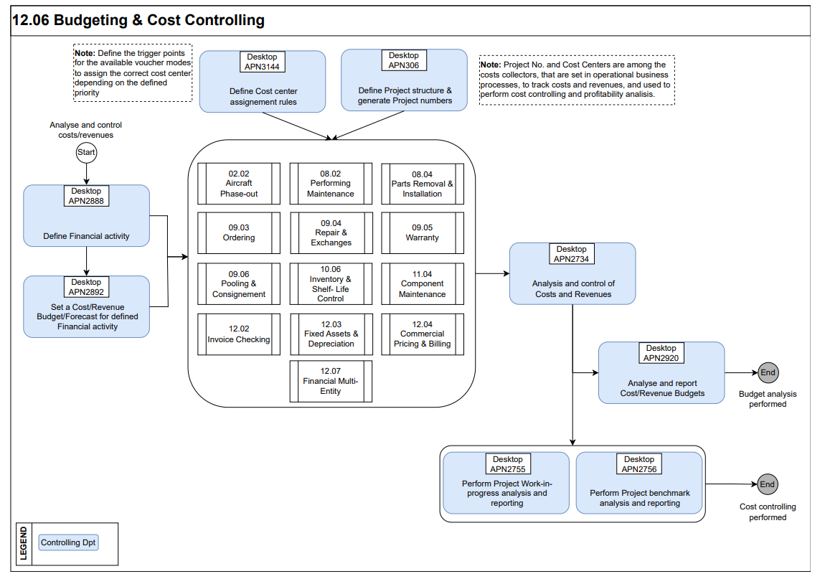

Process Design Questions

# | Question | Answer
1 | Who is responsible for creating projects in your organisation – Finance/Commercial department or Technical Department?  A decision needs to be taken how to handle adhoc projects for MCC – who will create adhoc projects?
2 | When new workpackage is created in AMOS by planning department, will the planner create a new project number or use an existing project number to link to the workpackage?
3 | What type of projects are there in your organization? Do you perform cost controlling for all of them?
4 | How would the project structure look like in your organization? For instance:  a. LM events - one project per A/C reg. per year.  b. BM events - one project per A/C reg. per event.
5 | What would be the scope of a sub-project in your organization? E.g., project for Findings, MODs, Additional Work etc.
6 | Who is going to control the state of the projects - open/closed? Is the same person responsible to close the projects?
7 | Are project costs accounted for with a dedicated project cost center and a project cost type?
8 | What is the concept of Cost Center in your Organization?
9 | What is the concept of Cost Type in your Organization? In AMOS Cost type is another layer of details used for cost controlling purposes.
10 | Are you going to issue customer invoices (bills) for customer projects from AMOS (APN: 196 - Billing)?
11 | Are you going to use APN: 1993 - Quotation Manager?
12 | For what type of activities do you perform cost control in AMOS?
13 | What is the primary level of cost control in your organization? e.g. on cost center level, on project level, on AC reg. level, on AC type level, on component level, on GL account level, on station level, on shop level etc.
14 | What kind of costs do you collect for a project? Which material stock movements are cost relevant for the project these movements are related to? Are there costs relevant to the maintenance business which do not originate from AMOS and are booked directly in the Finance ERP system?
15 | Do you also define cost budgets for activities performed in AMOS (generating expenses which are significant to company's operations)?
16 | Do you provide sales and services to third parties? What type?
17 | Do you also define budgets for anticipated revenues?
18 | In Multi-entity environment, do multiple entities need to work on the same Customer project? E.g. Entity 1 provides parts, Entity 2 provides repair services, Entity 3 provides labour.

Data Source Mapping

Data Sources | Description | Volume / Manual / Automatic / Static / Dynamic
 | -/- | -/-

Other Software Used

Other Softwares | Used by: | Description
-/- | -/- | -/-

AMOS Configuration

Process specific configuration programmes
AMOS APN | Notes
1940 – Financial Entity Administration | The entry point for the financial configuration is the setup of the single or multi financial entities. Here, the user is going to configure the entity address (coming from the address APN53), entity owner, the functional (not mandatory) and the local entity currency (coming from the currency management APN355)
59 – Part Administration | The creation/modification/classification of the part in AMOS have significant financial impacts. The following part’s attributes have financial impacts especially when one of those attributes change: the material class, material type, FA Type, fixed asset flag, tool flag, repairable flag. Those attributes are relevant to setup the financial transactions in the APN1658.
1664 – Chart of Accounts | Usually, the CoA numbers are the same as the financial ERP. The user defines the CoA within the pre-defined structure proposed by AMOS and generated automatically after importing the default financial transaction in APN1658.
1658 – Financial Transaction Definition | Each financial-relevant transaction/movement in AMOS is identified by a code, called voucher mode (VM). Voucher modes are transaction-specific, e.g. B1 = Receiving of Material, YE = Rotable removal from aircraft, and thus, can be used to define each financial transaction’s logic. Complete list of voucher modes may be found in Basic-Data Administration (APN:18)- ‘Voucher Mode’ table.
781 – Define FA Qty calculation | Each company has internal regulations and processes describing the criteria that need to be fulfilled if the parts should be counted in its financial quantity. In AMOS this is configured in Define FA Qty Calculation (APN:781) program.  The Financial Quantity is the quantity of material that is used for calculation of the Financial Stock Value.
2365 – Financial Configuration | See bellow in the Parameter paragraph b.

Basic Data

Basic Data Table | Notes
Cost Center | Define the list of cost centers
Cost Type | Define the list of cost types, if available
Project type | Define additional project types to the default ones, if necessary
Aircraft Type | Define the Financial fleet types as in the financial system, if possible

Parameters

Parameter Code | Parameter Name | Notes
1448 | ASSIGNED TO IN PROJECT ADMIN. MANDATORY
1455 | PROJECT NUMBER MANDATORY IN WORKPACKAGE
882 | PROJECTNO MANDATORY IN PICKSLIP
1282 | CHECK PROJECT-FIELD IN PICKSLIPS
1479 | NEW PROJECT VISIBLE IN BILLING MODULE | String = Y / Mandatory for organizations using AMOS Billing modules
1542 | DISPLAY PROJECT INFORMATION
1470 | WORKPACKAGE GROUPS SETTINGS
1658 | COST COLLECTION DYNAMIC | String = Y
1702 | REVENUE COLLECTION DYNAMIC | String = Y
1696 | Activate/Deactivate the Rule Based Labor Cost Amount Calculation | String = Y
1475 | TIME MANAGEMENT CUSTOMIZE | Integer = 100 / Used to define default productivity value for time entries
1540 | TIME MANAGEMENT CUSTOMIZE | String: used to define which skills and scope are available to store and are prefilled with a time entry
1486 | TIME MANAGEMENT CUSTOMIZE | String: used to setup commercial type of work behavior on time entries
1702 | Dynamic Revenue Collection

Workflows

Workflow Number | Workflow Name | Workflow Setup Notes
213 | Project Administration Event | Triggered when a project is being deleted or saved
115 | Put part on pickslip | This workflow may be used to control accessibility of parts on projects in Pickslip confirmation. For instance, if a part is exclusively bought for a project, then it should not be allowed to pickslip it for another project. Use conditions part_projectno <> pickslip_projectno
428 | Budget Threshold Reached | This workflow is triggered when a budget activity’s threshold is reached. You need to setup the BudgetthresholdControlTask in AMOS Scheduler Task Editor for this workflow
429 | Budget Modification Control | This Workflow will be triggered by the Budget Administration at different time: - When creating a new budget/forecast  - When saving a budget/forecast  - When canceling a budget/forecast  - When uncanceling a budget/forecast  - When releasing a budget/forecast  - When unreleasing a budget/forecast

Scheduled Tasks

Scheduled Task Reference | Frequency | Notes
AutoadjustProjectStateTask | Daily
CostBookingsPriceUpdateTask - this task will update all material and service costs generated after a given date | Daily
CostCollectionTask – this task will create all missing cost bookings | Daily
RevenueCollectionTask - this task will create all missing revenue bookings | Daily
InitializeProjectCostAnalysisInfoTask | Daily
BudgetThresholdContolTask - This task will run the "Budget Threshold Reach" workflow (ID 428, to set in APN 612) for each budget matching the selection criteria and for which an activity reached its threshold. If this service is not active, threshold of budgets will not be checked. | Daily

API’s & Interfaces

Reference | Direction | Trigger | Frequency
TRANSFER PROJECT | OUT
TRANSFER BOOKING | OUT

UAT Guidance

1 | Create a project number and its structure by subprojects. Make it visible in billing module and assign it to a customer.
2 | Create some cost center allocation rules on the available trigger points. You have the possibility to define a default cost center for a dedicated trigger point. Generate some operational transactions (purchase order, goods receiving, time booking, pickslip etc.). Check if the cost center is correctly assigned in the AMOS reporting tools (Cost and Revenue Tracking, General Ledger etc.).
3 | Create a budget activity and a budget and define the level on which you wish to perform the analysis. Enter some budgeted amounts for the period you have specified. Perform a budget forecast and edit the budgeted amounts.
4 | Analyze the costs and revenue in the cost and revenue tracking related to a project. As an input you need to have some data like orders performed and received, time booked, pickslip issued, customer invoices generated and closed.

Annex – Additional Info
-/-

