**Starting Skills**

<https://www.emmablock.co.uk/>

Nice Font + Large compared to website.

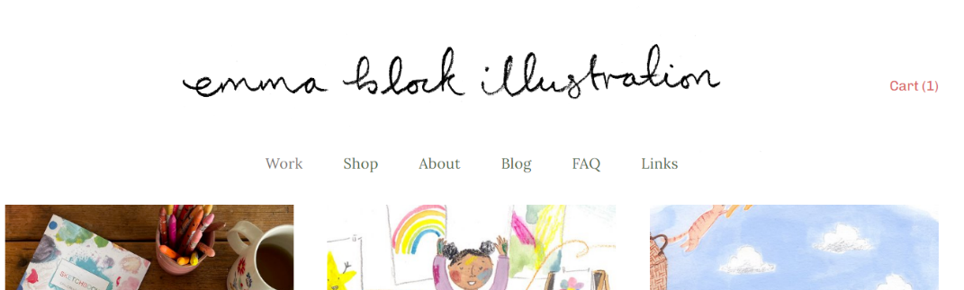 The part of this website I liked and would like to influence my website is the fonts used, their large and soft, making them great for people with visual impairment as less strain is required to look at the text. The fonts used are Lora and Omnes pro. It also gives a more casual smart approach to the website, so it doesn’t look too sterile and corporate (Not something you want for an artist’s portfolio). I also like the size of the navigators, where other websites have there’s small, this website has them in a fairly large size in that nice Lora font.

<https://www.darrenhughesart.com/>

The parts I like in this website is the way the pictures can be interacted with. When selecting a picture, the entire screen is covered in a greyish black, and a larger version of the picture with all the details of the picture are shown next to it. I found a lot of other gallery website would attempt to fit in other pictures, and whilst they were enlargeable, the data required to explain was in small writing or difficult to find due to trying to fit other parts of the website such as the navigator titles, name or even other pictures. This is the website I found did this aspect the best. However, I think the actual website is too simplistic, I don’t like the font and I also don’t like the name art covering the image when hovering over it with your mouse cursor. Another aspect of this website I liked was using a shopping cart to represent the checkout which is something I’ll be using in my website somehow.

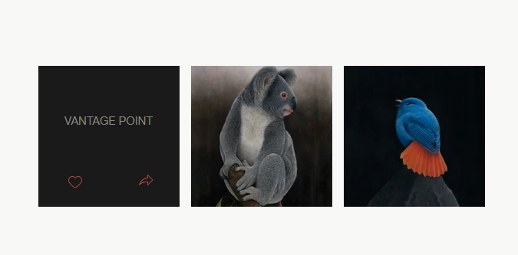

How pictures are normally shown, as you can see when hovering over one of the pictures, the name covers the picture with the name. Personally, I don’t think this looks good.

All pieces of information for the given art piece are given neatly on the side + overall you can you ESC and to leave this view mode making navigation through the website fluid.

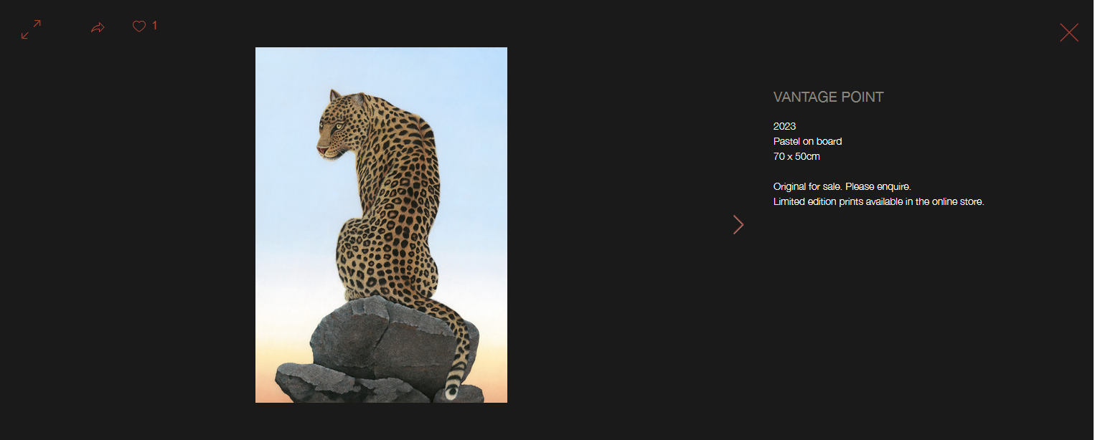

This is when you click on an image, the image becomes full sized so you can see the full thing.

<https://www.nicksheehy.com/>

<https://www.rickyleungart.com/>

Both galleries are very similar layout wise, but both have certain aspects that I like that the other doesn’t do. Firstly, the layout for both websites is how I want to base my website, with a logo on the top left and the navigators on the side and the art on the rest of the screen, I think its both clean and easy to see where everything is. For Ricky I also really like that the logo is animated with the name at the bottom, something nick doesn’t do. However, I feel Ricky’s navigator is too complicated, with small text, drop downs and technically non sensical names for a newcomer to the site. This contrasts with Nicks website where there are a few navigators and there easy to see and understand. However, the way Nicks images are formatted and moved through isn’t efficient vs Ricky’s more efficient way of navigating different pictures gallery, eg I like that the image expands a little when hovered over. Although I think Ricky’s images are too small and Nicks are too large, id like mine to be the middle of the two. One last thing I like about nicks website is the checkout page, its clean, and easy to remove, 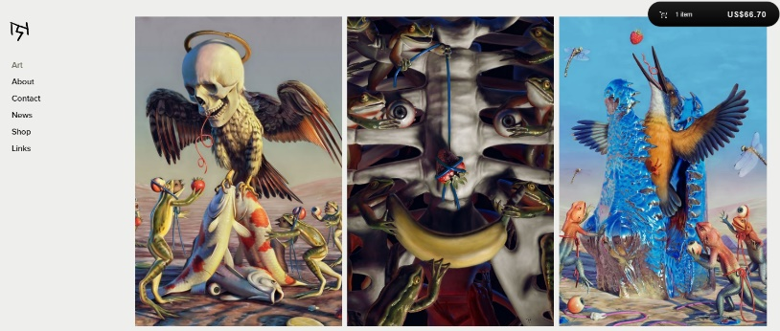add and view the items in your basket. So, I will be using that as inspiration for my checkout site.

Image on the top has much larger images vs the bottoms smaller image, I want to reach a middle ground of the two, however interacting with the bottom image’s pictures is much nicer than the top, so ill take more from the bottom image than the top when it comes to the layout of the gallery.

Both use a similar layout however the top image is neater and easier to understand however leaves plenty of dead space vs the bottom image which has a good logo layout and using more of the left side of the screen, however there are dropdowns in the navigation which in my opinion makes the website messy and difficult to navigate.

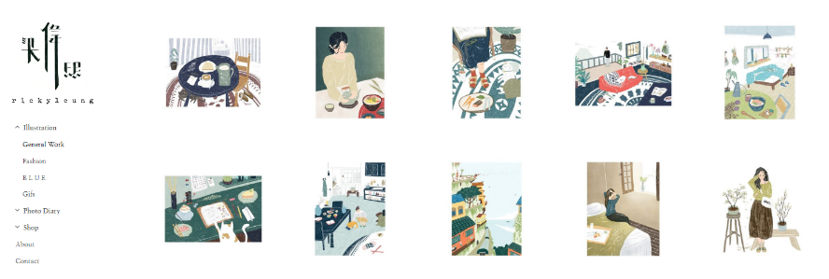

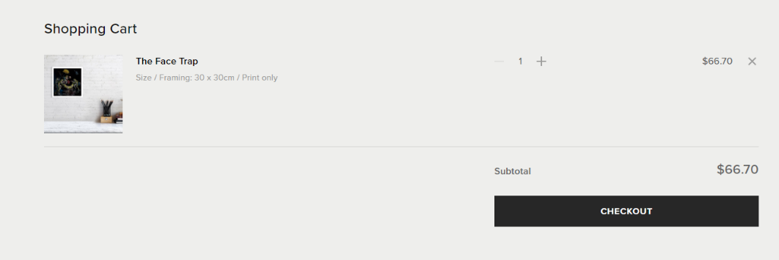

Easy to add more if needed without having to go back.

Gives name + small description with image of artwork.

Easy to remove item.

Price + total price Is given(more convenient)

Nice clean separator between items and total price, Overall its very minimalist and easy on the eyes

<https://moss51.com/using-white-background-on-web-design/> (source)

This is for all websites.

I find that a lot of websites use a white background or a slightly darker shade for their portfolios, and in their websites generally. I looked up why this was and turns it turns out that white backgrounds are great for minimalistic design, it gives of a professional feeling while also making your website more readable, however I feel that the background too white might make it piercing to look at, I also have to keep in mind that many people use dark mode when viewing websites which could look ugly contrasting with a black background, however for people with light mode, it could be too bright and therefore decrease readability. There are other more interesting conflicts within colour theory which is the cultural aspect of certain colours, for example in China and South Korea, the colour white symbolises negative emotion. Personally, I’ll be focusing on the western view (which expands on further in User Personas) for this website however in a larger website this is an interesting problem. Overall, I will most likely go for a whiteish background, so it’s not too bad although having a dark mode and light mode version of the website is also a valid design choice which could be thought about.

**User Personas**

Person 1

Name: Jade Yuan

Country: UK

Age: 23

Job: Retail Worker

Key Points:

* Lives in small apartment
* Has a small disposable income

Bio:

Jade is a retail worker who works a 10 – 6pm shift before returning home and playing games on her PlayStation. To use the web, she mostly uses her phone as she can’t afford a PC/Laptop, on top of that, for her there is no reason to get one. Normally if a website doesn’t load on her phone, unless she really needs to get onto it, Jade will just forget about it and move on. On top of that, her job doesn’t give her enough of a disposable income to buy expensive pieces of art/merch on top of other things she buys such as video games, streaming services to TV/Movies and going out with her friends. Therefore, if she were to buy something of a merch website it would have to be cheap enough to warrant her buying it.

User Story: As someone with limited budget, items on the cheaper end would be beneficial.

Person 2

Name: Artur Key

Country: UK

Age: 44

Job: Accountant

Key points:

* Has plenty of free time
* Has a large disposable income
* Fairly large house

Bio:

Artur is an accountant who has worked for a long time in the industry. He doesn’t work too many hours a week and therefore has lots of free time which he spends getting into various hobbies. One of which is Art Collecting, he’ll investigate different genres and buy anything he finds interesting. He’s even been known to spends hundreds on art pieces. His large house allows him to keep a collection of different pieces he’s found interest in. His primary form of web usage is through his laptop as finds phone too finicky. Although, he will usually collect more traditional pieces of art like painting’s he can hang up on a wall.

User Story: As someone who loves to collect, I want something amazing no matter the price.

Person 3

Name: Jacey Kristin

Country: UK

Age: 25

Job: Software Developer

Key points:

* Loves video games
* Optimiser

Bio: Jacey is an obsessed gamer, and has tried almost every kind of genre, like Strategy games, RPG’s, Survival Games, shooters, Indie games and more. She’ll even buy video game related product from time to time. However, she spends a lot of her time either playing games or creating a program for her job some kind of crunch time in a project, therefore she can’t dedicate her time to reading over some website with loads of information and difficult to traverse design. It needs to be quick and easy for her otherwise she’ll get frustrated and go somewhere else.

User Story: As a busy person, I don’t want to waste my time on laborious things

Person 4

Name: Chet Karter

Country: USA

Age: 14

Job: None/Student

Key points:

* Fan of the pixel art genre
* Visually Impaired

Bio: Chet is a huge fan of pixel art, following pixel artists on his multiple social media accounts, and he collects loads of pixel art works which he uses as decoration in his room. Chet, being a child, has the privilege of living with his parents which means he has no financial burden to get in the way of his collecting hobby. He often uses his pocket money to buy small indie video games, where his love of pixel art started, and to buy art from pixel art artists. However, he does struggle at times as he unfortunately has visual impairment therefore using websites not equipped to deal with his disability is difficult and generally will tend to give up unless he is very invested in the website.

User Story: As someone who loves to buy pixel art, I really want a website that considers my visual impairment.

Person 5

Name: [Gyeong](https://www.behindthename.com/name/gyeong) [Sung-Jin](https://www.behindthename.com/name/sung01jin)

Country: South Korea

Age: 20

Job: Salaryman

Key Points:

* Korean
* Used to like games.

Bio: Gyeong Sung-Jin is a salaryman who was born and raised in South Korea. Growing up he loved old school RPG’s like Dragon Quest however nowadays he doesn’t really play games. Whilst he feels nostalgia for his games, he’s quite the minimalist and would probably only buy something that really connected to him for a specific game (such as Dragon Quest). There are also cultural differences between him and western people, example being perception of colour that could signify different emotions. Though he can speak English, he doesn’t search using English words, therefore he will most likely find himself solely using Korean websites.

User Story: A website that looks like a Korean website and only specifies on specific games is not a valid design consideration. Parameters like focusing on broader western audience is easier and more lucrative for website traffic, having consideration for the very small minority will create little return.

**Basic Wireframes**

1080px Width wireframe:

Checkout Wireframe

Bio(for artist) Wireframe

Shop Wireframe

Item List Wireframe

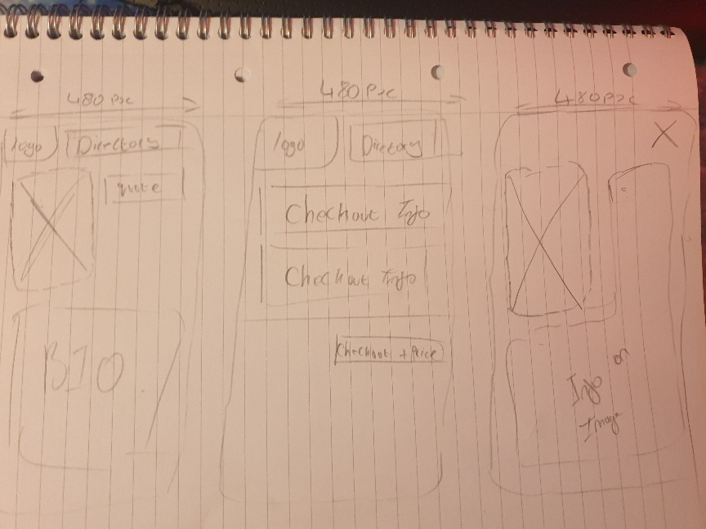480px Basic Wireframe:

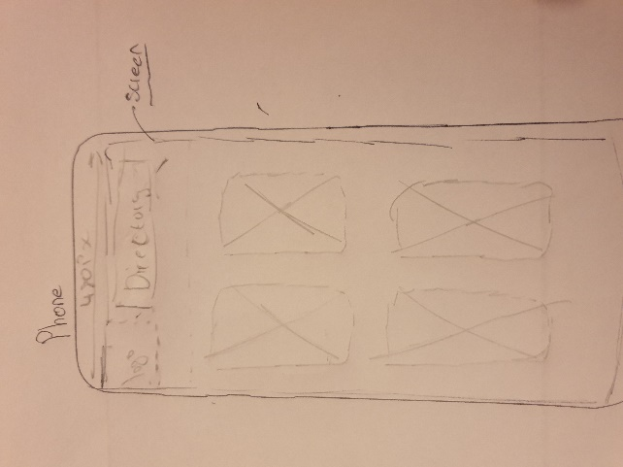

**Design inspiration:**

The websites in the similar design section can also be considered design inspiration as a lot of the layout, font choice, font size inspiration and colour pallet of the website are inspired by multiple parts of those 4 websites. However here are other websites I’ve considered inspiration for:

<https://www.youtube.com>

The Mobile version of this app is the part I’m taking inspiration from. For the 1080px version of the website I wanted to have large text to represent directories. However, on a mobile phone it would be difficult to fit these onto the screen. Theres not enough room on the top of the screen and it would look awkward on the side of the screen. I considered a drop-down menu on the side to move around the website, although not be as intuitive as I may perceive to someone doesn’t frequent the internet, like someone in the older generation. Therefore, I feel YouTube’s mobile layout would be great for my website. I want to use YouTube symbol + small words system to indicate the directory. This both is small enough to fit on the top of the screen and make it easier to indicate a directory to another page. YouTube is also coincidently one of the highest visited websites on the internet, so many people would know what these directories would do.

Octavi Navarro (The pixel artist I’m using)

<https://octavinavarro.com/>

The parts ill use for this other than the art, is how the art is presented which is in using a smaller image for the gallery, however when clicked on, I’ll use the full image in the item listing. This makes loading the website more efficient and using the website space more efficiently as a lot of these images are portrait pictures making them difficult to fit on a screen. Another design choice I like from this is the logo being in pixel art, which works well with the theme of the website, being all pixel art. I personally want to extend this to more of the website. I’d like the background of the left side, where the page changes per directory eg the about/shop/checkout section of the webpage, to have a pixel art background of slightly different shade of white, to make it look blockier and more vibrant.

Another inspiration I want to use in Terraria.

Upon loading into Terraria there are multiple pieces of text shown in front of you, however when hovered they become bigger and become yellow. Whilst I don’t want the entire text to become yellow as I feel that wouldn’t work with a white background, making the the text bigger and having a colour appear around the text, such as yellow, would be a nice touch and make the website feel nicer to navigate.

**Detailed Wireframes/graphical mock-up:** **Justification of Design**

Home Page

No scroll wheel.

Wanted a clean look to the website and felt a scroll bar would disrupt the style of the website.

Immediately obvious that it’s a clickable link.

Text and socials will have low opacity and increase when hovered.

Bigger and be rounded when hovered.

No scrolling

Shop page

Makes title smoother instead of blocky and out of place.

Will be a gradient

Reduce options as much as possible to not confuse or annoy the user.

No horizontal scrolling

No scrolling

About Page

If scrolling was enabled the page would scroll a little big, would annoy user.

Checkout Page

Make clear that the buttons are interactable/will do something when clicked.

Will become bigger and change opacity when hovered.

Gallery example page

This applies to other webpages as well but wanted left side of all webpages to be the same to give the user a consistent pattern on how the website worked, if there was no constant, navigation would become needlessly complicated.

Shop example page.

Also, in general, nearly all parts of the website is done in pixel art which is to reflect the artist, I wanted the style of the website to match the style of artist to make the images feel seamless in my website.

The peachy background was the perfect color for a light but not too bright approach I wanted to have, many people use dark mode on webpages so having something very bright would be discomforting, and it works well with a lot of other colors as its inoffensive.

**Questionnaire:**

**1.** What do you dislike about the gallery page and what would you change about it?

**2.** What do you dislike about the shop and what would you change about it?

3. What do you dislike about the about page and what would you change about it?

4. What do you dislike about the checkout page and what would you change about it?

**5.** How obvious is moving around the webpage?

**6.** Is there anything else you dislike about the webpage?

**7**. What do you like about the webpage?

Answer 1:

1. Scroll-wheel needed

2. Thumbnail to show art on product

3. takes up a lot of space

4. Something to show payment methods allowed

5. Navigation is generally good

6. No

7. Simple/clean

Answer 2:

1. Must go back from pictures to the gallery page to look at other images, no info when hovering over image and no filter to find specific genre

2. Don’t like font for heading titles in shop

3. text is too crowded, inappropriate font

4. inappropriate font for description of product in checkout and elements of the checkout should be bigger

5. make directory more obvious to interact with and more obvious to scroll

6. logo image not centred with rest of directory + pointer should change when hovering over a link to make more obvious that it’s a link

7. colours are nice, background is nice, and layout is clean and nice to look at

Answer 3:

1. no scrolling obviousness, lack of info on images

2. messy layout, lots going on but no info

3. bad font, more explicit title name for directory, description to blocky and uneasy on the eyes. Text is too small for reading and theirs to much of it.

4. downsize image in checkout, checkout not a good title name and quick scrolling to actual checkout so don’t have to scroll down all the way on my own

5. first time users might find difficult to navigate properly (too much time spent learning how to navigate the website). Lots of clicking is required to move around website.

6. directory to big, not aligned, logos to big, not dark mode accessible

7. Clean and the image hovering expansion is a nice touch.

Overall reading through these responses, the respondents immediately had problems with the directory, it being to large or difficult to see there was navigation or that it wasn’t centred. Another major problem is that of scrolling, due to there not being a scroll wheel, was not immediately obvious. They also didn’t like the about page in general, being too wordy and compact on the screen. Another large prevailing problem was there generally a lack of information, and you navigate the website, and having to spend to much time to get a general understanding of where everything is. Such as confusing name conventions for the titles in the directory or the moving in and out of image description being annoying and time consuming. However, everyone agrees that the positive of the website is that it is a simple, clean webpage. Obviously, this is something I will try to build on by revamping or reworking features such as where the shop should be and how it should be accessed, as it’s clear the current structure isn’t good enough for users.

What I’ve implemented with this questionnaire:

Immediately I’ve changed the names of the titles to better reflect the actual content or to remove confusion. So about has been changed to add The Artist to allow the user to immediately understand what the section contains. I also changed the Checkout directory name to be called basket instead as I had people confused on what the checkout was whilst on the checkout, not understanding why they had a checkout page which more commonly shows when you you’ve already added a product. Ill also alter colour changes for the directory and make the social media’s more obviously clickable by decreasing opacity so they become more colourful when hovered over. Finally, ill make simple reformatting changes to the about page and the directory by making the about page easier to look at, and forcing the directory to always centre. Further improvements to the directory will be made during the PHP implementations.

What I’ll implement in the future.

As I learn PHP and JavaScript, implementing specific parts to a website, therefore trying to fix and improve on the directory will be far easier to do. Therefore, in the future ill try to make the directory more aligned and smaller in the future. Also, I plan to overhaul the Shop and Gallery to make them easier to understand/ easier to navigate. For the Gallery I’ll be adding a previous art piece and next art piece on the art description, so you don’t have to click of and onto another gallery image, making navigation between images feel nicer. The reason I’m doing this into the future is because I believe cyclic cycling of images within the description will be easier to implement with something like an array that stores each image location so that can be used instead of individually linking each website on each webpage. This feeds into improving the shop where in the gallery, I want an option to either visit the shop page through the gallery or to add merchandise from the gallery using a dropdown menu. In the much closer future ill improve the actual about page by decreasing the amount of information within the website, with this change will be a change in font for p tags so they can be easier to read. Lastly revamping the basket will also be done in the in the future as using PHP will be a large section for the basket, as divs will need to be inserted and info on said items be saved. This will include payment methods as well, as I believe that will be a useful feature in the future. Lastly, if there is enough time, adding animation to the logo or making the website dark-mode accessible would be a great direction. Ill also move my website to have its own layout for mobile phones instead of using scalability, as I can be more targeted with where elements go, in addition elements for pc/laptop don’t necessarily work well on mobile. Another feature I’ll try to implement in the future is the hidden scoll wheel as having the ability to interact with certain parts of the website to detect user interaction will allow me to only show the scroll when its being hovered over.

**Error Evaluation + Debugging**

Index.html error evaluation

1. **Warning: Consider adding a**lang**attribute to the**html**start tag to declare the language of this document.**
2. **Error: The character encoding was not declared. Proceeding using**windows-1252**.**
3. **Error: Start tag seen without seeing a doctype first. Expected**<!DOCTYPE html>**.**
4. **Error: No space between attributes.**
5. **Error: Attribute**alt**not allowed on element**[a](https://html.spec.whatwg.org/multipage/#the-a-element)**at this point.**
6. **Error: Attribute**alt**not allowed on element**[a](https://html.spec.whatwg.org/multipage/#the-a-element)**at this point.**
7. **Error: Attribute**alt**not allowed on element**[a](https://html.spec.whatwg.org/multipage/#the-a-element)**at this point.**
8. **Error: Attribute**alt**not allowed on element**[a](https://html.spec.whatwg.org/multipage/#the-a-element)**at this point.**
9. **Error: No space between attributes.**
10. **Error: Start tag**a**seen but an element of the same type was already open.**
11. **Error: No space between attributes.**
12. **Error: No space between attributes.**
13. **Error: No space between attributes.**
14. **Error: No space between attributes.**

After debugging all problems were resolved.

**Document checking completed. No errors or warnings to show.**

about.html

1. **Warning: Consider adding a**lang**attribute to the**html**start tag to declare the language of this document.**
2. **Error: The character encoding was not declared. Proceeding using**windows-1252**.**
3. **Error: Start tag seen without seeing a doctype first. Expected**<!DOCTYPE html>**.**
4. **Error: No space between attributes.**
5. **Error: Start tag**a**seen but an element of the same type was already open.**
6. **Error: No space between attributes.**
7. **Error: No space between attributes.**

After debugging all problems were resolved

**Document checking completed. No errors or warnings to show.**

Bubble.html

1. **Warning: Consider adding a**lang**attribute to the**html**start tag to declare the language of this document.**
2. **Error: The character encoding was not declared. Proceeding using**windows-1252**.**
3. **Error: Start tag seen without seeing a doctype first. Expected**<!DOCTYPE html>**.**
4. **Error: No space between attributes.**
5. **Error: Attribute**alt**not allowed on element**[a](https://html.spec.whatwg.org/multipage/#the-a-element)**at this point.**
6. **Error: Attribute**alt**not allowed on element**[a](https://html.spec.whatwg.org/multipage/#the-a-element)**at this point.**
7. **Error: Attribute**alt**not allowed on element**[a](https://html.spec.whatwg.org/multipage/#the-a-element)**at this point.**
8. **Error: Attribute**alt**not allowed on element**[a](https://html.spec.whatwg.org/multipage/#the-a-element)**at this point.**
9. **Error: No space between attributes.**
10. **Error: Start tag**a**seen but an element of the same type was already open.**
11. **Error: No space between attributes.**
12. **Error: Attribute**alt**not allowed on element**[a](https://html.spec.whatwg.org/multipage/#the-a-element)**at this point.**

After debugging all problems were resolved – bubble.html is very similar to this webpage so they have all the same errors and therefore are all debugged to show no warnings.

**Document checking completed. No errors or warnings to show.**

bubblePosterBuy.html

1. **Warning: Consider adding a**lang**attribute to the**html**start tag to declare the language of this document.**
2. **Error: The character encoding was not declared. Proceeding using**windows-1252**.**
3. **Error: Start tag seen without seeing a doctype first. Expected**<!DOCTYPE html>**.**
4. **Error: No space between attributes.**
5. **Error: Attribute**alt**not allowed on element**[a](https://html.spec.whatwg.org/multipage/#the-a-element)**at this point.**
6. **Error: Attribute**alt**not allowed on element**[a](https://html.spec.whatwg.org/multipage/#the-a-element)**at this point.**
7. **Error: Attribute**alt**not allowed on element**[a](https://html.spec.whatwg.org/multipage/#the-a-element)**at this point.**
8. **Error: Attribute**alt**not allowed on element**[a](https://html.spec.whatwg.org/multipage/#the-a-element)**at this point.**
9. **Error: No space between attributes.**
10. **Error: Start tag**a**seen but an element of the same type was already open.**
11. **Error: No space between attributes.**
12. **Error: Attribute**alt**not allowed on element**[a](https://html.spec.whatwg.org/multipage/#the-a-element)**at this point.**

After debugging all problems were resolved – bubble.html is very similar to this webpage so they have all the same errors and therefore are all debugged to show no warnings.

**Document checking completed. No errors or warnings to show.**

Checkout.html

1. **Warning: Consider adding a**lang**attribute to the**html**start tag to declare the language of this document.**
2. **Error: The character encoding was not declared. Proceeding using**windows-1252**.**
3. **Error: Start tag seen without seeing a doctype first. Expected**<!DOCTYPE html>**.**
4. **Error: No space between attributes.**
5. **Error: Attribute**alt**not allowed on element**[a](https://html.spec.whatwg.org/multipage/#the-a-element)**at this point.**
6. **Error: Attribute**alt**not allowed on element**[a](https://html.spec.whatwg.org/multipage/#the-a-element)**at this point.**
7. **Error: Attribute**alt**not allowed on element**[a](https://html.spec.whatwg.org/multipage/#the-a-element)**at this point.**
8. **Error: Attribute**alt**not allowed on element**[a](https://html.spec.whatwg.org/multipage/#the-a-element)**at this point.**
9. **Error: No space between attributes.**
10. **Error: Start tag**a**seen but an element of the same type was already open.**
11. **Error: No space between attributes.**
12. **Error: No space between attributes.**

After debugging all problems were resolved

**Document checking completed. No errors or warnings to show.**

Shop.html

1. **Warning: Consider adding a**lang**attribute to the**html**start tag to declare the language of this document.**
2. **Error: The character encoding was not declared. Proceeding using**windows-1252**.**
3. **Error: Start tag seen without seeing a doctype first. Expected**<!DOCTYPE html>**.**
4. **Error: No space between attributes.**
5. **Error: Attribute**alt**not allowed on element**[a](https://html.spec.whatwg.org/multipage/#the-a-element)**at this point.**
6. **Error: Attribute**alt**not allowed on element**[a](https://html.spec.whatwg.org/multipage/#the-a-element)**at this point.**
7. **Error: Attribute**alt**not allowed on element**[a](https://html.spec.whatwg.org/multipage/#the-a-element)**at this point.**
8. **Error: Attribute**alt**not allowed on element**[a](https://html.spec.whatwg.org/multipage/#the-a-element)**at this point.**
9. **Error: No space between attributes.**
10. **Error: Start tag**a**seen but an element of the same type was already open.**
11. **Error: No space between attributes.**

After debugging all problems were resolved

**Document checking completed. No errors or warnings to show.**

Style.css

1. **Error:**background-color**:**EAE7DC**is not a**background-color**value.**

After debugging all problems were resolved

**Document checking completed. No errors or warnings to show.**

**My Current skill Tree Set.**

**Self-Appraisal**

First off, there is some CSS elements that I feel I need to improve on, especially working with divs and their functionality with each-other, I would like to in the future when improving the website have a scalability function that perfectly changes the resolution of the left container of the website, as currently changing this causes an unwanted change to the directory side of the website. Furthermore, I want to remove the number of webpages that my website uses, as many of them are duplicates, and therefore I feel managing these webpages would become more straightforward. This culminates in using a template webpage to put other elements that would reduce download times and allow me to focus on specific elements of the webpage, instead of constantly having to make new webpages to add items. I would also like to improve the shopping experience as currently I don’t believe its as good as it could be, including thumbnails to show off merch and a more interactive and personalised shopping experience. I will need to improve my graphic design skills, learning to use photo editors such as photoshop to accomplish this. Limitations I currently have is a lack of knowledge when it comes to php and understanding how it works. With php I can have a competent client-server model that simplifies web development, remove the number of webpages I need to maintain, and allow for interactivity. It also incorporates databases to save information and to have information requested from. Also, having a higher knowledge of JavaScript would let me add interactivity to the buttons, and insert Divs when needed such as adding an item to the checkout. Lastly, I would like to try and simplify the shop by adding the gallery and the shop into one entity. Instead of two separate web pages, I can have a gallery page with the option to look at merchandise associated with the product, within the gallery, making purchasing from the website far simplifier than navigating a gallery to find images you like, and then navigating the shop to find whether the image you like can be bought on an item you want. A slight overhaul in design therefore would be beneficial. I also instead of trying to just do scalable design, also use media queries to change the layout of the website for when the user is using a mobile phone, as this is a large part of internet users. I also want to make the colour pallet more interesting in the future, by changing the background slightly to reflect the pixel art aesthetic. Overall quality of life features to make navigation easier and a functioning shop are my priorities, whilst the next important thing is a more engaging colour pallet and website functionality (apparent pop-ups for buttons and links).

**Checklist for CE154 Assignment 1 (approx. total time 40 hours)**

**Task 1 (submitted in report) – 20% approx. 8 hours**

|  |  |
| --- | --- |
| Tick | Assignment Word doc is called CE154_assignment_1.doc |
| Tick | Similar website content research included (list sites and discuss) |
| Tick | Define sections of content (purpose and names): e.g., home, about, listing, detail, basket |
| Tick | User personas enough to cover main user groups and any specific user characteristics mentioned |
| Tick | User stories (enough to cover the main roles and functions of the site) |
| Tick | Wireframe template for layout for specified resolutions |

**Task 2 (submitted in report) – 20% approx. 8 hours**

|  |  |
| --- | --- |
| Tick | Design inspiration research included (list and discuss) |
| Tick | Art genre explicitly stated |
| Tick | Add design details to wireframe |
| Tick | Graphical mockup |
| Tick | Justification of design |

**Task 3 (submitted in code zip) – 40% approx. 16 hours**

|  |  |
| --- | --- |
| Tick | Lorum ipsum text used for content |
| Tick | Files correctly named (e.g., index.html and style.css) |
| Tick | Files in specified folder structure |
| Tick | Source credited in code/reference doc |
|  | Work for firefox!!!! Do tomorrow if can |
| Tick | At least 5 pages |
| Tick | At least 5 items in product list |
| Tick | No horizontal scrolling |
| Tick | Minimum data transfer (no massive video or image files) |
| Tick | The pages must take the following aspects into account:   * + the correct type of graphics files for the images you want to show - change logo to gif   + suitable font types and sizes   + appropriate use of colour and contrast   + functional navigation based on a linked unordered list   + avoid text in graphics   + add suitable alt tags to hyperlinks and images (for users with restricted vision)   + include copyright and updating information the page footer |
| Tick |
| Tick |
| Tick |
| Tick |
| Tick |
| Tick |
| Tick | Code comments |

**Task 4 (submitted in report) – 20% approx. 8 hours**

|  |  |
| --- | --- |
| Tick | Questionnaire (min 3 questions) evidence |
| Tick | Results and analysis |
| Tick | Iterative evaluation evidence – What did you change? What will you change in the future? |
| Tick | Code evaluation against HTML |
| Tick | Code evaluation against CSS |
| Tick | Code report and bug fixing log |
| Tick | Self-appraisal |
| Tick | Skill tree screenshot |
| Tick | Checklist completed |