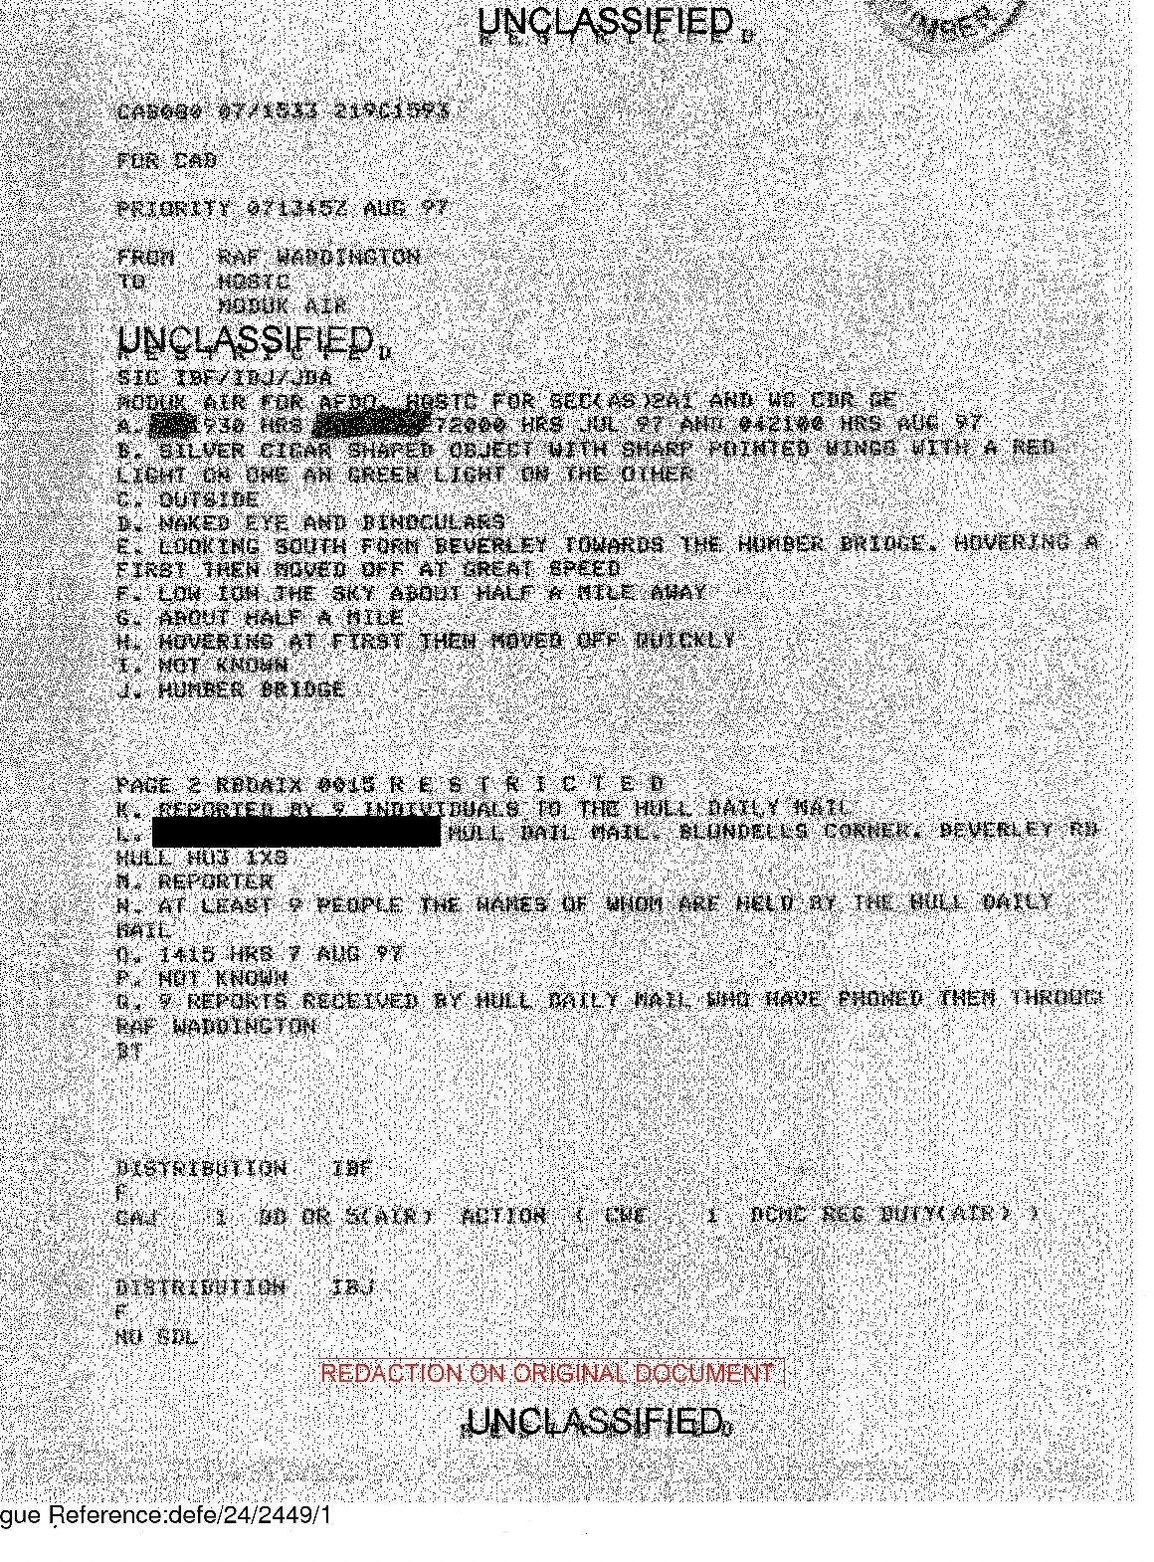

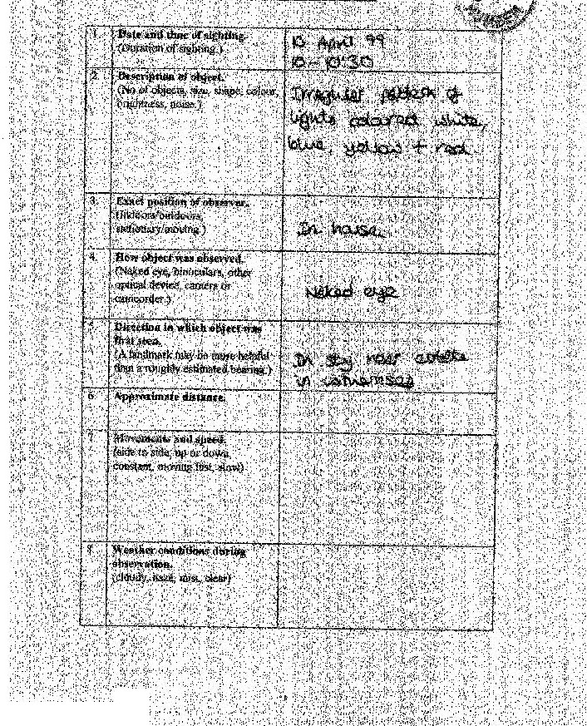

f,,,..;.•.·'.t:.•:/i•}:;.

*:\f:,·.*

• :;'·tt:::•.·.

Catalogue Reference:dele/24i2449/1

© Crown Copyright

The National Archives' reference DEFE *2412449n*

