Page I of I



**Air CmdSecCS-RAFBusSec2**

**From:**

Sent: 01 November 2009 01:37 **To:** Air C:ndSecCS•UFO Oeskl **Subject:** large sighting

*Oeat* Sir

I have just seen sixUFOS whils1 driving home.tam sure there is a good explanation and would like to check

!!_x,ou h d military c'.aft onexerc in thearea to this n!! ber.

At 12:31 this evening, approx half an hour agoI saw 6 lights almost in an S shape slowly moving across the sky. I was on the road FROM Humberston (suburb of Cleelhorpes) to Tetncy, Norlh East Lines. I was on the so-aight just before Tetney village when I saw through my cars front window lllese 6 !ights. I've never seen anylhing like them, ,t jus1looked verv odd. I pulle-d over and got ou1to look further. They were moving In

formation lrom West to north east (towards the sea). The conditions weremistyInthe sky, although at ground

level it was clear. Then one ol thelights disappeared quic:l<ly. I got back into thecar10 follow the hghts ana pulledover again further along. Only twolights remained ano gradually faded out. I would like to note that

!here was NO sound.

I would like this to be anonymous, you are welcome to contact me discreetly but I donot want themedia 10 know of me or my name as I runseveral businesses and have a reputation to oonsider. I have taken several photographs *on* my phone but can not examine them or blow them upun1il I get back into office as I have left cable there.

I would appreciate knowing if you t>acl six helicopters in thearea at this time or have I s""n "genuine UFO formation?

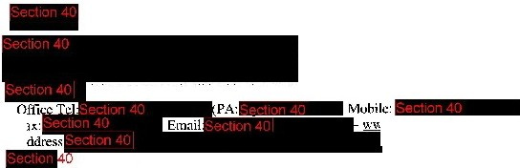Many thanks

. .

c.:rt·...i.1.h-.:r*1 1*. *ntiJ* .t.rd

Fa [www.stonetimher.co.uk](http://www.stonetimher.co.uk/)

*A* NorthCotes, Lincolnshire-40