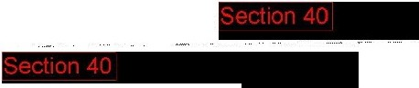Air CmdSecCS-RAFBusSec13

**From:**

**Sent:** 03 September 2009 17:40

**To:** Air CmdSecCS-UFO Desk1

**Subject:** UFO Filey

**Attachments:** DSC00052.jpg; DSC00053.jpg; DSC00055.jpg

I attach photographs of a flying object I encountered over Filey town centre at 00.46 yesterday (2nd September.)

I was completely transfixed by it and watched it for a few minutes before I panicked and hurried back to my parents flat.

The best way I can describe its appearance is a brilliant and dazzling pure white horizontal ring of light. It appeared to be perfectly still in the sky above the houses and was totally silent.

I took these pictures from the corner of Chapel Street and Station Avenue and I would estimate that it was hovering above the Belle Vue Crescent area.

l noticed that RAF jets were doing fly over the town the following morning.... surely this is not a coincidence? All I can say is that it was the strangest experience of my life and thought I should report it to someone.

