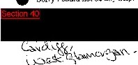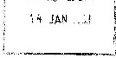**yours sincerely**



-,

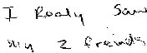*)N*



' -·

* ♦ ,.

.. *. . ,*

"' **·f \** ,:_

 

 **f)J··S.v,...,** :::_\.,,.,*.<* ***<v\***



***C r***

.

**\V\ s**

*i;*,...v-1

*•*•*-,(-* .

**V°'f'-.&** "I -

•



***c_¢'1'"***

\"'\,M,.

*'-J* Ci ._.... *i.J* **G_c:, J** •



2.  

**1** c,..,,-

G¼t,,.

l-e..- -.

.\,dt.:"'-'\.

*Jv.. ·ti..t>-Ct*. ).R ...k c,





t> ......'-- ..,..--JA.

;:JA \'¼ f 1·,.J

t,.,h..J, **!.,Jv-.**,;. '"'"'tfc-.• ,.

'-..l

*cu'L o;.Ii u ve.r*

()i':> - -,:.....

•

*-Ao* '.>ov..-,J.

*\} *'::,\.-\\ **<t<**,**-\**

'o,j1--L*,',t.*

*V*'*\f.>e..*<>' -"'""· *(,-i'' '\O*

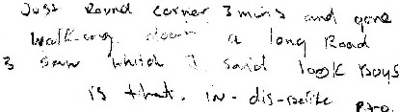



**1** \/wJ< ¥'N- i .._t

**latalcgue Heterence:deto/24/262811**

 *s \o I(* fl.,.;(..

*oJ,.,.,,...._.r*/ :,;_\

J;\ o

   

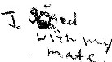1·1...*,< v V-"'- ..}.,,-.x,.-..'>..:·* ·,7- '"' +'''I._;."\ o '-.;:.)i;, <:

1,,-\-._, .S1:.., 0 1 w.,._,...C!. ...,,_ <'. •

·.:X'M,v.·,

  

Ji y *..r,oq*

w wJ.



*\,.J* •-·

l,J(;.'1\V:,,._.•"-

***--A-*** \ \'-.'· ·n

0ioI\,111r.,t \'.e.:;,{

l>,..o \ \,,,tJ'..c.nS

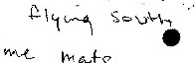

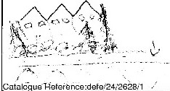

  

'



I1,.,..,:,,_vs

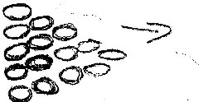r,:re,;'1 c.r-

