**Documentation: vod-function-1-thumbnail**

**Table of Contents**

**1.** **Introduction**

**1.1** Overview

**1.2** Architecture Overview

**1.3** Function Details

**2. Implementation of the Main.py Function**

**2.1** Importing Libraries and Initial Setup

**2.2** Extracting Source File Information

**2.3** Initializing the Transcoder Service Client

**2.4** Thumbnail Creation

**2.5** Error Handling

**2.6** Publishing Pub/Sub Message

**3. Testing and Validation**

**4. Glossary**

**5.** **References**

**Introduction**

**1.1 Overview**

The `vod-function-1-thumbnail` automates thumbnail generation in a Video-On-Demand (VOD) pipeline using Google Cloud Platform (GCP). The function is triggered upon a new video upload to a Google Cloud Storage (GCS) bucket, processes the video, and stores the generated thumbnail in a separate bucket for visual previews. This function ensures scalability and automation of the thumbnail generation process.

**1.2 Architecture Overview**

**Trigger Event:** The function is activated when a video file is uploaded to `vod-unprocessed-videos` GCS bucket.

**- Thumbnail Generation:** Using the Google Cloud Video Transcoder API, a specific frame from the video is extracted to serve as the thumbnail.

**- Storage:** The thumbnail is stored in `vod-processed-thumbnails` bucket, named similarly to the video file.

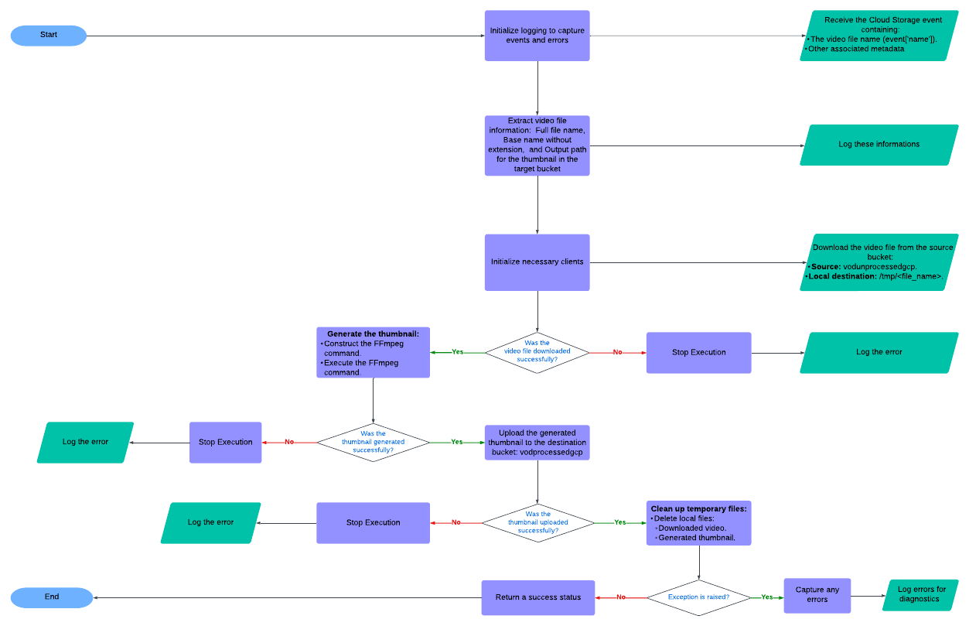**Architecture Diagram:**

**1.3 Function Details**

The function works in the following steps:

**- Trigger:** When a video is uploaded to the GCS source bucket.

**- Process:** Generates a thumbnail using the Google Cloud Video Transcoder.

**- Storage:** Saves the generated thumbnail to a separate GCS destination bucket.

**- Notification:** Sends a Pub/Sub notification indicating success or failure of the task.

**2. Implementation of the Main.py Function**

**2.1 Importing Libraries and Initial Setup**

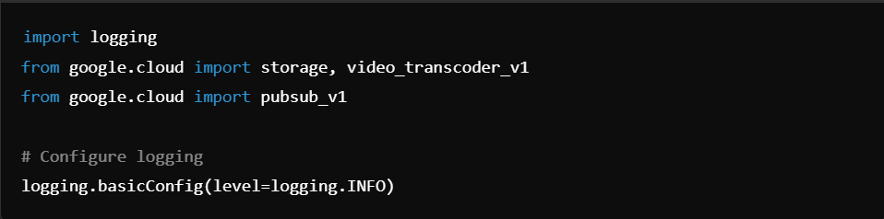

This imports essential Google Cloud libraries, including `storage` for interacting with GCS, `video_transcoder_v1` for video processing, and `pubsub_v1` for sending notifications.

**2.2 Extracting Source File Information**

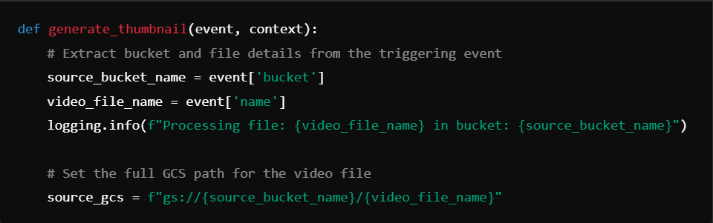

This section extracts the file path and logs the file being processed.

**2.3 Initializing the Transcoder Service Client**

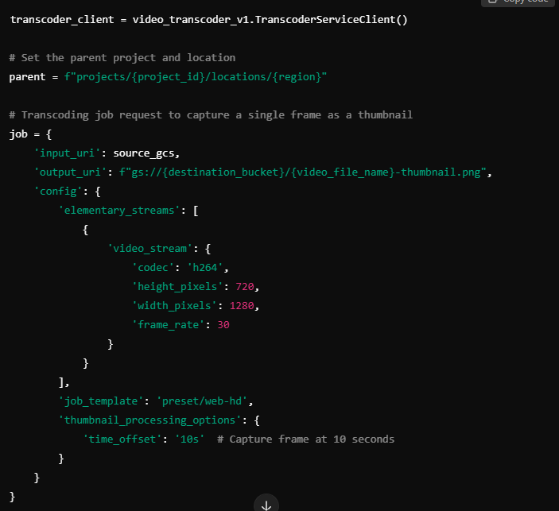

This code block initializes the transcoder client and configures the job for thumbnail generation.

**2.4 Submitting the Thumbnail Creation Job**

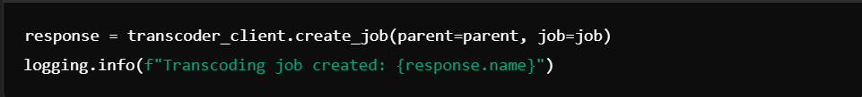

Here, the function submits the job to Google Cloud Video Transcoder and logs the job's creation.

**2.5 Error Handling**

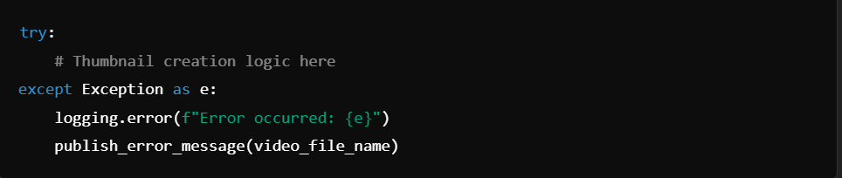

The function catches any errors, logs them, and triggers an error notification through Pub/Sub.

**2.6 Publishing Pub/Sub Message**

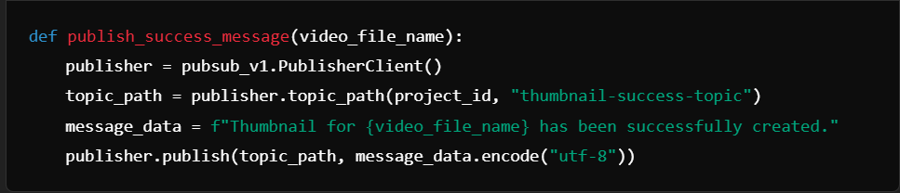

This function sends a Pub/Sub notification indicating the successful creation of the thumbnail.

**3. Testing and Validation**

**3.1 Test Cases:**

**- Successful Execution:** Verify that thumbnails are generated and stored in the destination bucket.

**- Failure Scenarios:** Ensure that errors are correctly handled and notifications sent via Pub/Sub.

**3.2 Validation Criteria:**

**- Output:** Check that thumbnails appear in the `vod-processed-thumbnails` bucket.

**- Notifications:** Confirm that Pub/Sub messages are sent upon job completion.

**4. Glossary**

**- GCP:** Google Cloud Platform

**- GCS:** Google Cloud Storage

**- VOD:** Video-On-Demand

**- Transcoding:** The process of converting a video file into different formats or extracting frames.

**- Thumbnail:** A small image representing the content of a video, typically used for previews.

**- Pub/Sub:** A messaging service for event-driven communication.

**5. References**

- [Google Cloud Video Transcoder Documentation](https://cloud.google.com/transcoder/docs/)

- [Google Cloud Pub/Sub Documentation](https://cloud.google.com/pubsub/docs)