Abstract
Background/purpose: Accurate determination of caries lesion depth is essential for treatment planning, but low radiographic contrast can create diagnostic uncertainty, potentially leading to missed lesions or overtreatment. We developed a multi-channel image-preprocessing method coupled with a convolutional neural network (CNN) to enhance radiographic features and improve caries depth determination in primary teeth.
Materials and methods: A total of 1,119 periapical radiographs were standardized to 256 × 256 pixels. The preprocessing pipeline used percentile normalization in the R channel to suppress extreme values, assigned contrast-limited adaptive histogram equalization (CLAHE) to the G channel to strengthen local contrast, and applied black top-hat morphology in the B channel to emphasize dark lesion-like structures. The processed images were evaluated using the EfficientNet-B0 model to classify caries lesions by depth into enamel, dentin, and pulp levels. An ablation experiment further compared original images, individual preprocessing methods, and the proposed multi-channel fusion using the same classifier.
Results: EfficientNet-B0 yielded 85.97% accuracy. The F1-scores for enamel-, dentin-, and pulp-level lesions were 84.35%, 83.56%, and 89.93%, respectively. In the ablation analysis, the proposed multi-channel input improved accuracy from 75.11% with original images to 85.97% and outperformed the individual preprocessing approaches.
Conclusion: The proposed multi-channel preprocessing approach effectively preserves and enhances varying image features, significantly improving the CNN-based automated determination of caries lesion depth on periapical radiographs of primary teeth.
Keywords: Deep Learning; Dental Caries; Diagnosis; Computer-Assisted; Image Processing; Dental
Introduction
Dental caries in primary teeth remains a major global oral health burden, with an estimated global average prevalence of 43% in the primary dentition.¹ ⁻³ Early and accurate detection is particularly important because primary teeth have thinner enamel and dentin than permanent teeth, and their pulp horns are more prominent and located closer to the dentinoenamel junction (DEJ), allowing carious lesions to progress more rapidly toward the pulp. Beyond detecting the presence of caries, accurate determination of lesion depth is essential for treatment planning, as management decisions depend substantially on whether a lesion is confined to the enamel, extends into the dentin, or involves the pulp. Periapical radiography provides a noninvasive means of evaluating lesion extent; however, interpretation may be affected by anatomical superimposition, variations in radiographic acquisition, and the low contrast of early demineralization. Consequently, determining radiographic depth relative to the DEJ and pulp depends considerably on the clinician’s interpretation and experience, potentially resulting in interobserver variability.⁴
Artificial intelligence, especially convolutional neural network (CNN)-based deep learning, has shown considerable potential for computer-assisted interpretation of dental radiographs.⁵⁻⁷ Although various CNN models have been proposed for automated caries detection, their performance may be affected by variations in the quality and contrast of input radiographs. Direct application of deep learning models on original radiographs without proper enhancement often results in the loss of critical diagnostic information, as extreme intensity values or low local contrast can obscure subtle pathological features. Therefore, rather than solely relying on the architecture of advanced classification networks, improving the foundational image quality through targeted preprocessing is essential to enhance the model's recognition capability for caries depth.
To address the limitations of raw periapical radiographs, multi-channel image preprocessing techniques can be employed to systematically preserve and highlight different aspects of the image information.⁸ By transforming a single-channel grayscale image into multiple channels, specific enhancement algorithms can be independently applied to extract complementary features. For example, percentile normalization suppresses outlying pixel intensities while expanding global contrast. In parallel, local contrast was strengthened with contrast-limited adaptive histogram equalization (CLAHE), which also sharpened structural boundaries.⁹ Furthermore, black top-hat morphology is particularly advantageous for extracting dark, lesion-like structures against varying backgrounds. Integrating these distinct processed outputs into a single composite multi-channel image allows the CNN model to extract more comprehensive, diverse, and discriminatory pathological features.
Therefore, this study aimed to develop a multi-channel image preprocessing framework for automated determination of caries lesion depth in primary teeth on periapical radiographs. This framework utilizes percentile normalization, CLAHE, and black top-hat morphology to preprocess periapical radiographs. Subsequently, an EfficientNet-B0 classification model is employed to automatically classify caries lesions into three depth levels: enamel, dentin, and pulp. By prioritizing robust image preprocessing to retain varying image information, this study aims to provide a highly accurate, objective, and reliable computer-assisted diagnostic tool for dental clinicians.

Materials and methods
Dataset collection
A total of 1,119 de-identified periapical radiographs (PAs) of primary teeth were obtained from Chang Gung Memorial Hospital, Taoyuan, Taiwan. The study protocol was approved by the Chang Gung Medical Foundation Institutional Review Board (IRB number: 202400084B0), which waived the requirement for informed consent. All PAs were acquired using a high-frequency intraoral X-ray generator (HELIODENT PLUS, Sirona Dental
Systems GmbH, Bensheim, Germany). Exposure time ranged from 0.12 to 0.16 s according to clinical requirements. Digital sensors measuring 31.3$×$44.5 mm and 22.5$×$35.0 mm were used, producing images with dimensions of 825$×$1200 pixels and 820$×$562 pixels, respectively. Before model input, all images were resized to 256$×$256 pixels. For development and evaluation, the images were randomly allocated at an 8:2 ratio: 898 to the training set (284 enamel-level, 304 dentin-level, and 310 pulp-level) and 221 to the test set (69 enamel-level, 75 dentin-level, and 77 pulp-level).
Definition and radiographic classification of caries lesion depth
Caries lesions were classified into three depth levels—enamel, dentin, and pulp—according to their radiographic extent relative to the DEJ and pulp chamber. Two experienced pediatric dentists independently classified all lesions while blinded to each other's assessments. Disagreements were resolved by consensus, with adjudication by a third senior pediatric dentist when consensus could not be reached. The final classifications served as the ground-truth labels for model development and evaluation. The three caries depth levels were defined as follows, with representative periapical radiographs shown in Figure 1:
- Enamel-level: The radiolucency is confined to the enamel, including lesions involving the outer or inner half of the enamel and those reaching the DEJ without radiographic extension into the dentin.
- Dentin-level: The radiolucency crosses the DEJ and extends into the dentin without radiographic extension into the pulp chamber.
- Pulp-level: The radiolucency extends through the full thickness of the dentin and into the pulp chamber.
Proposed multi-channel image preprocessing
The overall flowchart of the proposed framework, encompassing image standardization, multi-channel preprocessing, and the classification model, is illustrated in Figure 2. To standardize neural network input, all original periapical radiographs were resized to $256×256$ pixels. Raw dental X-rays often suffer from uneven illumination and low contrast, making subtle caries lesions difficult to distinguish.¹⁰ Since state-of-the-art CNNs natively extract hierarchical features from RGB inputs, duplicating a grayscale image across three channels wastes computational potential. Therefore, rather than a simple grayscale duplication, a systematic multi-channel preprocessing pipeline was developed to explicitly encode distinct pathological information into separate channels, forcing the network to learn complementary representations.
- Percentile normalization (R channel):
The red channel captures global macro-structures and standardizes baseline radiopacity. Initially, the EXIF-corrected image was converted into a grayscale image, denoted as $I$, as shown in $\left(1\right)$. Since raw X-rays contain extreme intensity outliers from metallic restorations, percentile normalization was applied to stretch the overall contrast. By clipping intensities at the 1st and 99th percentiles ($p_{low}$ and $p_{high}$), it provides a stable anatomical representation, making caries appear as reliable, normalized radiolucent shadows against consistent surrounding bone density, effectively mitigating sensor noise. The normalized output, $I_{norm}$, assigned to the red channel, was calculated as expressed in $\left(2\right)$:
$$\begin{aligned}I=grayscale\left(\text{EXIF-corrected image}\right)\#\left(1\right)\end{aligned}$$
$$\begin{aligned}I_{norm}=clip\left(\frac{\left(I-p_{low}\right)×255}{p_{high}-p_{low}},0,255\right)\#\left(2\right)\end{aligned}$$
- Contrast-limited adaptive histogram equalization (G channel):
The green channel enhances local micro-structures and critical boundaries, such as the DEJ. Clear visualization of the DEJ is essential for determining caries depth. CLAHE was applied to $I_{norm}$ to adaptively enhance local contrast without over-amplifying background noise, making the borders of the caries lesions sharper and more distinguishable from healthy dentin, which significantly aids the CNN in identifying early-stage demineralization. The green channel output, $G$, utilized a clip limit of 2.0 and an $8×8$ grid, as defined in $\left(3\right)$:
$$\begin{aligned}G=CLAHE\left(I_{norm};clipLimit=2.0,tileGridSize=8×8\right)\#\left(3\right)\end{aligned}$$
- Black top-hat morphology (B channel):
The blue channel isolates dark, localized lesion-like structures—the primary radiographic signature of caries. A black top-hat transformation explicitly extracted these dark valleys. A morphological closing operation using a $15×15$ elliptical kernel ($K$) estimated the background. Subtracting $I_{norm}$ from this closed image yielded $B_{raw}$, visually highlighting caries lesions as distinct, bright focal spots against a dark background, thereby removing anatomical superimposition, as formulated in $\left(4\right)$. $B_{raw}$ was then normalized to 8-bit to form the blue channel, $B$, as described in $\left(5\right)$:
$$\begin{aligned}B_{raw}=close\left(I_{norm},K\right)-I_{norm},K=ellipse\left(15×15\right)\#\left(4\right)\end{aligned}$$
$$\begin{aligned}B=clip\left(\frac{\left(B_{raw}-\min\left(B_{raw}\right)\right)×255}{\max\left(B_{raw}\right)-\min\left(B_{raw}\right)},0,255\right)\#\left(5\right)\end{aligned}$$
- Multi-channel fusion:
Finally, the independently processed channels were stacked to generate the composite RGB image. This fusion successfully leverages global density (R), local boundaries (G), and isolated lesions (B), providing a highly distinguishable and feature-rich input for model training, as described in $\left(6\right)$:
$$\begin{aligned}RGB=stack\left(\left[I_{norm},G,B\right]\right)\#\left(6\right)\end{aligned}$$
Model training parameters
We compared five state-of-the-art CNN architectures to assess the multi-channel pipeline for caries-depth classification: ConvNeXt-Tiny, DenseNet121, EfficientNet-B0, MobileNet v3, and ResNet50.¹¹⁻¹⁵
All models were trained using the generated multi-channel RGB images (resized to 256 × 256 pixels). Training used 100 epochs and batches of 16 images. Optimization used a learning rate of 0.0001 and weight decay of 0.0001 to limit overfitting.
An ablation experiment using the same EfficientNet-B0 classifier and training settings compared original images, each individual preprocessing method, and the proposed multi-channel fusion. Each input setting was evaluated by precision, recall, F1-score, and accuracy.
Evaluation metrics
Model performance and clinical reliability were quantified using precision, recall (sensitivity), specificity, F1-score, and accuracy. Calculations used four confusion-matrix outcomes: TP, TN, FP, and FN, representing true-positive, true-negative, false-positive, and false-negative cases, respectively. Precision describes class-specific positive predictive correctness, whereas recall measures how many actual cases of that class are detected. Specificity reflects correct exclusion of other classes, an important safeguard against overtreatment. F1-score summarizes the trade-off between precision and recall, whereas accuracy reports the percentage of images assigned to the correct caries-depth category.^{16,17} The mathematical expressions for these metrics are presented in $\left(7\right)$-$\left(11\right)$. Furthermore, a 95% confidence interval (95% CI) was calculated for the accuracy to estimate the true performance range, thereby enhancing the statistical rigor and credibility of the clinical evaluation.
$$\begin{aligned}Precision=\frac{TP}{TP+FP}\#\left(7\right)\end{aligned}$$
$$\begin{aligned}Recall=\frac{TP}{TP+FN}\#\left(8\right)\end{aligned}$$
$$\begin{aligned}Specificity=\frac{TN}{TN+FP} \#\left(9\right)\end{aligned}$$
$$\begin{aligned}F1\text{-}score=\frac{2×Precision×Recall}{Precision+Recall}\#\left(10\right)\end{aligned}$$
$$\begin{aligned}Overall accuracy=\frac{TP+TN}{TP+TN+FP+FN}\#\left(11\right)\end{aligned}$$

Results
Aggregate model performance and statistical reliability
The performance of caries-depth classification across the five evaluated deep learning models is summarized in Table 1. Integrated with the proposed multi-channel preprocessing framework, the EfficientNet-B0 model produced the strongest overall result: 85.97% accuracy and a mean F1-score of 86.11%. Crucially, the 95% CI for its accuracy ranged from 81.39% to 90.55%. This CI range confirms a high degree of statistical reliability and robust generalization capability on unseen clinical data. Compared to other baseline architectures, EfficientNet-B0, with its optimized compound scaling, more effectively leverages the enhanced structural boundaries and lesion signatures extracted by the multi-channel pipeline, thereby delivering superior discriminative capability across varying caries-depth levels.
Class-specific consistency and clinical viability
In dental clinical practice, avoiding overtreatment is as critical as the accurate detection of lesions. As detailed in Table 2, EfficientNet-B0 exhibited exceptional specificity across all diagnostic categories, achieving 89.47%, 93.15%, and 96.53% for enamel, dentin, and pulp-level caries, respectively. These substantial specificity values validate that the proposed framework can accurately exclude non-target lesions, significantly reducing the risk of false-positive diagnoses and unnecessary invasive procedures.
Furthermore, the diagnostic consistency of the model is evidenced by the confusion matrix in Figure 3. EfficientNet-B0 successfully identified the vast majority of cases. Most misclassifications occurred between adjacent caries-depth levels, although a small number of non-adjacent enamel-pulp errors remained. Distinguishing dentin-level caries remains inherently challenging due to anatomical superimposition and the ambiguous nature of the DEJ on 2D radiographs; nevertheless, the framework still accurately classified 61 of 75 true dentin cases. These quantitative results suggest that the proposed multi-channel CNN framework can provide a stable adjunctive tool for automated caries depth staging.
Ablation analysis of image preprocessing
The ablation experiment clarified how the preprocessing components affected performance. Table 3 shows that unprocessed images yielded 75.11% accuracy and a 75.42% F1-score. Percentile normalization and CLAHE improved the accuracy to 80.09% and 82.81%, respectively, whereas black top-hat morphology alone reduced performance to 63.80%. The proposed multi-channel fusion achieved the best overall performance, reaching 85.97% accuracy and an F1-score of 86.10%.

Discussion
The principal finding of this study was that the proposed framework achieved 85.97% accuracy, improving performance by 10.86 percentage points over original radiographs. Given the substantial use of caries-related dental services among Taiwanese children, accurate depth determination is clinically relevant.¹⁸ Artificial intelligence has expanded rapidly in dentistry,¹⁹ including tooth recognition and bone-loss measurement^{20,21} and other diagnostic applications.²² Radiographic projection may affect caries detection,²³ while initial lesions may be managed preventively.²⁴ However, previous studies have focused mainly on lesion detection rather than depth classification. By distinguishing enamel-, dentin-, and pulp-level lesions in primary teeth, our approach addresses a more clinically informative task that may support treatment planning.
This study addresses that gap by combining multi-channel preprocessing with CNN classification. Percentile normalization represents global density, CLAHE enhances local boundaries, and black top-hat morphology highlights lesion-like dark regions. Their combination supplies anatomical context and lesion-focused information for distinguishing enamel-, dentin-, and pulp-level disease.
The ablation analysis supports complementary feature fusion. CLAHE was the strongest individual method, indicating that local contrast aids visualization of the enamel-dentin boundary, whereas black top-hat alone lacked anatomical context. The multi-channel input performed best, consistent with evidence that image quality and dentin-level ambiguity influence radiographic caries assessment.^{25,26}
EfficientNet-B0 did not lead every class-specific metric in Table 2 reflecting precision-recall trade-offs. It favored recall for enamel lesions, potentially detecting more subtle lesions at the cost of additional false positives, while its pulp predictions were more conservative. Its clearest advantage occurred for dentin lesions, the diagnostically ambiguous intermediate class. Thus, its overall benefit arose from balanced performance rather than superiority on every metric. Without class-specific confidence intervals or pairwise tests, these comparisons remain descriptive.
The framework should complement rather than replace dentists. Interpretation varies with image quality, anatomical superimposition, and experience.²⁷ AI assistance may reduce variability and flag difficult cases for review,²⁸ supporting more consistent staging.
Limitations include the single-institution dataset, possible variation across imaging devices and populations, and the constraints of two-dimensional radiographs, which may not reflect true lesion depth.²⁹⁻³² External validation and prospective evaluation were not performed. Multi-center, patient-level studies and comparisons with clinicians are needed before clinical use.
The proposed multi-channel preprocessing approach effectively preserves and enhances complementary radiographic features, significantly improving CNN-based automated determination of caries lesion depth on periapical radiographs of primary teeth. This approach may provide objective decision support for clinicians, by assisting in the determination of caries lesion depth. More consistent and accurate depth assessment may, in turn, facilitate appropriate treatment planning for carious primary teeth.
In conclusion, multi-channel preprocessing with EfficientNet-B0 improved caries-depth classification by integrating global density, local boundaries, and lesion-focused features. External validation remains necessary before implementation.
Declaration of competing interes
The authors have no conflicts of interest relevant to this article.
Acknowledgments
This study was supported by the National Science and Technology Council (NSTC) of Taiwan under grant number 115-2637-E-035-002 and 114-2222-E-131 -005 -MY2. The project included human subjects or animals. The Research Institution Review Board (IRB) authorized the study procedures and protocol under Application No. [202400084B0].

References
- Cherian JM, Kurian N, Varghese KG, Thomas HA. World Health Organization's global oral health status report: paediatric dentistry in the spotlight. J Paediatr Child Health 2023;59:925-6.
- GBD 2017 Oral Disorders Collaborators, Bernabe E, Marcenes W, et al. Global, regional, and national levels and trends in burden of oral conditions from 1990 to 2017: a systematic analysis for the Global Burden of Disease 2017 Study. J Dent Res 2020;99:362-73.
- Peres MA, Macpherson LMD, Weyant RJ, et al. Oral diseases: a global public health challenge. Lancet 2019;394:249-60.
- Ariji Y, Shimizu Y, Okano T, et al. Influence of X-ray beam angulation in the detection of proximal caries: interobserver agreement in the CCD system. Oral Radiol 1999;15:27-35.
- Saini D, Jain R, Thakur A. Dental caries early detection using convolutional neural network for teledentistry. In: 2021 7th International Conference on Advanced Computing and Communication Systems. IEEE, 2021:958-63.
- Gopinath B, Santhi R, Bindhu V. Deep U-Net based dental caries detection and classification in panoramic X-ray images. In: 2024 9th International Conference on Communication and Electronics Systems. IEEE, 2024:1931-5.
- Lee JH, Kim DH, Jeong SN, Choi SH. Detection and diagnosis of dental caries using a deep learning-based convolutional neural network algorithm. J Dent 2018;77:106-11.
- Krishnan AP, Joy A, Paul JS. Improved image reconstruction of low-resolution multichannel phase contrast angiography. J Med Imaging (Bellingham) 2016;3:014001.
- Sharma M, Kumar D. Comparative analysis of image enhancement techniques for chest X-ray images. In: 2022 International Conference on Computational Intelligence and Sustainable Engineering Solutions. IEEE, 2022:130-5.
- Sukanya A, Krishnamurthy K, Balakrishnan T. Comparison of preprocessing techniques for dental image analysis. Curr Med Imaging 2020;16:776-80.
- Liu Z, Mao H, Wu CY, Feichtenhofer C, Darrell T, Xie S. A ConvNet for the 2020s. In: 2022 IEEE/CVF Conference on Computer Vision and Pattern Recognition. IEEE; 2022:11966-76.
- Huang G, Liu Z, Van Der Maaten L, Weinberger KQ. Densely connected convolutional networks. In: 2017 IEEE Conference on Computer Vision and Pattern Recognition. IEEE, 2017:2261-9.
- Tan M, Le QV. EfficientNet: rethinking model scaling for convolutional neural networks. In: Proceedings of the 36th International Conference on Machine Learning. PMLR; 2019: 6105-14.
- Howard A, Sandler M, Chu G, et al. Searching for MobileNetV3. In: 2019 IEEE/CVF International Conference on Computer Vision. IEEE; 2019:1314-24.
- He K, Zhang X, Ren S, Sun J. Deep residual learning for image recognition. In: 2016 IEEE Conference on Computer Vision and Pattern Recognition. IEEE, 2016:770-8.
- Sokolova M, Lapalme G. A systematic analysis of performance measures for classification tasks. Inf Process Manag 2009;45:427-37.
- Tharwat A. Classification assessment methods. Appl Comput Inform 2020;17:168-92.
- Chiang CP, Cheng FC, Wang YL. The dental use for dental caries under the National Health Insurance system in Taiwan in 2020. J Dent Sci 2023;18:330-7.
- Wen X, Xie B, Xu D, Zou X, Peng X, Lu M. Artificial intelligence in dentistry: a bibliometric analysis from 2000 to 2023. J Dent Sci 2024;19:1722-33.
- Chang WJ, Chen CC, Wu YF, et al. Automatic recognition of teeth and periodontal bone loss measurement in digital radiographs using deep-learning artificial intelligence. J Dent Sci 2023;18:1301-9.
- Chen IH, Lin CH, Lee MK, et al. Convolutional-neural-network-based radiographs evaluation assisting in early diagnosis of the periodontal bone loss via periapical radiograph. J Dent Sci 2024;19:550-9.
- Khanagar SB, Al-Ehaideb A, Vishwanathaiah S, et al. Developments, application, and performance of artificial intelligence in dentistry - a systematic review. J Dent Sci 2021;16:508-22.
- Natto ZS, Olwi A, Abduljawad F. A comparison of the horizontal and vertical bitewing images in detecting approximal caries and interdental bone loss in posterior teeth: a diagnostic accuracy randomized cross over clinical trial. J Dent Sci 2023;18:645-51.
- Karabekiroglu S, Kahraman FB, Unlu N. Effectiveness of different preventive agents on initial occlusal and proximal caries lesions: a follow-up study. J Dent Sci 2018;13:109-15.
- Zhang Y, Tian Y, Kong Y, Zhong B, Fu Y. Residual dense network for image super-resolution. In: 2018 IEEE/CVF Conference on Computer Vision and Pattern Recognition. IEEE, 2018:2472-81.
- Alammar R, Sadaf D. Accurate detection of non-cavitated proximal caries in posterior permanent teeth: an in vivo study. Risk Manag Healthc Policy 2020;13:1431-6.
- Espelid I, Tveit AB, Fjelltveit A. Variations among dentists in radiographic detection of occlusal caries. Caries Res 1994;28:169-75.
- Mertens S, Krois J, Cantu AG, Arsiwala LT, Schwendicke F. Artificial intelligence for caries detection: randomized trial. J Dent 2021;115:103849.
- Mosavat F, Ahmadi E, Amirfarhangi S, Rafeie N. Evaluation of diagnostic accuracy of CBCT and intraoral radiography for proximal caries detection in the presence of different dental restoration materials. BMC Oral Health 2023;23:419.
- Xu Y, Rajeh TM, Zhang Y, et al. Enhancing cross-dataset generalization with quasi-multimodal training and the diamond hybrid backbone. Biomed Signal Process Control 2026;119:109902.
- Şeker O, Kamburoğlu K, Şahin C, et al. In vitro comparison of high-definition US, CBCT and periapical radiography in the diagnosis of proximal and recurrent caries. Dentomaxillofac Radiol 2021;50:20210026.
- Safi Y, Shamloo Mahmoudi N, Aghdasi MM, et al. Diagnostic accuracy of cone beam computed tomography, conventional and digital radiographs in detecting interproximal caries. J Med Life 2015; 8(Spec Iss 3):77-82.

Table 1. Overall performance comparison of the five evaluated deep learning models for caries-depth classification.
Model | Precision | Recall | F1-score | Accuracy | 95% CI
ConvNeXt-Tiny | 83.90% | 84.04% | 83.97% | 84.16% | 79.35% - 88.97%
DenseNet121 | 83.23% | 82.67% | 82.95% | 82.81% | 77.84% - 87.78%
EfficientNet-B0 | 86.15% | 86.07% | 86.11% | 85.97% | 81.39% - 90.55%
MobileNetv3 | 76.81% | 76.63% | 76.72% | 76.92% | 71.36% - 82.48%
ResNet50 | 80.97% | 81.06% | 81.01% | 81.00% | 75.83% - 86.17%
B0, baseline EfficientNet model variant; CI, confidence interval; F1-score, harmonic mean of precision and recall; FN, false negative; FP, false positive; TN, true negative; TP, true positive.
Precision = TP / (TP + FP)
Recall = TP / (TP + FN)
F1-score = 2 × (Precision × Recall) / (Precision + Recall)
Accuracy = (TP + TN) / (TP + TN + FP + FN)

Model | Class | Precision | Recall | Specificity | F1-score
ConvNeXt-Tiny | Enamel | 80.28% | 82.61% | 90.79% | 81.42%
 | Dentin | 81.43% | 76.00% | 91.10% | 78.62%
 | Pulp | 90.00% | 93.51% | 94.44% | 91.72%
DenseNet121 | Enamel | 84.62% | 79.71% | 93.42% | 82.09%
 | Dentin | 73.17% | 80.00% | 84.93% | 76.43%
 | Pulp | 91.89% | 88.31% | 95.83% | 90.06%
EfficientNet-B0 | Enamel | 79.49% | 89.86% | 89.47% | 84.35%
 | Dentin | 85.92% | 81.33% | 93.15% | 83.56%
 | Pulp | 93.06% | 87.01% | 96.53% | 89.93%
MobileNet v3 | Enamel | 76.19% | 69.57% | 90.13% | 72.72%
 | Dentin | 69.23% | 72.00% | 83.56% | 70.58%
 | Pulp | 85.00% | 88.31% | 91.67% | 86.62%
ResNet50 | Enamel | 75.64% | 85.51% | 87.50% | 80.27%
 | Dentin | 79.10% | 70.67% | 90.41% | 74.64%
 | Pulp | 88.16% | 87.01% | 93.75% | 87.58%
Table 2. Class-specific diagnostic performance (enamel, dentin, and pulp) across the evaluated CNN models
B0, baseline EfficientNet model variant; CNN, convolutional neural network; F1-score, harmonic mean of precision and recall; FN, false negative; FP, false positive; TN, true negative; TP, true positive.
Precision = TP / (TP + FP)
Recall = TP / (TP + FN)
Specificity = TN / (TN + FP)
F1-score = 2 × (Precision × Recall) / (Precision + Recall)

Table 3. Ablation analysis of image preprocessing strategies using EfficientNet-B0.
Method | Precision | Recall | F1-score | Accuracy
Original image | 75.79% | 75.06% | 75.42% | 75.11%
Percentile normalization | 80.28% | 80.15% | 80.21% | 80.09%
CLAHE | 82.96% | 82.87% | 82.91% | 82.81%
Black top-hat | 64.08% | 63.83% | 63.95% | 63.80%
Proposed multi-channel | 86.15% | 86.07% | 86.10% | 85.97%
B0, baseline EfficientNet model variant; CLAHE, contrast-limited adaptive histogram equalization; F1-score, harmonic mean of precision and recall; FN, false negative; FP, false positive; TN, true negative; TP, true positive.
Precision = TP / (TP + FP)
Recall = TP / (TP + FN)
F1-score = 2 × (Precision × Recall) / (Precision + Recall)
Accuracy = (TP + TN) / (TP + TN + FP + FN)

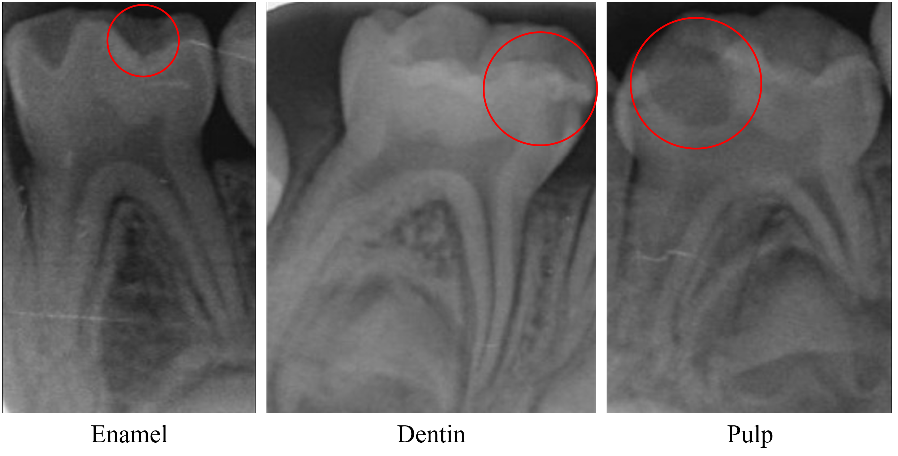
Figure 1. Representative periapical radiographs demonstrating the three caries-depth levels: enamel-level, dentin-level, and pulp-level. The red circles indicate the region of interest for each caries lesion and their depth.

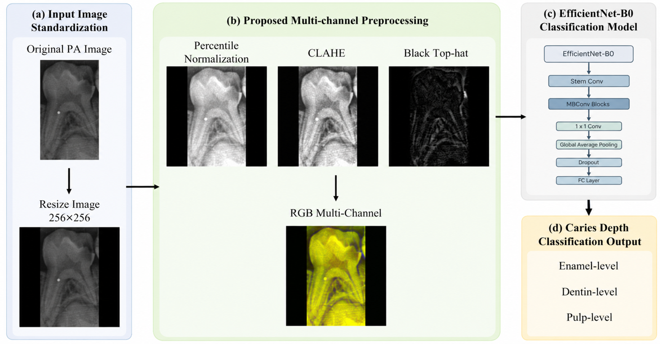
Figure 2. The overall flowchart of the proposed multi-channel image preprocessing and EfficientNet-B0 classification framework for caries-depth classification.
B0, baseline EfficientNet model variant; CLAHE, contrast-limited adaptive histogram equalization; Conv, convolution; FC, fully connected; MBConv, mobile inverted bottleneck convolution; PA, periapical radiograph; RGB, red-green-blue.

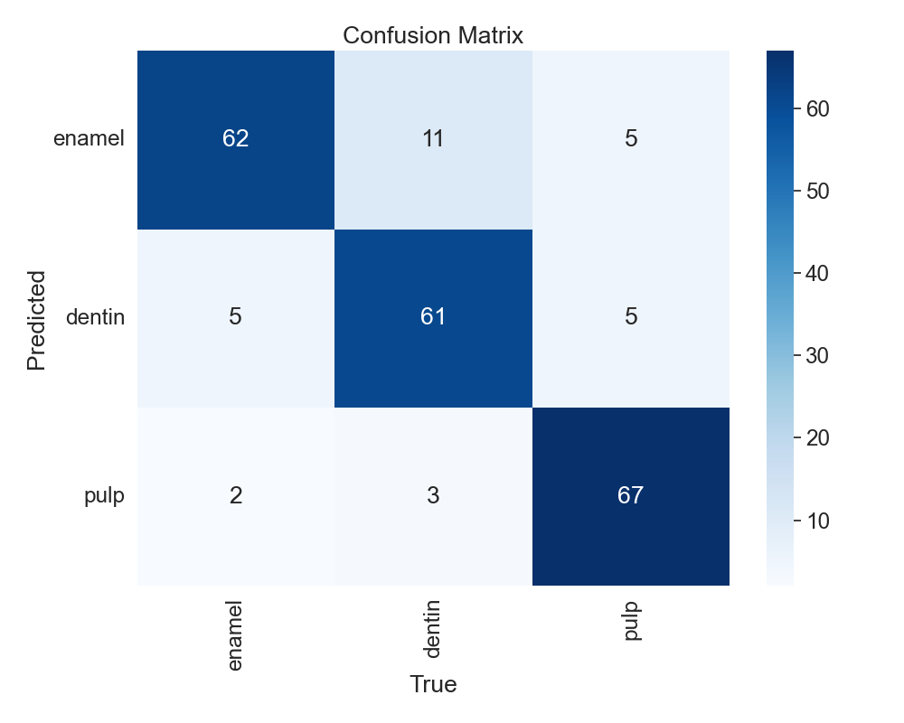
Figure 3. Confusion matrix of the best-performing EfficientNet-B0 model.
B0, baseline EfficientNet model variant.

