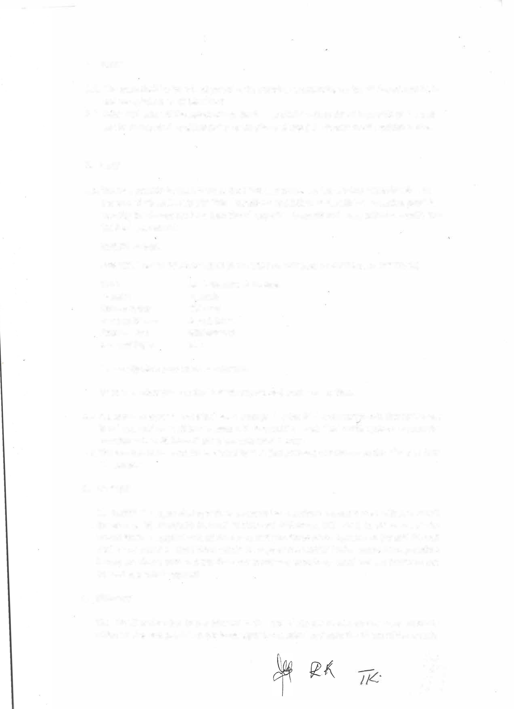

*ij*

**1. Terms**

1.1. The lease shall be for a fixed period of 12 months, commencing on the 1st day of June 2024 and terminating on 31 May 2025.

1.2. After expiration of the above-stated fixed lease shall continue for an indefinite period and can be terminated by either party by the giving of one (1) calendar month written notice.

**2. RENT**

2.1. The rent payable by the LESSEE to the LESSOR in respect of the LEASED PREMISES shall be the sum of N$ 50 000.00 {FIFTY THOUSAND NAMIBIAN DOLLARS) VAT exclusive, payable monthly in advance not later than the 5th day of each month and every calendar month, into the bank account of:

**JOSEPH ISMAEL**

**FOR THE PERIOD OF 12 MONTHS (JUNE 2024 TO MAY 2025 OF EACH RENTAL CONTRACT)**

|  |  |
| --- | --- |
| **Bank:**  **Branch:**  **Branch Code:**  **Account Name: Account No.:**  **Account Type:** | **Bank Windhoek Limited**  **Tsumeb**  **483-073**  **Joseph Ismael**  **8002968973**  **Chk** |

Please stipulate your name as reference

Or at such other place as the LESSOR may appoint from time to time.

2.2. lt is expressly agreed, that if the rentai is not paid by the 5th day of every month this agreement is null and void and will be cancelled with immediate effect. The LESSÈE agrees to vacate the premises within 48 hours if late payments should occur.

2.3. The monthly rentai shall be escalated by 10% {ten percent) per annum on the 1st day of June of each year.

**3.**  **DEPOSIT**   
 The LESSEE shall upon signing of the se presents lease contract deposit in trust with the LESSOR the sum of N$ 50 000.00 {FIFTY THOUSAND NAMIBIAN DOLLARS). ln the event of the LESSEE having complied with all the terms and conditions of the Agreement the said deposit shall be refunded to the LESSEE within 30 days of the LESSEE having vacated the premises hereby let. Please note that this does not in any way constitute rentai and can therefore not be used as a rentai payment.

**4. INTEREST**

The LESSEE undertakes to pay interest at the rate of 2% per month on any arear amounts

which are due and payable as per lease agreement, calculated from the 5th day of the month.

|  |  |
| --- | --- |
| **2** | *;/J* |