# Hands-on Experiment # 11: Worksheet

Section 2 Date 14 November 2019

No more than 3 students per one submission of this worksheet.

Student ID 6238063321 Name Nattawat Pornthisan

Student ID 6238138821 Name Pattanun Sangvijitr

## Part A: A java class “Employee” Class is given below

public class Employee {

private static String company = “Tekkaden Co,Ltd.”;

private String name;

}

What are class variable and instance variable from the above code?

The ***company* variable is the class variable**, whereas the ***name* variable is instance variable**.

Add more code to class “Employee” as follows.

* Add a private attribute “salary” as an integer, and a private attribute “id” as an integer.
* Create a detailed constructor for this class. Do not initialize any static variable.
* Create a no-argument constructor for the “Employee” class that sets default initial values for name, ID, and salary to “no one”, 1, and 15000 respectively.
* Add a public mutator method “setSalary” to set value of this.salary. The method does not return anything. Salary has to be zero or positive number, so if the number to set is negative, change it to zero.
* Add a public accessor method “getSalary” to return value of this.salary.
* Add a public mutator method “setId” to set value of this.id. The method does not return anything. Id has to be zero or positive number, so if the number to set is negative, change it to zero.
* Add other setters/getters so that all variables can be accessed.
* Add “toString()” method to return all attributes of the object.
* Create a copy constructor that makes a clone of an object being passed along as an input argument. (Note: clone values of all attributes including the private ones.)
* Add a “compareTo(Employee anotherEmployee) to compare salary of this employee and another employee. The method will
  + return 1 if the current employee has higher salary than anotherEmployee.
  + return 0 if the current employee and anotherEmployee have equal salary.
  + return -1 if the current employee has lower salary than anotherEmployee.
* Add a “promote(int promotion)” method to increase salary of this employee. The **increment** will be equal to a value of input argument “promotion”.

List all your source code here.

*public class* Employee {  
  
 *private static* String *company* = "Tekkaden Co,Ltd.";  
 *private int* id;  
 *private int* salary;  
 *private* String name;  
  
 *public* Employee() {  
 *this*.id = 1;  
 *this*.salary = 15000;  
 *this*.name = "no one";  
 }  
  
 *public* Employee(*int* id, *int* salary, String name) {  
 *this*.id = id;  
 *this*.salary = salary;  
 *this*.name = name;  
 }  
  
 *public* Employee(Employee employee) {  
 *this*.id = employee.id;  
 *this*.salary = employee.salary;  
 *this*.name = employee.name;  
 }  
  
 *public int* getId() { *return this*.id; }  
 *public void* setId(*int* n) { *this*.id = Math.*max*(n, 0); }  
  
 *public int* getSalary() { *return this*.salary; }  
 *public void* setSalary(*int* n) { *this*.salary = Math.*max*(n, 0); }  
  
 *public* String getName() { *return this*.name; }  
 *public void* setName(String s) { *this*.name = s; }  
  
 *public* String getCompany() { *return* Employee.*company*; }  
 *public void* setCompany(String s) { Employee.*company* = s; }  
  
 *public* String toString() {  
 *return* "(Company: " + getCompany()  
 + ", ID: " + getId()  
 + ", Salary: " + getSalary()  
 + ", Name: " + getName()  
 + ")";  
 }  
  
 *public int* compareTo(Employee employee) {  
 *if* (*this*.salary == employee.salary) *return* 0;  
 *return this*.salary > employee.salary ? 1 : -1;  
 }  
  
 *public void* promote(*int* promotion) {  
 *this*.salary += promotion;  
 }  
  
}

## Part B: Use the “Employee” class as instructed below

Create a “MyCompany” class and implement a main method as follows.

* Create an “employee1” of type Employee using no-argument constructor.
* Create an “employee2” of type Employee using detailed constructor, and pass along arguments to set initial values of name, ID, and salary to “Mika”, 2, and 30,000 respectively.
* Print employee1 and employee2 on the screen. (based on toString() method).
* For the object “employee1”, set values of name, ID, and salary to “Orga”, 1, and 70,000 respectively.
* Use compareTo() to compare salary of employee1 and employee2 and then print on the screen which one has higher salary (or no one?).
* Create an “employee3” as a clone of employee2 (Hint: Using a copy constructor)
* Promote employee3 by increase the salary by 40,000 baht.
* Use compareTo() to compare salary of employee1 and employee3 and then print on the screen which one has higher salary (or no one?).
* Print all employees on the screen. (based on toString() method).

List all your source code here.

*public class* MyCompany {  
  
 *public static void* main(String[] args) {  
 Employee employee1 = *new* Employee();  
 Employee employee2 = *new* Employee(2, 30000, "Mika");  
  
 System.*out*.println(employee1.toString());  
 System.*out*.println(employee2.toString());  
  
 employee1.setId(1);  
 employee1.setName("Orga");  
 employee1.setSalary(70000);  
  
 *if* (employee1.compareTo(employee2) == -1) System.*out*.print("Employee2");  
 *else if* (employee1.compareTo(employee2) == 0) System.*out*.print("No one");  
 *else* System.*out*.print("Employee1");  
 System.*out*.println(" has more salary.");  
  
 Employee employee3 = *new* Employee(employee2);  
 employee3.promote(40000);  
  
 *if* (employee1.compareTo(employee3) == -1) System.*out*.print("Employee3");  
 *else if* (employee1.compareTo(employee3) == 0) System.*out*.print("No one");  
 *else* System.*out*.print("Employee1");  
 System.*out*.println(" has more salary.");  
  
 System.*out*.println(employee1.toString());  
 System.*out*.println(employee2.toString());  
 System.*out*.println(employee3.toString());  
 }  
  
}

Paste your screenshot here.

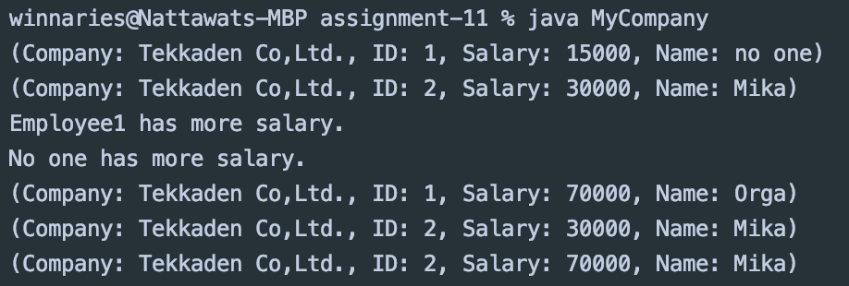

Submit this worksheet (by only one member of the group) via <http://www.myCourseVille.com> (Assignments > Hands-on Experiment # 11) **within the day after your lecture**.