

Algorithm and Data Structure

Country Management System

Comprehensive CLI Application for Country Data Management
Burak Osman, Gökalp, Ceren
1712127, 1712400, 1712247
Instituto Politécnico da Guarda
Computer Engineering Students

TABLE OF CONTENTS
Algorithms and Data Structures 1
Country Management System 1
TABLE OF CONTENTS 1
1. AUTHENTICATION SYSTEM 1
1.1 Super User Creation 1
1.2 Login System 1
2. COUNTRY MANAGEMENT (CRUD) 1
2.1 List Countries (Option 1) 1
2.2 Add New Country (Option 2) - Super User Only 1
2.3 Edit Country (Option 3) - Super User Only 1
2.4 Delete Country (Option 4) - Super User Only 1
3. CITY MANAGEMENT (OPTION C) 1
3.1 List Cities 1
3.2 Add City 1
3.3 Edit City 1
3.4 Delete City 1
4. FILTERING (OPTION 5) 1
5. SEARCH (OPTION 6) 1
6. PDF EXPORT (OPTION 7) 1
7. IMPORT (OPTION 8 - SUPER USER ONLY) 1
8. STATISTICS (OPTION 9) 1
9. COLORFUL TERMINAL UI 1
10. FILE STRUCTURE 1
11. SECURITY FEATURES 1

1. AUTHENTICATION SYSTEM

1.1 Super User Creation
On first run, the application prompts for a super user password. The password must be at least 4 characters long and requires confirmation by entering it twice. Encryption is performed using SHA256 algorithm with a random salt, and the hashed password is securely stored in the users.json file.
Technical Details:
- Minimum 4 characters password requirement
- Password confirmation mechanism
- SHA256 + 32-character random salt for secure hashing
- Encrypted storage in users.json file
Screenshot: First Time Setup
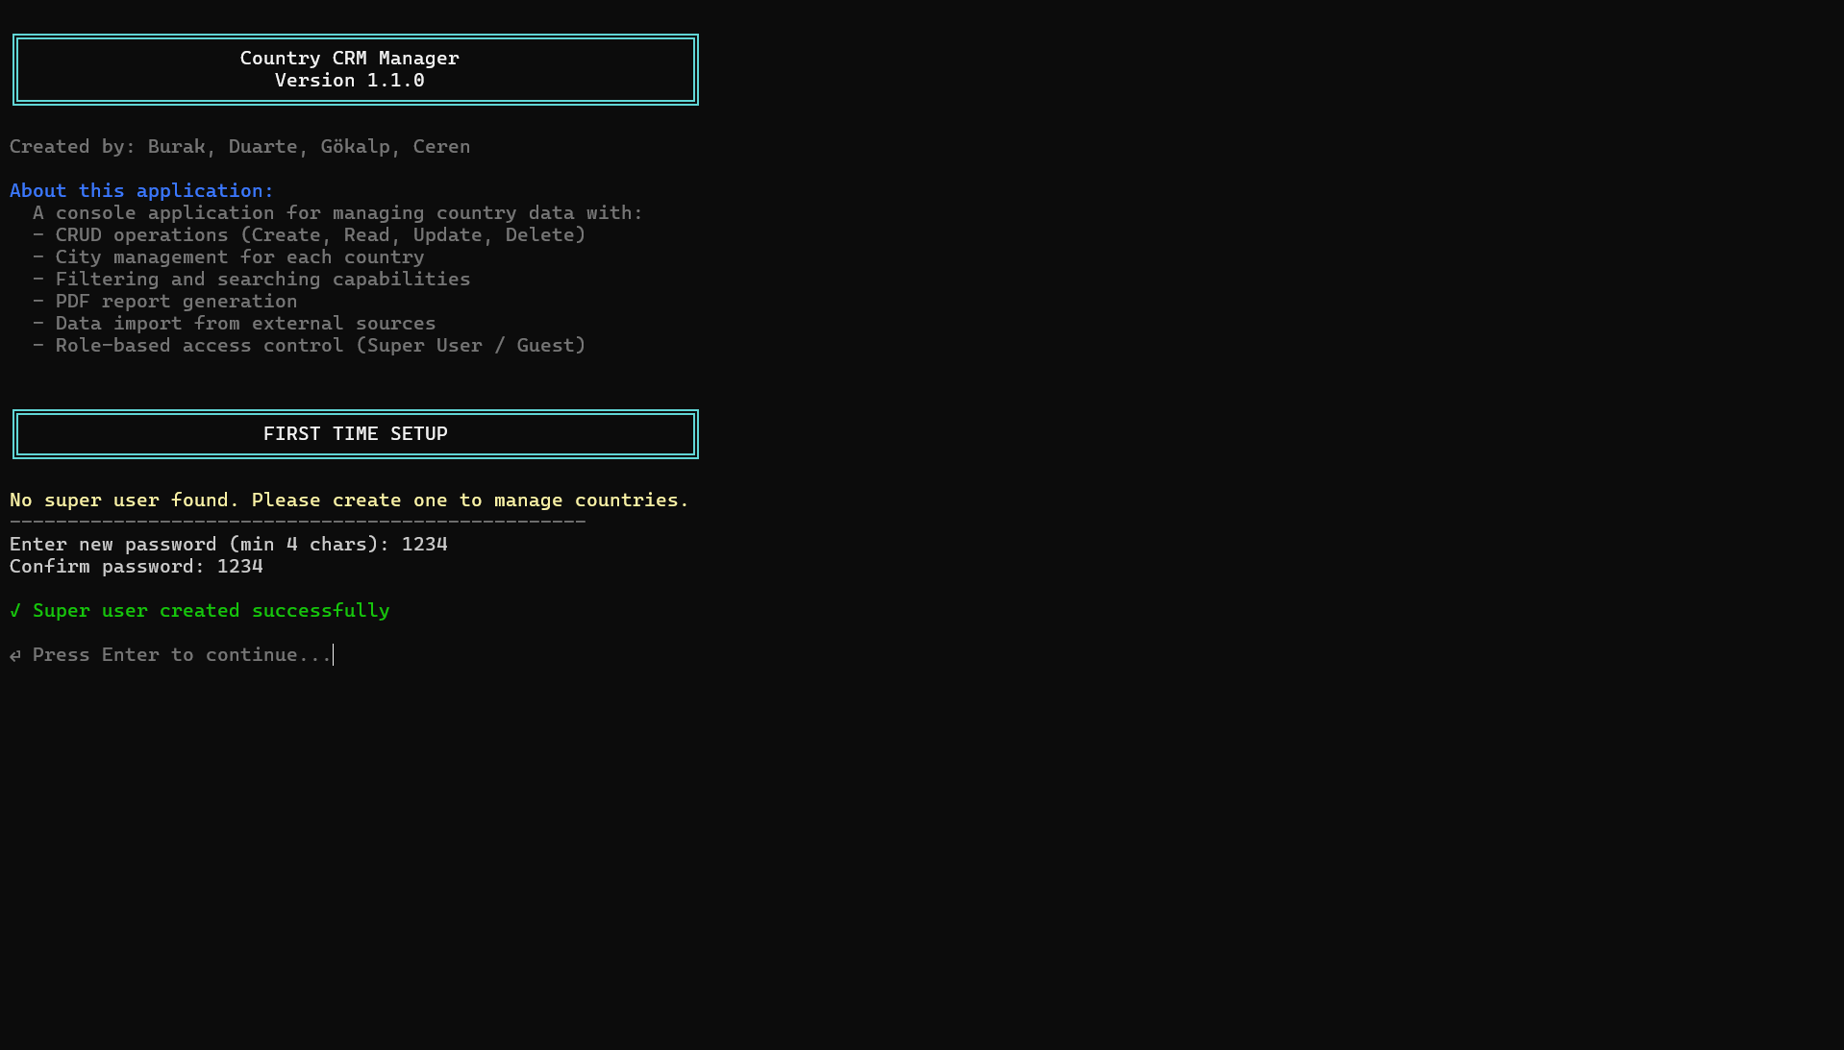
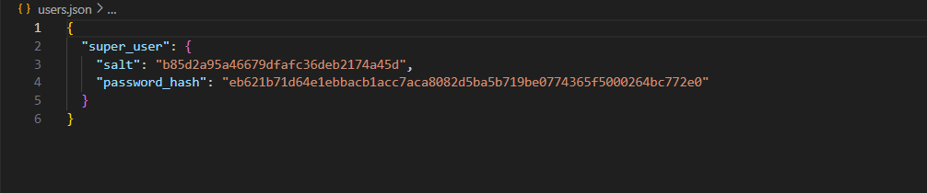

1.2 Login System
The system supports two different user roles. Super User has full access rights (CRUD + import + city management), while Guest users can only perform read operations (listing, filtering, searching, PDF export). In case of incorrect password entry, the user is given the opportunity to retry.
User Roles:
- Super User: Full access (CRUD + import + city management)
- Guest: Read-only access (listing, filtering, searching, PDF export)
Screenshot: Login Screen
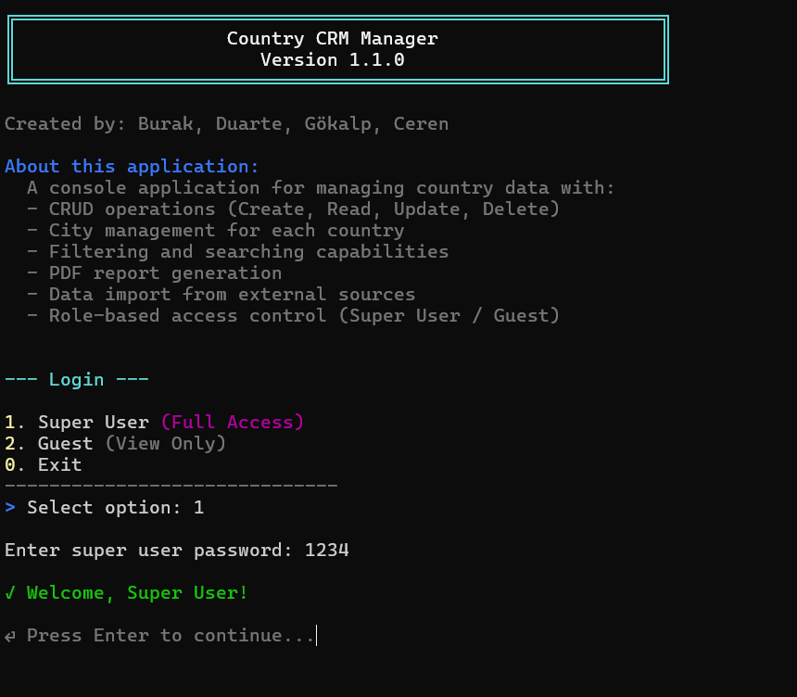

2. COUNTRY MANAGEMENT (CRUD)

2.1 List Countries (Option 1)
All countries are displayed in a professional table format. The table includes ISO Code, ISO3 Code, Country Name, Currency, and Phone information. Users can sort countries by ISO Code or Country Name. With the detailed view option, all fields including cities can be listed.
Features:
- Professional table format view
- Sorting options: ISO Code / Country Name
- Detailed view: All fields including cities
- Displayed fields: ISO, ISO3, Country Name, Currency, Phone
Screenshot: Country List View
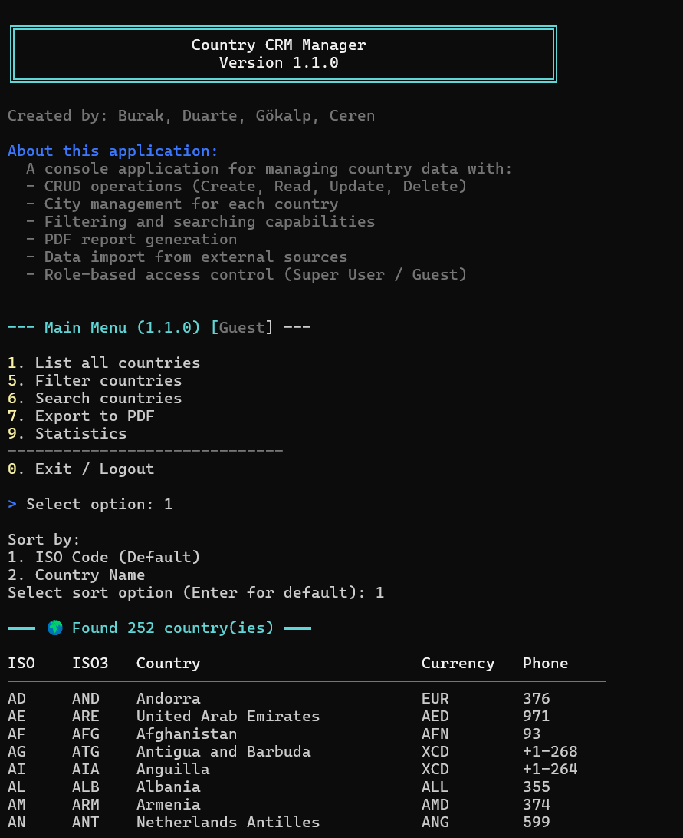

2.2 Add New Country (Option 2) - Super User Only
All fields are requested in form format with real-time validation. ISO code must be 2 characters and unique. ISO3 code must be 3 characters and unique. Country Name must also be unique. Each field is checked instantly as it is entered, and the addition is completed after a confirmation prompt.
Real-time Validation Rules:
- ISO Code: 2 characters, must be unique
- ISO3 Code: 3 characters, must be unique
- Country Name: Must be unique
- Instant validation as each field is entered
- Record saved after confirmation prompt
Screenshot: Add Country with Real-time Validation
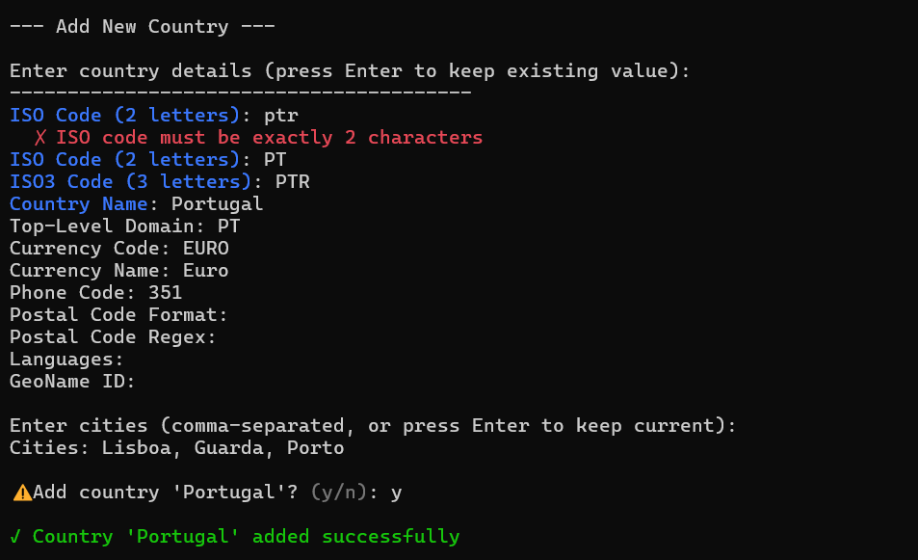

2.3 Edit Country (Option 3) - Super User Only
The country is selected by ISO code and current values are displayed. The current value can be preserved by pressing Enter. Real-time uniqueness checking is performed, but the country being edited is excluded from this check.
Process Steps:
- Country selection by ISO code
- Display of current values
- Press Enter to keep current value
- Real-time uniqueness validation
Screenshot: Edit Country
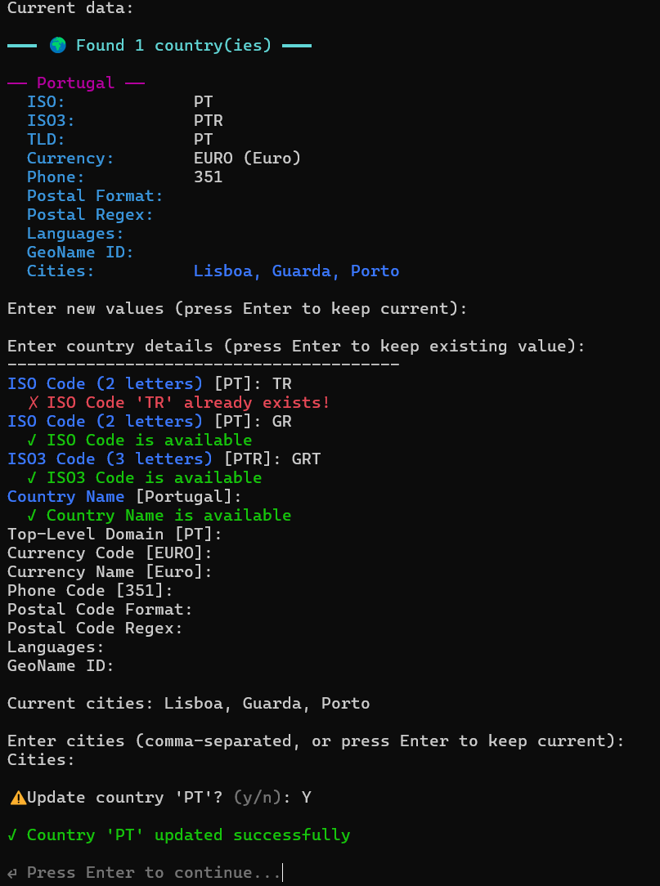

2.4 Delete Country (Option 4) - Super User Only
The country is selected by ISO code. All information about the country to be deleted is displayed to the user, and the deletion is performed after confirmation. This operation is irreversible.
Screenshot: Delete Country Confirmation
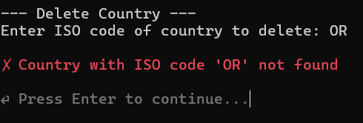
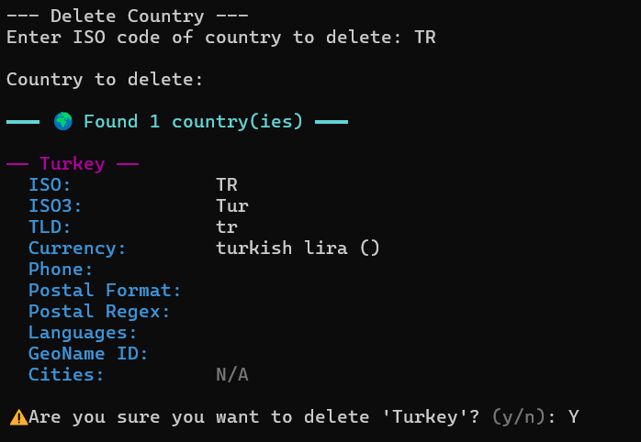

3. CITY MANAGEMENT (OPTION C)

3.1 List Cities
The country is selected by ISO code, and all cities of that country are displayed in a numbered list format. This format allows referencing by number when performing operations on cities.
Screenshot: City List
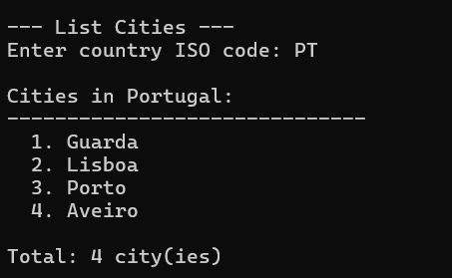

3.2 Add City
The country is selected by ISO code, the new city name is entered, and duplicate checking is performed within the same country. This prevents two cities with the same name in the same country.
Screenshot: Add City
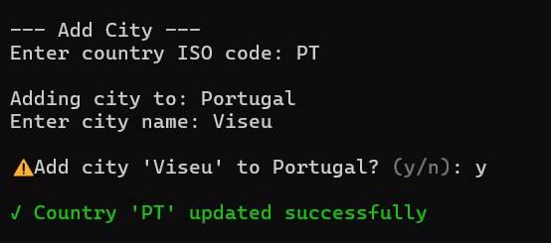

3.3 Edit City
The country is selected by ISO code, the city is selected by number, a new name is entered, and duplicate checking is performed. The city being edited is excluded from this check.
Screenshot: Edit City
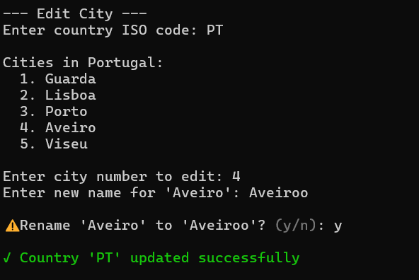

3.4 Delete City
The country is selected by ISO code, the city is selected by number, and after confirmation, the city is permanently deleted. This operation is irreversible.
Screenshot: Delete City Confirmation
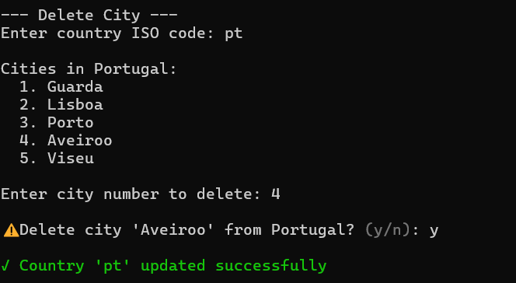

4. FILTERING (OPTION 5)
The filtering feature allows users to search in various fields and get case-insensitive results.
Filterable Fields:
- ISO Code
- ISO3 Code
- Country Name
- Top-Level Domain
- Currency Code
- Currency Name
- Phone Code
- Languages
- Cities
Screenshot: Filter Results
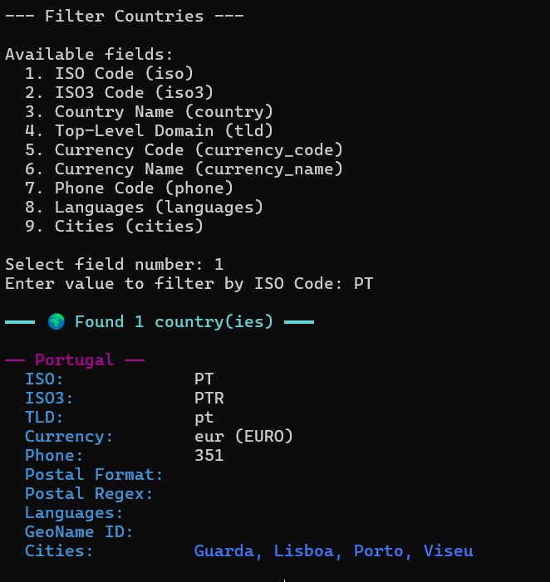

5. SEARCH (OPTION 6)
The search function performs global search across all fields. If the entered keyword appears in any field, results are returned. The search is performed case-insensitively.
Search Features:
- Global search across all fields
- Case-insensitive search
- Partial match support
Screenshot: Search Results
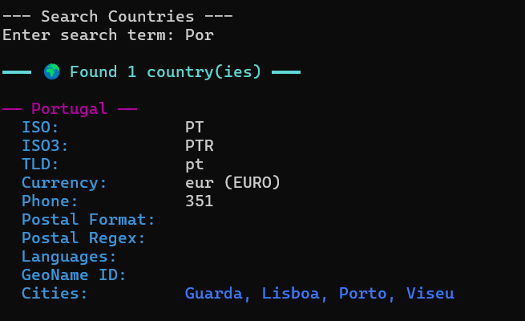

6. PDF EXPORT (OPTION 7)
The PDF Export feature allows all country data to be converted into a professional PDF report.
PDF Contents:
Page 1: Cover Page
- Logo (if logo.png exists)
- Application name (APP_NAME)
- Version information
- Date/time
- Creators list
Page 2: Executive Summary
- Application description
- Total number of countries
- Data description
Page 3+: Data Table
- ISO, ISO3, Country, Currency, Phone, TLD, Languages, Cities
- Automatic page breaks at page end
- Table header repetition on each page
Screenshot: PDF Report Sample
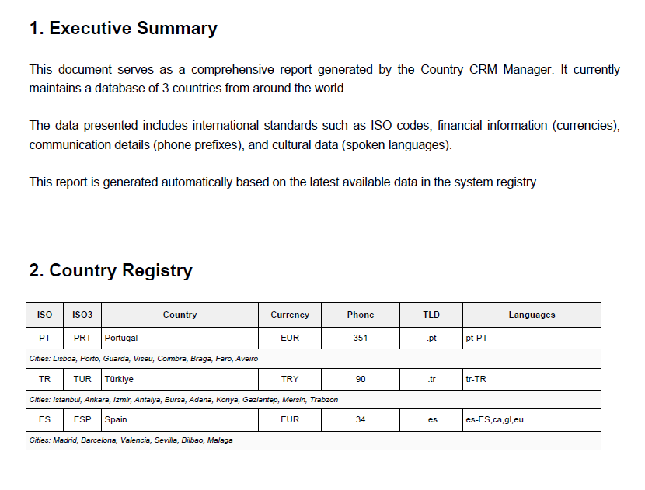

7. IMPORT (OPTION 8 - SUPER USER ONLY)
The import feature allows bulk data loading from the countryInfo.txt file. The file must be in tab-separated format and column mapping is done with CSV_MAPPING.
Import Features:
- Reading from countryInfo.txt file
- Tab-separated format support
- Column mapping with CSV_MAPPING
- Adding to existing data
- Super User access only
Screenshot: Import Process
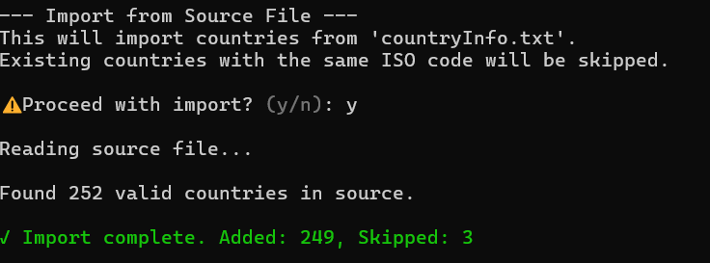
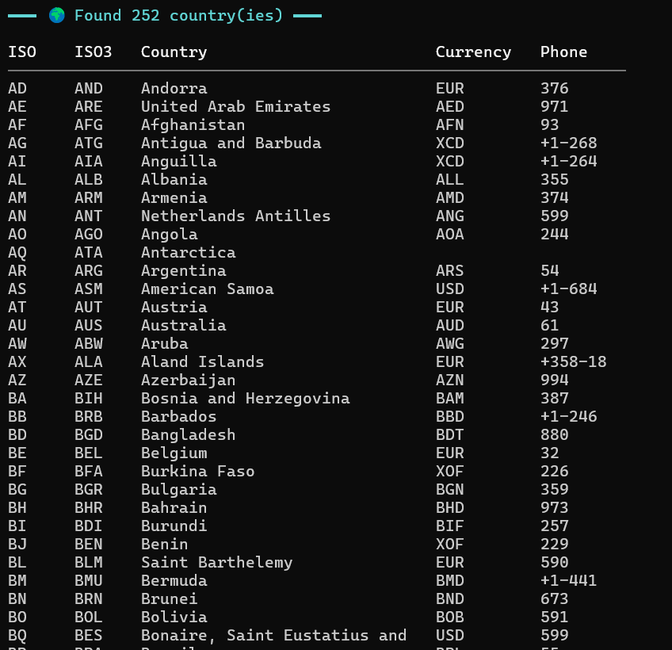

8. STATISTICS (OPTION 9)
The statistics module provides detailed analytical information about the dataset.
Statistics Types:
- Total number of countries
- Currency distributions
- Language statistics
- Regional analyses
Screenshot: Statistics Dashboard
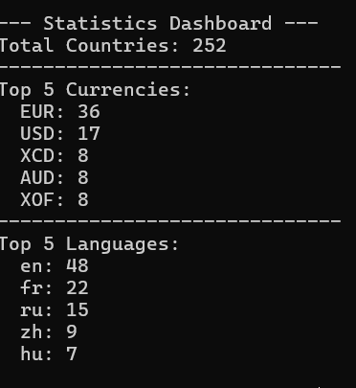

9. COLORFUL TERMINAL UI
The application provides a colorful and interactive terminal interface to enhance user experience.
Color Usage:
- Cyan: Headers, field labels
- Green: Success messages (✓)
- Red: Error messages (✗)
- Yellow: Warnings, menu numbers
- Magenta: Highlights (Super User role)
- Gray (dim): Secondary information
Visual Elements:
- Box borders (╔═══╗)
- Separator lines (───)
- Colorful input prompts
Screenshot: Terminal UI - Application Start
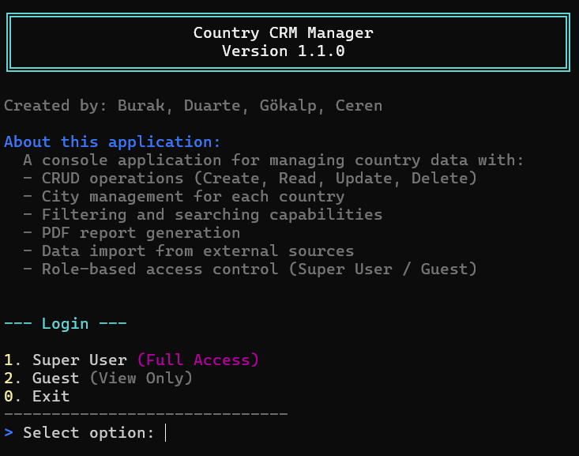
Screenshot: Super User Main Menu
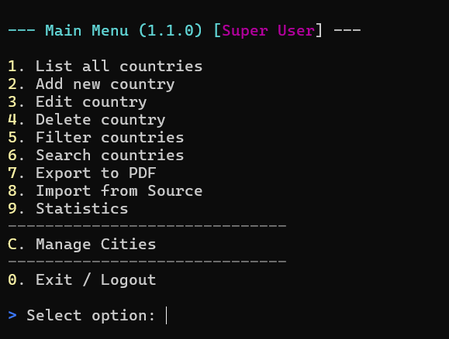
Screenshot: Guest Main Menu
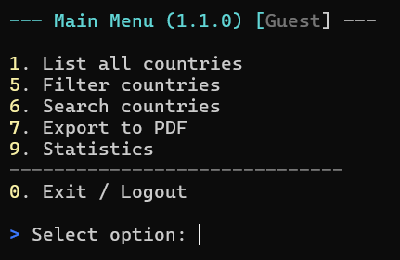
Screenshot: Success Message Example
Screenshot: Error Message Example


10. FILE STRUCTURE
The application has a modular file structure, and each module assumes a specific responsibility.
File/Folder | Description
main.py | Main application entry point
dados.json | Country data (including cities)
users.json | Encrypted super user information
country_types.py | Type definitions and validation
countryInfo.txt | Import source file
logo.png | Logo for PDF reports
components/ | Module folder
constants.py | APP_NAME, CREATORS, APP_INTRO
colors.py | ANSI color codes
menu_component.py | All UI functions
data_handler.py | CRUD operations
filter_component.py | Filtering functions
pdf_component.py | PDF generation
importer_component.py | Import functionality
analytics_component.py | Statistics and analytics
handlers/ | Handler modules
auth_handlers.py | Login and setup handlers
country_handlers.py | Country CRUD handlers
city_handlers.py | City CRUD handlers

11. SECURITY FEATURES
The application has various security layers and protects user data.
Security Mechanisms:
- Password Hashing: SHA256 + 32-character random salt
- Role-based Access Control: Super User vs Guest
- Real-time Validation: Duplicate checking in every field
- Input Sanitization: Strip and case handling
- JSON Validation: Data integrity checks
- Secure File Storage: Protected configuration files

