

Algorithms and Data Structures

Customer Relationship Management (CRM) System

Team Work
Fikret Gökalp ÇAKMAKÇI - 1712400
Ceren BULUT - 1712247

Course
Algorithms and Data Structures

Teacher
Paulo Jorge Costa Nunes

INDEX

- Introduction and Project Requirements…………..
  - Project Context and Overview………………...
  - Problem Statement and Scope…………………
  - Functional Requirements……………………...
  - Non-Functional Requirements………………...

- Data Storage and Validation………………………

- System Architecture and Design…………………..
  - Architectural Design: The Repository Pattern...

- Entities……………………………………………..
  - Country Entity…………………………………
  - Lead Source Entity…………………………….

- Functionalities and Program Execution………….
  - Country Management………………………….
    - List All Countries…………………………
    - Insert Country…………………………….
    - Update Country…………………………...
    - Delete Country……………………………
    - Search Country……………………………
    - Generate Country…………………………

  - Lead Source Management……………………..
    - List Lead Sources…………………………
    - Insert Lead Source………………………
    - Update Lead Source………………………
    - Delete Lead Source……………………….
    - Generate Lead Source PDF Report……….

- Data Structures…………………………………….
  - Lists……………………………………………
  - Dictionaries……………………………………
  - JSON Files…………………………………….

- Algorithms………………………………………….
  - Search Algorithms……………………………..
  - Menu-Based Algorithms………………………
  - Validation Algorithms…………………………

- Conclusion
  - Work Done…………………………………….
  - Features to Be Added………………………….
  - Learned From the Project……………………...

- References………………………………………….

1. Introduction and Project Requirements

1.1 Project Context and Overview

Customer Relationship Management (CRM) systems are essential tools for modern organizations, enabling them to manage interactions with current and potential customers efficiently. In a globalized market, managing structured data such as country profiles and lead sources is critical for accurate reporting and marketing analysis.

In this project, a command-line based CRM system was developed using the Python programming language. unlike simple scripts, this application simulates a real-world software architecture. The primary goal is to apply the algorithms and data structures concepts learned during the course—specifically lists, dictionaries, linear search algorithms, and file handling—to build a robust tool for data management.

1.2 Problem Statement and Scope

The main objective of this work is to solve the problem of persistent data management without using a full-scale database server (like SQL). Instead, the system relies on JSON (JavaScript Object Notation) for data persistence, requiring the implementation of custom algorithms to read, write, and manipulate this data efficiently.
The scope of the project focuses on two key modules:
- Country Management: Storing and verifying standardized geographic data.
- Lead Source Management: Tracking the origins of potential business opportunities.

1.3 Functional Requirements

To ensure the system meets the user's needs, specific functional requirements were defined. The system supports full CRUD (Create, Read, Update, Delete) capabilities. The following tables detail the required operations and the rules applied to them.

Table 1: Country Management Requirements

Feature | Description | Validation Rules
Add Country | Allows the user to register a new country in the system | - ISO Code must be unique (2 chars).  - ISO3 Code must be unique (3 chars).  - Fields cannot be empty
List Countries | Displays a paginated list of all countries stored in the JSON file. | If list > 20, show “…” for readability.
Search Country | Finds a specific country using its Name or ISO code. | - Case-insensitive search.  - Linear search algorithm.
Update Country | Modifies details (Capital, currency) of an existing country. | - Validates that the country exists before updating.  - Preserves old data if input is skipped.
Delete Country | Removes a country record permamently. | - Required explicit user confirmation (“YES”).

Table 2: Lead Source Management Requirements

Feature | Description | Validation Rules
Add Lead Source | Registers a new marketing channel (e.g., "Web", "Referral"). | • Name cannot be empty.  • ID is auto-incremented.
Update Lead Source | Edits the name of an existing lead source. | • Checks if ID exists.  • Prevents empty names.
Delete Lead Source | Removes a lead source from the system. | • Requires ID verification and user confirmation.
Generate Report | Exports the current list of entities to an external PDF file. | • Must handle file permission errors gracefully.

1.4 Non-Functional Requirements
In addition to the features above, the system was designed with the following technical constraints:
- Persistence: All data must be saved in countries.json and lead_sources.json immediately after any modification.
- Usability: The interface must be a menu-driven Command Line Interface (CLI) that is easy to navigate.
- Performance: The system should handle data loading and searching with minimal delay using efficient list iterations.
- Environment: Developed to run on Python 3.x, utilizing only standard libraries (except for PDF generation).

2. Data Storage and Validation
All data used in the CRM system is stored in JSON (JavaScript Object Notation) files. JSON was chosen because it is a lightweight, human-readable, and language-independent data format that integrates naturally with Python. This approach allows data to be stored persistently and reloaded each time the program is executed.
Each entity in the system is represented as a dictionary and stored inside a list within the JSON file. This structure makes it possible to easily read, write, and manipulate data using Python’s built-in libraries.
During data entry, several validation mechanisms are applied to ensure data correctness and consistency. These validations prevent invalid or incomplete data from being stored in the system. Examples of validation rules include:
- Preventing empty input fields
- Ensuring unique identifiers (ISO codes or numeric IDs)
- Checking data types (string, integer)
- Ensuring required fields are provided
If invalid data is entered, the system displays an error message and requests the user to re-enter the information. This validation process ensures that the data stored in JSON files remains reliable and usable.

3. System Architecture and Design

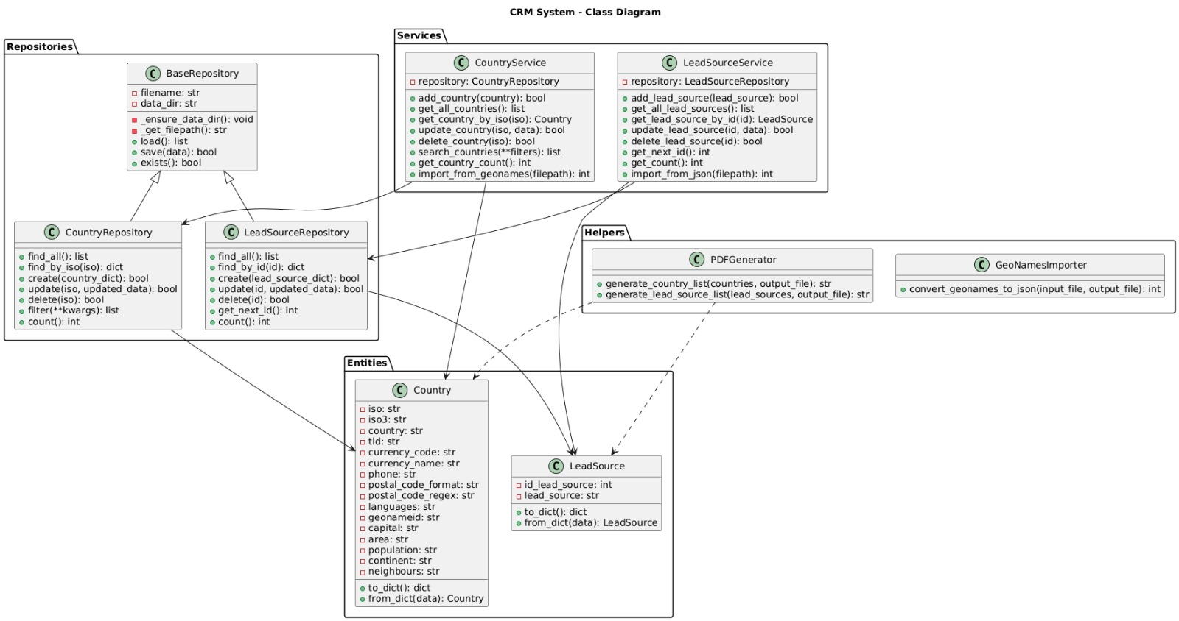

3.1 Architectural Design: The Repository Pattern
To keep the code organized and maintainable, this project implements the Repository Pattern. This design pattern was chosen to separate the logic of the application (Services) from the data access layer (Repositories).

- Repositories: These classes (e.g., CountryRepository, LeadSourceRepository) are solely responsible for interacting with the JSON files. They handle the low-level operations such as reading the file, parsing the JSON data, and saving updates back to the disk. They do not contain business logic.
- Services: The service classes (e.g., CountryService) act as a bridge between the user interface and the repositories. They contain the business rules of the application, such as checking if a country code already exists before adding it or validating that a name is not empty.
By using this structure, the code becomes easier to test and modify. For example, if we decided to switch from JSON files to a SQL database in the future, we would only need to update the Repository layer, leaving the rest of the application unchanged.

4. Entities
The CRM system is composed of two main entities: Country and Lead Source. Each entity is designed with a specific purpose and set of attributes.

4.1 Country Entity
The Country entity is used to store geographic and economic information related to countries. Each country record includes attributes such as:
- ISO code
- ISO3 code
- Country name
- Capital city
- Currency code and currency name
- Phone code
- Top-level domain (TLD)
These attributes are essential for representing standardized country information in CRM systems. Countries are uniquely identified using their ISO codes, which allows efficient searching, updating, and deletion operations.

4.2 Lead Source Entity
The Lead Source entity represents the origin from which potential customers are acquired. Each lead source includes:
- A numeric identifier
- A lead source name
Lead sources are commonly used in CRM systems to analyze marketing performance and customer acquisition channels. Managing lead sources allows the system to simulate real CRM scenarios used in sales and marketing departments.

5. Functionalities and Program Execution
The CRM system uses a menu-based algorithm to allow users to navigate through different functionalities. The main menu provides access to Country Management and Lead Source Management modules. Each module contains its own sub-menu with specific operations.
The system supports CRUD operations (Create, Read, Update, Delete) for both entities, as well as search and report generation features.

5.1 Country Management

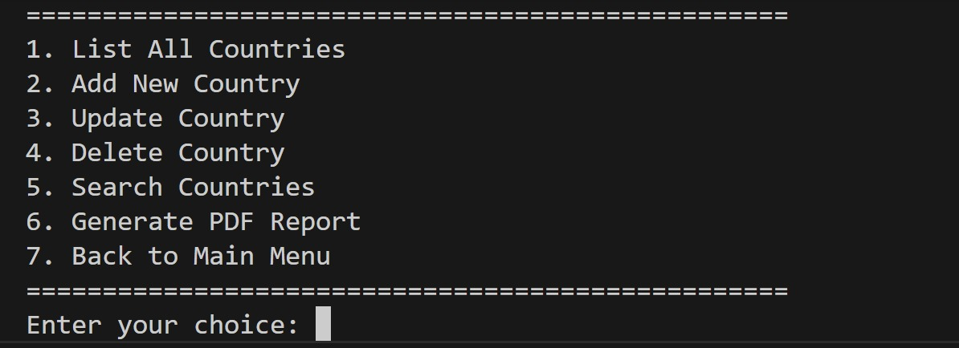

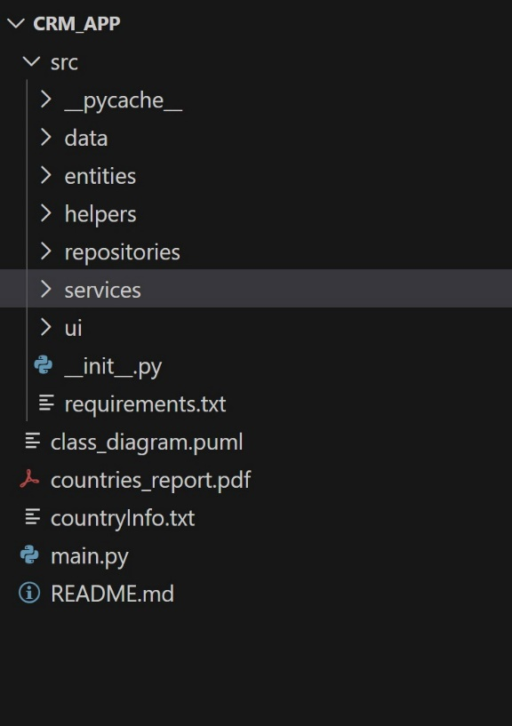

5.1.1 List All Countries
This functionality lists all country records stored in the system. The program retrieves country data from the JSON file and displays it in a structured format. If the number of records is large, only a subset is displayed to maintain readability. This operation allows users to quickly review existing data.



5.1.2 Insert Country
This functionality allows the user to add a new country to the system. The user is prompted to enter all required attributes, including ISO codes, country name, capital city, and currency information. Before the data is stored, validation checks are applied to ensure correctness.
If all validations pass, the new country record is added to the JSON file. If validation fails, the system displays an error message and prevents incorrect data from being stored.
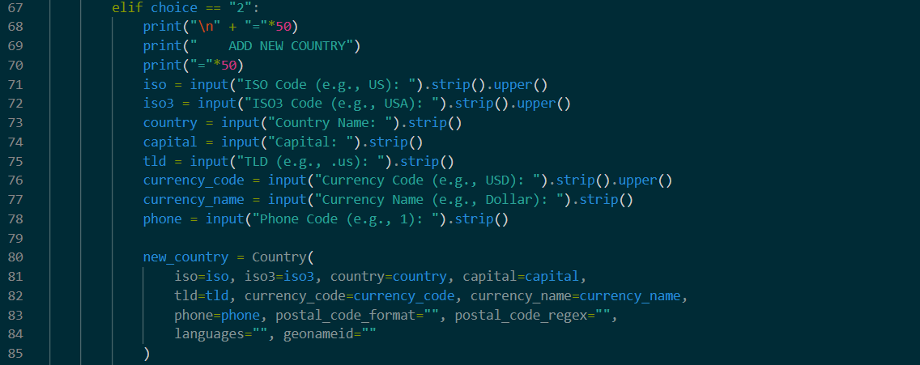

5.1.3 Update Country
The update functionality allows the user to modify an existing country record. The country is identified using its ISO code. If the specified ISO code does not exist in the system, the user is informed accordingly.
Only the fields entered by the user are updated, while unchanged fields retain their previous values. This approach ensures flexibility and prevents unnecessary data modification.
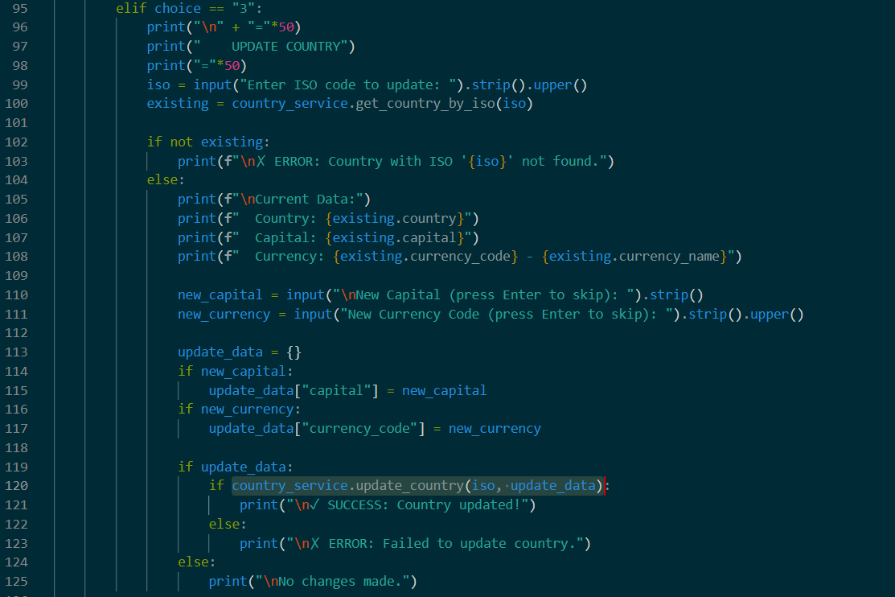

5.1.4 Delete Country
This functionality allows the user to delete a country record from the system. Before deletion, the system displays the selected country’s information and requests confirmation from the user. This confirmation step prevents accidental data loss.
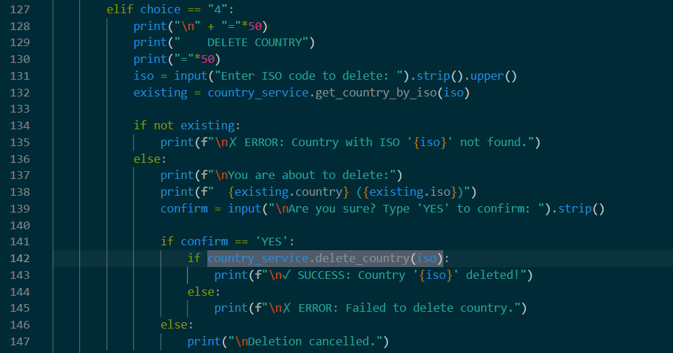

5.1.5 Search Country
The search functionality allows users to find countries by name or ISO code. A linear search algorithm is used to iterate through the list of countries and match the search criteria. If matching records are found, they are displayed to the user.
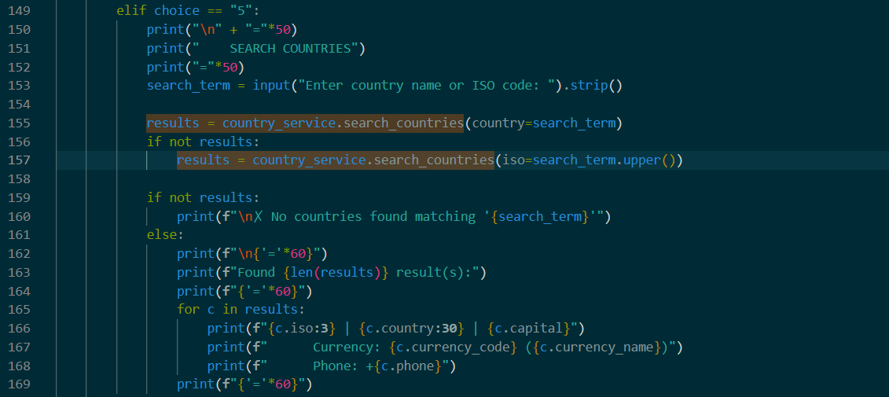

5.1.6 Generate Country PDF Report
The system allows users to generate a PDF report containing all country records. This report provides a structured and printable overview of the stored data and can be used for documentation or analysis purposes.
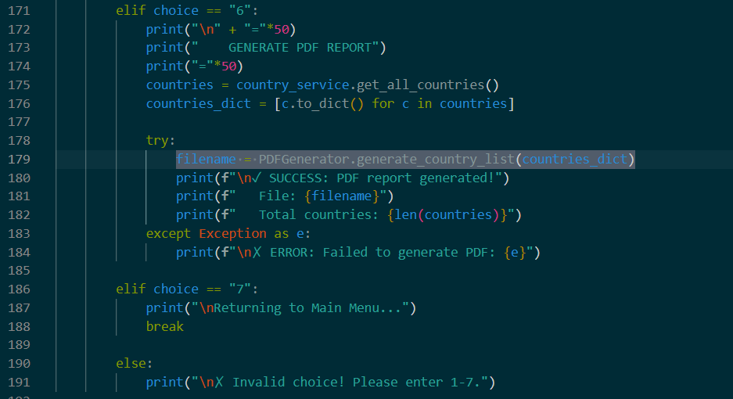

5.2 Lead Source Management

5.2.1 List Lead Sources
This functionality displays all lead sources stored in the system. Each lead source is displayed with its identifier and name.
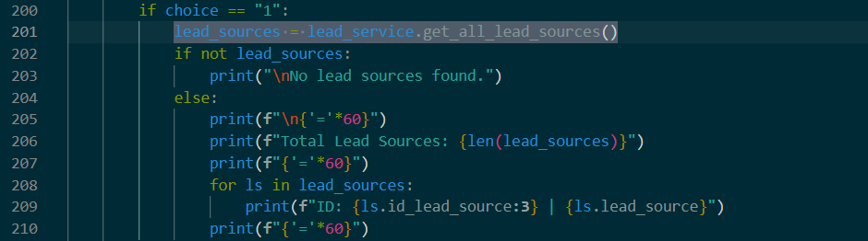

5.2.2 Insert Lead Source
Users can add new lead sources by entering a lead source name. The system automatically assigns a unique numeric identifier. Validation ensures that the lead source name is not empty.
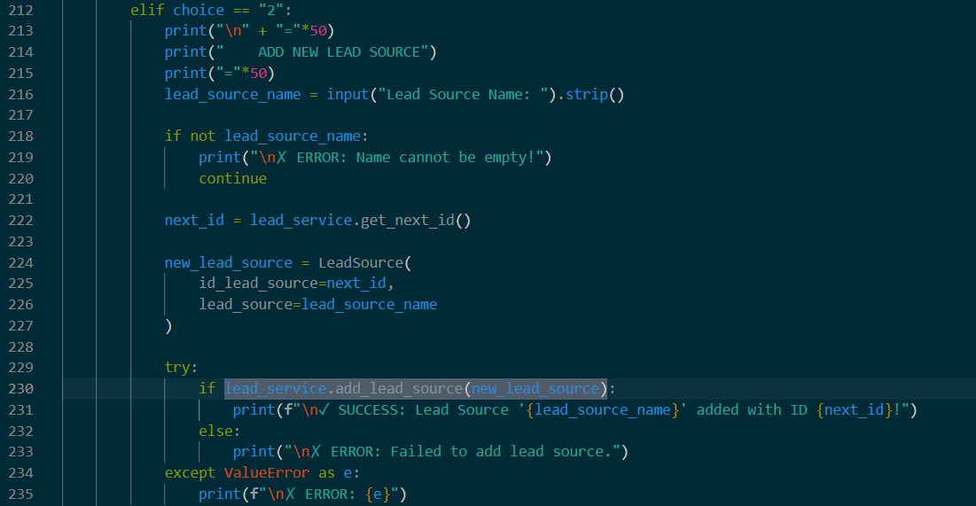

5.2.3 Update Lead Source
This functionality allows users to update the name of an existing lead source using its identifier. If the identifier does not exist, the system informs the user.
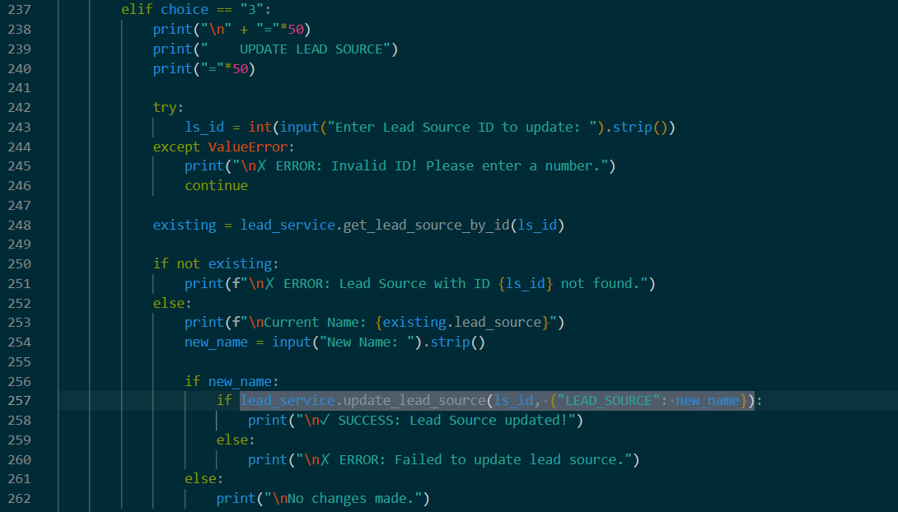

5.2.4 Delete Lead Source
Users can delete lead sources from the system after confirming their action. This prevents accidental deletion of data.
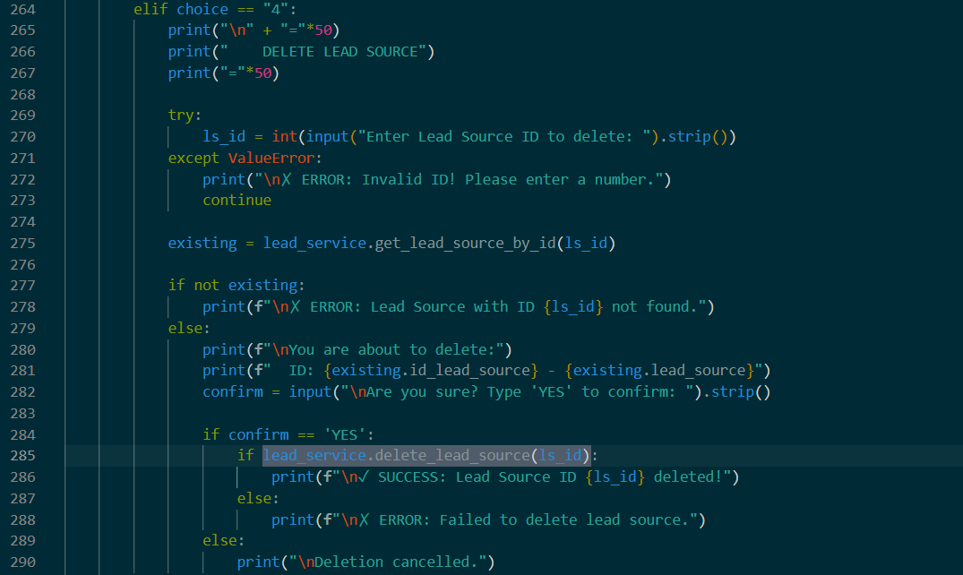

5.2.5 Generate Lead Source PDF Report
A PDF report containing all lead sources can be generated. This feature supports external analysis and documentation.
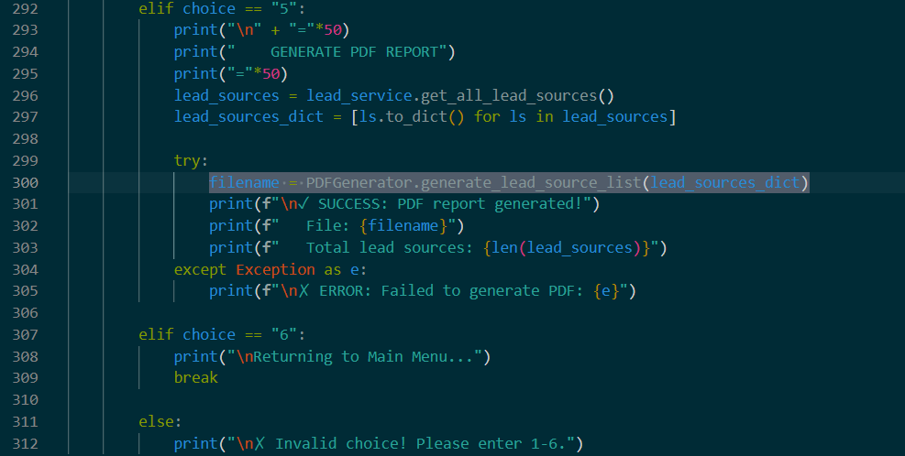

6. Data Structures
Several data structures were used in this project to store and manage data efficiently.

6.1 Lists
Lists are used to store collections of countries and lead sources. Lists allow dynamic resizing and sequential access, making them suitable for CRUD operations.
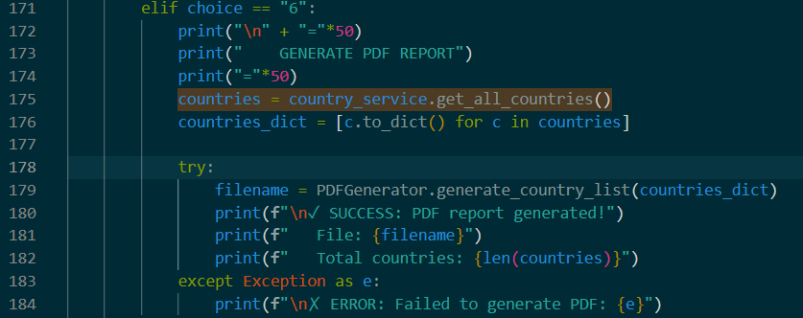

6.2 Dictionaries
Dictionaries are used to represent individual entities as key-value pairs. This structure allows fast access to attributes and improves code readability.
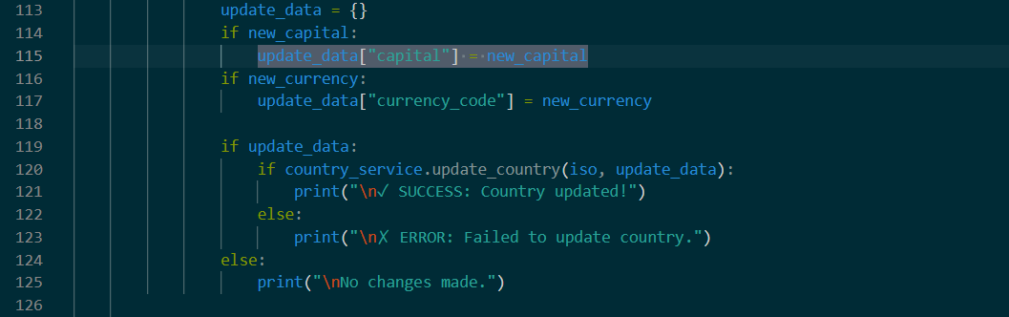

6.3 JSON Files
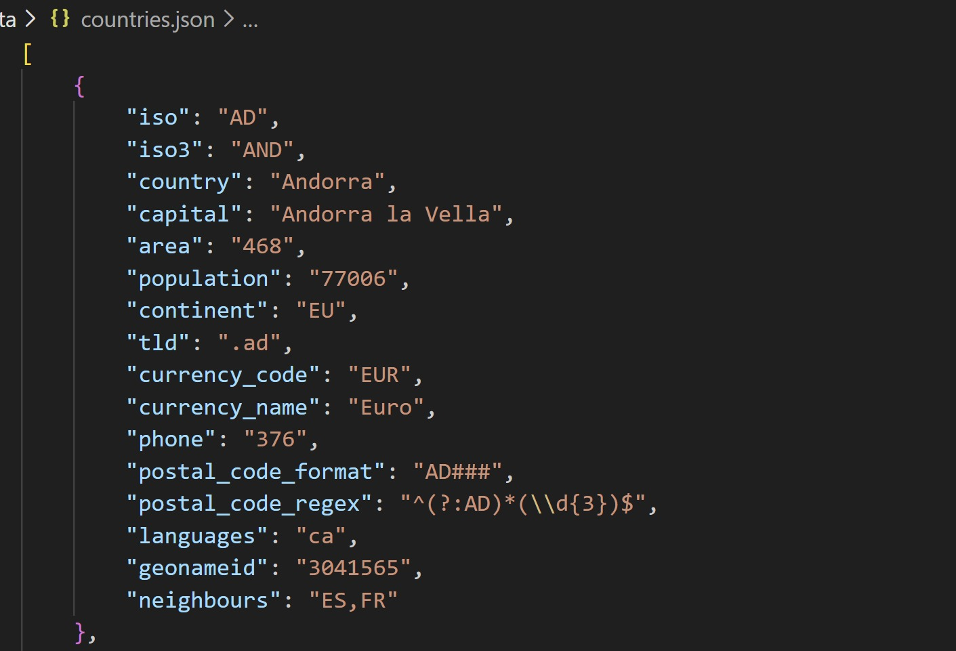
JSON files are used for persistent data storage. They store lists of dictionaries representing the entities managed by the application.
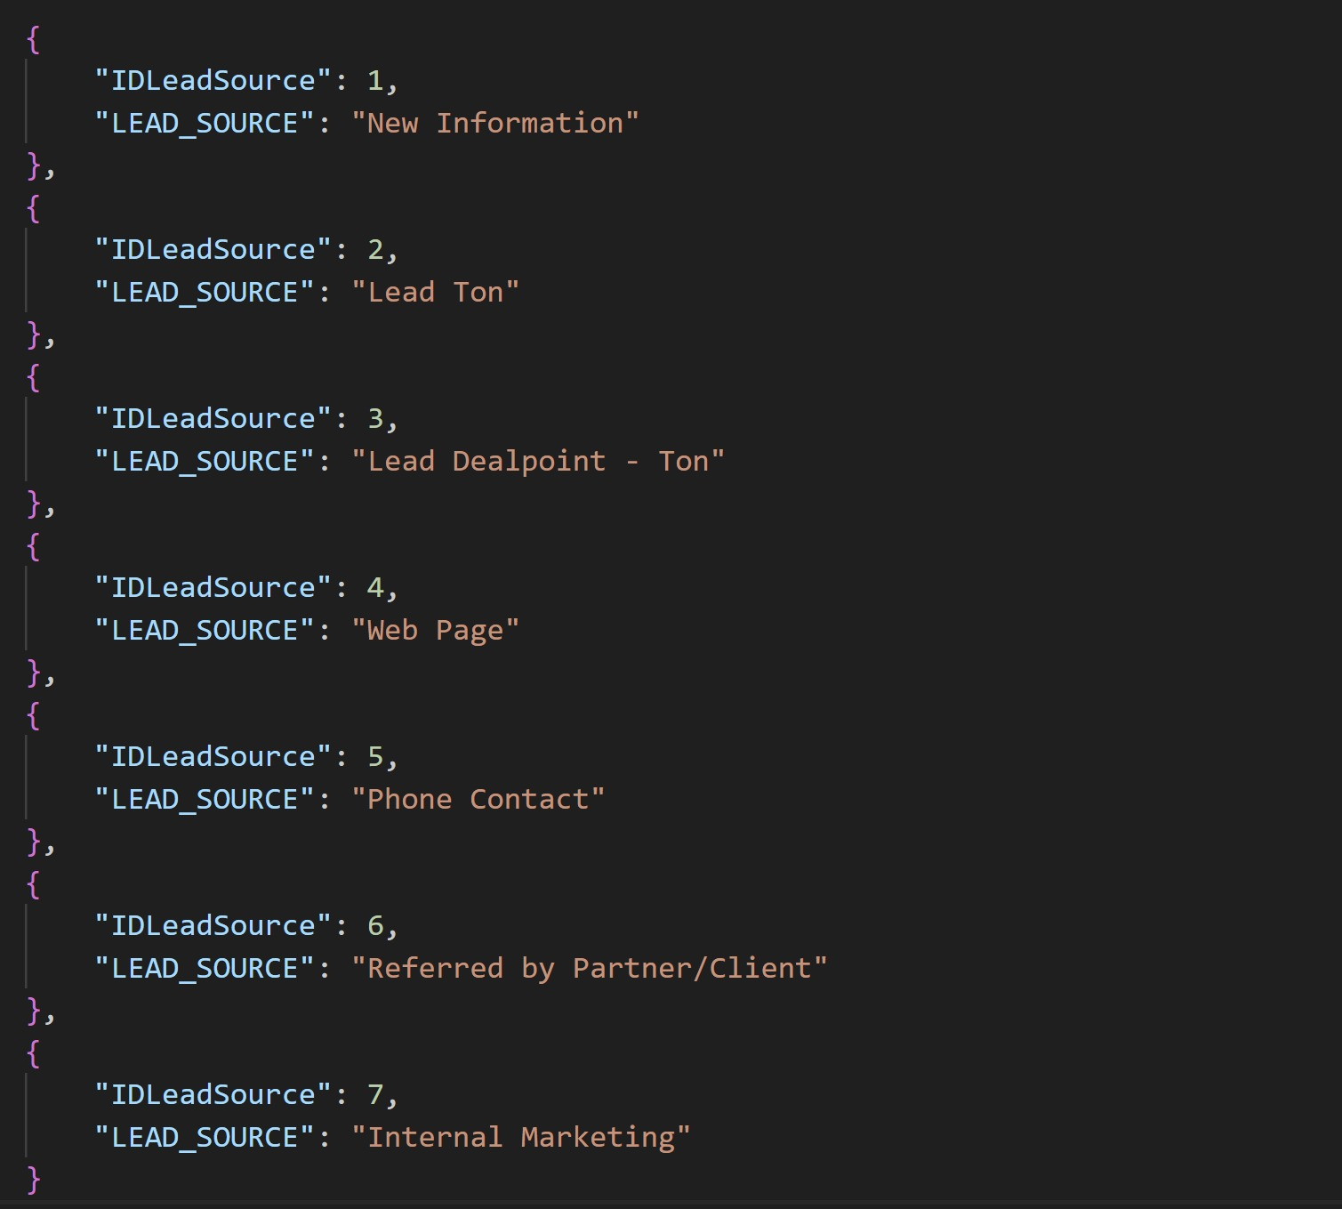

7. Algorithms

7.1 Search Algorithms
The system uses linear search algorithms to locate records based on user input. Linear search is suitable for the dataset size used in the project and is simple to implement.
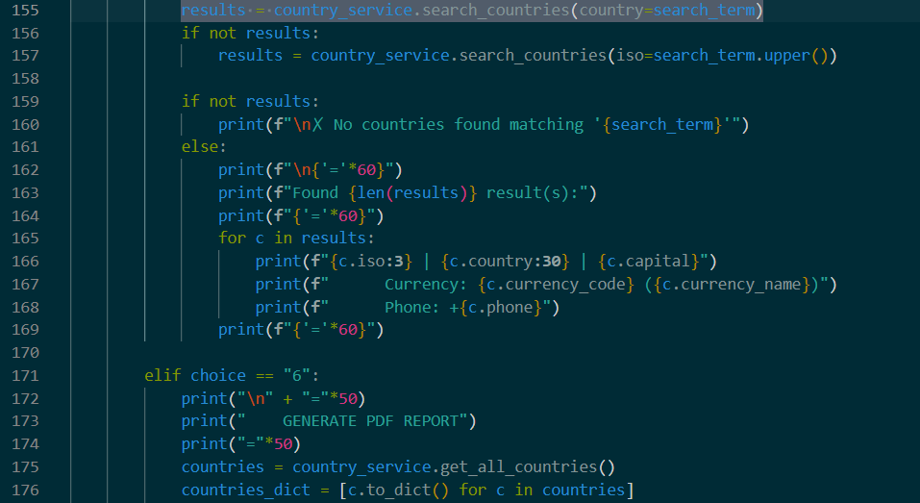

7.2 Menu-Based Algorithms
Menu-based algorithms are used to control program flow. Conditional statements and loops allow users to navigate between menus and execute selected operations.


7.3 Validation Algorithms
Validation algorithms ensure that user input conforms to expected formats and constraints. These algorithms prevent invalid data from being stored in the system.
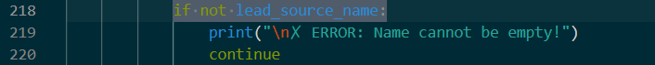

8. Conclusion

8.1 Work Done
In this project, a functional CRM system was successfully developed. CRUD operations, search functionality, data validation, and report generation were implemented using appropriate data structures and algorithms.

8.2 Features to Be Added
Future improvements may include:
- Graphical User Interface (GUI)
- Database integration
- User authentication

8.3 Learned From the Project
Through this project, we gained practical experience in applying algorithms and data structures, working with JSON files, and developing structured Python applications.

9. References

- Python Software Foundation. (2024)(?). Python 3.x Documentation.
- JSON (JavaScript Object Notation).json.org.
- PlantUML
- Course Material – Algorithms and Data Structures

