Name: Yun Winner

Class: M2(ITE)

1.Create a complete copy of the Invoices table​

* 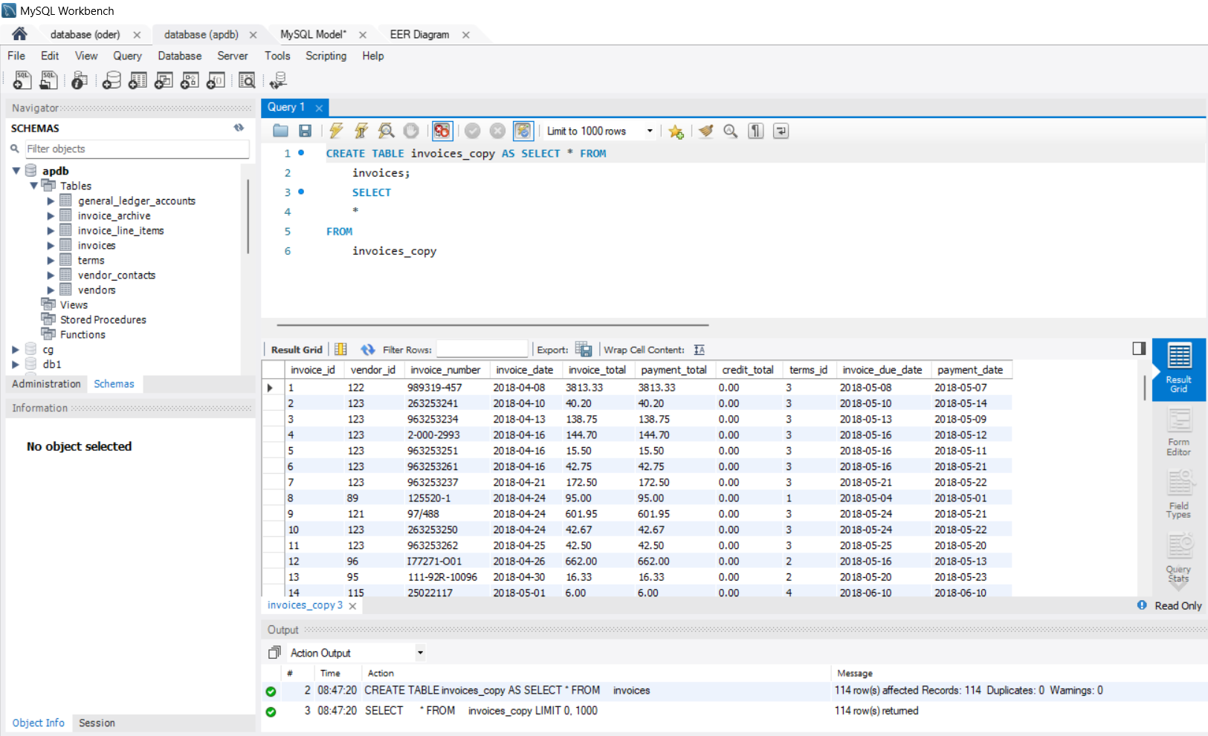

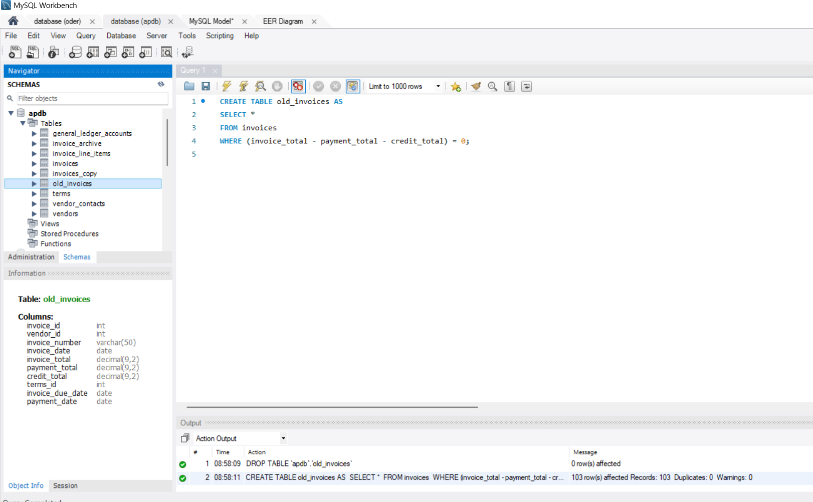2.Create a partial copy of the Invoices table​

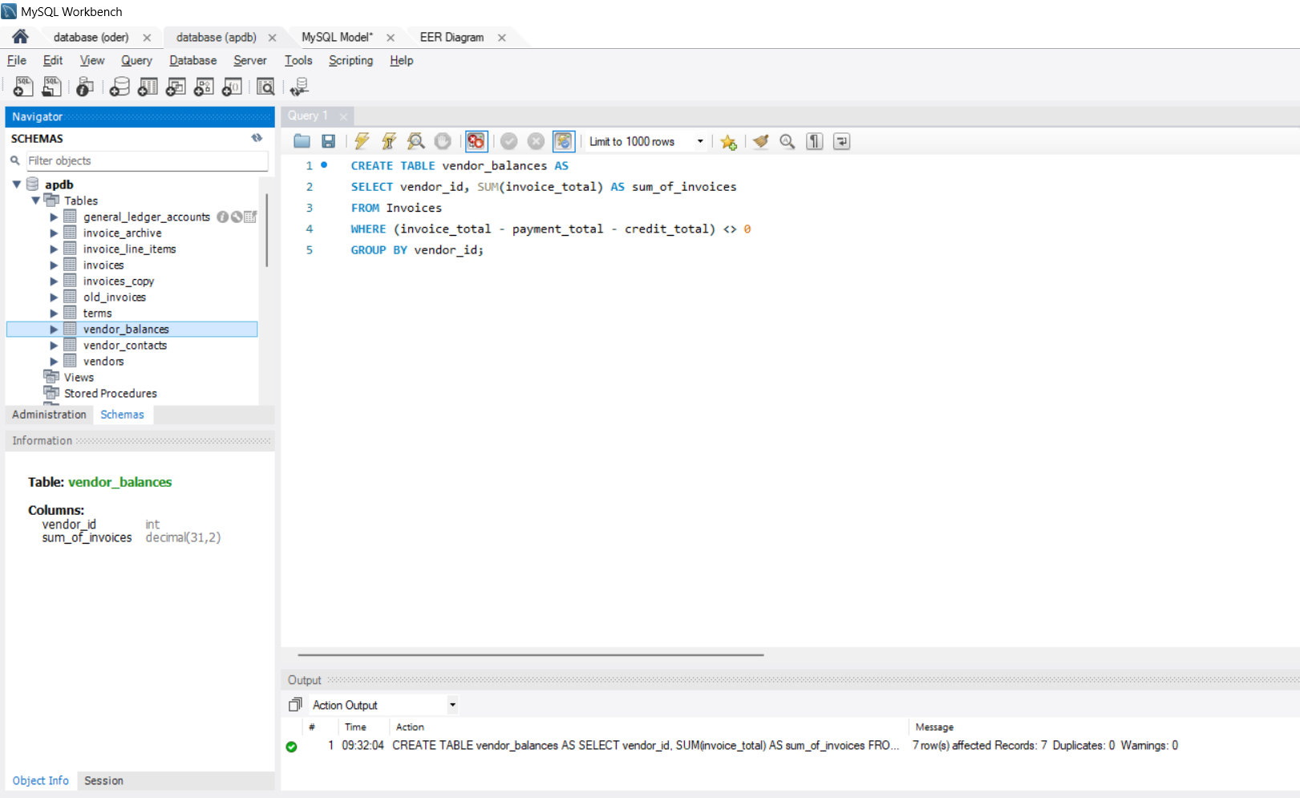3. Create a table with summary rows from the Invoices table

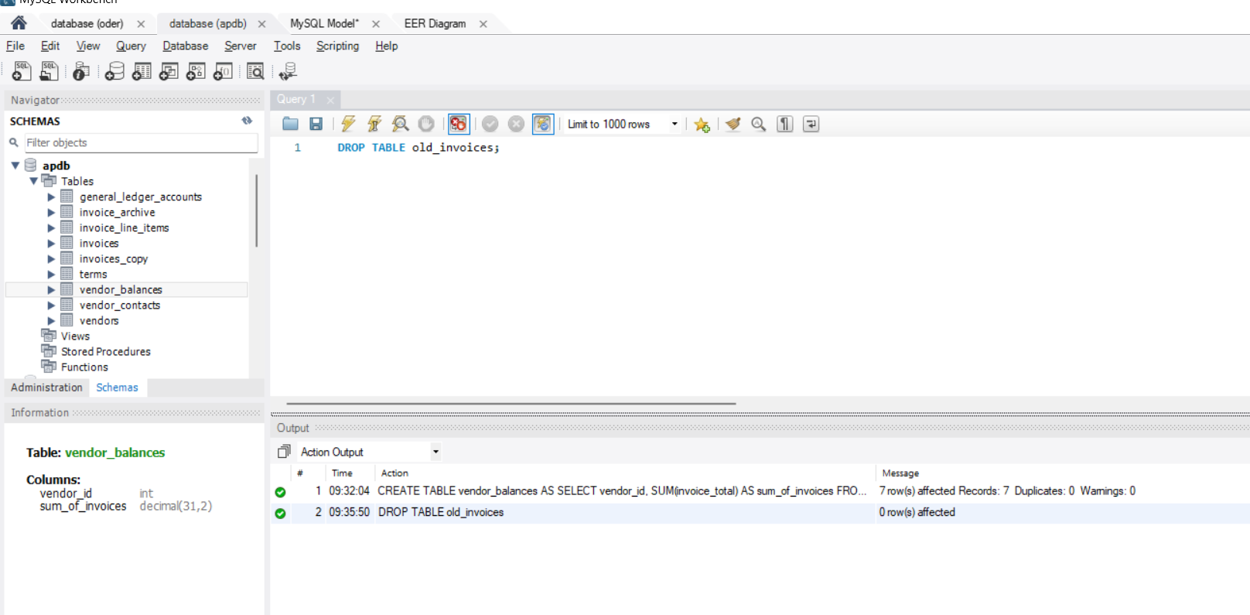4. Delete Table

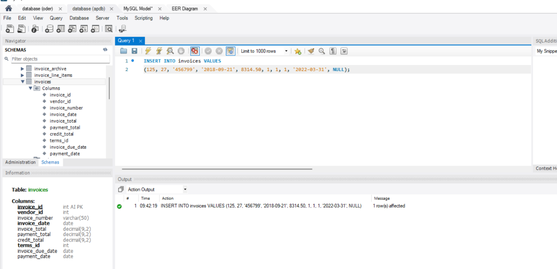5. Insert a single row without using a column list

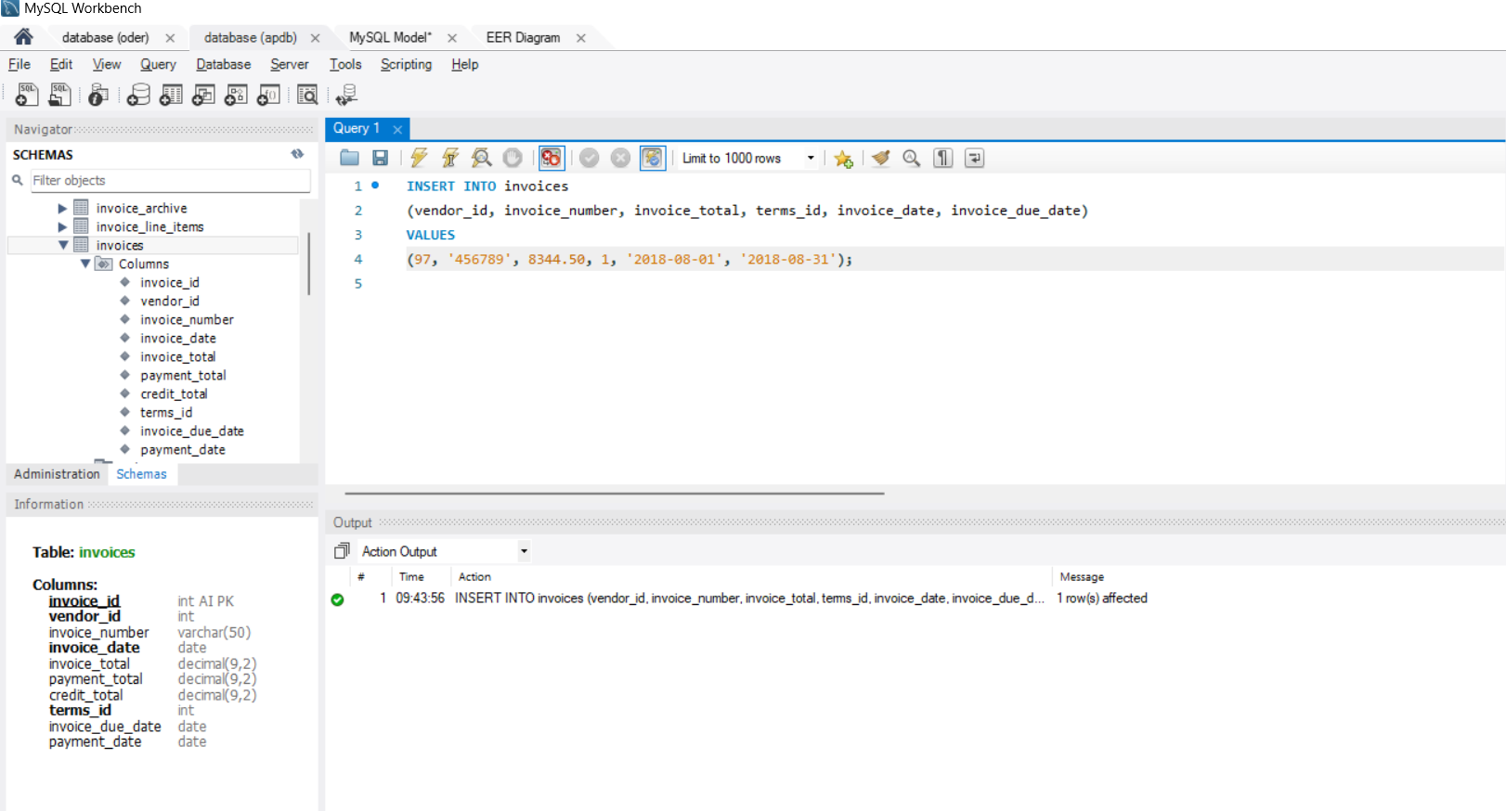6. Insert a single row using a column list

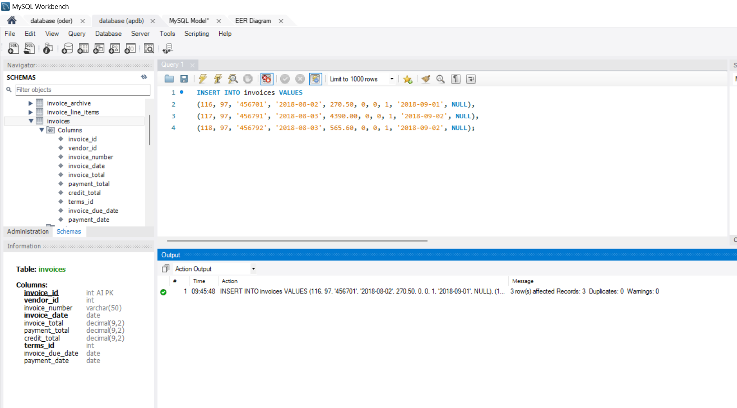7. Insert multiple rows

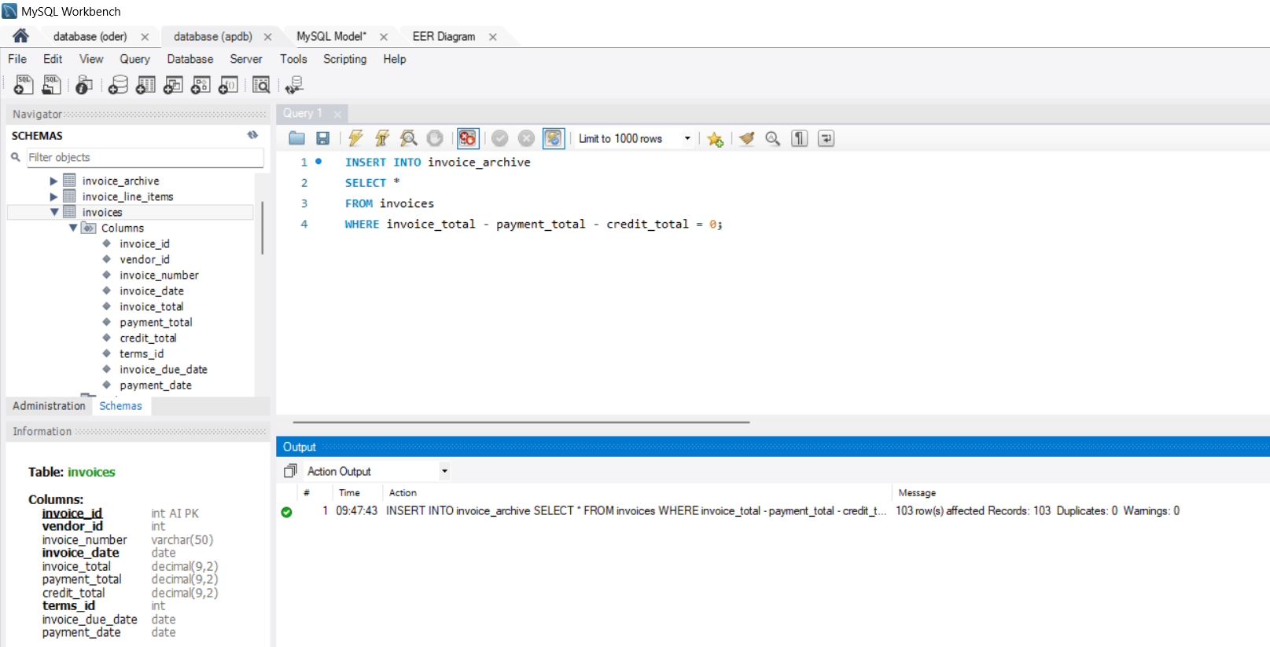8.Insert paid invoices into the Invoice_Archive table

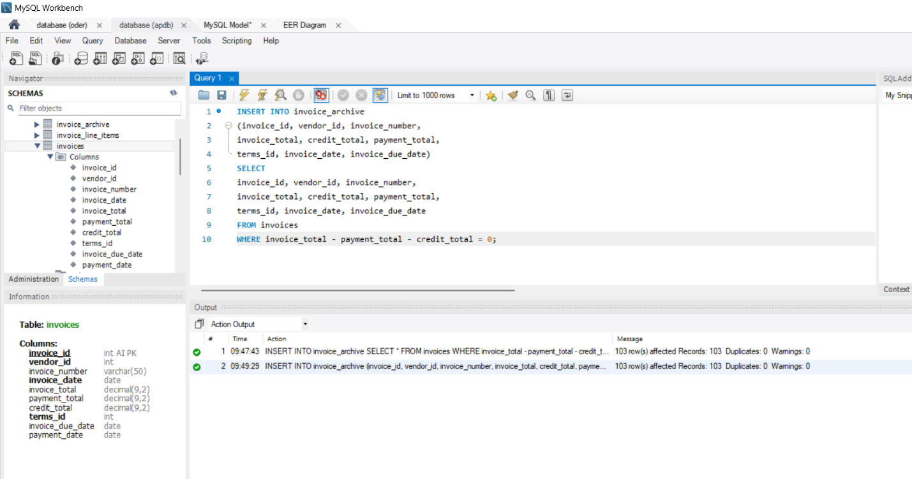9. The same statement with a column list

10. Update two columns for a single row

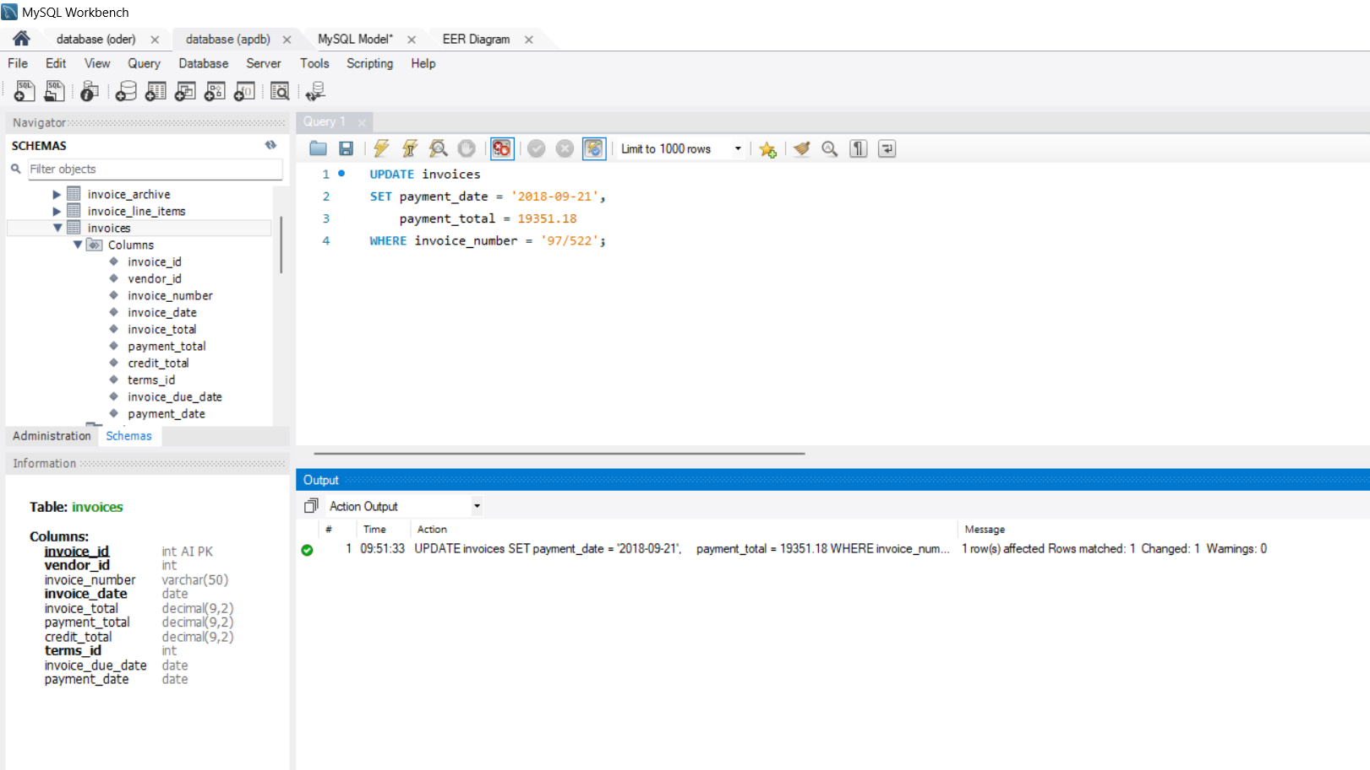

11. Update one column for one row

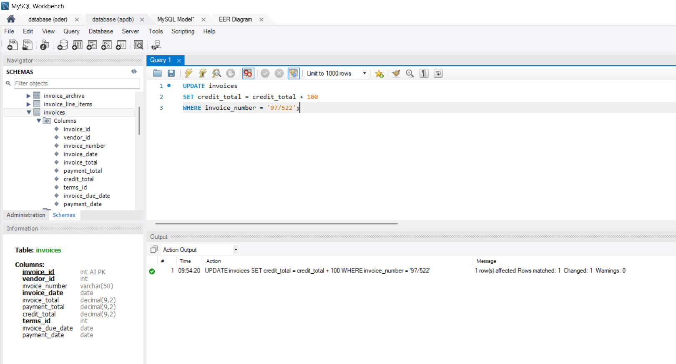

12. Update all invoices for a vendor

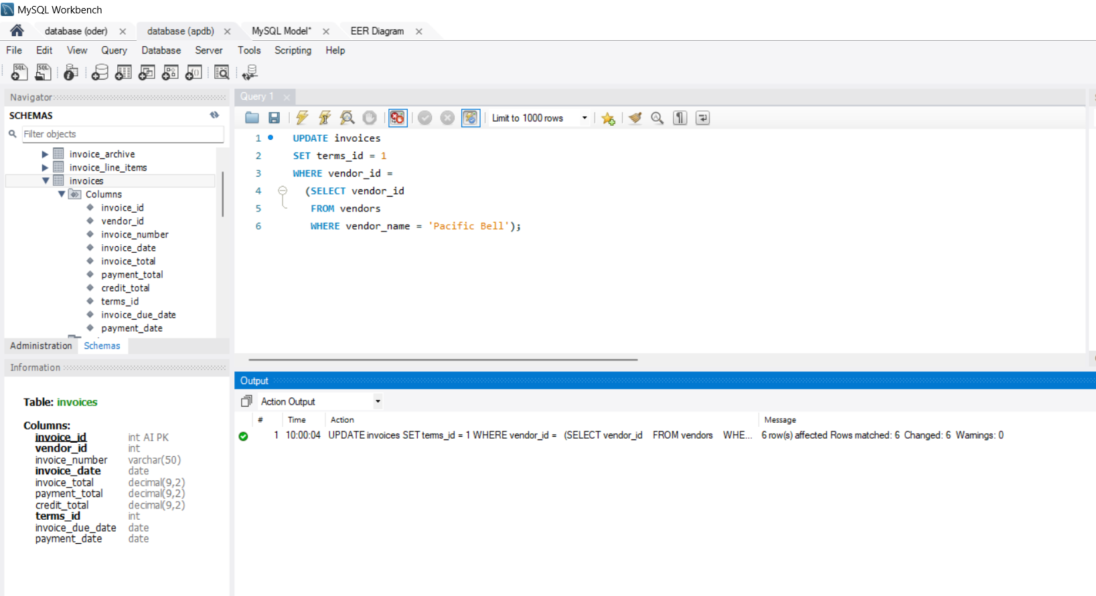

13. Update the terms for all invoices for vendors in three states

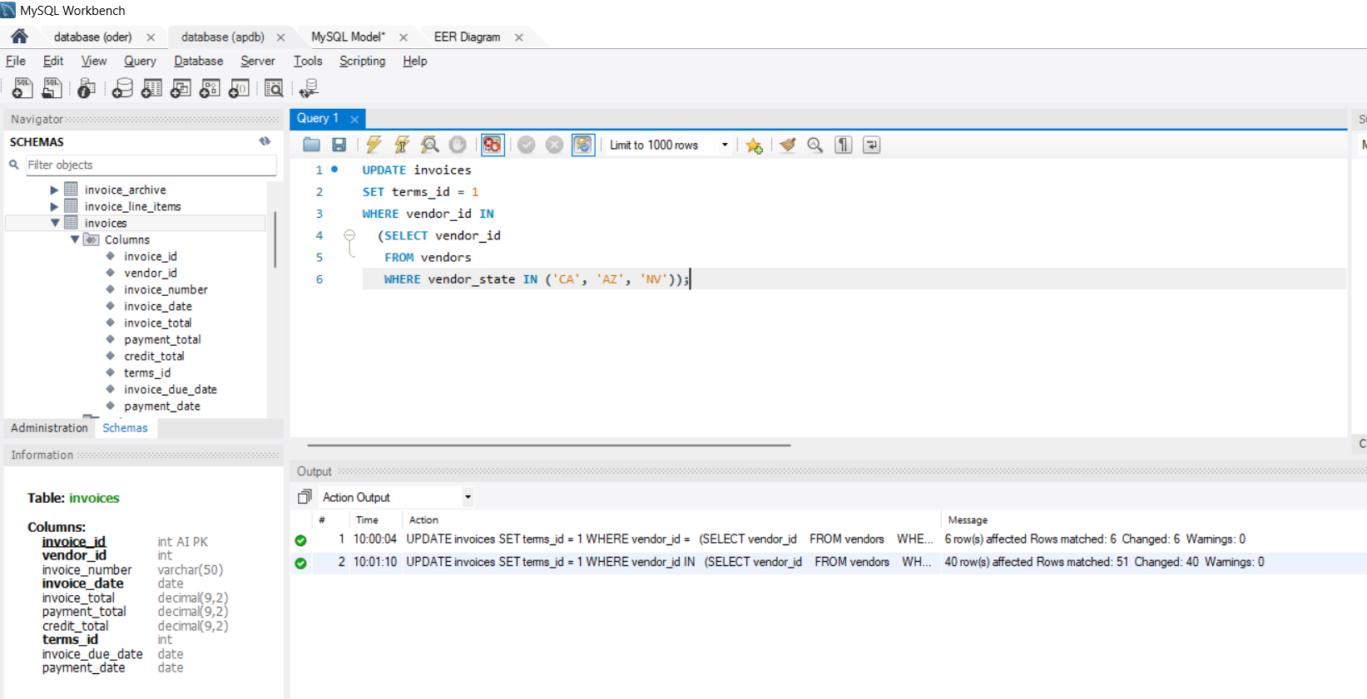

14. Delete one row

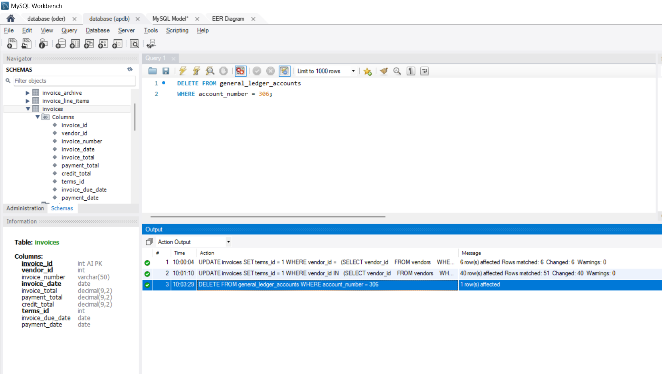

15. Delete one row using a compound condition

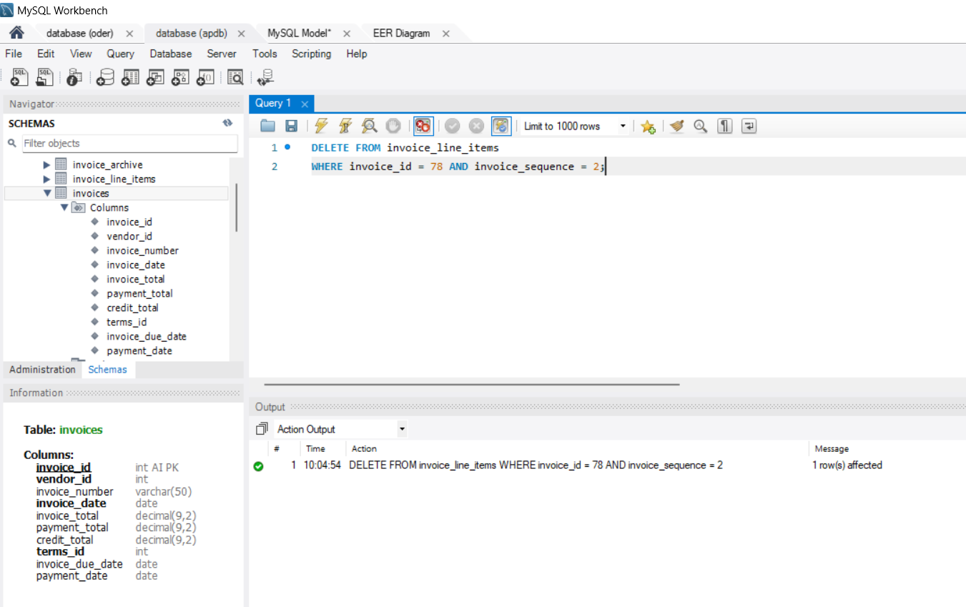

16. Delete multiple rows

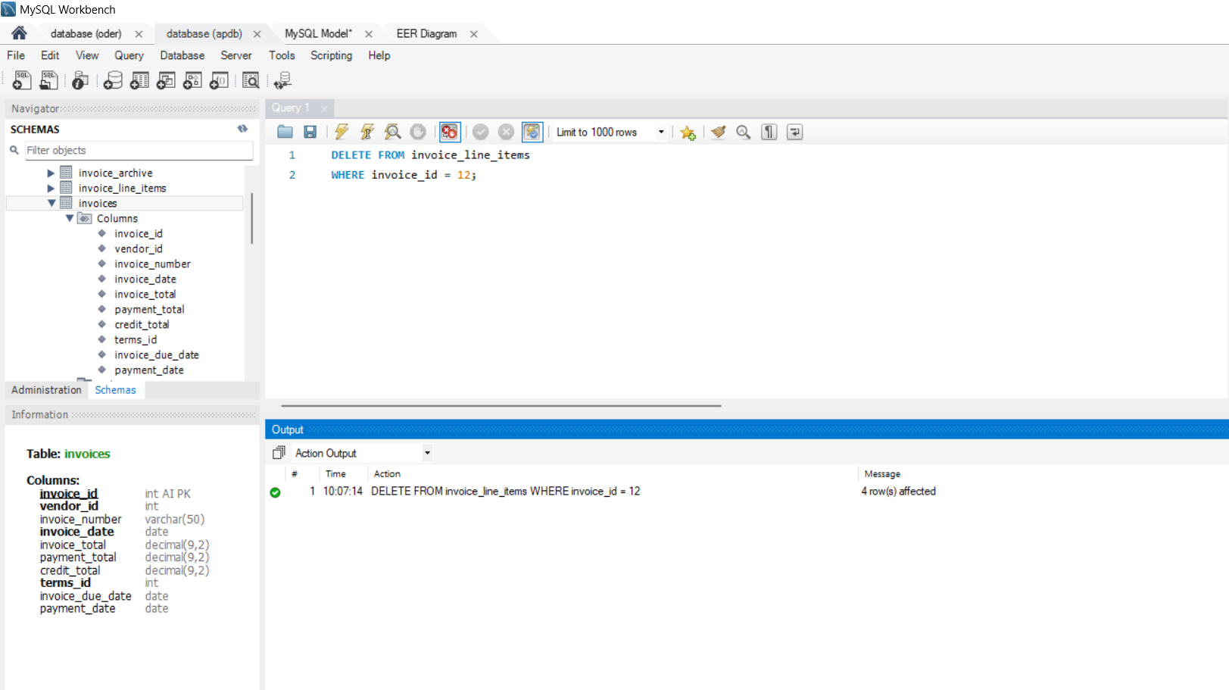

17. Use a subquery in a DELETE statement

