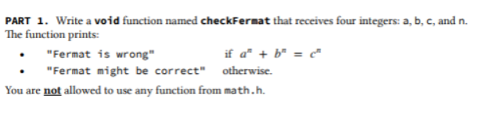

#include <stdio.h>

void CeckFormat(int a, int b, int c, int n){

int Bcounter=1,Acounter=1,Ccounter=1;

for(int i=1 ;i<=n;i++){

int Bcounter=Bcounter\*b;

int Acounter=Acounter\*a;

int Ccounter=Ccounter\*c;

}

int check=Acounter+Bcounter;

if(check==Ccounter)

printf("Format is Wrong");

else

printf("Format is correct");

}

int main() {

int a,b,c,n;

printf("Enter a \n");

scanf("%d",&a);

printf("Enter b \n");

scanf("%d",&b);

printf("Enter c \n");

scanf("%d",&c);

printf("Enter n \n");

scanf("%d",&n);

CeckFormat( a, b, c, n);

return 0;

}