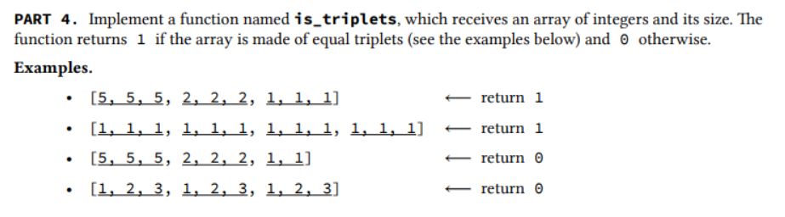

#include <stdio.h>

int is_triplets(int a[],int size) {

int c=0;

if(size%3 ==0 ){

for(int i=0;i<size;i+=3){

if(a[0+i]==a[1+i] && a[1+i]==a[2+i]) {

c=1;

break;

}

else

c=0;

}

return c;

}

else

return 0;

}

int main() {

int size;

printf("Enter the number or characters you wish to enter ");

scanf("%d",&size);

int number[size];

for (int i=0; i<size;i++){

printf("a[%d]=",i);

scanf("%d",&number[i]);

printf("\n");

printf("%d",is_triplets( number,size));

}

return 0;

}