COMPUTER MEMORY

# INTRODUCTION

The computer’s memory stores data, instructions required during the processing of data, and output results. Storage may be required for a limited period of time, instantly, or, for an extended period of time. Different types of memories, each having its own unique features, are available for use in a computer. *The cache memory, registers, and RAM* are fast memories and store the data and instructions temporarily during the processing of data and instructions. *The secondary memory like magnetic disks and optical disks* has large storage capacities and store the data and instructions permanently, but are slow memory devices.

The memories are organized in the computer in a manner to achieve high levels of performance at the minimum cost.

# MEMORY REPRESENTATION

The computer memory stores different kinds of data like input data, output data, intermediate results, etc., and the instructions. ***Binary digit*** or ***bit*** is the basic unit of memory. A ***bit*** is a single binary digit, i.e., 0 or 1. A bit is the smallest unit of representation of data in a computer. However, the data is handled by the computer as a combination of bits. A group of 8 bits form a **byte**.

One byte is the smallest unit of data that is handled by the computer.

One byte (8 bit) can store **28** = 256 different combinations of bits, and thus can be used to represent 256 different symbols. In a byte, the different combinations of bits fall in the range 00000000 to 11111111. A group of bytes can be further combined to form a **word**. A word can be a group of 2, 4 or 8 bytes.

**Bit (b): The smallest unit of data, representing either 0 or 1.**

**Byte (B):1 Byte = 8 bits**

**Kilobyte (KB): 1 KB = 2¹⁰ = 1,024 Bytes**

**Megabyte (MB):1 MB = 2²⁰ = 1,024 KB = 1,024 × 1,024 Bytes**

**Gigabyte (GB):1 GB = 2³⁰ = 1,024 MB = 1,024 × 1,024 KB = 1,024 × 1,024 × 1,024 Bytes**

**Terabyte (TB):1 TB = 2⁴⁰ = 1,024 GB = 1,024 × 1,024 MB = 1,024 × 1,024 × 1,024 KB**

**Petabyte (PB):1 PB = 2⁵⁰ = 1,024 TB = 1,024 × 1,024 GB**

**Exabyte (EB):1 EB = 2⁶⁰ = 1,024 PB = 1,024 × 1,024 TB**

**Zettabyte (ZB):1 ZB = 2⁷⁰ = 1,024 EB = 1,024 × 1,024 PB**

**Yottabyte (YB):1 YB = 2⁸⁰ = 1,024 ZB = 1,024 × 1,024 EB**

# CHARACTERISTICS OF MEMORIES

* + **Volatility**

# Volatile {RAM}

* + - **Non-volatile {ROM, Flash memory}**

# Mutability

* + - **Read/Write {RAM, HDD, SSD, RAM, Cache, Registers…}**

# Read Only {Optical ROM (CD/DVD…), Semiconductor ROM}

* + **Accessibility**

# Random Access {RAM, Cache}

* + - **Direct Access {HDD, Optical Disks}**

# Sequential Access {Magnetic Tapes}

### :

| **Memory Type** | **Volatility** | **Mutability** | **Accessibility** | **Speed** | **Cost (Per GB)** | **Portability** |
| --- | --- | --- | --- | --- | --- | --- |
| **RAM** (DRAM, SRAM) | Volatile | Read/Write | Random Access | Very Fast (DRAM slower than SRAM) | High (especially SRAM) | Not portable (internal) |
| **Cache** (L1, L2, L3) | Volatile | Read/Write | Random Access | Extremely Fast (faster than RAM) | Very High | Not portable (internal) |
| **Registers** | Volatile | Read/Write | Random Access | Fastest | Very High | Not portable (internal) |
| **HDD** | Non-volatile | Read/Write | Direct Access | Moderate (100-150 MB/s) | Low | Portable (external HDD) |
| **SSD** (NAND Flash) | Non-volatile | Read/Write | Direct Access | Fast (500-7000 MB/s) | Higher than HDD | Portable (external SSD) |
| **Optical Disks** (CD/DVD/Blu-ray) | Non-volatile | Read Only (or RW for rewritable discs) | Direct Access | Slow (~1-16 MB/s) | Very Low (per GB) | Portable (easily removable) |
| **Magnetic Tapes** | Non-volatile | Read/Write | Sequential Access | Very Slow | Very Low | Not portable (requires special drives) |
| **Flash Drives** | Non-volatile | Read/Write | Direct Access | Moderate (up to 300 MB/s) | Low to moderate | Highly portable (USB form factor) |
| **SD Cards** | Non-volatile | Read/Write | Direct Access | Moderate (50-250 MB/s) | Moderate | Highly portable |
| **ROM** (Semiconductor ROM) | Non-volatile | Read Only | Random Access | Slow to Moderate | Low | Not portable (embedded) |
| **Cloud Storage** | Non-volatile | Read/Write | Remote Access (via internet) | Dependent on internet speed | Subscription-based | Portable (accessible from any device) |

### **D**

1. **MEMORY HIERARCHY**

The memory is characterized on the basis of two key factors: ***capacity*** and ***access time***.

* + ***Capacity*** is the amount of information (in bits) that a memory can store.
  + ***Access time*** is the time interval between the read/ write request and the availability of data. The lesser the access time, the faster is the *speed of memory*.

Ideally, we want the memory with *fastest speed and largest capacity*. However, the cost of fast memory is very high. The computer uses a hierarchy of memory that is organized in a manner to enable the fastest speed and largest capacity of memory. The hierarchy of the different memory types is shown in the Figures below.

***The Internal Memory*** and ***External Memory*** are the two broad categories of memory used in the computer. *The Internal Memory* consists of the CPU registers, cache memory and primary memory. The internal memory is used by the CPU to perform the computing tasks. *The External Memory* is also called the *Auxiliary* or *secondary memory*. The secondary memory is used to store the large amount of data and the software.

In general, referring to the computer memory usually means the internal memory.

# Internal Memory

The key features of internal memory are:

1. Limited storage capacity.
2. Temporary storage.
3. Fast access.
4. High cost.

*Registers*, *cache memory*, and *primary memory* constitute the internal memory. *The primary memory* is further of two kinds: RAM and ROM. *Registers* are the fastest and the most expensive among all the memory types. The registers are located inside the CPU, and are directly accessible by the CPU. The speed of registers is between 1-2 ns (nanosecond). The sum of the size of registers is about 200B. *Cache memory* is next in the hierarchy and is placed between the CPU and the main memory. The speed of cache is between 2-10 ns. The cache size varies between 32 KB to 64MB. Any program or data that has to be executed must be brought into RAM from the secondary memory. Primary memory is relatively slower than the cache memory. The speed of RAM is around 60ns. The RAM size varies from 512KB to 64GB.

# Secondary Memory

The key features of secondary memory storage devices are:

* 1. Very high storage capacity.
  2. Permanent storage (non-volatile), unless erased by user.
  3. Relatively slower access.
  4. Stores data and instructions that are not currently being used by CPU but may be required later for processing.
  5. Cheapest among all memory.

To get the fastest speed of memory with largest capacity and least cost, the fast memory is located close to the processor. The secondary memory, which is not as fast, is used to store information permanently, and is placed farthest from the processor.

With respect to CPU, the memory is organized as follows:

* + *Registers* are placed inside the CPU (small capacity, high cost, very high speed)
  + *Cache memory* is placed next in the hierarchy (inside and outside the CPU)
  + *Primary memory* is placed next in the hierarchy
  + *Secondary memory* is the farthest from CPU (large capacity, low cost, low speed) The speed of memories is dependent on the kind of technology used for the memory. The registers, cache memory and primary memory are **semiconductor memories**. They do not have any moving parts and are fast memories. The secondary memory is **magnetic or optical memory** has moving parts and has slow speed.

# CPU REGISTERS

**Registers** are very high-speed storage areas located inside the CPU. After CPU gets the data and instructions from the cache or RAM, the data and instructions are moved to the registers for processing. Registers are manipulated directly by the control unit of CPU during instruction execution. That is why registers are often referred to as the CPU’s *working memory*. Since CPU uses registers for the processing of data, the number of registers in a CPU and the size of each register affect the power and speed of a CPU. The more the number of registers (ten to hundreds) and bigger the size of each register (8 bits to 64 bits), the better it is.

# CACHE MEMORY

Cache memory is placed in between the CPU and the RAM. Cache memory is a fast memory, faster than the RAM. When the CPU needs an instruction or data during processing, it first looks in the cache. If the information is present in the cache, it is called a ***cache hit***, and the data or instruction is retrieved from the cache. If the information is not present in cache, then it is called a ***cache miss*** and the information is then retrieved from RAM.

# Types of Cache memory

Cache memory improves the speed of the CPU, but it is expensive. Type of Cache Memory is divided into different levels that are L1, L2, L3, L4:

# Level 1 (L1) cache or Primary Cache

L1 is the primary type cache memory. The Size of the L1 cache very small comparison to others that is between 16KB to 128KB, it depends on computer processor. It is an embedded register in the computer microprocessor (CPU). The Instructions that are required by the CPU that are firstly searched in L1 Cache. Example of [registers](http://ecomputernotes.com/fundamental/input-output-and-memory/what-is-registers-function-performed-by-registers-types-of-registers) are accumulator, address register, Program counter etc.

* Size: Typically 16 KB to 128 KB
* Location: Closest to the CPU core; usually divided into instruction and data caches.
* Speed: Fastest, with the lowest latency, as it's directly integrated into the CPU core

**Memory latency refers to the time delay between a request for data from a memory unit and the delivery of the requested data. It's a crucial factor in determining the overall performance of a computer system, especially in applications that require rapid data access.

# Level 2 (L2) cache or Secondary Cache

L2 is secondary type cache memory. The Size of the L2 cache is more capacious than L1 that is between 256KB to 1MB. L2 cache is located on computer microprocessor. After searching the Instructions in L1 Cache, if not found then it searched into L2 cache by computer microprocessor. The high-speed system bus interconnecting the cache to the microprocessor.

* Location: Located near the CPU, either per core or shared by multiple cores.
* Speed: Slower than L1 but still much faster than main memory (RAM).

# Level 3 (L3) cache or Main Memory

The L3 cache is larger in size but also slower in speed than L1 and L2, its size is between 4MB to 64MB. In Multicore processors, each core may have separate L1 and L2, but all cores share a common L3 cache. L3 cache double speed than the RAM.

* Location: Shared among all cores of a multi-core processor.
* Speed: Slower than L2, but faster than accessing system RAM.

# Level 4 (L4) cache or Main Memory

# Level 4 (L4) cache is relatively uncommon compared to L1, L2, and L3 caches, but it exists in some high-performance processors. It generally serves as an additional layer between the CPU and main memory (RAM). Acts as a larger but slower cache compared to L1, L2, and L3 caches. It provides an intermediate storage layer to reduce latency when accessing data from main memory. Typically ranges from 128 MB to several GB. For example, some Intel processors, like those with integrated eDRAM (embedded DRAM), use an L4 cache of around 128 MB.

* Location: Can be either on-die (integrated within the CPU) or off-die (on a separate chip), sometimes shared across the entire CPU and GPU in certain architectures.
* Speed: Faster than main memory (RAM) but slower than L1, L2, and L3 caches. It reduces the time spent accessing main memory for frequently used data or instructions.
* Use Cases: Common in high-performance CPUs or processors that handle graphics or intensive data processing tasks. For example, Intel's Crystal Well architecture uses L4 cache for integrated graphics performance optimization.

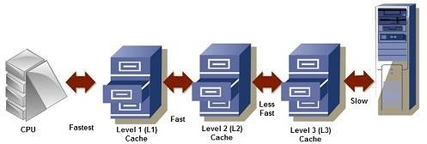

The advantages and disadvantages of cache memory are as follows:

# Advantages

The advantages of cache memory are as follows:

* Cache memory is faster than main memory.
* It consumes less access time as compared to main memory.
* It stores the program that can be executed within a short period of time.
* It stores data for temporary use.

# Disadvantages

The disadvantages of cache memory are as follows:

* Cache memory has limited capacity.
* It is very expensive.

# PRIMARY MEMORY (Main Memory)

Primary memory is the main memory of computer. It is a chip mounted on the motherboard of computer. Primary memory is categorized into two main types: Random access memory (ram) and read only memory (rom). **RAM** is used for the temporary storage of input data, output data and intermediate results. The input data entered into the computer using the input device, is stored in RAM for processing. After processing, the output data is stored in RAM before being sent to the output device. Any intermediate results generated during the processing of program are also stored in RAM. Unlike RAM, the data once stored in **ROM** either cannot be changed or can only be changed using some special operations. Therefore, ROM is used to store the data that does not require a change.

Characteristics of Main Memory

• It is known as main memory.

• Usually volatile memory.

• Data is lost in case power is switched off .

• It is working memory of the computer.

• Faster than secondary memories.

• A computer cannot run without primary memory.

# Types of Primary Memory

1. **RAM (Random Access Memory)**

The Word “**RAM**” stands for “random access memory” or may also refer to short- term memory. It’s called “random” because you can read store data randomly at any time and from any physical location. It is a temporal storage memory. RAM is volatile that only retains all the data as long as the computer powered. It is the fastest type of memory. RAM stores the currently processed data from the CPU and sends them to the graphics unit.

The latest technologies in RAM (Random Access Memory) are focused on improving **speed, capacity, efficiency**, and **durability** to meet the demands of modern computing.

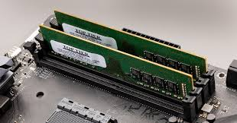

# There are generally two broad subcategories of RAM:

* **Static RAM** (**SRAM**): Static RAM is the form of RAM and made with flip-flops and used for primary storage are volatile. It retains data in latch as long as the computer powered. SRAM is more expensive and consumes more power than DRAM. It used as Cache Memory in a computer system. As technically, SRAM uses more transistors as compared to DRAM. It is faster compared to DRAM due to the latching arrangement, and they use 6 transistors per data bit as compared to DRAM, which uses one transistor per bit.
* **Dynamic Random Access Memory (DRAM)**: It is another form of RAM used as Main Memory, its retains [information](http://ecomputernotes.com/fundamental/information-technology/what-do-you-mean-by-data-and-information) in Capacitors for a short period (a few milliseconds) even though the computer powered. The Data is Refreshed Periodically to maintain in it. The DRAM is cheaper, but it can store much more information. Moreover, it is also slower and consumes less power than SRAM.

Comparison of **SRAM** and **DRAM**

| **Aspect** | **SRAM (Static RAM)** | **DRAM (Dynamic RAM)** |
| --- | --- | --- |
| **Storage Method** | Flip-flop circuits using 6 transistors per bit | Capacitors with 1 transistor per bit |
| **Data Retention** | Data remains as long as power is supplied (no refresh) | Requires constant refreshing to retain data |
| **Speed** | Faster (lower latency) | Slower (higher latency due to refreshing) |
| **Power Consumption** | Lower when active (no refresh needed), but higher static power | Lower active power but higher overall due to refresh cycles |
| **Density** | Lower density (requires more space per bit) | Higher density (more compact) |
| **Cost** | More expensive (complex circuitry) | Less expensive (simpler design) |
| **Use Cases** | Cache memory (L1, L2, L3 in CPUs), small, high-speed applications | Main system memory (RAM in computers, servers) |
| **Refresh Requirement** | No refresh needed | Requires periodic refresh |

A summary of the most recent types of memory technologies

1. **DDR5 RAM**: Released in 2020, it offers higher bandwidth (up to 6,400 MT/s (mega-transfers per second), increased capacity (up to 128 GB per DIMM (DIMMs use a 64-bit data path, since processors used in personal computers have a 64-bit data width), improved power efficiency. Ideal for AI, gaming, content creation, and servers.
2. **LPDDR5 and LPDDR5X**: Designed for mobile and embedded devices, LPDDR5 (2020) offers speeds up to 6,400 MT/s, while LPDDR5X (2021) reaches 8,533 MT/s. These are optimized for power efficiency and reduced latency, making them suitable for smartphones, tablets, and laptops.
3. **HBM3**: Introduced in 2021, it provides ultra-high bandwidth (819 GB/s per stack) with 3D stacking technology. It’s used in high-performance computing, AI/ML, data centers, and GPUs.
4. **GDDR6X**: Released in 2020, it offers high speeds (up to 21 Gbps) and uses PAM4 signaling for efficiency. It’s mainly used in high-end GPUs for gaming and AI applications.
5. **3D XPoint / Intel Optane Memory**: Launched in 2017, this non-volatile memory bridges the gap between DRAM and storage. It’s used for fast data access in data centers and high-performance applications.
6. **MRAM**: An emerging non-volatile memory technology with high endurance and fast speeds, making it promising for AI, edge computing, and embedded systems.
7. **ReRAM**: Another emerging non-volatile memory technology with faster speeds than NAND flash, it’s a potential candidate for next-gen storage and embedded memory.
8. **Faster Memory Interfaces (CXL and Gen-Z)**:
   * **CXL**: Enables faster data transfers between memory and processors, reducing latency and boosting bandwidth for AI and data centers.
   * **Gen-Z**: Provides direct access to shared memory pools between processors, enhancing memory interconnects.

## ROM (Read Only Memory)

ROM is the long-term internal memory. ROM is “Non-Volatile Memory” that retains data without the flow of electricity. ROM is an essential chip with permanently written data or programs. It is similar to the RAM that is accessed by the CPU. ROM comes with pre-written by the computer manufacturer to hold the instructions for booting-up the computer.

# There is generally three broad type of ROM:

* + **PROM (Programmable Read Only Memory)**: PROM stands for programmable ROM. It can be programmed only be done once and read many. Unlike RAM, PROMs retain their contents without the flow of electricity. PROM is also nonvolatile memory. The significant difference between a ROM and a PROM is that a ROM comes with pre-written by the computer manufacturer whereas PROM manufactured as blank memory. PROM can be programmed by PROM burner and by blowing internal fuses permanently.
  + **EPROM (Erasable Programmable Read Only Memory)**: EPROM is pronounced ee-prom. This memory type retains its contents until it exposed to intense ultraviolet light that clears its contents, making it possible to reprogram the memory.
  + **EEPROM (Electrically Erasable Programmable Read Only Memory)**: EEPROM can be burned (programmed) and erased by first electrical waves in a millisecond. A single byte of a data or the entire contents of device can be erased. To write or erase this memory type, you need a device called a PROM burner.

1. **Hybrid types**

As memory technology has matured in recent years, the line between RAM and ROM has blurred. Now, several types of memory combine features of both. These devices do not belong to either group and can be collectively referred to as hybrid memory devices. Hybrid memories can be read and written as desired, like RAM, but maintain their contents without electrical power, just like ROM. Two of the hybrid devices, EEPROM and flash, are descendants of ROM devices. These are typically used to store code. The third hybrid, NVRAM, is a modified version of SRAM. NVRAM usually holds persistent data.Hybrid memory types blend the speed and flexibility of RAM with the non-volatility of ROM, providing fast data access while retaining data even when powered off. Here's a summary of common hybrid memory types:

1. **NVRAM** **(Non-Volatile RAM):** Non-volatile, retains data without power like ROM, but with fast RAM-like access. Used in embedded systems, BIOS chips, and storage devices.
2. **Flash Memory**: Non-volatile and rewritable, bridging RAM and ROM. Found in SSDs, USB drives, and smartphones.
3. **PRAM (Phase-Change RAM)**: Uses heat-induced phase changes to store data, faster and more durable than flash. Used in high-performance storage non-volatile memory solutions, often in storage devices and data centers.
4. **FeRAM** **(Ferroelectric RAM)**: Non-volatile, fast read/write speeds using a ferroelectric layer. Seen in smart cards and low-power systems.
5. **MRAM** **(Magnetoresistive RAM)**: Non-volatile, using magnetic states instead of electric charge, making it non-volatile and offering fast read/write speeds like RAM. Applied in wearables, automotive, and enterprise storage.
6. **ReRAM** **(Resistive RAM)**: Non-volatile, fast read/write speeds, changing material resistance to store data. Expected in future computing architectures such as AI/ML and storage systems.

# SECONDARY MEMORY

**Secondary Memory**, also known as **Non-Volatile Memory**, refers to storage devices that retain data even when the system's power is turned off. Unlike **primary memory** (RAM), which is fast but temporary, secondary memory is slower but provides long-term data storage. Below are the main features and types of secondary or non-volatile memory:

### **Key Characteristics**

* **Persistent Storage**: Retains data without power.
* **Larger Capacity**: Typically much larger than primary memory (ranging from GB to multiple TB or more).
* **Slower Access**: Access times are slower compared to RAM but adequate for most storage tasks.
* **Cost-Effective**: Offers a cheaper solution for large-scale data storage.
* **Used for Long-Term Storage**: Ideal for storing files, applications, operating systems, backups, and more.

### **Types of Secondary/Non-Volatile Memory**

1. **Hard Disk Drives (HDD)**
   * **Description**: Mechanical storage devices that use spinning magnetic platters and read/write heads to store data.
   * **Capacity**: Can range from **500 GB** to **20 TB** or more.
   * **Speed**: Slower compared to solid-state drives, with typical read/write speeds of around **100-150 MB/s**.
   * **Use Cases**: Large-scale data storage for **desktop PCs**, **servers**, and **backup solutions**.

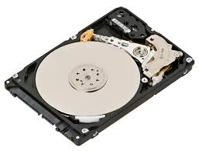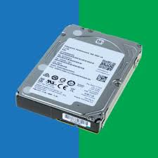

1. **Solid-State Drives (SSD)**:

Solid-State Drives (SSDs) are a type of data storage device that uses flash memory to store data persistently, unlike traditional Hard Disk Drives (HDDs), which rely on spinning magnetic disks. F**lash memory** uses NAND, (NAND is an acronym that stands for "Not AND." It's a logic gate used in digital circuits to perform a specific logical operation) to store data without moving parts, making them faster and more durable than HDDs. SSDs have become increasingly popular due to their numerous advantages over traditional storage solutions.

**Advantages of SSDs**

1. **Speed** -The most significant advantage of SSDs is their speed. They significantly reduce boot times, application load times, and file transfer speeds, leading to improved overall system performance.
2. **Durability**: Due to the absence of moving parts, SSDs are less susceptible to damage from drops and shocks, making them ideal for portable devices.
3. **Lower Latency** SSDs offer lower latency compared to HDDs, resulting in faster data retrieval and improved responsiveness.
4. **Noise Reduction**: SSDs operate silently, while HDDs can produce noise from spinning disks and moving read/write heads.
5. **Energy Efficiency**: The lower power consumption of SSDs can lead to longer battery life for laptops and reduced electricity costs for data centers.

**Types of SSDs**

1. **SATA SSDs**: Uses the SATA interface, which limits speed compared to other types. Commonly used in upgrading older systems to improve performance.
2. **NVMe SSDs**: Connects via the PCIe interface, allowing for significantly higher data transfer rates. Ideal for high-performance tasks such as gaming, video editing, and data-intensive applications.
3. **M.2 SSDs**: A compact form factor that can support both SATA and NVMe protocols. They are commonly used in ultrabooks and desktops with limited space.
4. **External SSDs**: Portable SSDs connected via USB or Thunderbolt, offering fast external storage solutions for users on the go.
5. **Enterprise SSDs**: Designed for data centers and enterprise applications, these SSDs are optimized for durability, performance, and high write endurance.

**Applications of SSDs**

1. **Consumer Electronics**: Used in laptops, desktops, and gaming consoles to improve performance and user experience.
2. **Data Centers**: Implemented in servers to accelerate database transactions and improve the overall efficiency of cloud storage solutions.
3. **Mobile Devices**: Found in smartphones and tablets, providing faster data access and enhanced application performance.
4. **Embedded Systems**: Used in devices requiring fast and reliable storage, such as IoT devices, drones, and automotive systems.
5. **High-Performance Computing**: Employed in environments requiring rapid data processing, such as scientific simulations, big data analytics, and AI workloads.

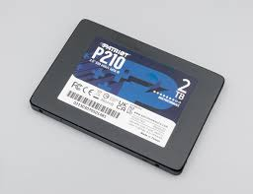 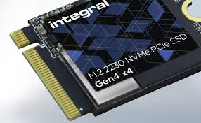 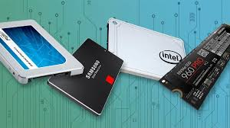

### Key Characteristics of NAND Flash Memory

* **Non-volatile:** Data is retained even when power is lost.
* **High density:** NAND flash memory can store a large amount of data in a relatively small space.
* **Fast read speeds:** NAND flash memory can read data very quickly, making it suitable for applications that require rapid data access.
* **Slower write speeds:** While read speeds are fast, write speeds can be slower, especially for large amounts of data.
* **Limited write cycles:** NAND flash cells have a limited number of times they can be programmed and erased before they wear out. This is typically measured in program-erase (P/E) cycles.
* **Wear leveling:** To distribute writes evenly across all cells and prolong the life of the memory, NAND flash controllers use wear leveling algorithms.

1. **Optical Discs (CD, DVD, Blu-ray)**

Discs that use laser technology to read and write data to a plastic disc coated with a reflective material.

* + **Capacity**:
    - **CDs**: ~700 MB
    - **DVDs**: ~4.7 GB to 17 GB (dual-layer)
    - **Blu-ray**: ~25 GB to 128 GB
  + **Speed**: Significantly slower than HDDs and SSDs, but cost-effective for **archival** purposes.
  + **Use Cases**: **Archiving**, **software distribution**, **media storage** (movies, music), and **backup**.

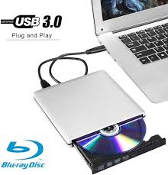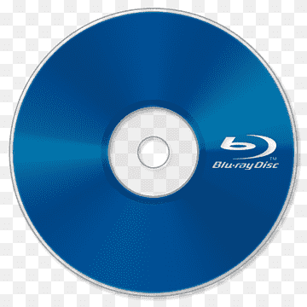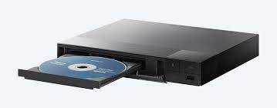

1. **USB Flash Drives**

Portable storage devices that use NAND flash memory, similar to SSDs, but in smaller, removable form factors.

* + **Capacity**: Typically range from **1 GB** to **1 TB**.
  + **Speed**: Varies, but generally slower than SSDs; some advanced USB 3.0/3.1 drives can offer speeds similar to low-end SSDs.
  + **Use Cases**: **Portable file storage**, **transferring data** between devices, and **backup** solutions.

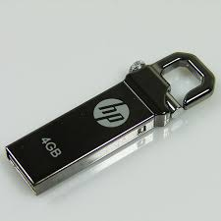 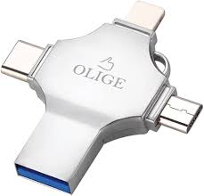

1. **Memory Cards (SD, microSD)**

Small, portable storage devices used primarily in cameras, smartphones, and tablets.

* + **Capacity**: Usually range from **1 GB** to **1 TB**.
  + **Speed**: Speeds vary depending on the **UHS (Ultra High Speed)** class, with faster cards used for high-performance tasks such as **4K video recording**.
  + **Use Cases**: **Portable storage** for **smartphones**, **cameras**, **drones**, and **gaming consoles**.

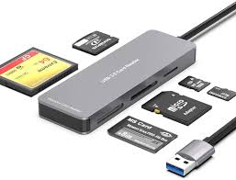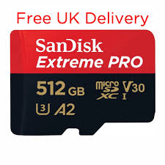

1. **Cloud Storage**

**Cloud storage is a model of data storage in which digital data is stored on remote servers that are accessed via the internet, rather than being stored locally on a physical device like a hard drive or SSD. This model allows users and organizations to store, manage, and retrieve data from anywhere with an internet connection. Cloud storage has become increasingly popular due to its convenience, scalability, and accessibility.**

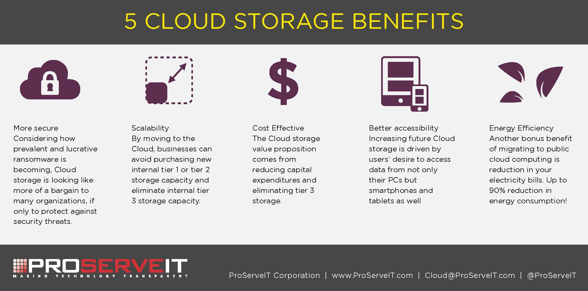

**Characteristics of Cloud Storage**

1. **Remote Accessibility**: Data stored in the cloud can be accessed from any device connected to the internet, including laptops, smartphones, and tablets. This provides users with flexibility and ease of access.
2. **Scalability**: Cloud storage solutions can easily scale up or down according to the needs of the user or organization. This means users can increase storage capacity as their data needs grow without needing to invest in additional physical hardware.
3. **Cost-Effectiveness**: Many cloud storage providers offer pay-as-you-go pricing models, allowing users to pay only for the storage they use. This reduces upfront costs associated with purchasing and maintaining physical storage infrastructure.
4. **Data Redundancy and Backup**: Most cloud storage providers implement redundancy measures, storing multiple copies of data across different locations. This helps protect against data loss due to hardware failure or disasters.
5. **Collaboration Features**: Cloud storage often includes collaboration tools that allow multiple users to access, edit, and share files simultaneously. This is particularly beneficial for teams working on projects together.
6. **Security Measures**: Cloud storage providers typically employ various security protocols, including encryption, access controls, and authentication measures, to safeguard data from unauthorized access.

**Advantages of Cloud Storage**

1. **Accessibility**: Users can access their data from anywhere in the world at any time, making it ideal for remote work and travel.
2. **Cost Savings**: Reduces the need for physical storage hardware and the associated maintenance costs, leading to potential savings for both individuals and organizations.
3. **Automatic Updates and Maintenance**: Cloud storage services are typically managed by the provider, meaning users benefit from automatic updates, backups, and maintenance without additional effort.
4. **Enhanced Collaboration**: Teams can easily share files and collaborate in real-time, improving productivity and efficiency in projects.
5. **Disaster Recovery**: In case of data loss due to hardware failure or other disasters, cloud storage provides an effective disaster recovery solution, as data is backed up off-site.

**Types of Cloud Storage**

1. **Public Cloud**: Cloud storage services offered over the internet by third-party providers (e.g., Google Drive, Dropbox, Amazon S3). Users share the same infrastructure but have their data isolated and secure.
2. **Private Cloud**: Cloud storage solutions that are dedicated to a single organization, providing greater control over data security and privacy. Private clouds can be hosted on-premises or by a third-party provider.
3. **Hybrid Cloud**: Combines elements of both public and private clouds, allowing organizations to keep sensitive data secure in a private cloud while leveraging the scalability and cost-effectiveness of public cloud resources for less sensitive data.
4. **Community Cloud**: A shared cloud infrastructure that is used by several organizations with similar interests or requirements, such as security, compliance, or performance.

**Applications of Cloud Storage**

1. **File Storage and Backup**: Individuals and businesses use cloud storage for securely storing files and data backups, ensuring they are protected against data loss.
2. **Application Hosting**: Cloud storage is often used to host applications and data for SaaS (Software as a Service) solutions, enabling users to access software applications over the internet.
3. **Media Hosting**: Cloud storage is widely used for storing and distributing media content, such as videos, images, and audio files, facilitating streaming services and media sharing platforms.
4. **Collaboration Tools**: Many productivity tools (e.g., Google Workspace, Microsoft 365) leverage cloud storage to allow users to collaborate on documents and projects in real time.
5. **Big Data Analytics**: Cloud storage provides the infrastructure necessary for storing and processing large volumes of data, enabling organizations to analyze and derive insights from big data.
6. **Magnetic Tapes**

An older technology that stores data on reels of magnetic tape, still used for archival purposes in some industries.

* + **Capacity**: **100 GB** to **15 TB** per tape, depending on the technology (e.g., LTO tapes).
  + **Speed**: Very slow compared to modern HDDs and SSDs but cost-effective for large-volume storage.
  + **Use Cases**: **Long-term archival**, **data backup** in large enterprises, and for compliance reasons (e.g., financial and healthcare data storage).

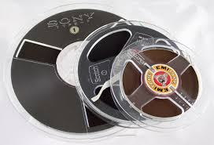

### **Comparison of Secondary Memory to Primary Memory**

* **Non-volatile**: Data persists even without power, unlike RAM.
* **Slower**: Secondary memory has higher latency and lower throughput compared to RAM.
* **Larger Capacity**: Secondary memory offers much higher storage capacity, suited for holding operating systems, programs, and personal files, as opposed to the temporary, fast-access data stored in RAM.

### IDE Technology And SATA Technology

IDE (Integrated Drive Electronics) and SATA (Serial ATA) are both technologies used to connect storage devices, such as hard drives, to a computer's motherboard. While they serve the same purpose, they have distinct characteristics and advantages. The transition from **IDE (Integrated Drive Electronics)** technology to **SATA (Serial ATA)** technology marks a significant advancement in data storage interfaces for hard drives and solid-state drives. This shift has improved performance, efficiency, and usability in modern computing systems. Below is a detailed overview of both technologies, their differences, and the implications of this transition.

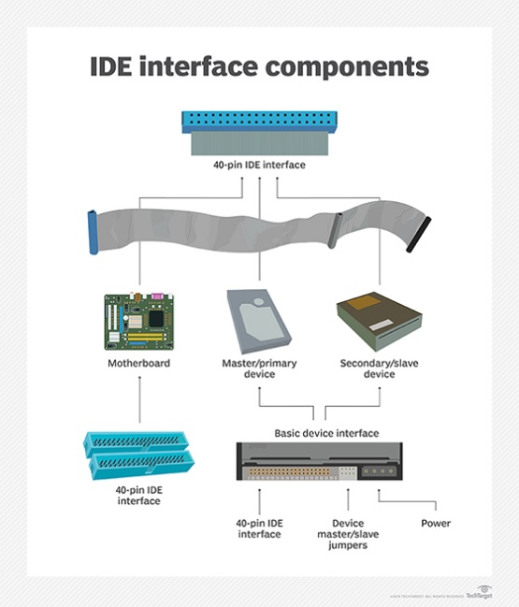 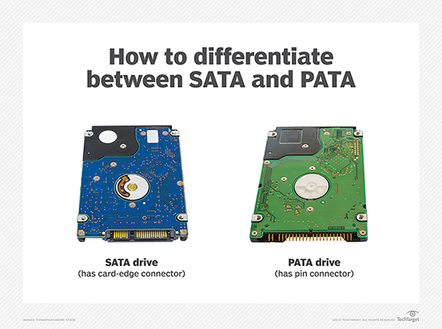

#### **IDE Technology**

IDE, also known as ATA (Advanced Technology Attachment), was introduced in the 1980s and became the standard interface for connecting hard drives and optical drives to computers. IDE technology employs a parallel data transfer method, where multiple bits of data are transmitted simultaneously over multiple wires. Standard IDE cables can support two devices per channel (master/slave configuration). The maximum data transfer rates for IDE technology are relatively low. The most common version, **ATA/133**, can achieve speeds up to 133 MB/s, although real-world speeds are typically lower. IDE uses a 40-pin or 80-pin ribbon cable to connect drives to the motherboard. The physical bulk of the ribbon cables can make cable management difficult in modern cases. IDE technology has several limitations, including:

1. **Limited speed** compared to newer technologies. Due to the parallel interface, IDE has a relatively limited data transfer rate compared to SATA.
2. **Bulkiness** of the ribbon cables.
3. **Master/slave configuration** restrictions, which complicate drive setup and can lead to performance bottlenecks. IDE can support a maximum of four storage devices on a single cable.

#### **SATA Technology**

SATA was introduced in 2003 as a successor to IDE technology, offering a more efficient and flexible interface for connecting storage devices to computers. SATA uses a serial data transfer method, transmitting data one bit at a time over a single channel. SATA devices are connected to the motherboard using a data cable and a power cable. SATA utilizes a thin, flexible cable with a 7-pin connector, allowing for easier cable management and better airflow within the computer case. This allows for higher speeds and more efficient data transfer. Many SATA controllers support hot swapping, allowing devices to be added or removed without powering down the computer. SATA technology has evolved through several versions, each increasing the maximum data transfer rate:

* + **SATA I**: 1.5 Gbit/s (approximately 150 MB/s)
  + **SATA II**: 3 Gbit/s (approximately 300 MB/s)
  + **SATA III**: 6 Gbit/s (approximately 600 MB/s)
  + Real-world performance often approaches the theoretical maximums, especially with SSDs.

SATA technology offers several advantages over IDE, including:

* **Higher data transfer rates** for improved performance.
* **Simpler cabling** that is easier to route and manage.
* **No master/slave configuration**, allowing for multiple drives on the same controller without restrictions.
* **Hot-swappable capability** (in some implementations), allowing drives to be added or removed without shutting down the system.

#### **Implications of the Shift from IDE to SATA**

1. **Performance Improvements**: The shift to SATA technology has resulted in significantly higher data transfer rates, improving the performance of both traditional hard drives and solid-state drives.
2. **Increased Storage Capacity**: SATA's ability to support more advanced storage technologies (such as SSDs) has led to increased storage capacities and faster access times for modern computing systems.
3. **Enhanced User Experience**: Easier cable management and improved airflow within cases have led to better overall user experiences, especially in high-performance gaming and workstation builds.
4. **Support for Advanced Features**: SATA technology has paved the way for advanced features such as Native Command Queuing (NCQ), which enhances performance by allowing multiple commands to be sent to the drive in a single queue.
5. **Legacy Systems**: As SATA became the standard, IDE technology has become largely obsolete, with most modern motherboards no longer supporting IDE connections. This has necessitated the use of SATA drives in new builds and upgrades.

The shift from IDE technology to SATA technology has revolutionized the way storage devices connect to computers, offering significant improvements in speed, efficiency, and usability. As technology continues to evolve, SATA remains a key player in data storage, though newer interfaces like NVMe (Non-Volatile Memory Express) are beginning to emerge, further pushing the boundaries of performance in the digital landscape.

**Virtual Memory**

**Virtual memory** is a memory management technique used by operating systems to provide an "idealized abstraction of the storage resources" that allows a computer to compensate for physical memory shortages by temporarily transferring data from random access memory (RAM) to disk storage. memory management technique used by operating systems to provide a program with the illusion of having more memory available than is physically present. It does this by mapping a portion of the hard disk to serve as an extension of the physical RAM. This enables systems to run larger applications or multiple applications simultaneously without running out of physical memory.

**Characteristics of Virtual Memory**

1. **Abstraction**: Virtual memory provides an abstraction layer that allows programs to operate as though they have access to a large contiguous block of memory, regardless of the actual physical memory available.
2. **Paging**: Virtual memory is typically implemented using a method called **paging**, where memory is divided into fixed-size blocks called **pages**. Similarly, the virtual address space is divided into corresponding blocks called virtual pages. These pages are mapped to physical memory frames, which may not be contiguous.
3. **Segmentation**: In addition to paging, some systems implement **segmentation**, where memory is divided into segments of varying lengths based on logical divisions in a program, such as functions or data structures.
4. **Page Table**: The operating system maintains a **page table** that keeps track of the mapping between virtual addresses (used by the program) and physical addresses (used by the hardware). This table enables the OS to quickly translate virtual addresses into physical addresses.
5. **Page Fault:** If a virtual page is not currently in physical memory, a **page fault** occurs. The operating system must then load the required page from the hard disk into a free physical memory frame.
6. **Swapping**: When the physical memory is full, the operating system may use a process called **swapping** to move less frequently used pages from RAM to a special area on the hard drive known as the **swap space** or **paging file**. This frees up RAM for more active processes.

**Advantages of Virtual Memory**

1. **Increased Memory Capacity**: Virtual memory allows systems to use more memory than is physically available by leveraging disk storage, enabling the execution of larger applications or multiple applications concurrently.
2. **Isolation and Security**: Each process runs in its own virtual address space, providing isolation between processes and enhancing security. This prevents one process from accessing the memory space of another process.
3. **Simplified Memory Management**: Virtual memory simplifies memory management for programmers by allowing them to use a large, contiguous block of memory without worrying about the physical organization of memory.
4. **Efficiency**: The operating system can manage memory more efficiently by keeping the most frequently accessed pages in physical memory while offloading less frequently used pages to disk storage.
5. **Simplified Programming Model**: Programmers can write applications without worrying about the limits of physical memory, leading to better resource utilization and increased application performance.

**Disadvantages of Virtual Memory**

1. **Performance Overhead**: Accessing data in virtual memory can be slower than accessing data in physical memory. If a program frequently accesses pages that have been swapped out to disk (a phenomenon known as **thrashing**), it can lead to performance degradation.
2. **Disk Space Usage**: Virtual memory requires disk space for the swap file or paging file. If the disk space is limited, it can constrain the amount of virtual memory available.
3. **Complexity**: The implementation of virtual memory adds complexity to the operating system and requires additional hardware support, such as a Memory Management Unit (MMU).
4. **Fragmentation**: Over time, the virtual memory system can become fragmented, leading to inefficient use of disk space and increased overhead in managing page tables.

**Applications of Virtual Memory**

1. **Operating Systems**: Most modern operating systems, including Windows, Linux, and macOS, use virtual memory to manage memory resources and provide a better user experience.
2. **Multi-User Environments**: Virtual memory is essential in multi-user environments, where multiple processes run concurrently without interfering with one another.
3. **Large Applications**: Applications that require large amounts of memory, such as database management systems, graphic design software, and video editing tools, benefit greatly from virtual memory.
4. **Gaming**: Virtual memory allows modern video games to run smoothly by managing large assets and resources efficiently.
5. **Development and Testing**: Developers can test applications under various memory conditions, ensuring their software is robust and efficient in utilizing system resources.

Virtual memory is a critical component of modern operating systems, allowing for more efficient memory management and enabling the execution of larger applications. While it has its drawbacks, the advantages it provides in terms of flexibility, security, and increased memory capacity make it an essential technology in computing today. As software and hardware continue to evolve, virtual memory will remain a key factor in managing system resources effectively.