>> docker pull jenkins/jenkins:lts

>> docker run -d --name my-jenkins-server -v /Users/mac/Documents/DayThem/BK1.DevOpsonline/L5/config/:/var/jenkins_home -p 8080:8080 -p 50000:50000 jenkins/jenkins:lts

>> docker logs <id>

>> admin/b3a520bd359e45a4ae32312e5b6e0c0c

>> brew install ngrok/ngrok/ngrok

<https://ngrok.com/download>

**Freestyle Project**

cấu hình github webhook

Cấu hình jenkins:

Tạo new item, freestyle project

Source Git hub chọn git hook, source code managerment chọn git.

Thử change và push github

/var/jenkins_home/workspace/hello-nodejs

**Pipeline project**

Tạo project pipeline, github project, cấu hình webhook

Sẽ cần bấm Build Now lần đầu tiên. Sau đó sẽ chạy tự động.

**Setting Variable:**

**Setting Directory:**

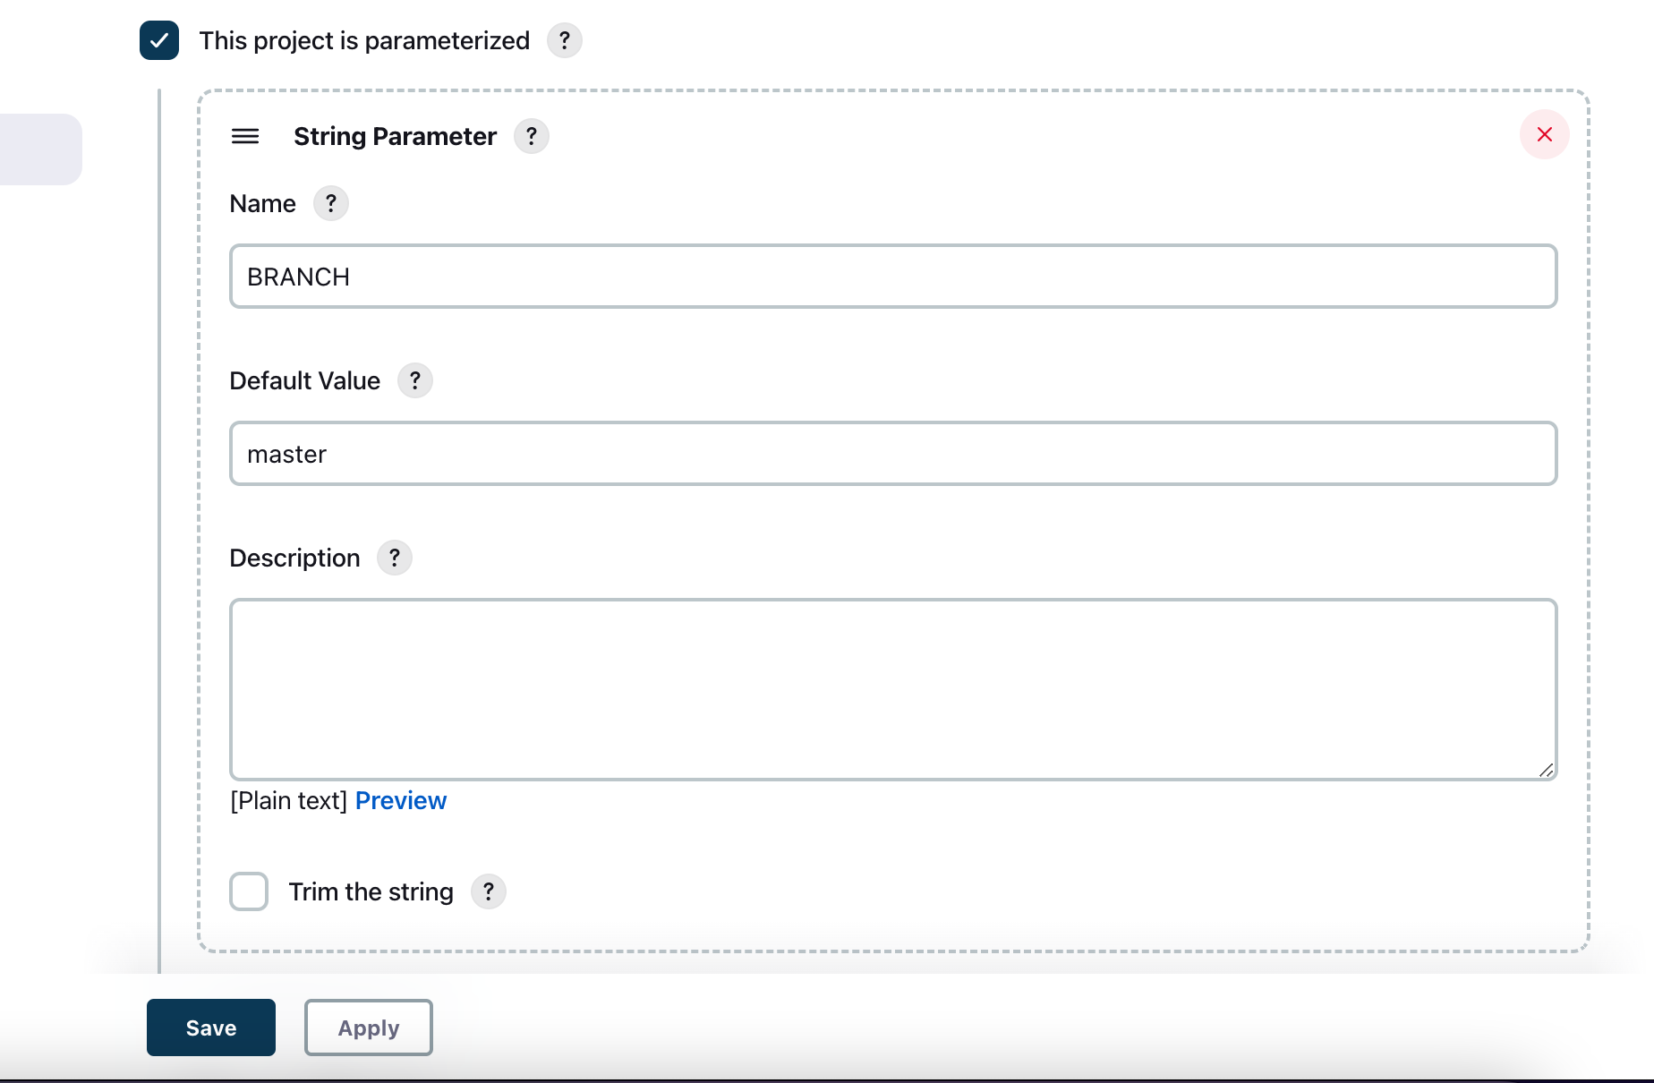

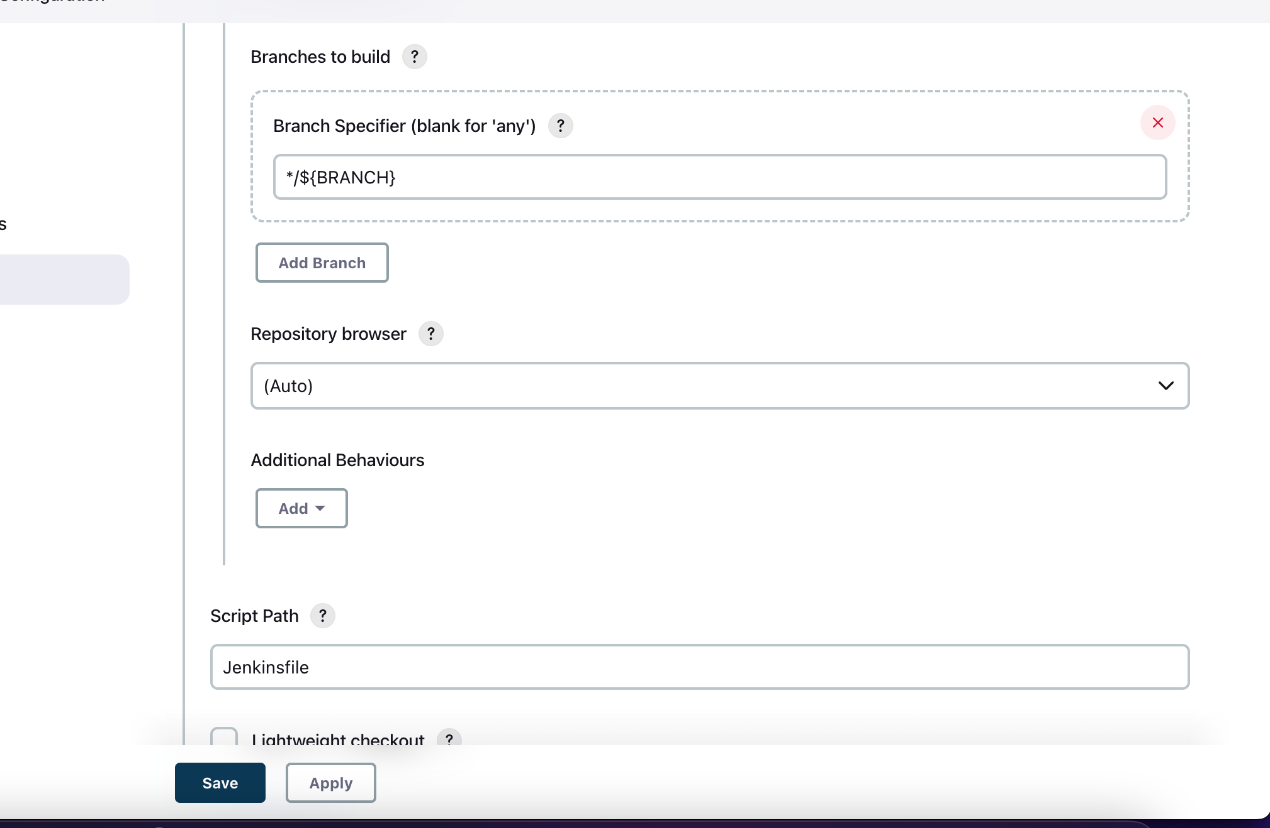

Phải bỏ tick Lightweight checkout

**Master-slave:**

>> docker run -itd --name linux-build-slave -p 50001:22

>> docker run -itd --name linux-build-slave-1 -p 50001:22 jenkins-slave:develop

<https://chathura-siriwardhana.medium.com/step-by-step-guide-to-add-jenkins-slave-nodes-f2e756c8849e>

<https://phoenixnap.com/kb/ssh-with-key>

<https://www.youtube.com/watch?v=TXbOw0ffTMk>

<https://www.jenkins.io/doc/book/using/using-agents/>

***Master Node***

>> Ubuntu:20.04

>> apt-get install git

>> apt-get install ssh

>> ssh-keygen

>> cd ~/.ssh/

>> cat id_rsa

>> cat id_rsa.pub

***Slave Node***

>> apt-get install ssh

Cấu hình ssh

>> vim /etc/ssh/sshd_config

**PubkeyAuthentication** **yes**

**PermitRootLogin** **yes**

**PasswordAuthentication** **no**

**>> cd ~/.ssh/**

**>> echo “your-key” >> authorized_keys**

Test Web Jenkins

Cấu hình Jenkins ssh credential.

Cấu hình Nodes Slave Only build with label.

**Build With agent:**

