**Ansible**

[**https://stevelasker.blog/2018/03/01/docker-tagging-best-practices-for-tagging-and-versioning-docker-images/**](https://stevelasker.blog/2018/03/01/docker-tagging-best-practices-for-tagging-and-versioning-docker-images/)

1. **Ansible vs Chef**

<https://www.upgrad.com/blog/ansible-vs-chef-difference-between-ansible-and-chef/>

1. Setting up: ansible use SSH, agentless. Chef run with agent.
2. Language: Ansible use YAML, Chef use Ruby => harder to learn
3. Static/dynamic inventories: Ansible > Chef
4. Pricing: Ansible $ >> Chef $
5. Source of truth: Ansible can use Git, Chef use Chef server to store configuration settings.
6. Getting started:

>> **Requirements:** <https://docs.ansible.com/ansible/latest/installation_guide/intro_installation.html#installation-guide>

Host>> apt-get install python3

Host>> apt-get install python3-pip

Host>> apt-get install openssh-server

>> **Installation:**

<https://docs.ansible.com/ansible/latest/getting_started/index.html>

host>> pip install –user ansible

host>> PATH=$PATH:/root/.local/bin

host>> export PATH

host>> ansible –version

host>> ansible all --list-hosts

>> ansible nodes --list-hosts

**Setting ssh:**

Host>> ssh-keygen

Node-1>> mkdir ~/.ssh

Node-1>> echo “ssh_public_key” > ~/.ssh/authorized_keys

**Commands:**

Host>> ansible nodes -m ping

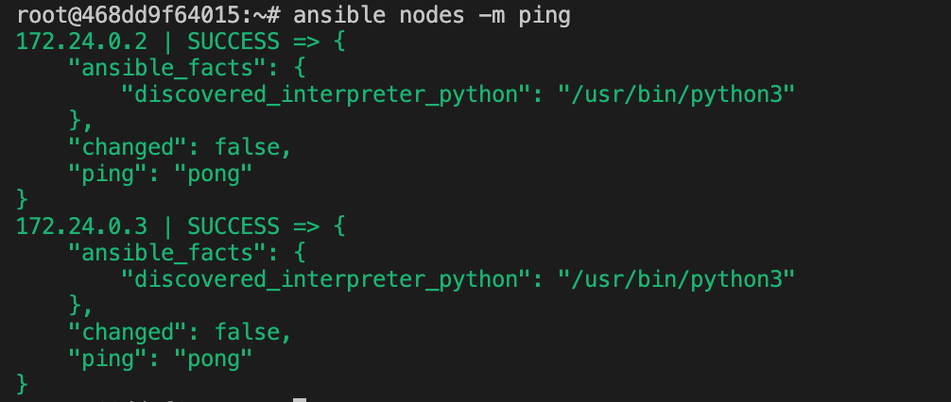

1. Setting up ansible:

* Setting Dockerfile as examples

Host>> ansible-config init --disable > ansible.cfg

Host>> ansible-config --version

Host>> ansible nodes -m ping

**Basic AdHoc Command:**

1. ansible all -a "/sbin/reboot"

reboot cannot work with docker containers of Ubuntu

1. Directory and file:

**Copy files:**

Host>> ansible nodes -m file -a "path=/root/workspace/data mode=755 state=directory"

Host>> ansible nodes -m ansible.builtin.copy -a "src=/root/workspace/data/test_copy.txt dest=/root/workspace/data/test_copy.txt"

**Delete Directory:**

Host>> ansible nodes -m file -a "dest=/root/workspace/test_delete_dir mode=755 state=directory"

Host>> ansible nodes -m file -a "dest=/root/workspace/test_delete_dir state=absent"

**Shell**

Host>> ansible nodes -m shell -a "cat /etc/passwd"

**Change Owner**

Host>> echo "this is test change owner from host" > data/test_chown

Host>> ansible nodes -m copy -a "src=/root/workspace/data/test_chown dest=/root/workspace/data/test_chown"

Host>> ansible nodes -m user -a "name=khoa group=root"

Host>> ansible nodes -m file -a "dest=/root/workspace/data/test_chown mode=600 owner=khoa"

**Managing packages:**

Host>> ansible nodes -m apt -a "name=acme state=present"

Host>> ansible nodes -m apt -a "name=iputils-ping state=latest"

Host>> ansible nodes -m apt -a "name=acme state=absent"

**Managing users and groups:**

Host>> ansible nodes -m user -a "name=nam password={{ '123456' | password_hash('sha512') }}"

Host>> ansible nodes -m user -a "name= nam group=root"

Host>> ansible nodes -m user -a "name=nam state=absent"

**Managing Services:**

Host>> ansible nodes

**Gathering Facts:**

Host>> ansible nodes -m setup

**Patterns:** [**https://docs.ansible.com/ansible/latest/inventory_guide/intro_patterns.html#intro-patterns**](https://docs.ansible.com/ansible/latest/inventory_guide/intro_patterns.html#intro-patterns)

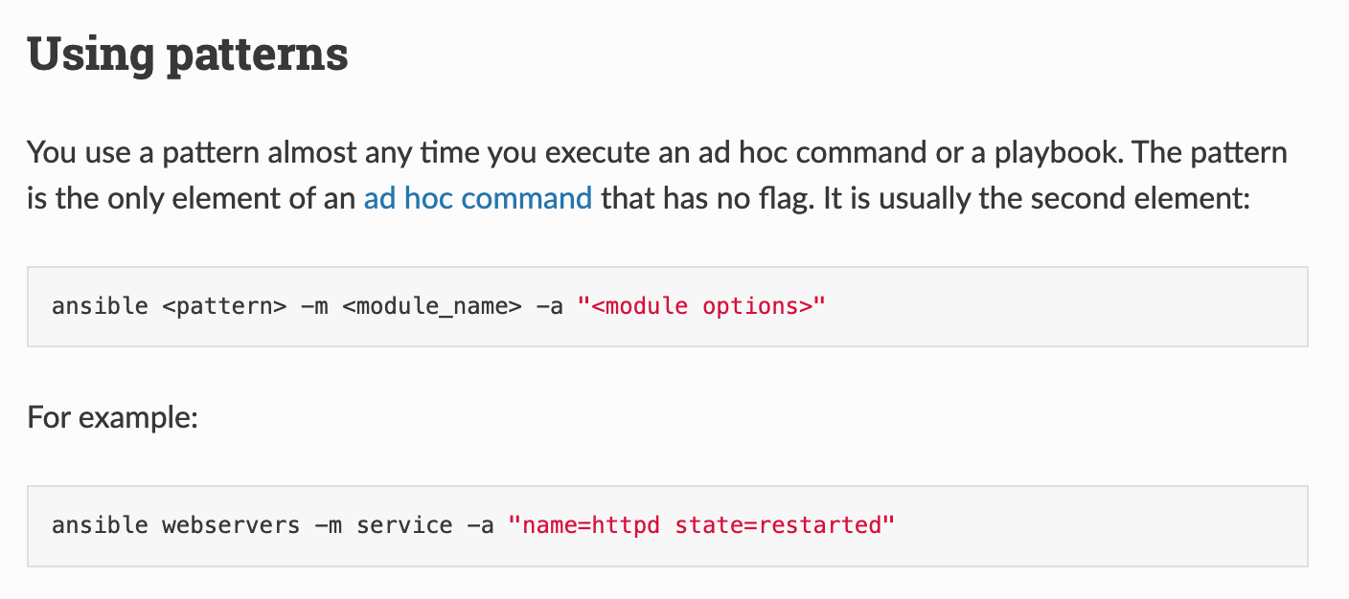

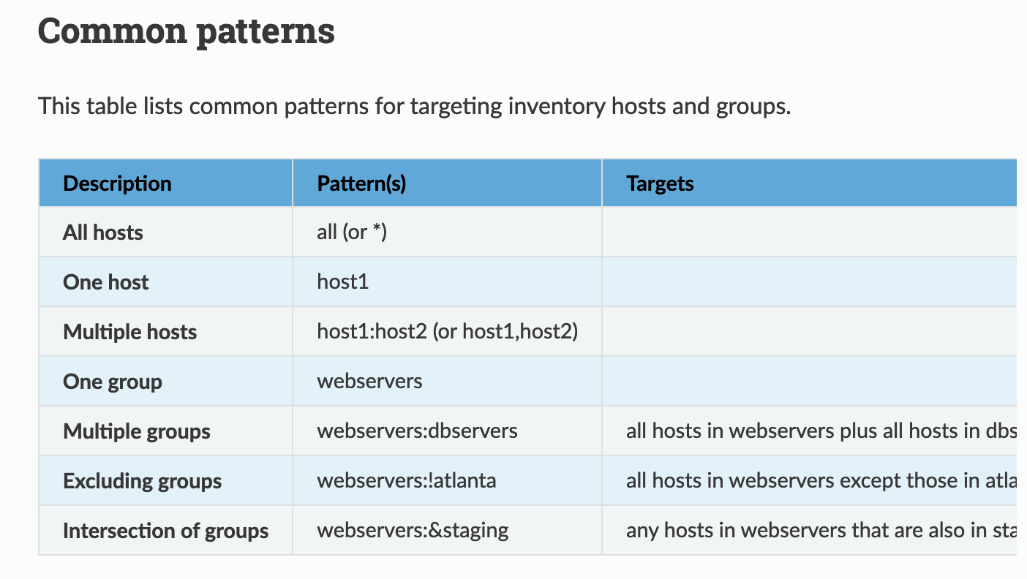

Host>> ansible 172.24.0.3* -m ping

Host>> ansible 172.24.0.3:172.24.0.2 -m ping

**Ansible Playbook**

**Basic Playbook:**

Host>> ansible-playbook data/install_apache.yml

**The when conditional:**

Host>> ansible nodes -m gather_facts --limit 172.24.0.3 | grep ansible_distribution

**Improve the Playbook**

/etc/ansible/hosts

Using the Parameter in the inventory

References to <https://docs.ansible.com/ansible/latest/collections/ansible/builtin/package_module.html>