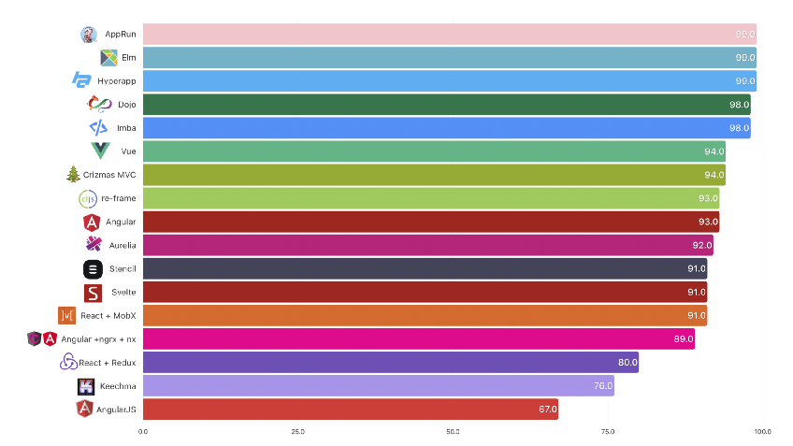
_Performance: +AngularJS:67
+React + Redux: 80
+Vue: 94

_Learning curve:
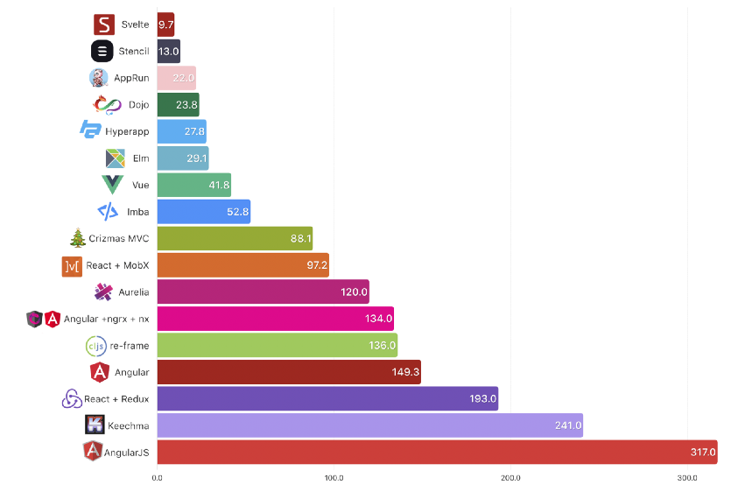
_Size: +Angular: 317
+React + Redux:193
+Vue: 41.8

_Data binding: + React one way data binding.
+ Angular 2 way.

_App achitechture: Flux, MVC

https://www.freecodecamp.org/news/a-realworld-comparison-of-front-end-frameworks-with-benchmarks-2019-update-4be0d3c78075/
https://www.altexsoft.com/blog/engineering/react-vs-angular-compared-which-one-suits-your-project-better/
https://www.educba.com/reactjs-vs-angularjs/
https://hackernoon.com/reactjs-vs-angular-comparison-which-is-better-805c0b8091b1

