_Getting started: <https://blog.mailtrap.io/send-emails-with-gmail-api/>

How to send email with attachment: <https://www.youtube.com/watch?v=YVgj9ngUlaY>

_Gmail API guide: <https://developers.google.com/gmail/api/guides>

_Gmail message: <https://developers.google.com/gmail/api/v1/reference/users/messages#resource>

_Gmail API download: <https://developers.google.com/gmail/api/downloads>

1. Work to do:
2. REST, RESTful: description, examples
3. File reading, directory in JavaScript.
4. OOP in JavaScript, Data structure, algorithm
5. Getting started with: Send, Receive Gmail:

Complete the Sign up application. (1 week)

1. Deep learn about Gmail API:

_Sign in with Google: <https://developers.google.com/identity/sign-in/web/sign-in>

_Big project: Shopping Management, with gmail extention.

1. Requirement:

_Have login: only admin can login, new account must be created.

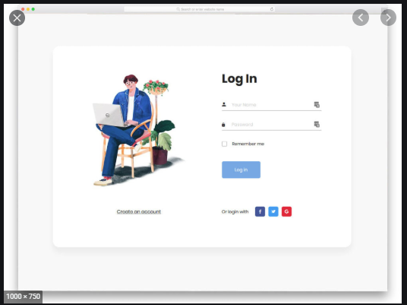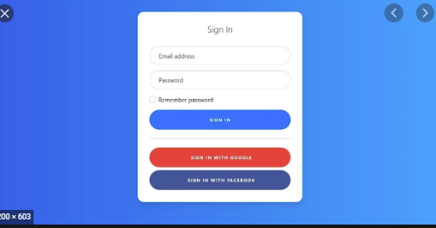

Figure 1: Log in page.

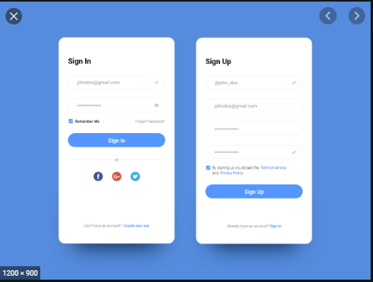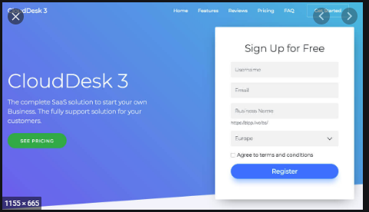

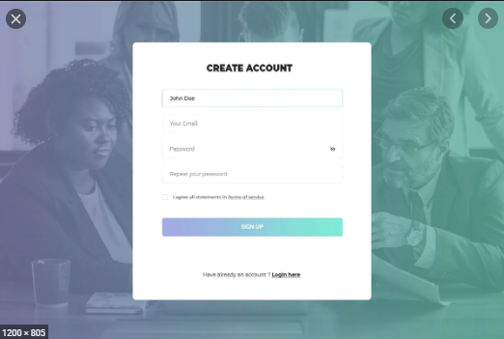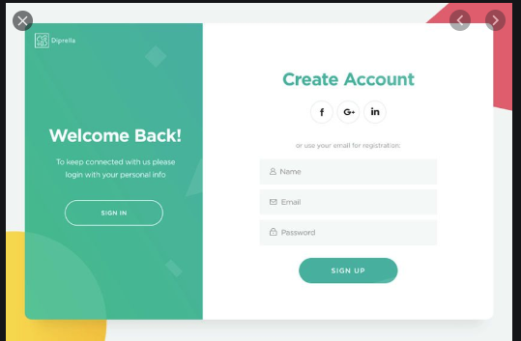

Figure 2: Sign up page

_

**_**

_