1) Abstraction:
2) Encapsulation:
Here is the comparision of ES5 and ES6 classes:
Note that the JS doesnt have actual class like Java, not very pure class. However, we can implement is in many way with function and prototype.

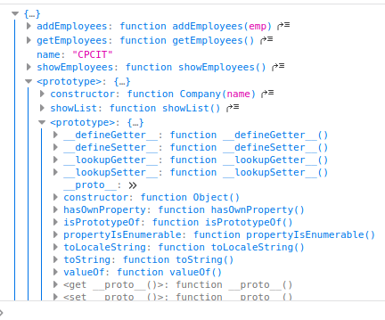
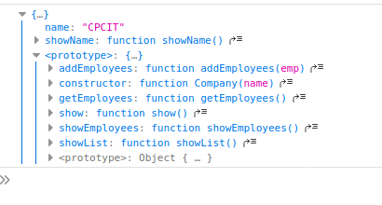

3) Inheritance-Subclassing:
In ES6 class, we cannot change the prototype of a class.
In function class, we can change the prototype => We can use inheritance by Programmer.prototype = new Person("khoa", 21);

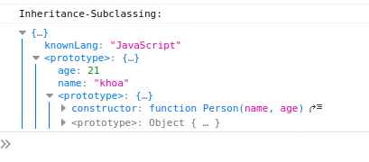
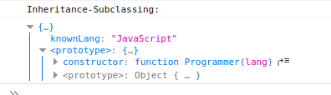

4)Polymophism:
_Different from classical OOP.
_Dynamic type, and Object can derive from parent objects.

