RESTful
I/ What is REST?
_Representational State Transfer.
_Daily life analogous: articles on some website is Creat-ed by a author. Then he can Edit, Update. Then he decided to Delete the articles.
_When trying to Create a resource, try to use POST.
Example: <form method=”POST” action=”www.google.com”><\form>
_When Update a resource, try to use PUT.
_Delete a resource by DELETE.
_When trying to display anything to the user, try to use GET.
_REST is an architecture for client to communicate with servers.
_RESTful API is any API support client to exploit the server by using REST architecture, which is HTTP but follow REST rules.

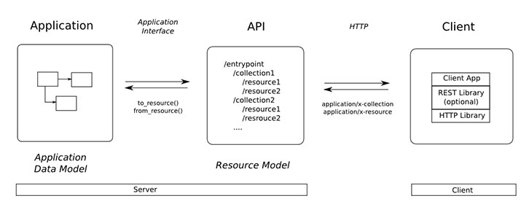
Figure 1: How RESTful works

II/How it works?
1) Data return:
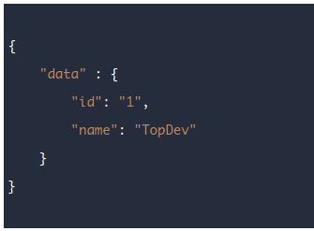

Figure 2: Data return is an objects in JS

2) Status code:
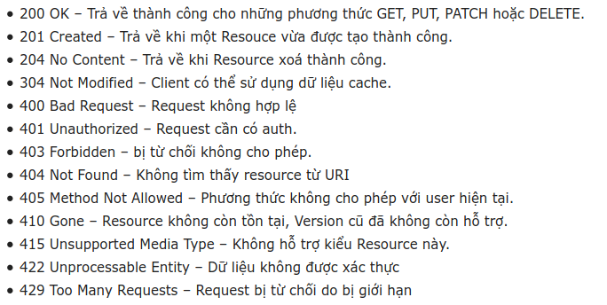
3) Properties of RESTful API:
_Client-Server: Client and server are separated → improve portability of API.
_Stateless
_Cacheable: client can reuse data from server after using it.
_Uniform interface:
_Layered System:
_Code on demand: download extention and execute in form of applets or scripts on demand
without pre-implemented.
=> A truthly RESTful API looks like Hypertext.

