_Getting started: https://blog.mailtrap.io/send-emails-with-gmail-api/
How to send email with attachment: https://www.youtube.com/watch?v=YVgj9ngUlaY
Google sign in button: https://developers.google.com/identity/branding-guidelines?hl=vi
_Gmail API guide: https://developers.google.com/gmail/api/guides
_Gmail message: https://developers.google.com/gmail/api/v1/reference/users/messages#resource
_Gmail API download: https://developers.google.com/gmail/api/downloads
- Work to do:
- REST, RESTful: description, examples
- File reading, directory in JavaScript.
- OOP in JavaScript, Data structure, algorithm
- Getting started with: Send, Receive Gmail:
Complete the Sign up application. (1 week)
- Deep learn about Gmail API:
_Sign in with Google: https://developers.google.com/identity/sign-in/web/sign-in
_Big project: Shopping Management, with gmail extention.
- Requirement:
_Have login: only admin can login, new account must be created.
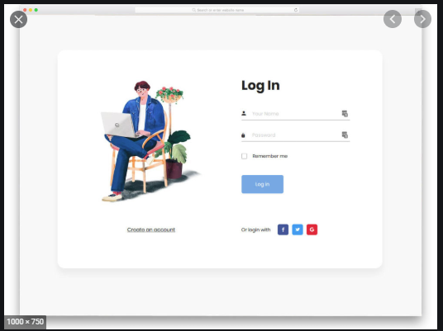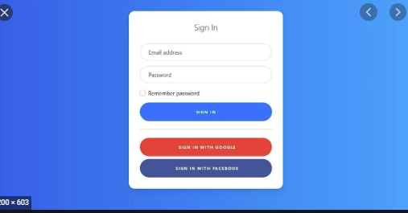
Figure 1: Log in page.

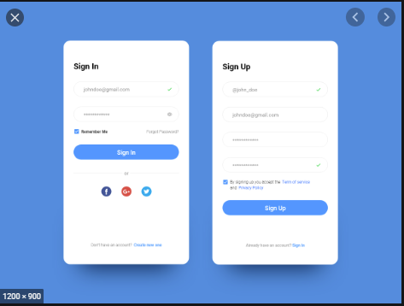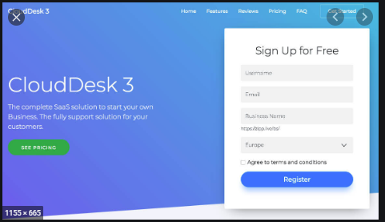
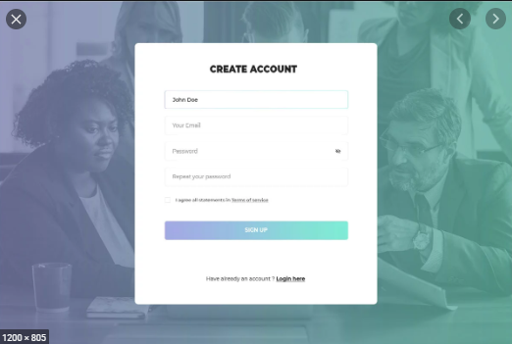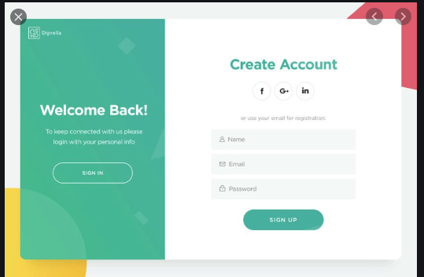
Figure 2: Sign up page

_
_
_

