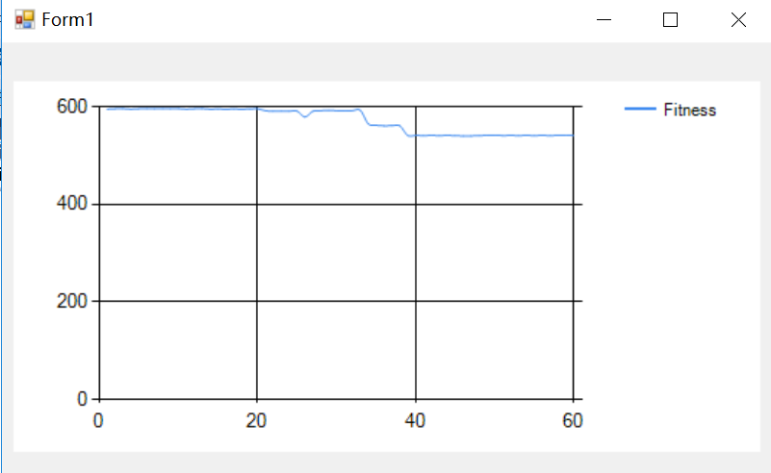

595

596

596

595

596

596

596

596

596

596

595

596

596

595

595

595

595

595

595

596

592

591

591

591

591

579

591

592

593

592

592

592

593

565

562

561

561

561

541

541

541

541

541

541

541

540

540

541

541

542

541

541

541

541

541

541

541

541

542

541

Best Fitness: 540, with ChromosomeXs: 268, 225, 59, 29, 541, 102, 41, 166, 41, 58, 195, 203, 557, 19, 456, 170, 346, 498, 598, 185, 222, 176, 48, 394, 51, 139, 515, 180, 468, 17, 234, 68, 134, 231, 418, 25, 60, 125, 531, 558, 68, 504, 163, 96, 340, 417, 13, 451, 283, 232, 131, 40, 29, 33, 310, 182, 516, 52, 133, 462, 288, 19, 475, 141, 204, 415, 276, 396, 326, 71, 125, 222, 57, 406, 185, 227, 322, 443, 483, 281, 373, 271, 112, 58, 84, 65, 549, 571, 65, 478, 600, 437, 142, 133, 353, 176, 205, 177, 296, 197, 355, 211, 214, 534, 160, 78, 105, 143, 324, 378, 99, 274, 234, 381, 230, 118, 78, 92, 255, 230, 256, 379, 198

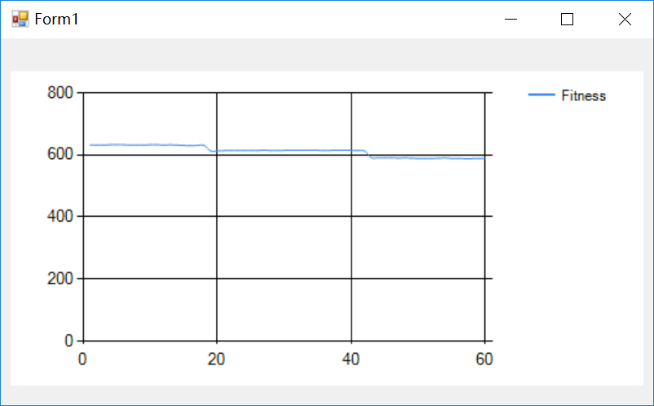

632

632

632

633

633

633

632

632

632

633

633

632

633

632

631

630

631

631

613

613

614

614

614

615

614

614

616

614

614

615

616

615

615

615

615

614

615

615

616

615

614

613

591

591

591

591

590

591

590

589

589

589

590

591

589

589

588

588

589

589

Best Fitness: 588, with ChromosomeXs: 120, 146, 200, 84, 144, 99, 302, 249, 565, 518, 102, 355, 159, 10, 193, 138, 487, 54, 196, 138, 201, 95, 323, 495, 411, 414, 424, 413, 192, 461, 286, 370, 321, 140, 14, 45, 216, 48, 559, 61, 238, 91, 55, 120, 382, 91, 136, 216, 418, 279, 398, 375, 295, 582, 20, 10, 416, 287, 277, 332, 582, 507, 63, 99, 272, 326, 42, 78, 584, 136, 528, 415, 184, 64, 284, 296, 495, 578, 37, 124, 389, 323, 165, 180, 262, 134, 194, 193, 225, 120, 237, 87, 355, 249, 90, 359, 59, 568, 436, 59, 73, 117, 231, 274, 341, 559, 460, 177, 45, 569, 132, 437, 548, 44, 187, 160, 105, 65, 442, 387, 262, 272, 560

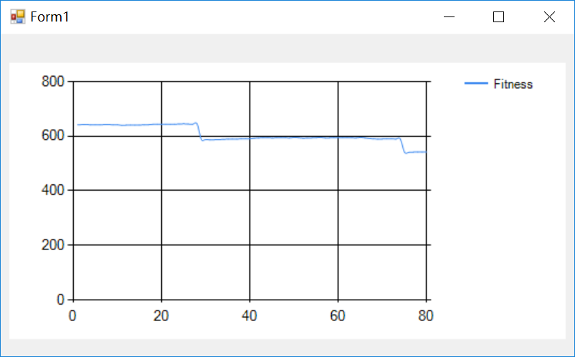

642

643

643

642

642

642

643

643

642

642

640

641

641

641

641

642

642

644

644

644

644

644

644

645

646

645

644

646

588

588

587

587

588

589

590

590

590

591

591

591

593

594

595

595

594

595

595

595

594

596

595

593

594

594

595

596

594

594

595

595

595

595

595

594

596

594

592

591

590

590

591

591

590

590

541

541

542

542

542

542

Best Fitness: 541, with ChromosomeXs: 474, 177, 180, 226, 432, 47, 416, 415, 232, 372, 151, 144, 407, 10, 20, 125, 268, 379, 498, 46, 227, 45, 81, 353, 320, 236, 438, 13, 154, 311, 453, 249, 434, 571, 531, 92, 307, 462, 210, 109, 544, 432, 319, 543, 143, 158, 68, 211, 228, 489, 245, 89, 214, 127, 135, 467, 127, 10, 254, 79, 68, 415, 366, 212, 20, 229, 161, 15, 288, 32, 559, 462, 207, 406, 106, 357, 309, 110, 151, 161, 136, 243, 408, 243, 79, 360, 10, 279, 465, 33, 589, 317, 211, 104, 49, 104, 27, 130, 526, 562, 591, 241, 251, 177, 206, 196, 53, 427, 13, 339, 177, 46, 495, 72, 508, 389, 42, 139, 594, 513, 317, 105, 538

//初始化

static public int OFFSET = 30000;

static private int NP = 60;//种群个数

//static private int[][] ChromosomeSize = new int[Station.stationCount][];//染色体长度

static private int ChromosomeSize = Station.stationCount * Time.K;//染色体长度

//static private int ChromosomeSize = 41;//染色体长度

static private int NM = 80;//最大迭代次数

static private float PC = 0.3f;//交叉因子

static private float PM = 0.1f;//变异系数

//public int[] Fit_values = new int[48];//存储适应度值

//public int fit_value_change;

//初始化

static public int OFFSET = 30000;

static private int NP = 60;//种群个数

//static private int[][] ChromosomeSize = new int[Station.stationCount][];//染色体长度

static private int ChromosomeSize = Station.stationCount * Time.K;//染色体长度

//static private int ChromosomeSize = 41;//染色体长度

static private int NM = 80;//最大迭代次数

static private float PC = 0.3f;//交叉因子

static private float PM = 0.1f;//变异系数

//public int[] Fit_values = new int[48];//存储适应度值

//public int fit_value_change;

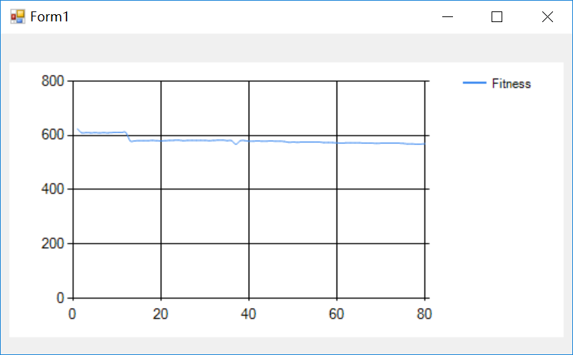

Best Fitness: 568, with ChromosomeXs: 428, 184, 212, 26, 97, 204, 150, 595, 150, 47, 86, 474, 211, 362, 240, 13, 364, 161, 176, 350, 516, 379, 342, 204, 143, 462, 312, 321, 176, 127, 278, 296, 215, 355, 22, 487, 366, 148, 533, 321, 544, 518, 410, 64, 20, 331, 127, 61, 50, 164, 233, 156, 259, 193, 287, 65, 94, 269, 592, 45, 109, 268, 36, 200, 34, 339, 249, 501, 320, 329, 270, 235, 209, 442, 397, 581, 569, 304, 210, 438, 325, 422, 245, 246, 502, 142, 79, 56, 62, 546, 436, 79, 155, 514, 208, 276, 503, 233, 60, 275, 86, 229, 339, 336, 490, 17, 566, 393, 372, 282, 97, 391, 116, 178, 277, 467, 569, 19, 301, 488, 272, 220, 42

625

610

611

610

610

610

610

610

611

611

611

611

580

580

581

581

581

582

581

580

581

582

582

583

581

582

582

582

582

582

581

582

583

583

581

581

568

581

581

579

579

580

579

579

580

579

579

578

575

576

575

576

线程 0x470c 已退出，返回值为 0 (0x0)。

576

576

576

576

574

574

574

573

572

573

573

573

573

572

572

572

571

572

572

572

572

572

571

569

569

568

568

570

//初始化

static public int OFFSET = 30000;

static private int NP = 60;//种群个数

//static private int[][] ChromosomeSize = new int[Station.stationCount][];//染色体长度

static private int ChromosomeSize = Station.stationCount * Time.K;//染色体长度

//static private int ChromosomeSize = 41;//染色体长度

static private int NM = 100;//最大迭代次数

static private float PC = 0.3f;//交叉因子

static private float PM = 0.1f;//变异系数

//public int[] Fit_values = new int[48];//存储适应度值

//public int fit_value_change;

5个站

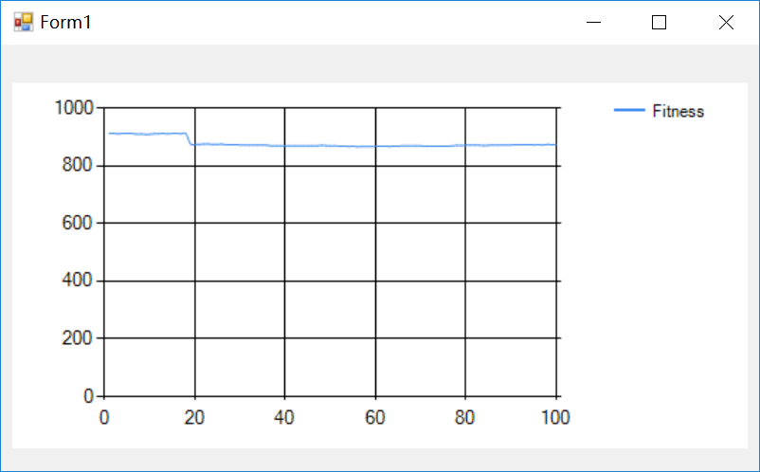

913

912

911

912

912

912

910

910

909

909

911

911

912

911

912

912

911

911

876

874

874

875

875

874

874

875

873

873

873

872

872

871

872

871

871

871

869

870

869

869

869

869

869

869

869

869

869

871

870

869

869

868

868

867

868

866

867

867

867

867

868

868

867

868

868

869

869

869

870

869

868

868

868

868

线程 0x5c30 已退出，返回值为 0 (0x0)。

868

868

869

871

870

871

871

871

871

870

871

871

871

872

872

872

873

873

873

873

872

873

872

874

873

874

//初始化

static public int OFFSET = 30000;

static private int NP = 60;//种群个数

//static private int[][] ChromosomeSize = new int[Station.stationCount][];//染色体长度

static private int ChromosomeSize = Station.stationCount * Time.K;//染色体长度

//static private int ChromosomeSize = 41;//染色体长度

static private int NM = 100;//最大迭代次数

static private float PC = 0.3f;//交叉因子

static private float PM = 0.1f;//变异系数

//public int[] Fit_values = new int

5个站

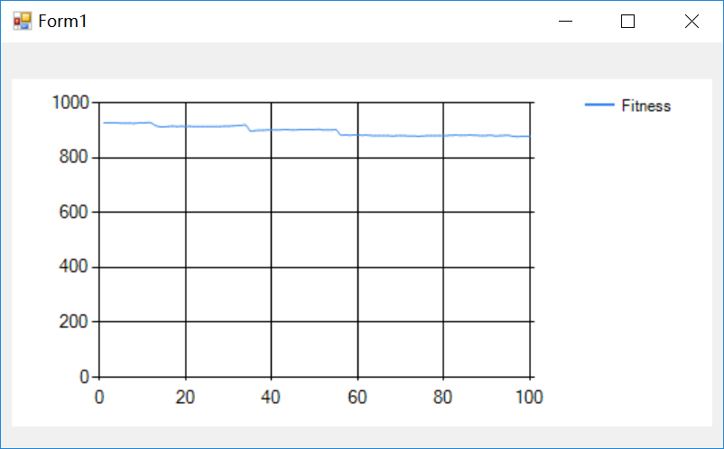

Best Fitness: 877, with ChromosomeXs: 486, 347, 529, 508, 430, 317, 177, 479, 70, 307, 266, 484, 154, 394, 70, 137, 226, 33, 98, 528, 218, 345, 351, 261, 13, 423, 572, 551, 402, 77, 367, 285, 503, 51, 193, 577, 237, 507, 416, 430, 270, 148, 99, 197, 301, 76, 366, 242, 161, 94, 281, 447, 491, 255, 31, 440, 25, 305, 469, 11, 374, 186, 48, 13, 529, 544, 14, 134, 200, 30, 498, 327, 228, 296, 312, 17, 253, 123, 526, 556, 94, 318, 382, 322, 442, 512, 427, 238, 520, 404, 599, 542, 10, 396, 89, 44, 128, 72, 280, 421, 92, 230, 31, 127, 210, 535, 234, 227, 544, 13, 528, 333, 41, 79, 121, 67, 150, 42, 591, 229, 50, 23, 139, 284, 175, 530, 223, 281, 331, 529, 344, 15, 240, 442, 482, 533, 272, 587, 19, 242, 58, 130, 328, 314, 214, 529, 43, 410, 164, 336, 159, 173, 137, 499, 251, 273, 63, 275, 61, 286, 254, 416, 87, 325, 143, 559, 575, 328, 109, 137, 346, 146, 256, 298, 323, 10, 117, 245, 196, 578, 388, 248, 583, 158, 220, 357, 235, 335, 57, 576, 120, 484, 215, 400, 290, 44, 10, 261, 54, 343, 488, 286, 266, 332, 81

927

927

927

927

926

926

926

925

927

927

928

927

917

913

912

914

915

914

914

914

914

913

913

913

913

913

913

914

914

915

916

917

918

918

898

899

900

900

901

901

901

901

903

902

901

902

902

902

902

903

903

901

901

901

901

883

883

882

882

883

882

882

881

880

880

880

880

线程 0x63a4 已退出，返回值为 0 (0x0)。

879

880

880

880

879

879

878

879

880

880

880

880

880

881

882

882

881

882

882

882

881

880

881

881

879

880

881

881

878

877

877

878

878

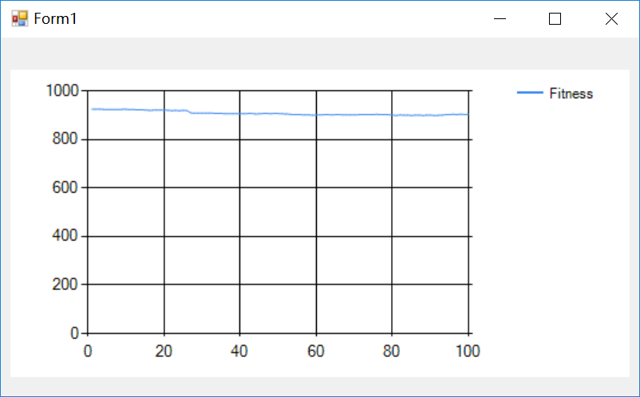

925

925

925

924

923

923

923

923

924

924

923

923

922

922

921

920

920

921

921

921

920

919

919

919

919

919

910

908

908

908

909

909

908

907

907

906

907

906

906

906

906

907

907

905

906

907

907

906

908

907

906

905

904

902

902

902

901

901

900

901

901

902

902

901

902

902

901

901

901

901

902

902

903

902

903

903

902

902

902

线程 0x4e50 已退出，返回值为 0 (0x0)。

901

899

901

900

900

899

900

900

899

900

900

899

899

900

902

903

903

903

904

903

903

Best Fitness: 899, with ChromosomeXs: 496, 599, 188, 136, 485, 483, 42, 31, 335, 316, 477, 34, 75, 334, 153, 55, 541, 521, 249, 119, 439, 580, 494, 10, 482, 481, 379, 28, 461, 209, 202, 151, 139, 174, 435, 238, 166, 291, 296, 39, 511, 256, 392, 287, 369, 430, 27, 33, 202, 139, 248, 343, 467, 264, 161, 488, 53, 184, 244, 546, 87, 46, 182, 146, 135, 299, 471, 522, 470, 519, 520, 246, 202, 204, 242, 224, 235, 210, 250, 19, 481, 357, 422, 313, 531, 443, 271, 473, 13, 554, 123, 581, 23, 307, 580, 463, 85, 260, 144, 68, 582, 144, 135, 267, 213, 20, 120, 256, 38, 533, 238, 453, 540, 248, 118, 345, 230, 424, 189, 280, 10, 40, 485, 499, 409, 587, 213, 505, 234, 365, 160, 571, 64, 184, 97, 336, 279, 128, 103, 546, 330, 50, 441, 79, 305, 299, 53, 420, 232, 241, 244, 190, 53, 457, 32, 540, 269, 207, 471, 264, 405, 240, 15, 272, 419, 281, 386, 336, 136, 357, 99, 114, 310, 242, 583, 97, 141, 444, 238, 122, 508, 387, 273, 590, 133, 548, 560, 241, 159, 96, 119, 37, 271, 436, 166, 120, 12, 203, 257, 600, 513, 290, 275, 445, 130

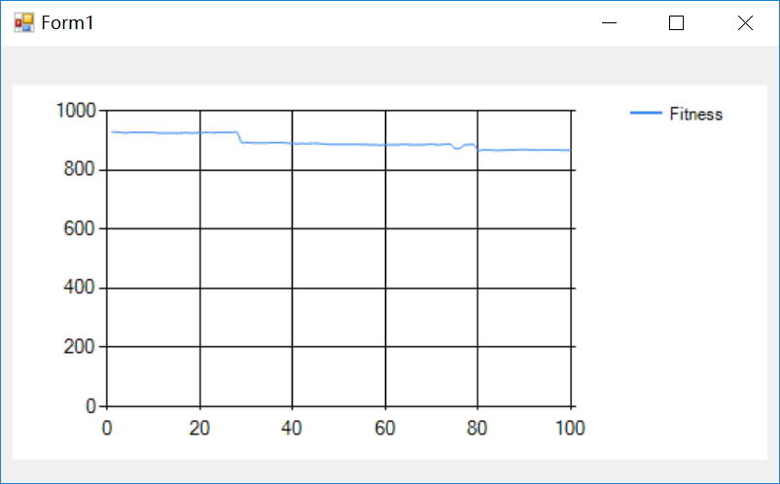

Best Fitness: 866, with ChromosomeXs: 45, 416, 115, 493, 216, 164, 14, 133, 530, 349, 36, 326, 578, 366, 401, 63, 350, 28, 151, 318, 170, 460, 513, 304, 162, 175, 260, 68, 521, 98, 193, 386, 40, 344, 256, 296, 182, 396, 64, 448, 111, 308, 195, 149, 103, 134, 288, 345, 135, 109, 324, 84, 63, 60, 83, 181, 514, 459, 330, 32, 491, 585, 242, 402, 144, 237, 274, 201, 222, 25, 257, 250, 465, 267, 475, 480, 310, 29, 239, 292, 356, 479, 265, 219, 193, 310, 14, 237, 56, 529, 350, 87, 519, 205, 204, 134, 10, 306, 151, 153, 362, 191, 307, 14, 226, 389, 62, 359, 537, 240, 511, 145, 316, 303, 198, 520, 585, 370, 41, 56, 522, 311, 532, 548, 305, 168, 457, 66, 283, 588, 312, 516, 352, 336, 172, 383, 293, 583, 260, 589, 56, 563, 87, 81, 197, 276, 31, 370, 400, 48, 206, 384, 342, 546, 514, 152, 166, 305, 333, 36, 560, 43, 103, 484, 516, 28, 375, 581, 186, 396, 204, 33, 100, 61, 589, 576, 220, 454, 376, 24, 145, 21, 226, 217, 389, 529, 186, 439, 342, 600, 234, 20, 218, 235, 56, 46, 419, 182, 155, 198, 517, 79, 228, 27, 468

928

928

927

925

927

927

927

927

928

927

925

924

925

925

924

925

926

925

925

926

926

927

926

928

927

928

927

927

893

893

892

891

892

891

892

892

892

892

891

890

889

890

889

890

890

889

888

886

886

886

886

886

887

886

886

886

885

885

884

886

885

885

886

887

886

885

886

885

887

887

885

886

887

887

873

873

885

885

886

867

线程 0x1384 已退出，返回值为 0 (0x0)。

868

868

867

866

867

867

868

868

869

869

868

868

867

868

868

868

868

867

867

867

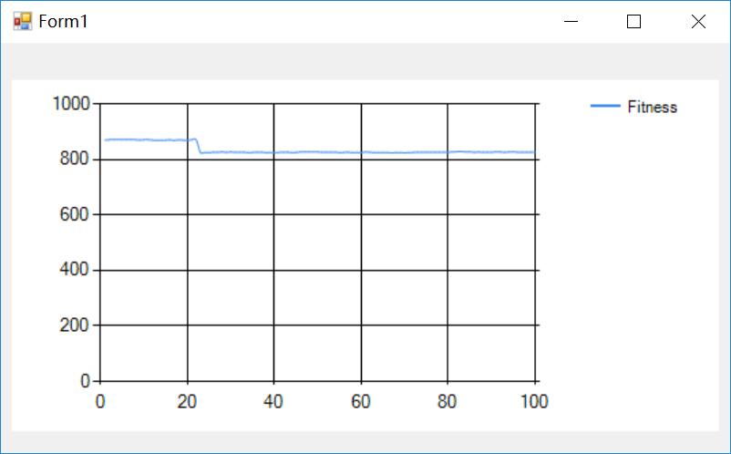

870

871

872

872

871

872

871

871

870

871

871

870

869

869

870

870

869

871

870

869

871

871

825

825

825

826

826

827

826

827

826

826

826

825

825

826

826

825

825

825

825

线程 0x6064 已退出，返回值为 0 (0x0)。

826

826

825

825

827

827

827

827

827

826

826

826

826

825

825

826

825

825

825

827

826

825

825

825

825

824

825

825

824

825

825

826

826

826

826

826

826

826

826

827

828

828

827

827

826

827

826

826

826

828

827

826

827

828

826

826

826

826

826

Best Fitness: 824, with ChromosomeXs: 325, 494, 401, 124, 511, 114, 586, 600, 171, 361, 98, 392, 416, 301, 57, 76, 189, 55, 57, 199, 27, 181, 520, 489, 423, 273, 10, 536, 576, 517, 10, 377, 170, 11, 454, 448, 585, 243, 315, 334, 257, 511, 457, 173, 220, 332, 544, 528, 513, 444, 203, 113, 96, 354, 16, 324, 258, 585, 106, 48, 358, 95, 457, 366, 84, 150, 345, 265, 332, 307, 146, 123, 587, 111, 246, 101, 228, 13, 19, 82, 568, 331, 292, 390, 97, 461, 229, 428, 25, 147, 166, 592, 129, 272, 558, 209, 50, 101, 139, 99, 556, 346, 227, 223, 306, 107, 116, 592, 142, 525, 64, 232, 567, 62, 99, 74, 437, 88, 255, 226, 493, 517, 243, 216, 150, 130, 14, 369, 137, 29, 29, 144, 503, 544, 107, 232, 135, 28, 88, 58, 328, 254, 304, 108, 125, 531, 46, 84, 201, 504, 384, 581, 403, 499, 218, 98, 89, 29, 105, 184, 82, 362, 423, 79, 472, 495, 314, 38, 520, 434, 522, 410, 27, 210, 476, 184, 192, 148, 94, 163, 110, 151, 80, 348, 524, 78, 428, 106, 42, 417, 547, 377, 553, 218, 248, 37, 133, 38, 577, 92, 137, 330, 132, 525, 199

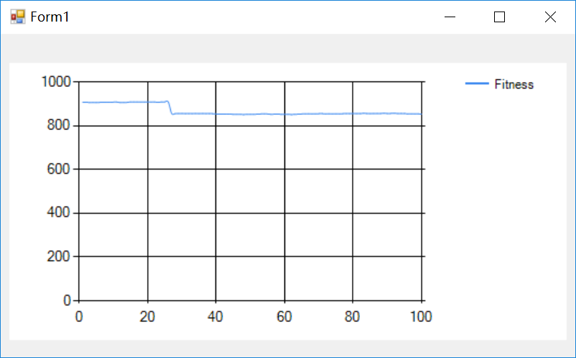

Best Fitness: 851, with ChromosomeXs: 52, 165, 368, 89, 41, 140, 260, 343, 178, 92, 560, 540, 87, 108, 600, 534, 150, 183, 175, 124, 451, 224, 400, 197, 380, 444, 287, 16, 402, 57, 15, 164, 203, 201, 543, 347, 351, 515, 468, 526, 280, 586, 191, 352, 87, 379, 410, 274, 529, 69, 88, 504, 324, 169, 104, 186, 329, 10, 430, 273, 289, 243, 116, 252, 272, 78, 68, 257, 132, 175, 207, 189, 538, 50, 125, 596, 532, 273, 275, 196, 448, 261, 586, 600, 384, 472, 326, 380, 502, 61, 51, 171, 240, 17, 228, 376, 521, 140, 104, 103, 487, 129, 421, 428, 223, 100, 190, 347, 309, 319, 488, 93, 511, 136, 376, 221, 278, 503, 340, 200, 83, 535, 567, 160, 136, 61, 527, 544, 402, 331, 81, 431, 185, 159, 314, 339, 429, 182, 375, 319, 312, 42, 99, 181, 146, 569, 253, 137, 247, 33, 125, 19, 396, 477, 62, 526, 173, 268, 333, 179, 356, 260, 519, 550, 238, 115, 513, 359, 427, 51, 369, 79, 117, 36, 494, 61, 474, 409, 593, 181, 398, 400, 295, 373, 238, 50, 55, 319, 81, 389, 171, 168, 466, 223, 190, 69, 114, 118, 509, 110, 65, 435, 293, 216, 301