Web-Based FYP Progress Tracking System

Name: Boon Yun Nee
Coventry Student ID: 16290411

Supervisor Name: Ms. Jivita Raja
Bachelor of Science with Honours in Computer Science
3+0 In Collaboration with Coventry University, UK

School of Computing, INTI International College Penang

19 June 2026

ACKNOWLEDGEMENT
I would like to express my deepest gratitude to Ms. Jivita Raja, my supervisor, for her invaluable guidance, support, and encouragement throughout this project. Her insights and expertise have been instrumental in shaping the direction and outcome of this work. Without her dedication and patience, this project would not have reached its full potential. I extend my sincere thanks to the faculty and staff of the School of Computing at INTI International College Penang for providing an excellent learning environment and the resources necessary to complete this project. Their unwavering support and dedication to student success have been greatly appreciated and have significantly contributed to my academic growth.
I am also grateful to Coventry University, UK, for offering this collaborative program, which has broadened my academic and professional horizons. The experience and knowledge gained through this collaboration have been invaluable, enriching my educational journey and preparing me for future challenges. A special thank you to my family and friends for their unwavering support and encouragement throughout my studies. Their belief in my abilities has been a constant source of motivation and strength, especially during challenging times.
Lastly, I would like to thank my fellow students and the entire community at INTI International College Penang for their camaraderie and support. Together, we have strived to create a positive and impactful learning experience, and their contributions have made this journey even more rewarding
TABLE OF CONTENTS
ACKNOWLEDGEMENT 2
LIST OF TABLES 5
LIST OF FIGURES 6
LIST OF ABBREVIATIONS 7
ABSTRACT 8
CHAPTER 1: INTRODUCTION 9
1.1 Problem Statement 9
1.2 Detailed Research Questions 12
1.3 Objectives 13
1.4 Clients, Audience, and Motivation 13
1.4.1 Students 13
1.4.2 Supervisors 14
1.4.3 Administrators 14
1.4.4 Motivation 15
1.5 Scope 16
1.6 Summary 17
Chapter 2: Literature Review 18
2.1 Introduction 18
2.2 Definition of Final Year Project Management 18
2.3 Challenges in Traditional FYP Management 19
2.4 Existing Systems and Technologies 20
2.4.1 FYP Management Systems in Higher Education 20
2.4.1.1 PSM Supervision System (UTHM) 20
2.4.1.2 Web-Based Information System for Monitoring Final Projects (STMIK Jayakarta) 22
2.4.1.3 UTM Final Year Project System 23
2.4.2 Comparison of Existing Technologies 26
2.5 Technology Stack Evaluation and Framework Selection 26
2.5.1 Enterprise Backend Architectures: PHP vs. Node.js vs. ASP.NET Core 27
2.5.2 Relational and NoSQL Storage Engines: MySQL vs. MongoDB vs. SQL Server 27
2.6 United Nations Sustainable Development Goals (SDG) Alignment 28
2.7 Conclusion 29
Chapter 3: Software Methodology 30
3.1 Introduction 30
3.2 Selection and Justification of Development Methodology 30
3.2.1 Waterfall Methodology 30
3.2.2 Prototyping Methodology 31
3.2.3 Selected Framework: Agile Scrum Methodology 31
3.4 Unified Modeling Language (UML) Use Case Architecture 32
3.5 System Interface Design 33
3.5.1 Mockup 1: Student Progress Tracking and Logbook Submission Interface 33
3.5.2 Mockup 2: Supervisor Request Evaluation & Time-Bound Allocation Interface 34
3.6 Project Schedule Planning (Gantt Chart) 35
3.7 Conclusion 35
REFERENCES 36
APPENDICES 38

LIST OF TABLES
Table No. | Title | Page
Table 2.1 | Modules of PSM Supervision System | 21
Table 2.2 | SWOT Analysis of Existing FYP Management System at STMIK Jayakarta | 23
Table 2.3 | Modules of UTM FYP Portal | 24
Table 2.4 | Comparative Analysis of Existing FYP Management Systems | 26

LIST OF FIGURES
Figure No. | Title | Page
Figure 1.1 | Students' final FYP scores, failure and non-submission rates under supervisor-centered allocation (AY2020-2021) and student-centered allocation mechanisms (AY2021-2022 and AY2022-2023) | 11
Figure 2.1 | Log in page of PSM Supervision System | 21
Figure 2.2 | Log in page of STMIK Jayakarta | 22
Figure 2.3 | Homepage for UTM FYP Portal | 24
Figure 3.1 | Structural Use Case Diagram Mapping Role-Isolated Operational Features to system actors | 32
Figure 3.2 | user interface for the primary Student Dashboard | 33
Figure 3.3 | user interface for the Supervisor Command Panel | 34
Figure 3.4 | Project Gantt Chart | 35

LIST OF ABBREVIATIONS
Abbreviation | Full Form
ASP.NET | Active Server Pages .NET Framework
CSS | Cascading Style Sheets
FYP | Final Year Projects
MVC | Model-View-Controller

ABSTRACT
The effective management of Final Year Projects (FYP) is essential to ensuring academic success and smooth collaboration among students, supervisors, and administrators. Despite its importance, current practices in many higher education institutions rely on manual or semi-digital approaches that lack integration and efficiency, often resulting in fragmented communication, delayed feedback, and challenges in monitoring project progress. This project addresses the critical gap in existing FYP management practices by proposing a dedicated web-based progress tracking system developed using ASP.NET Core MVC, Microsoft SQL Server, and Bootstrap.
The system digitises student progress submissions and tracking of weekly logbooks while implementing role-based dashboards for students, supervisors, and administrators that display real-time student progress, submission status, and pending approvals. Key functionalities include a supervisor selection module with automated 2-day rejection handling, a chapter submission and progress monitoring module, an online meeting booking system with status tracking, a supervisor report submission feature, and an administrative dashboard with Excel and CSV export capabilities. The system aims to modernise and streamline the FYP management workflow, improve transparency across all stakeholder levels, and ultimately enhance the quality of the final year project experience for students and supervisors alike.

CHAPTER 1: INTRODUCTION
The execution and management of a undergraduate Final Year Project (FYP) represents the definitive operational framework through which higher education institutions validate a student's technical, analytical, and professional competencies before graduation (Sa et al., 2021). Despite the critical academic weight carried by this milestone, contemporary management workflows within many modern tertiary institutions remain deeply tethered to disjointed, manual, or decentralized digital software infrastructures (Noor et al., 2023). This systemic reliance on fragmented channels—ranging from loose email threads to ad-hoc chat groups—consistently induces operational bottlenecks such as delayed feedback loops, untracked progress metrics, and severe communication mismatches between coordinators, faculty mentors, and candidates (Kolade et al., 2024). Consequently, an urgent academic requirement has emerged to research, design, and deploy integrated web-based tracking solutions capable of digitizing the thesis lifecycle, establishing transparent operational supervision, and standardizing real-time progress assessment across all institutional tiers (Hariyanto et al., 2025).

1.1 Problem Statement
The final year project (FYP) is a critical component of undergraduate programs, serving as a culmination of students' academic learning and a demonstration of their research and technical capabilities. However, the supervision and management of FYP processes across many higher education institutions remain fraught with inefficiencies, leading to negative outcomes for both students and supervisors (Sa et al., 2021). A significant challenge is the lack of a centralized, real-time system to monitor student progress throughout the project lifecycle. Traditional methods, which often rely on intermittent face-to-face meetings, email chains, and manual paper-based documentation, result in poor communication, delayed feedback, and an inability to identify at-risk students before it is too late. This fragmented approach contributes to missed deadlines, inconsistent supervisor expectations, and ultimately, lower quality project outcomes (Noor et al., 2023). Students frequently report confusion regarding submission requirements and a lack of clarity on their performance standing, while supervisors struggle to manage multiple supervisees efficiently (Zaheer & Munir, 2020).

The consequences of these inefficiencies are quantifiable. A study on Nigerian tertiary institutions identified that poor monitoring and communication frameworks directly contribute to project abandonment and extended completion times, with a call for digital interventions to mitigate these challenges (Kolade et al., 2024). Furthermore, the absence of an integrated system prevents the automated tracking of key performance indicators, such as milestone completion rates and supervisor feedback frequency, making it difficult for program coordinators to intervene proactively (Fatman et al., 2023). Research into prototype development for FYP management has shown that a dedicated system can significantly improve the monitoring of student performance and streamline administrative workflows (Isa et al., 2024).

A recent study by Yuan et al. (2024) highlights the profound effectiveness of student-centered allocation mechanisms in optimizing academic performance metrics, eliminating failures, and mitigating non-submission risks, as illustrated in Figure 1.1. According to the empirical data, the transition from a traditional supervisor-centered allocation framework to a student-centered model completely eradicated the student failure rate, driving it down from 3.8% in AY2020-2021 to 0.0% across both AY2021-2022 and AY2022-2023. Furthermore, the institutional non-submission rate experienced a drastic, continuous decline, falling from 3.9% under the supervisor-centric method down to 1.1% and subsequently to an ultimate low of 0.7% following the digital implementation of student-centered selection mechanics (Yuan et al., 2024). This concrete statistical evidence underscores the critical operational requirement for a structured, data-driven approach to managing higher education FYP processes.

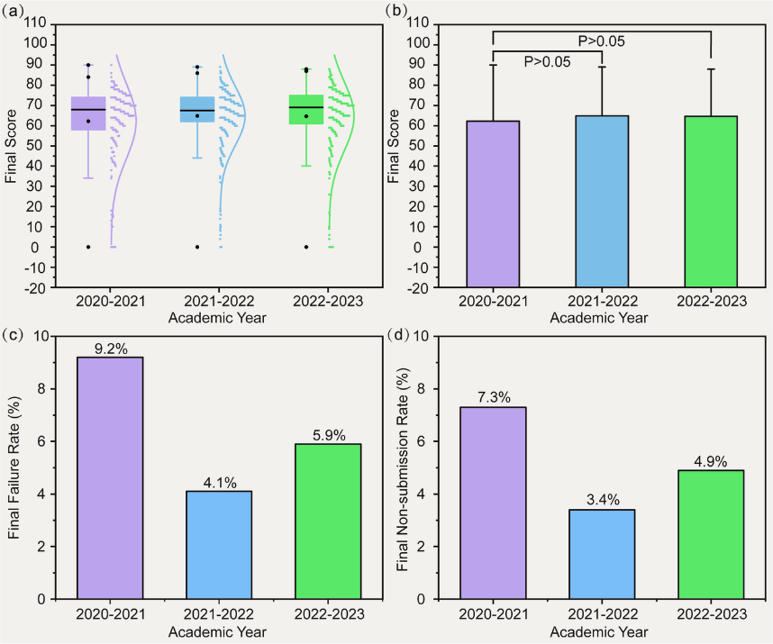
Figure 1.1: Students’ final FYP scores, failure and non-submission rates under supervisor-centered allocation (AY2020-2021) and student-centered allocation mechanisms (AY2021-2022 and AY2022-2023)
(Source: Yuan et al. (2024), Humanities and Social Sciences Communications)

The figure demonstrates that a student-centered approach leads to higher scores, lower failure rates, and reduced non-submission. This further supports the argument for a dedicated web-based tracking system that can facilitate such student-centered processes by providing real-time progress monitoring and automated alerts (Horng & Abdullah, 2025).

Therefore, this project addresses the critical gap in existing FYP management practices by proposing a dedicated web-based progress tracking system. The core issue lies in the absence of a centralized and role-specific platform that enables real-time monitoring of student progress, structured communication, and timely feedback. Without such a system, inefficiencies such as delayed feedback, poor monitoring, and inconsistent supervision will continue to affect student performance and project outcomes (Jailani et al., 2022).

1.2 Detailed Research Questions
To properly guide the architectural formulation of this digital intervention, specific research inquiries must be established. The following two research questions are systematically constructed utilizing the strict What, Why, and How analytical framework to ensure profound scholarly depth:
Research Question 1 (Progress Tracking & Logbook Digitization)
- What: What are the definitive architectural components required to engineer a centralized student progress tracking dashboard that accurately digitizes weekly logbooks and displays multi-tier chapter submission states? (Isa et al., 2024)
- Why: Why do traditional, paper-based, or unintegrated tracking methods consistently introduce extensive evaluation delays, suppress visibility into student task velocity, and cause students to miss critical thesis completion deadlines? (Noor et al., 2023)
- How: How can a web-based, role-specific tracking portal be systematically implemented to provide real-time completion percentages, color-coded visual progress indicators, and automated timeline alert banners to proactively mitigate project stagnation? (Hariyanto et al., 2025)

Research Question 2 (Supervisor Selection & Request Allocation)
- What: What automated backend logical policies and user-interface mechanisms must be coded to create an equitable, student-centered supervisor selection process within an institutional framework? (Jailani et al., 2022)
- Why: Why does the absence of structured, time-bound response policies within faculty selection systems lead to extreme allocation bottlenecks, heightened student anxiety, and prolonged delays in thesis commencement? (Horng & Abdullah, 2025)
- How: How can an automated request-handling pipeline utilizing a strict, server-side 2-day countdown expiration and auto-rejection mechanism be engineered to optimize student-mentor pairing equity and maximize available quota transparency? (Yuan et al., 2024)

1.3 Objectives
To achieve the technical and structural solutions necessary to overcome the institutional issues detailed in the problem statement, the implementation lifecycle of this software project is strictly governed by the following two core objectives:
- To design and develop a centralized web-based FYP progress tracking system using ASP.NET Core MVC, Microsoft SQL Server, and Bootstrap that digitizes student progress submissions and tracking of weekly logbooks (Fatman et al., 2023).
- To implement role-based dashboards (for students, supervisors, and administrators) that display real-time student progress, submission status, and pending approvals with integrated automated 2-day selection rejection handling (Horng & Abdullah, 2025).

1.4 Clients, Audience, and Motivation
The primary institutional client and deployment site for this project is the School of Computing at INTI International College Penang, an environment that demands rigorous monitoring of academic benchmarks across its degree programs. The deployment of this web-based tracking solution directly replaces fragmented, paper-based operations with a synchronized relational architecture (Fatman et al., 2023). To fully understand the operational necessity of this system, it is vital to analyze the target audience through distinct role-based segments, mapping how their individual administrative motivations align to solve the core problem of project tracking stagnation (Hariyanto et al., 2025).

1.4.1 Students
The primary end-user audience consists of final-year undergraduate computing students who are navigating the high-stakes execution of their thesis requirements under strict graduation timelines (Sa et al., 2021). From an operational standpoint, students frequently experience systemic cognitive overload due to fragmented milestone definitions, unclear submission feedback loops, and highly stressful supervisor allocation periods (Zaheer & Munir, 2020). The motivation for this user segment centers on the immediate need for extreme transparency regarding their milestone velocity, real-time access to progress metrics, and clear confirmation of supervisor availability (Noor et al., 2023).

By providing a specialized student dashboard complete with a dynamic chapter status table, a color-coded percentage tracking bar, and explicit 2-day request expiration alerts, the system actively reduces academic anxiety and prevents structural project abandonment (Yuan et al., 2024). This comprehensive visibility empowers students to manage their software engineering development timelines independently, receive critical feedback without communication lag, and ensure their logbook submissions strictly align with institutional expectations (Isa et al., 2024).

1.4.2 Supervisors
The secondary user audience comprises the academic faculty and lecturing staff who are tasked with simultaneously mentoring multiple final year research cohorts while managing heavy daily teaching workloads (Zaheer & Munir, 2020). Traditional supervision models burden lecturers with extensive manual data-tracking duties, such as sorting through overflowing email inboxes, maintaining disjointed grading spreadsheets, and manually monitoring student slot allocations (Noor et al., 2023). The fundamental motivation for the supervisor audience is the systemic optimization of their review pipelines and the enforcement of proactive student accountability frameworks (Kolade et al., 2024).

The web platform resolves these faculty bottlenecks by serving as an automated command center that segregates pending chapter reviews, visualizes at-risk student lists whose progress drops below the 30% threshold, and provides interactive 2-day countdown tickers for incoming placement requests (Horng & Abdullah, 2025). This centralized data delivery allows supervisors to drastically compress evaluation cycles, immediately input digital feedback logs, adjust their student slot capacity dynamically, and track weekly progress without manual administrative overhead (Fatman et al., 2023).

1.4.3 Administrators
The tertiary user audience encompasses the academic coordinators, program directors, and administrative staff members responsible for governing the macro-level execution, compliance, and graduation metrics of the entire FYP program (Sa et al., 2021). Historically, administrators have been forced to rely on retrospective manual audits, paper form collections, and intensive face-to-face follow-ups to determine which students have failed to secure an advisor or which cohorts are falling behind schedule (Jailani et al., 2022). The administrative motivation focuses heavily on securing real-time cohort visibility, eliminating human recordkeeping errors, and securing data-driven tools to execute preventative academic interventions (Kolade et al., 2024).

Through the centralized administrative control panel, these users gain immediate access to global cohort completion percentages, automated cross-referencing pairing tools, and dynamic database query options (Hariyanto et al., 2025). This complete data structural alignment allows administrators to effortlessly spot unassigned candidates, execute manual pairing overrides when necessary, publish global institutional deadline extensions, and export highly structured tracking summaries into standardized formats for institutional review (Horng & Abdullah, 2025).

1.4.4 Motivation
The foundational motivation driving the conception and technical engineering of this web-based tracking architecture is rooted in the urgent structural necessity to modernize traditional educational workflows through robust database management systems (Fatman et al., 2023). Historically, the lack of dedicated, integrated workflow tracking utilities inside higher education environments has forced institutions to tolerate severe execution inefficiencies, such as lost paper records, chronic communication lag, and highly disorganized feedback collection methods (Sa et al., 2021). These administrative frictions do not merely represent localized delays; they accumulate into massive systemic bottlenecks that directly compromise student retention rates, lower the quality of student research outputs, and cause immense friction for faculty supervisors (Noor et al., 2023). By executing a transition away from unintegrated, semi-digital patchworks like standalone emails and loose spreadsheet trackers toward a centralized transactional environment, this project is motivated to establish a definitive blueprint for institutional data transparency and operational accountability (Hariyanto et al., 2025).

Furthermore, this development is heavily motivated by recent empirical findings in educational data science, which conclusively prove that student-centered software mechanics drastically optimize academic performance metrics (Yuan et al., 2024). Traditional, supervisor-centric matching systems often result in structural assignment bottlenecks where students remain trapped in an unallocated status for weeks, creating significant anxiety and delaying early project development phases (Horng & Abdullah, 2025). Developing a system configured with strict, automated server-side expiration routines—specifically a 2-day countdown auto-rejection mechanism—is driven by the need to enforce operational equity, break allocation stalemates, and distribute faculty mentorship slots fairly (Jailani et al., 2022). Ultimately, the core motivation of this software implementation is to leverage modern enterprise application frameworks to eliminate administrative blind spots, provide real-time performance milestones, and elevate the collaborative experience for the entire computing cohort (Isa et al., 2024).

1.5 Scope
The technical, functional, and operational boundaries of this software development project are strictly constrained to the design, programming, deployment, and local server hosting of a role-based Web-Based FYP Progress Tracking System engineered explicitly for the School of Computing at INTI International College Penang. Functionally, the system restricts its runtime capabilities to three distinct, role-secured user modules: the Student Module, the Supervisor Module, and the Administrator Module, with all access permissions tightly managed by server-side authentication tokens (Fatman et al., 2023). The system features are intentionally bounded to core tracking operations, consisting of digital user registration, interactive completion percentage indicators, electronic weekly logbook submissions, structured supervisor selection forms embedded with a strict 2-day server-side auto-rejection rule, and administrative data coordination panels (Horng & Abdullah, 2025). To prevent project scope creep and preserve developmental focus, the application completely excludes peripheral administrative domains, meaning it is strictly barred from processing financial payments, scheduling external examinations, computing final academic GPA metrics, or interfacing with external public university registries (Isa et al., 2024).

1.6 Summary
This chapter has established the foundational context, critical problem statements, and explicit technical boundaries for the proposed Web-Based FYP Progress Tracking System. By clearly identifying the operational frictions present in manual administration and framing them against quantifiable data, the necessity for a digital, student-centered intervention has been justified. The defined objectives and restricted scope ensure the project remains technically viable and directly addresses the needs of students, supervisors, and administrators. The following chapter, Chapter 2, will present a comprehensive literature review of existing tracking frameworks and technologies to further substantiate the architectural choices of this project.

Chapter 2: Literature Review

2.1 Introduction
The governance and operational execution of Final Year Projects (FYP) have emerged as primary determinants of institutional excellence within modern global higher education frameworks (Sa et al., 2021). As academic institutions actively seek to solidify their pedagogical quality and optimize undergraduate retention rates, the deployment of integrated, web-based digital tracking suites has shifted from an operational luxury to a core structural requirement (Noor et al., 2023). This chapter presents a systematic, multi-tiered review of contemporary academic literature focusing on localized software frameworks engineered for thesis monitoring, milestone authorization, and faculty allocation protocols (Jailani et al., 2022). By conducting an exhaustive, comparative investigation of specialized architectures deployed across regional tertiary institutions, this section uncovers critical functional gaps regarding timeline visibility, request communication delays, and human recordkeeping vulnerabilities (Kolade et al., 2024). Ultimately, these compiled empirical insights establish the technical and logical justification for the proposed web platform, mapping its functional requirements directly to United Nations Sustainable Development Goals and institutional tech stacks (Hariyanto et al., 2025).

2.2 Definition of Final Year Project Management
The undergraduate Final Year Project (FYP) constitutes the ultimate academic capstone matrix within technical education curricula, requiring students to holistically synthesize complex theoretical models and execute practical applications derived throughout their enrolment lifecycle (Sa et al., 2021). Academic literature consistently highlights this research milestone as a decisive quality assurance mechanism through which universities empirically verify a candidate’s engineering, analytical, and self-directed problem-solving capabilities before certifying their graduation readiness (Arumugam & Abd Ishak, 2025). However, the underlying operational management of this process is inherently complex, demanding continuous, highly structured interactions between three distinct operational nodes: the independent student researcher, the mentoring faculty member, and the overarching academic program administrator (Zaheer & Munir, 2020).

According to transactional software paradigms established in educational data modeling, the lifecycle of an FYP cannot be treated as a static repository submission; rather, it represents a dynamic, multi-stage pipeline encompassing initial domain registration, proposal defense, sequential chapter submissions, weekly activity logging, and formal thesis presentation (Fatman et al., 2023). Maximizing the productivity of this collaborative pipeline requires real-time transparency across all functional nodes, ensuring that feedback latency is minimized and milestone deviations are caught proactively (Hariyanto et al., 2025). Without a centralized, relational system to regulate these asynchronous interactions, the academic integrity of the project lifecycle becomes vulnerable to severe operational friction, highlighting the absolute necessity of digital tracking architectures (Jailani et al., 2022).

2.3 Challenges in Traditional FYP Management
Traditional paradigms governing undergraduate project supervision remain heavily reliant on decentralized communication channels and manual tracking methods, including physical logbook check-offs, fragmented email attachments, and undocumented messaging applications (Noor et al., 2023). This absence of an integrated, real-time data layer consistently induces acute operational inefficiencies, characterized primarily by extensive feedback latency, lost data trails, and highly inconsistent alignment between supervisor expectations and student execution velocities (Zaheer & Munir, 2020). When project milestones and review loops are managed through unindexed, ad-hoc digital communication channels, student progress naturally stagnates, as individuals lack clear, immediate insight into their formal academic standing or upcoming deadlines (Kolade et al., 2024).

These operational deficits yield severe, quantifiable impacts on institutional performance, as demonstrated by empirical studies across diverse tertiary educational systems. Investigation into manual monitoring frameworks by Kolade et al. (2024) confirmed that a lack of integrated digital monitoring channels directly drives project abandonment rates, induces severe timeline overruns, and prolongs student graduation timelines due to administrative stagnation. Furthermore, research into supervisor-student allocation systems by Yuan et al. (2024) revealed that traditional, supervisor-centric pairing workflows generate extreme structural backlogs that stall early project development phases. Their data conclusively proved that migrating to an active, student-centered digital allocation mechanism eliminated the institutional failure rate entirely—driving it from 3.8% down to 0.0%—while simultaneously reducing the student non-submission index from 3.9% down to a minimal 0.7% through optimized communication (Yuan et al., 2024).

2.4 Existing Systems and Technologies

2.4.1 FYP Management Systems in Higher Education
To contextualize the software requirements of the proposed system, it is vital to dissect existing tracking applications developed within contemporary higher education environments. This review critically evaluates regional system architectures to determine specific module workflows, technical dependencies, and operational limitations (Isa et al., 2024).

2.4.1.1 PSM Supervision System (UTHM)
The PSM Supervision System deployed at Universiti Tun Hussein Onn Malaysia (UTHM) represents an early web-based approach engineered to digitize the administrative workflow of the Projek Sarjana Muda (PSM) lifecycle (Arumugam & Abd Ishak, 2025). Architecturally constructed upon a classical open-source stack utilizing hyper-text preprocessor (PHP) for server-side logic scripting and MySQL for relational data storage, the application provides a web portal for student choice and review tracking (Horng & Abdullah, 2025). The core functional architecture segregates operations into discrete user management screens, enabling basic form uploads, supervisor selection tracking, and asynchronous meeting booking workflows (Arumugam & Abd Ishak, 2025).
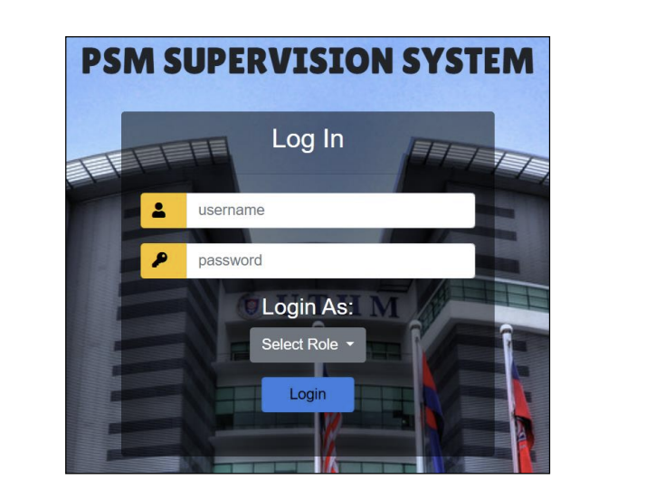
Figure 2.1 Log in page of PSM Supervision System
Table 2.1: Modules of PSM Supervision System
Module | Explanation
User registration | Administrator can register students and supervisors
User login | Student, supervisor, and admin can log into system
Select supervisor | Student can select supervisor
Form submission | Student can submit form related to PSM
Progress report submission | Student can submit progress report
Generate report | Administrator can generate report
Notification | Users can receive notification
Book meeting | Student can book meeting with supervisor
Set due date | Administrator can set due date for report submission
Source: Adapted from Fauzi & Alduais (2025)
While User Acceptance Testing (UAT) across a cohort of fifteen active faculty users indicated generic satisfaction with the user interface layout, deeper operational analysis exposed significant architectural vulnerabilities (Arumugam & Abd Ishak, 2025). The primary technical limitation identified within the PHP-driven PSM system centers on data security bottlenecks, specifically the lack of robust object-relational mapping (ORM) security layers, which exposes the data layer to cross-site scripting (XSS) and injection threats during file uploads (Horng & Abdullah, 2025). Furthermore, the application lacks automated, time-bound backend evaluation rules, meaning supervisor selection requests can remain pending indefinitely, causing acute allocation stagnation for students (Jailani et al., 2022).

2.4.1.2 Web-Based Information System for Monitoring Final Projects (STMIK Jayakarta)
In an effort to eradicate manual administrative cross-referencing, Hariyanto et al. (2025) designed a comprehensive web-based monitoring software model for STMIK Jayakarta. Prior to system engineering, the institution relied on an unintegrated mix of third-party platforms, utilizing Google Forms for data capture, Google Classroom for document routing, and WhatsApp for group communication (Hariyanto et al., 2025). This fragmented strategy exposed student metadata to severe data loss risks, prevented academic coordinators from gaining unified progress metrics, and heavily escalated supervisor evaluation delays (Fatman et al., 2023).
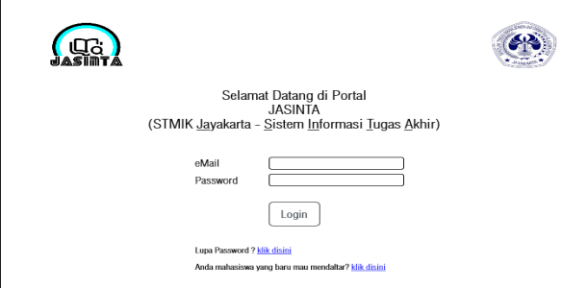
Figure 2.2 Log in page of STMIK Jayakarta
Table 2.2: SWOT Analysis of Existing FYP Management System at STMIK Jayakarta
Category | Factors
Strengths | Student, lecturer, and final project data managed centrally; straightforward workflow; active participation from students and lecturers
Weaknesses | Lack of integration between platforms; prone to data loss, communication delays, and input errors; limited time availability
Opportunities | Web-based system can automate workflows; cost-effective solutions; growing awareness of digitalisation
Threats | User resistance to change; limited IT infrastructure; data security risks
Source: Adapted from Hariyanto et al. (2025)
The resulting system designed by Hariyanto et al. (2025) successfully established centralized data tracking from proposal phases up to thesis defense clearance via Unified Modeling Language (UML) specifications. However, the system's runtime architecture operates purely as a passive document repository rather than an active notification engine. It provides no automated milestone warning mechanisms or intelligent dashboards to flag at-risk candidates, leaving the responsibility of tracking timeline slippage entirely to manual supervisor oversight (Isa et al., 2024).

2.4.1.3 UTM Final Year Project System
The Final Year Project System at the University of Technology Malaysia (UTM, 2021) is part of the academic experience, particularly in the School of Mechanical Engineering. The system provides students with a structured platform to manage the knowledge and skills they have gained throughout. The system guide students through the project’s scope, offers solutions to challenges, and presents research as reports and technical papers. Supervisors provide guidance through meetings. The system helps students manage tasks effectively, ensuring successful completion of final year projects (Jiang et al., 2021). It includes features for submitting project drafts, final reports, and technical papers. Students are required to present and defend their research. Detailed instructions help manage timelines and assessments. The system supports project management and helps develop skills like problem-solving and time management. Figure 2.3 illustrates the integration of features within the UTM Final Year Project System.

Figure 2.3 Homepage for UTM FYP Portal
Table 2.3: Modules of UTM FYP Portal
Module | Explanation
Login | Facilitates secure authentication utilizing institutional single sign-on (SSO) credential arrays (UTM, 2021).
Manage Supervision | Allows faculty coordinators to map student profiles to assigned supervisors manually (Jiang et al., 2021).
Manage Document | Serves as an institutional archive for grading criteria sheets and report guidelines (UTM, 2021).
Manage Submission | Establishes formal drop-boxes for mid-term drafts and finalized technical thesis manuscripts (Jiang et al., 2021).
Track Progress | Displays numerical milestones indicating a student's completion of core research units (UTM, 2021).
Schedule Meetings | Implements an internal booking log to record mandatory face-to-face consultation hours (Jiang et al., 2021).
Notification System | Fires basic email notifications to alert users when a document submission has occurred (UTM, 2021).
Generate Report | Compiles cohort assessment scores into spreadsheets for institutional evaluation panels (Jiang et al., 2021).
Manage Evaluation | Integrates rubrics directly into the portal for presentation grading purposes (UTM, 2021).
Manage AI Suggestions | Provides automated syntax testing and keyword cross-referencing for report drafts (Jiang et al., 2021).
Source: Adapted from UTM (2021) and Jiang et al. (2021)
Operational analysis of the UTM FYP Portal indicates that while it excels at structural document compliance and rubric-based evaluations, it lacks dynamic runtime flexibility (Jiang et al., 2021). The allocation module remains strictly supervisor-centric or coordinator-driven, meaning that students cannot independently navigate mentor availability or drive the pairing selection process based on real-time capacity parameters (UTM, 2021). Additionally, the tracking architecture operates retrospectively—updating metrics only after formal grading cycles—meaning that weekly supervisor feedback and logbook interactions remain dependent on external communication channels (Jiang et al., 2021).

2.4.2 Comparison of Existing Technologies
Table 2.4 synthesizes the core analytical findings established during the literature review phase, cross-referencing the functional footprints of the audited university platforms against the technical design specifications of the proposed tracking system.
Table 2.4: Comparative Analysis of Existing FYP Management Systems
Module Function | PSM System (UTHM) | STMIK System | UTM FYP Portal | Proposed System
Role-Based Dashboards | Yes | Yes | Yes | Yes
Supervisor Selection Interface | Yes | No | No | Yes
Automated Deadline Alerts | No | No | No | Yes
Chapter Submission Tracking | Yes | Yes | Yes | Yes
Meeting Management | Yes | Yes | Yes | Yes
Progress Velocity Monitoring | Yes | Yes | Yes | Yes
Report Generation/Export | Yes | No | Yes | Yes
Automated Request Deadlines | No | No | No | Yes
Student-Centered Allocation | No | No | No | Yes
E-Form | Yes | No | No | Yes

2.5 Technology Stack Evaluation and Framework Selection
To ensure the proposed Web-Based FYP Progress Tracking System delivers high availability, data security, and seamless role-based routing, a rigorous comparison of modern software development architectures is required. This section evaluates contemporary enterprise tools, frameworks, and database engines to justify the technical environment selected for this deployment.

2.5.1 Enterprise Backend Architectures: PHP vs. Node.js vs. ASP.NET Core
Historically, many legacy university management portals, such as the PSM system at UTHM, were constructed using PHP (Hypertext Preprocessor) (Arumugam & Abd Ishak, 2025). While PHP is lightweight and easily hosted, its loosely typed nature and fragmented security ecosystem make it highly vulnerable to injection attacks when handling sensitive student records (Horng & Abdullah, 2025). Conversely, Node.js provides a modern, asynchronous JavaScript runtime environment capable of handling high I/O requests, but it relies heavily on third-party packages, which can introduce severe dependency vulnerabilities over a multi-year institutional deployment (Fatman et al., 2023).
To overcome these structural deficits, the proposed system utilizes C# with the ASP.NET Core MVC (Model-View-Controller) framework. ASP.NET Core is a strongly typed, compiled enterprise framework engineered by Microsoft that inherently provides built-in protections against Cross-Site Scripting (XSS) and Cross-Site Request Forgery (CSRF) without relying on external plugins (Hariyanto et al., 2025). By utilizing C#, the application ensures memory safety and rapid compilation, while the MVC design pattern cleanly isolates the database logic (Model) from the user interface (View) and the operational routing rules (Controller). This isolation is absolutely critical for managing the automated 2-day supervisor request expiration engine reliably (Isa et al., 2024).

2.5.2 Relational and NoSQL Storage Engines: MySQL vs. MongoDB vs. SQL Server
The structural integrity of an FYP tracking system relies entirely on its database layer. NoSQL document databases like MongoDB offer flexible, schema-less data storage, which is useful for rapid prototyping; however, they lack strict ACID (Atomicity, Consistency, Isolation, Durability) compliance natively, making them unsuitable for complex, multi-table relationship mapping between students, supervisors, and logbooks (Kolade et al., 2024). Open-source relational databases like MySQL are widely used in legacy systems but often require manual query optimization when handling concurrent transactional locks, such as when multiple students attempt to book the same supervisor slot simultaneously (Yuan et al., 2024).

The proposed tracking architecture therefore implements Microsoft SQL Server, integrated directly with Entity Framework Core (EF Core) as its Object-Relational Mapper (ORM). SQL Server guarantees absolute transactional consistency, preventing data anomalies when a supervisor’s quota reaches its maximum limit. Furthermore, the EF Core ORM allows the system to query the database using secure LINQ (Language Integrated Query) expressions instead of raw SQL strings, effectively neutralizing the risk of SQL injection attacks against the student database (Arumugam & Abd Ishak, 2025).

2.6 United Nations Sustainable Development Goals (SDG) Alignment
The architectural objectives of the proposed FYP Progress Tracking System directly align with the global benchmarks established by the United Nations Sustainable Development Goals (SDGs). By transitioning from paper-based, manual administrative workflows to a centralized digital tracking environment, the project fulfills core targets within the following two pillars:
- SDG 4: Quality Education: SDG 4 mandates the provision of inclusive, equitable, and highly effective learning environments (United Nations, 2015). The current systemic reliance on fragmented emails and manual supervision delays feedback, putting students at risk of academic failure. By deploying real-time progress percentage trackers and ensuring a completely transparent, student-centered allocation process, the proposed system actively removes structural barriers to academic success. It guarantees that every student receives equitable, timely mentorship, thereby elevating the overall pedagogical quality of the computing faculty (Yuan et al., 2024).
- SDG 9: Industry, Innovation, and Infrastructure: SDG 9 emphasizes the necessity of upgrading technological capabilities and building resilient institutional infrastructure (United Nations, 2015). Legacy paper logbooks and decentralized chat applications represent outdated administrative infrastructure. By engineering a highly secure, web-based ASP.NET Core platform capable of automating complex background tasks (such as the 2-day auto-rejection rule), this project actively modernizes the digital infrastructure of the educational institution, aligning its operational capacity with modern enterprise industry standards (Hariyanto et al., 2025).

2.7 Conclusion
The comprehensive review of contemporary literature reveals that while higher education institutions globally acknowledge the critical importance of structured FYP tracking, current software deployments remain hindered by structural or technical limitations (Isa et al., 2024). Legacy systems constructed on basic PHP configurations lack the defensive object-relational mapping capabilities required to secure student records, while contemporary repositories function passively, completely lacking the predictive metrics needed to flag at-risk candidates before milestone failure occurs (Fatman et al., 2023). Most importantly, traditional allocation frameworks consistently introduce severe timeline bottlenecks due to the total absence of automated, time-bound response enforcement rules on supervisor interactions (Horng & Abdullah, 2025). The proposed Web-Based FYP Progress Tracking System closes these operational gaps by deploying a modern, strongly typed C# ASP.NET Core MVC framework featuring real-time percentage indicators, digital logbook entries, and an automated 2-day selection rejection rule to safeguard the completion velocity of computing cohorts (Hariyanto et al., 2025).

Chapter 3: Software Methodology

3.1 Introduction
The system engineering lifecycle of an enterprise academic utility demands a highly structured, scientifically justified developmental methodology. This chapter details the operational design, primary research data, and structural blueprints used to construct the Web-Based FYP Progress Tracking System for the School of Computing. It establishes the rationale for selecting an iterative Agile framework over rigid legacy models by evaluating execution risks, feedback loops, and deployment timelines (Fatman et al., 2023).

Furthermore, this chapter delivers the empirical foundation of the system by analyzing a primary diagnostic survey conducted with active institutional respondents. To bridge the gap between abstract requirements and production-ready code, this section presents comprehensive system design components, including multi-role Use Case architecture, project management scheduling matrixes, and high-fidelity interface wireframes governing the core tracking and allocation modules (Hariyanto et al., 2025).

3.2 Selection and Justification of Development Methodology
Selecting an inappropriate Software Development Lifecycle (SDLC) framework directly introduces code integration risks, budget overruns, and timeline slippage (Isa et al., 2024). To guarantee an optimal deployment window, three distinct methodologies were cross-evaluated against the institutional boundaries of this progress tracking application.

3.2.1 Selected Framework: Agile Scrum Methodology
To eliminate the rigid bottlenecks of Waterfall and the architectural instability of pure Prototyping, this project explicitly adopts the Agile Scrum Methodology. Scrum is an iterative and incremental management framework within which teams can address complex adaptive problems while the productivity and creativity of delivering products are at the highest possible value. By breaking the development lifecycle down into small, focused, and manageable chunks called Sprints, which are fixed two-week periods, this framework provides the core flexibility and agility required to adapt to changing institutional requirements, optimize stakeholder communication, and systematically mitigate data loss or administrative stagnation risks.
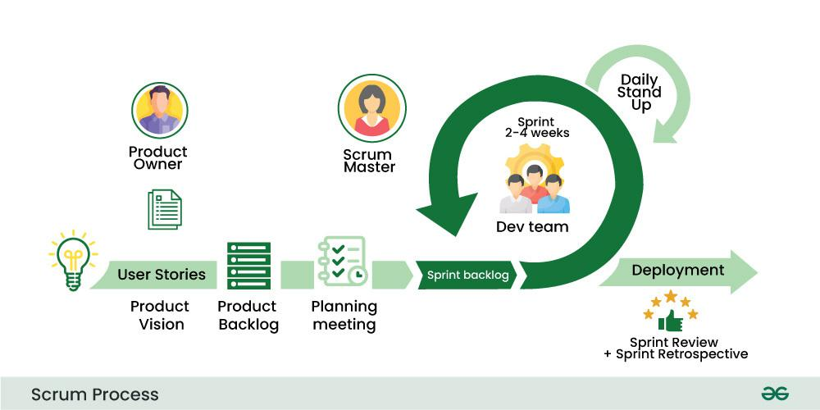
Figure 3.1 Scrum Model
The system engineering lifecycle of the Web-Based FYP Progress Tracking System follows a highly structured, cyclic approach to software development executed step-by-step through six distinct events. The first stage is Product Backlog Formulation, which establishes a prioritized list of features, user stories, enhancements, and bug fixes managed by the Product Owner to serve as the absolute source of work for the project. Managed under a Value-Based Prioritization mindset, backlog features are organized explicitly around role-isolated architectural boundaries specifically the Student, Supervisor, and Admin Modules to maximize available quota transparency and prevent communication lag. High-priority student user stories focus on submitting weekly digital logbooks and viewing real-time milestone progress velocity bars to prevent project abandonment, while supervisor stories center on interactive command panels to manage candidates and track at-risk individuals whose progress drops below 30%. Administrator stories focus on centralized dashboards to execute manual pairing overrides and export cohort data to CSV or Excel formats. Because traditional matching systems often leave candidates unallocated for weeks, the highest priority in the backlog is strategically assigned to student-centered allocation logic and the server-side 2-day auto-rejection mechanism to ensure that the most critical, risk-heavy backend features are engineered and stress-tested first.
The second stage is Planning Sprint, a key event held at the beginning of each iteration where the Product Owner, Scrum Master, and development roles collaboratively define a specific Sprint Goal and select items from the global repository to form a specialized Sprint Backlog. This planning session breaks high-level user goals down into the precise technical tasks required to complete the selected items within the strict time-box constraint, translating requirements into low-level engineering tasks using ASP.NET Core MVC and Microsoft SQL Server to achieve working milestones. For example, during Sprint 2, the goal of implementing the Student-Centered Allocation System is broken down into specific tasks: creating the SupervisorQuota table in SQL Server with an absolute data capacity lock, writing a server-side background routine using C# to monitor incoming student requests, programming a strict 48-hour expiration timer that fires an Auto-Reject status flag if a supervisor fails to respond, and designing the frontend Bootstrap alert banner to notify students of request statuses.
The third stage is the Sprint Meeting, often referred to as the Daily Scrum or Daily Stand-up, which functions as a brief daily meeting to provide updates on progress, discuss upcoming execution plans, and highlight any impediments. Because this is an individual Final Year Project, the traditional team-based Daily Scrum is modified into a disciplined individual development log and daily verification routine that maintains strict alignment with the 10-week project timeline to prevent academic overruns. Testing is performed continuously during sprint execution rather than being delayed until the end of the project lifecycle, allowing technical impediments to be handled immediately. For instance, if two students attempt to select the final available slot of a supervisor simultaneously, the daily review process forces the immediate identification of a potential database transaction lock, allowing the implementation of Entity Framework Core isolation levels right away rather than letting bugs accumulate until the final submission week.
The fourth stage is the Sprint Review, held at the end of each sprint to allow the team, stakeholders, and the Product Owner to review completed work, demonstrate the product increment, and gather direct feedback to inform future backlog adjustments. At the end of each sprint, a fully compiled, functioning software increment is evaluated against the project mockups. For instance, at the end of Sprint 3, a live demonstration of the primary Student Dashboard mockup is conducted to showcase the working real-time completion tracking component, color-coded progress indicators, and digital weekly logbook submission forms, ensuring the technical layout strictly matches the expectations of the supervisor, Ms. Jivita Raja, while any layout adjustments or validation gaps are immediately logged back into the backlog.
The fifth stage is the Sprint Retrospective, which occurs after the Sprint Review and involves reflecting on the previous sprint to discuss what went well, what could be improved, and any action items for enhancing development processes with a strict focus on continuous improvement. This stage serves as an internal quality and process audit to review technical execution velocity and development stack performance. If it is noticed during a sprint that writing raw SQL strings slows down implementation or exposes the system to security vulnerabilities, the retrospective is utilized to shift entirely to using secure LINQ expressions through Entity Framework Core, optimizing the database query pipeline and safeguarding the engineering timeline for subsequent sprints.
The final stage is Repeat, where the cycle continuously restarts with a new Sprint Planning meeting, followed by another sprint of development, daily stand-ups, Sprint Review, and Sprint Retrospective. This iterative process continues throughout the project, allowing adaptation to changing requirements, continuous improvement, and the delivery of product increments at the end of each sprint. To guarantee strict compliance with the institutional graduation framework and the 10-week project timeline, this cyclic workflow is repeated across five consecutive, highly focused sprints: Sprint 1 (Weeks 1–2) focuses on designing relational database schemas in Microsoft SQL Server and coding secure server-side role-based authentication tokens. Sprint 2 (Weeks 3–4) implements the student-centered supervisor selection interface and the automated backend 2-day countdown auto-rejection background worker. Sprint 3 (Weeks 5–6) establishes the digital logbook dropboxes, file-upload routing handlers, and dynamic percentage progress bars. Sprint 4 (Weeks 7–8) develops the online meeting booking logs, the Supervisor Command Panel, and the Admin Control Panel with Excel/CSV data exports and Sprint 5 (Weeks 9–10) concludes with comprehensive integration testing against SQL Injection and Cross-Site Scripting (XSS), local server hosting deployment, and final portfolio compilation. This cyclic nature of Scrum supports complete agility and responsiveness by emphasizing regular inspection, adaptation, and collaboration to deliver maximum value to stakeholders in a dynamic educational environment.

3.2.2 Key Principles of the Scrum Model in Project Context
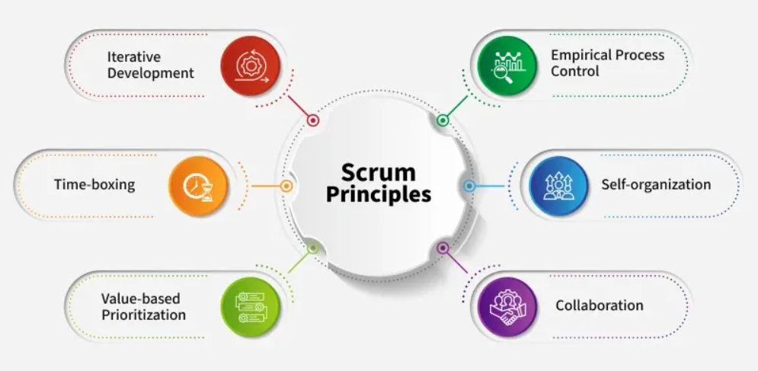
Figure 3.2 Scrum Principles
The Scrum framework is built on six essential principles that assist in maintaining focus, adaptability, and productivity throughout the software development lifecycle, which are systematically mapped to the operational execution of the Web-Based FYP Progress Tracking System.

The first principle is Empirical Process Control, which serves as the core backbone of the Scrum framework and is driven by three foundational pillars are transparency, inspection, and adaptation. Scrum encourages an empirical approach of learning through execution, which works especially well when dealing with complex software requirements that lack initial clarity. By establishing continuous inspection loops, development velocity remains aligned with institutional targets, allowing immediate adjustments to be executed before technical anomalies compromise the project schedule. Within this project, empirical control is enforced by utilizing the strongly typed features of ASP.NET Core MVC and the relational integrity of Microsoft SQL Server to achieve systemic transparency by exposing live, role-isolated dashboards that replace fragmented communication networks. Regular inspection of the codebase ensures that critical modules, such as the 2-day selection rejection background worker, are evaluated early to enable immediate adaptation if database constraints or data integration bottlenecks occur.

The second principle is Self-Organization, which operates under the principle that development outputs are optimized when the execution team possesses the autonomy to manage individual tasks, distribute technical sub-tasks, and self-organize the development workflow to establish absolute accountability, foster a structured work environment, and instill a rigorous sense of code ownership. As an individual Final Year Project, this principle is applied by maintaining structured control over the independent coding, database schema design, and local hosting deployment pipelines. Rather than depending on prescriptive external scheduling, development tasks are independently organized within the 10-week Gantt chart, empowering the independent execution of rapid fixes for technical impediments such as optimizing Entity Framework Core query speeds or refining Bootstrap layout interfaces.

The third principle is Collaboration, which prioritizes working together and promoting clear communication, mutual understanding, and collective problem-solving among development nodes, end-users, and institutional stakeholders to secure continuous alignment across all project tiers and ensure that the software features developed precisely address the practical needs of the targeted audience. The system actively addresses the traditional communication gaps and excessive feedback delays identified between students, faculty supervisors, and program coordinators by functioning as a centralized collaborative portal where students drop weekly electronic logbooks and supervisors input real-time digital evaluations. Furthermore, regular sprint updates are reviewed against the precise pedagogical benchmarks set by the project supervisor, Ms. Jivita Raja, guaranteeing total institutional alignment.

The fourth principle is Value-Based Prioritization, which mandates the continuous delivery of high-value software capabilities from the earliest phases of the development lifecycle by systematically ranking the product backlog based on operational impact and urgency to ensure development efforts remain focused exclusively on core, high-value operations. To eliminate matching bottlenecks that leave undergraduate candidates unallocated for weeks, value-based prioritization places student-centered allocation logic at the top of the development queue, while peripheral functionalities, such as administrative data export tools, are scheduled for later sprints. This ensures that complex backend validation logic, such as the strict 48-hour request expiration timer, is fully operational and stress-tested before lower-priority user interface refinements are initiated.

The fifth principle is Time-Boxing, which relies on time as a fixed constraint to strictly govern project execution and maintain structural control over task completion by assigning definitive, unalterable durations to all Scrum activities, including the 2-week Sprints, daily verification reviews, Sprint Planning, Sprint Reviews, and Sprint Retrospectives to maintain focus, prevent unnecessary timeline slippage, and ensure adherence to a clear schedule. The entire 10-week development window is divided into five precise, consecutive 2-week blocks where each milestone is tightly bounded to its assigned sprint, preventing scope creep, controlling documentation overhead, and guaranteeing that the system is fully compiled and ready for deployment within the institutional grading window.

The sixth principle is Iterative Development, which executes software production through small, manageable development cycles known as iterations to allow the system to be progressively refined through continuous coding, testing, and feedback loops, ensuring that the software steadily evolves to meet user needs while staying aligned with customer expectations. The tracking system is built incrementally rather than through a singular, late-stage monolithic release, meaning a basic database connection established in Sprint 1 evolves into a functional supervisor selection interface in Sprint 2, and integrates dynamic, color-coded progress velocity bars by Sprint 3. This iterative approach ensures that each layer of the application is compiled, tested for vulnerabilities like SQL injection, and verified against high-fidelity mockups before subsequent dependencies are introduced.

3.2.3 Methodological Conclusion and Justification for Selecting Scrum
The selection of the Software Development Life Cycle (SDLC) framework plays a decisive role in governing the architectural quality, milestone delivery, and structural stability of the Web-Based FYP Progress Tracking System. Based on a comprehensive cross-evaluation of the advantages, constraints, and inherent risks of competing development frameworks, the Agile Scrum Methodology is explicitly selected as the optimal implementation strategy for this project. The strategic core benefits of the Scrum model include its exceptional flexibility and high adaptability, allowing the development workflow to adapt smoothly to changing requirements, shifting priorities, and continuous stakeholder feedback without disrupting completed modules or destabilizing the foundational architecture. Additionally, its time-boxed sprints result in regular and predictable releases of functional product increments, facilitating the early delivery of valuable features and allowing the project schedule to stay completely aligned with the institutional timeline to reduce time to market. Scrum promotes absolute transparency and increased product quality through visibility tools like the Product Backlog and Sprint Backlog, fostering open communication and enhanced teamwork while its focus on regular inspection forces the early identification and mitigation of technical risks, structural exceptions, and integration conflicts through frequent evaluation reviews.
While the Scrum framework introduces unique operational challenges, specific architectural controls are implemented within this project scope to completely neutralize potential drawbacks. To prevent time-consuming Scrum events from reducing actual development hours, all review sessions, sprint planning meetings, and daily synchronization checks are strictly time-boxed to minimal, hyper-focused intervals. Although Scrum encourages continuous flexibility, scope creep is strictly controlled by binding the system to the explicit functional boundaries of the Student, Supervisor, and Admin Modules, barring backend adjustments between active sprint intervals to prevent cost overruns or timeline slippage. Because Scrum relies on self-organizing teams and can be hard to scale, the single-developer nature of this Final Year Project eliminates the communication complexities, scaling friction, and alignment bottlenecks typically found when coordinating large, multi-team "Scrum of Scrums" networks, ensuring that an experienced team member handles tasks independently. To counteract Scrum’s typical lack of heavy documentation focus, structural use cases, detailed data flow diagrams (DFDs), and comprehensive database relational schemas are meticulously integrated into this software methodology chapter to guarantee long-term system maintainability. Ultimately, the Scrum model provides the most resilient, secure, and responsive operational framework to execute the digital transformation of the thesis monitoring lifecycle, guaranteeing a highly secure, enterprise-grade application deployment that directly satisfies the pedagogical standards of the School of Computing at INTI International College Penang.

3.4 Unified Modeling Language (UML) Use Case Architecture
The structural boundaries, access privileges, and modular permissions defined for the Web-Based FYP Progress Tracking System are systematically mapped using formal Use Case notation. To maintain strict data integrity and streamline educational workflows, the application enforces rigid role isolation across three authorized, role-secured user actor segments: students, supervisors, and administrators. Isolating these interactive operational features within a centralized transactional environment is essential to eliminate the chronic communication lags, manual cross-referencing errors, and loose recordkeeping practices common to traditional educational management models (Fatman et al., 2023). By utilizing secure, server-side authentication tokens, the system ensures that each actor interacts only with their designated functional components, thereby establishing transparent operational supervision across all institutional tiers (Hariyanto et al., 2025)

This role-isolated layout maps the system's operational features directly to the specific administrative and academic motivations of each user class. Undergraduate computing candidates navigating strict graduation timelines interact with use cases designed to digitize weekly logbook submissions, track milestone velocity, and initiate supervisor selection requests (Sa et al., 2021). Academic faculty and lecturing staff utilize supervisor command use cases to review pending chapters, adjust their student slot capacity dynamically, and track at-risk candidates whose progress falls below established performance thresholds (Horng & Abdullah, 2025). Concurrently, program coordinators and academic directors access administrative use cases to audit global cohort completion data, execute manual pairing overrides, and export highly structured tracking summaries into standardized formats for institutional review (Kolade et al., 2024). This comprehensive UML architecture translates abstract institutional needs into a synchronized relational blueprint, setting a clear foundation for real-time progress monitoring and proactive academic interventions (Isa et al., 2024)
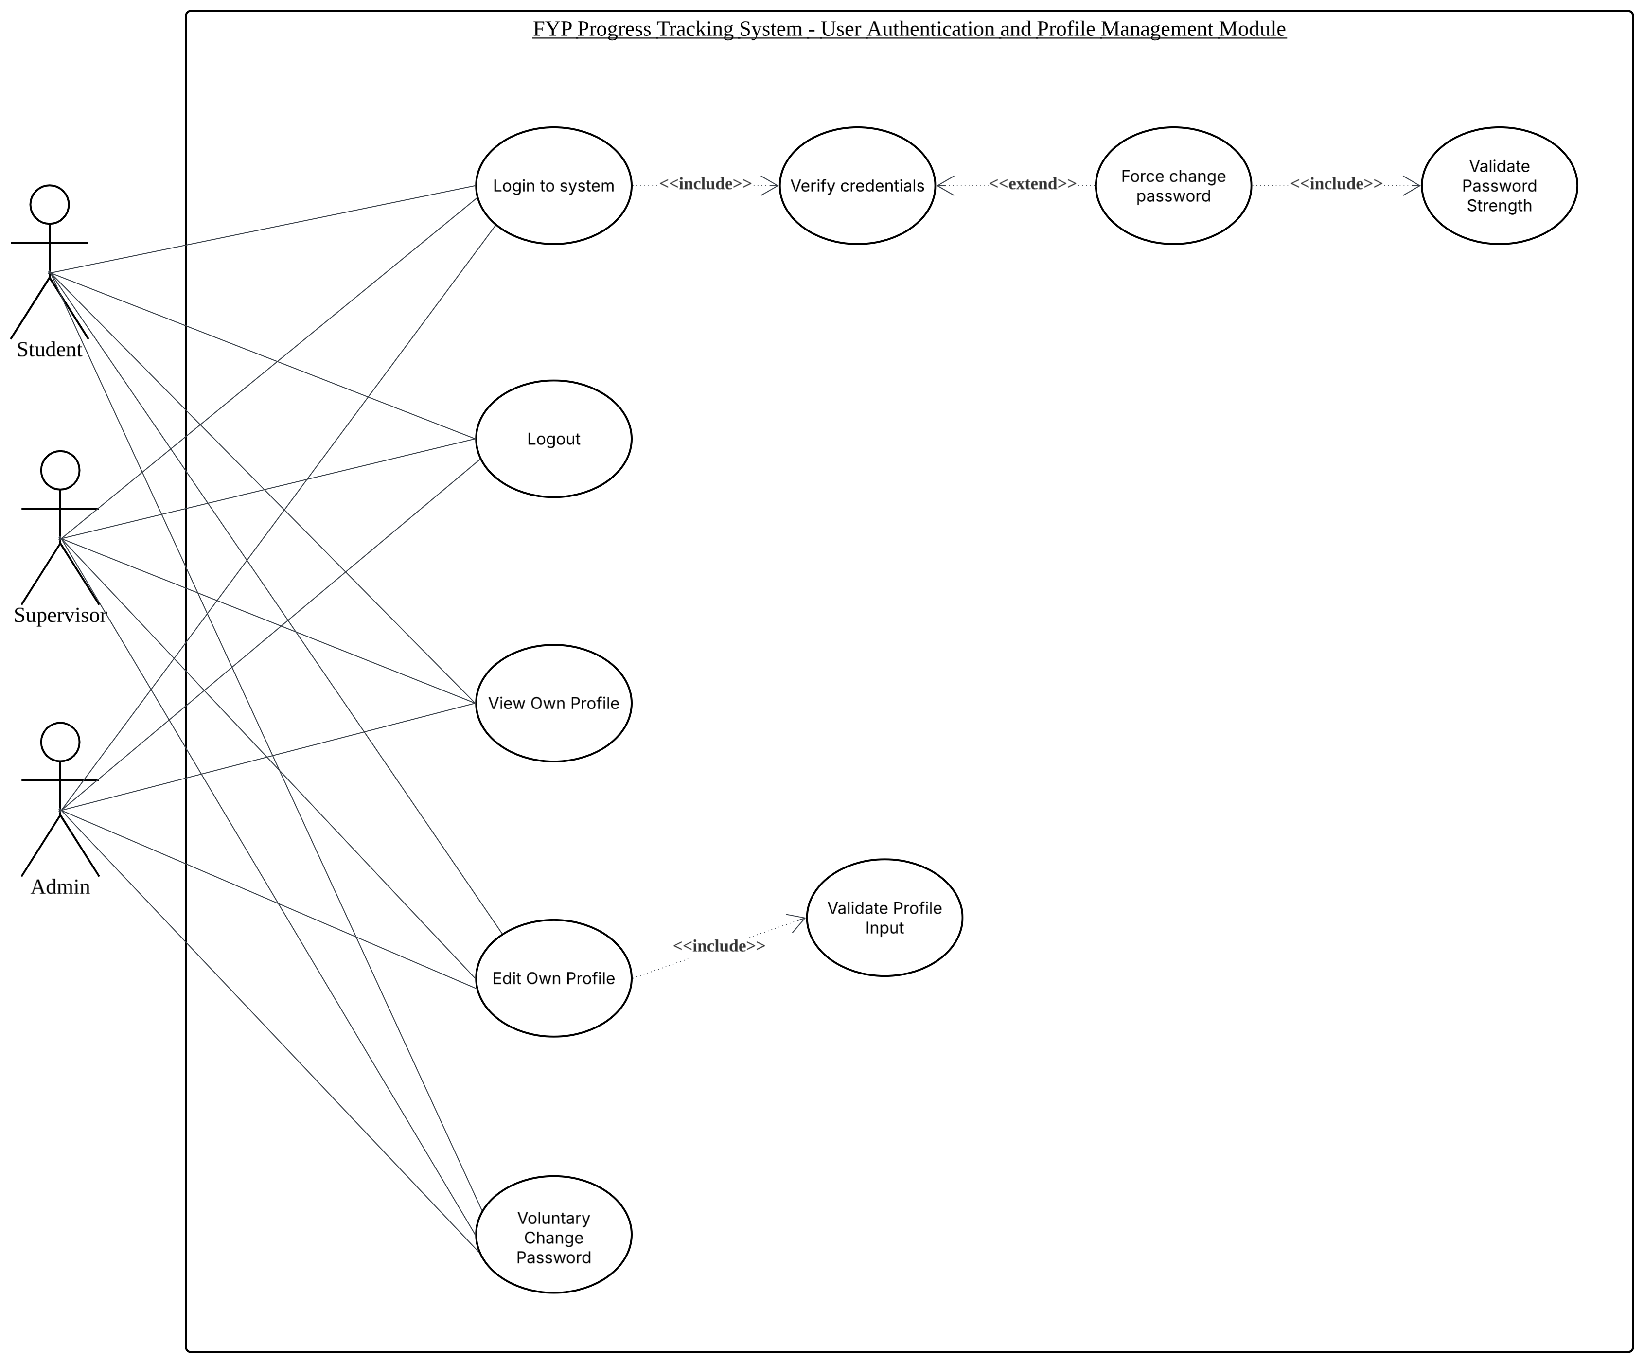
Figure 3.3 FYP Progress Tracking System - User Authentication and Profile Management Module

The User Authentication and Profile Management Module establishes the security boundary of the platform by regulating system-wide access and personal identity data management for Students, Supervisors, and Administrators. When an actor initializes the Login to System use case, the system mandatorily includes a credential verification loop against the database. If a first-time login flag evaluates as true, the workflow extends to a mandatory password change interface, which includes a password strength validation routine. Once authenticated, users can log out to terminate their active session, view their specific profile view, or modify their user profile metadata such as contact records or avatars which executes a background inputs validation check via specific regex syntax. Furthermore, users retain the capability to voluntarily trigger a password update sequence from their profile configurations page at any given time, which sequentially routes back through the password strength validation system to ensure ongoing cryptographic compliance.

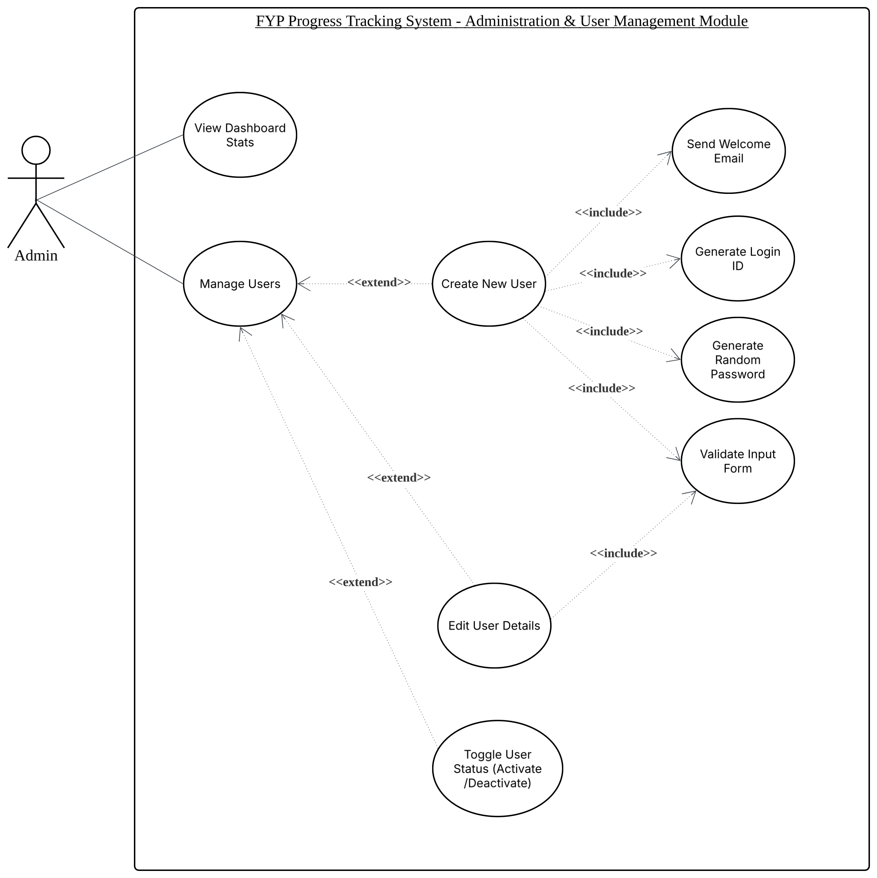
Figure 3.4 FYP Progress Tracking System - Administration & User Management Module
The Administrator Management Module governs the system provisioning workflow, metadata modification capabilities, and high-level tracking operations restricted strictly to authorized platform administrators. Upon accessing the dashboard, the administrator can view high-level analytical indicators summarizing cohort metrics, project counts, and pending system actions. Through the main user management dashboard interface, the administrator can optionally extend operations to edit user parameters, toggle account status switches to instantly suspend or reinstate profile access, or provision entirely new Student or Supervisor profiles. When the Create New User use case is executed, the platform sequentially includes four automated sub-processes: validating form inputs against duplicate data and regional phone formatting, parsing the user's INTI university email string to extract a smart login ID, generating a randomized temporary secure password, and utilizing an automated SMTP client to dispatch a welcome email containing the newly minted credentials.

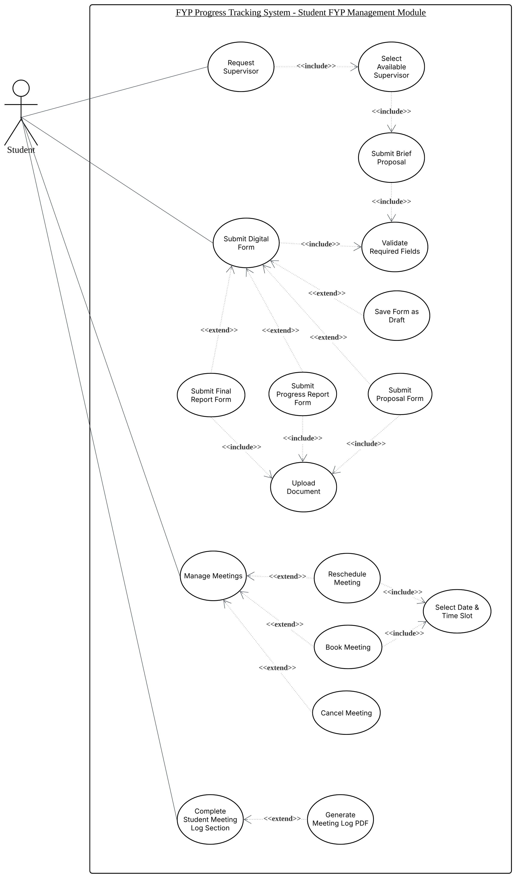
Figure 3.5 FYP Progress Tracking System - Student FYP Management Module
The Student Management Module encapsulates the complete project lifecycle operations executed by undergraduate candidates to secure a mentor, submit required documentation, and manage consultation histories. The workflow begins with requesting a supervisor, which explicitly includes selecting a supervisor with available capacity slots and submitting a mandatory brief proposal text field. For subsequent academic checkpoints, the student initiates a general digital form submission use case, which includes a background file size and fields validation check, and can be extended by saving an un-submitted draft or executing specific submissions for the Proposal Form, Progress Report Form, or Final Thesis Form. Depending on the milestone type, these actions include attaching valid DOCX or PDF files, capped by strict PDF enforcement for the final thesis report. Additionally, students can manage consultations to extend their workflow by booking, rescheduling, or canceling meetings via an interactive date-and-time picker, and they can actively edit a collaborative log section post-consultation, which can optionally extend to downloading a rendered meeting log PDF output.
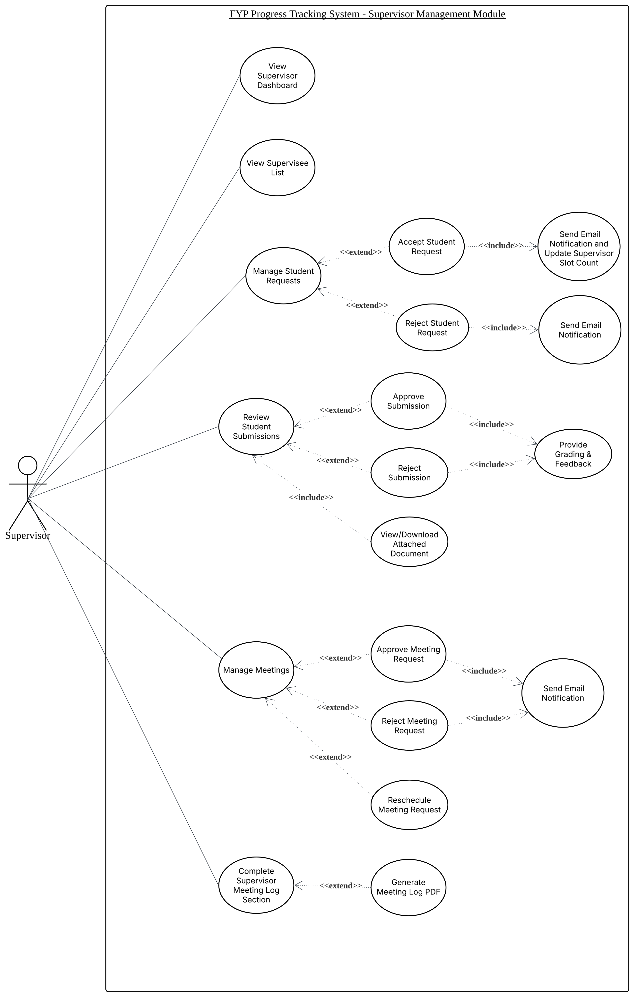
Figure 3.6 FYP Progress Tracking System - Supervisor Management Module

The Supervisor Management Module consolidates the academic workflows, progress tracking utilities, and grading systems utilized by assigned faculty members. Through a tailored landing panel, supervisors can view analytical summaries of active supervisees, upcoming appointments, and pending documentation tasks, or open a detailed tracking table to review a student's holistic performance. When managing incoming selection requests, the supervisor reviews the student's brief proposal text, which extends to an acceptance or rejection decision. An approval action automatically includes firing an email update to the candidate and executing a system-side decrement to lower the supervisor's remaining slot allowance counter. Furthermore, the supervisor reviews academic milestone forms by downloading attached documents, which extends to an approve or reject evaluation choice that triggers an email alert, leaving written commentary, or assigning percentage marks. Finally, supervisors handle meeting schedules to accept, cancel, or modify appointments, and they can complete the post-consultation log section to document task benchmarks, which locks the file and extends to generating a formatted local PDF artifact.

3.5 DFD
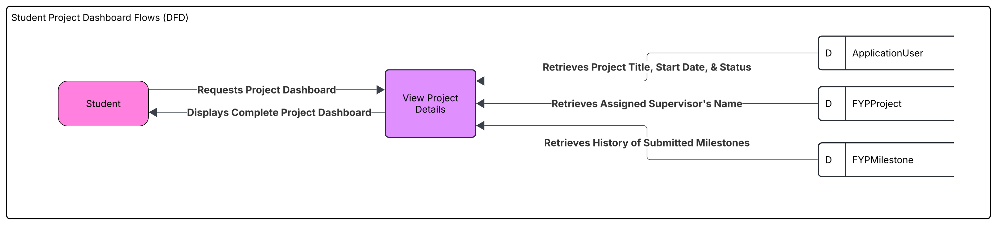
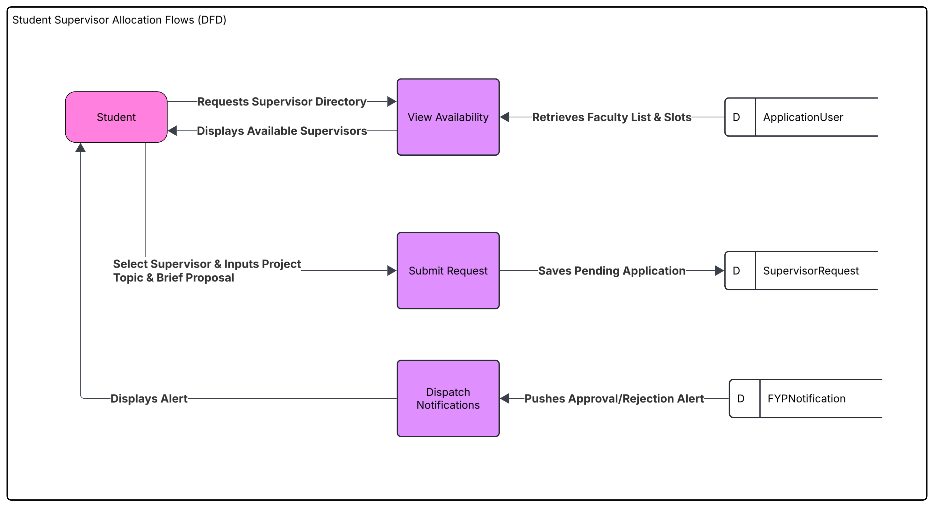
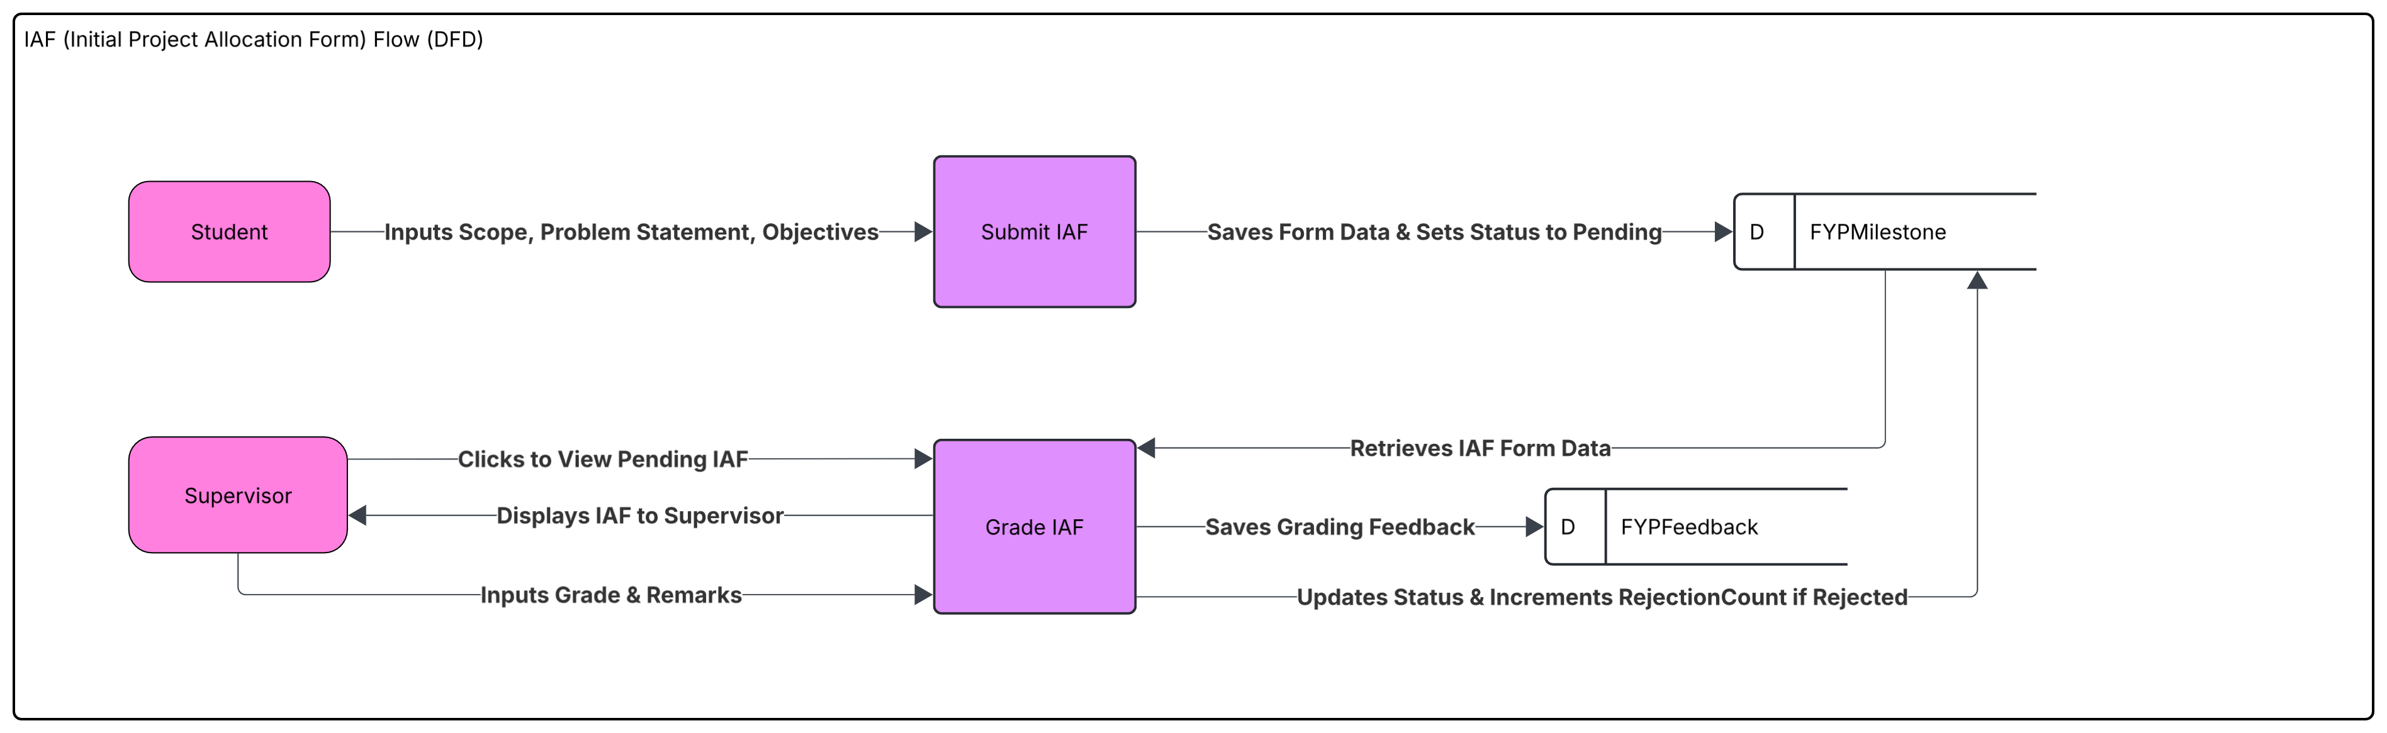
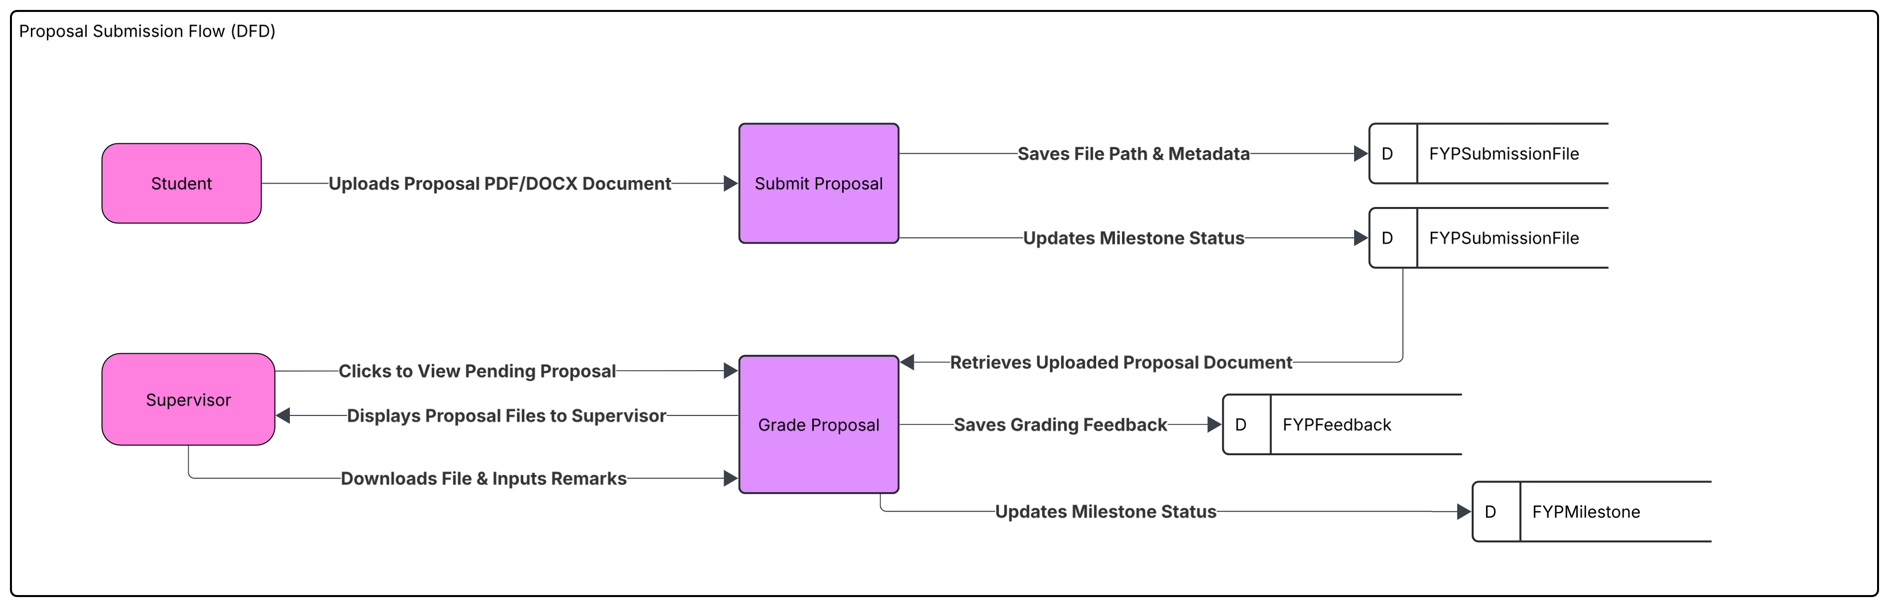
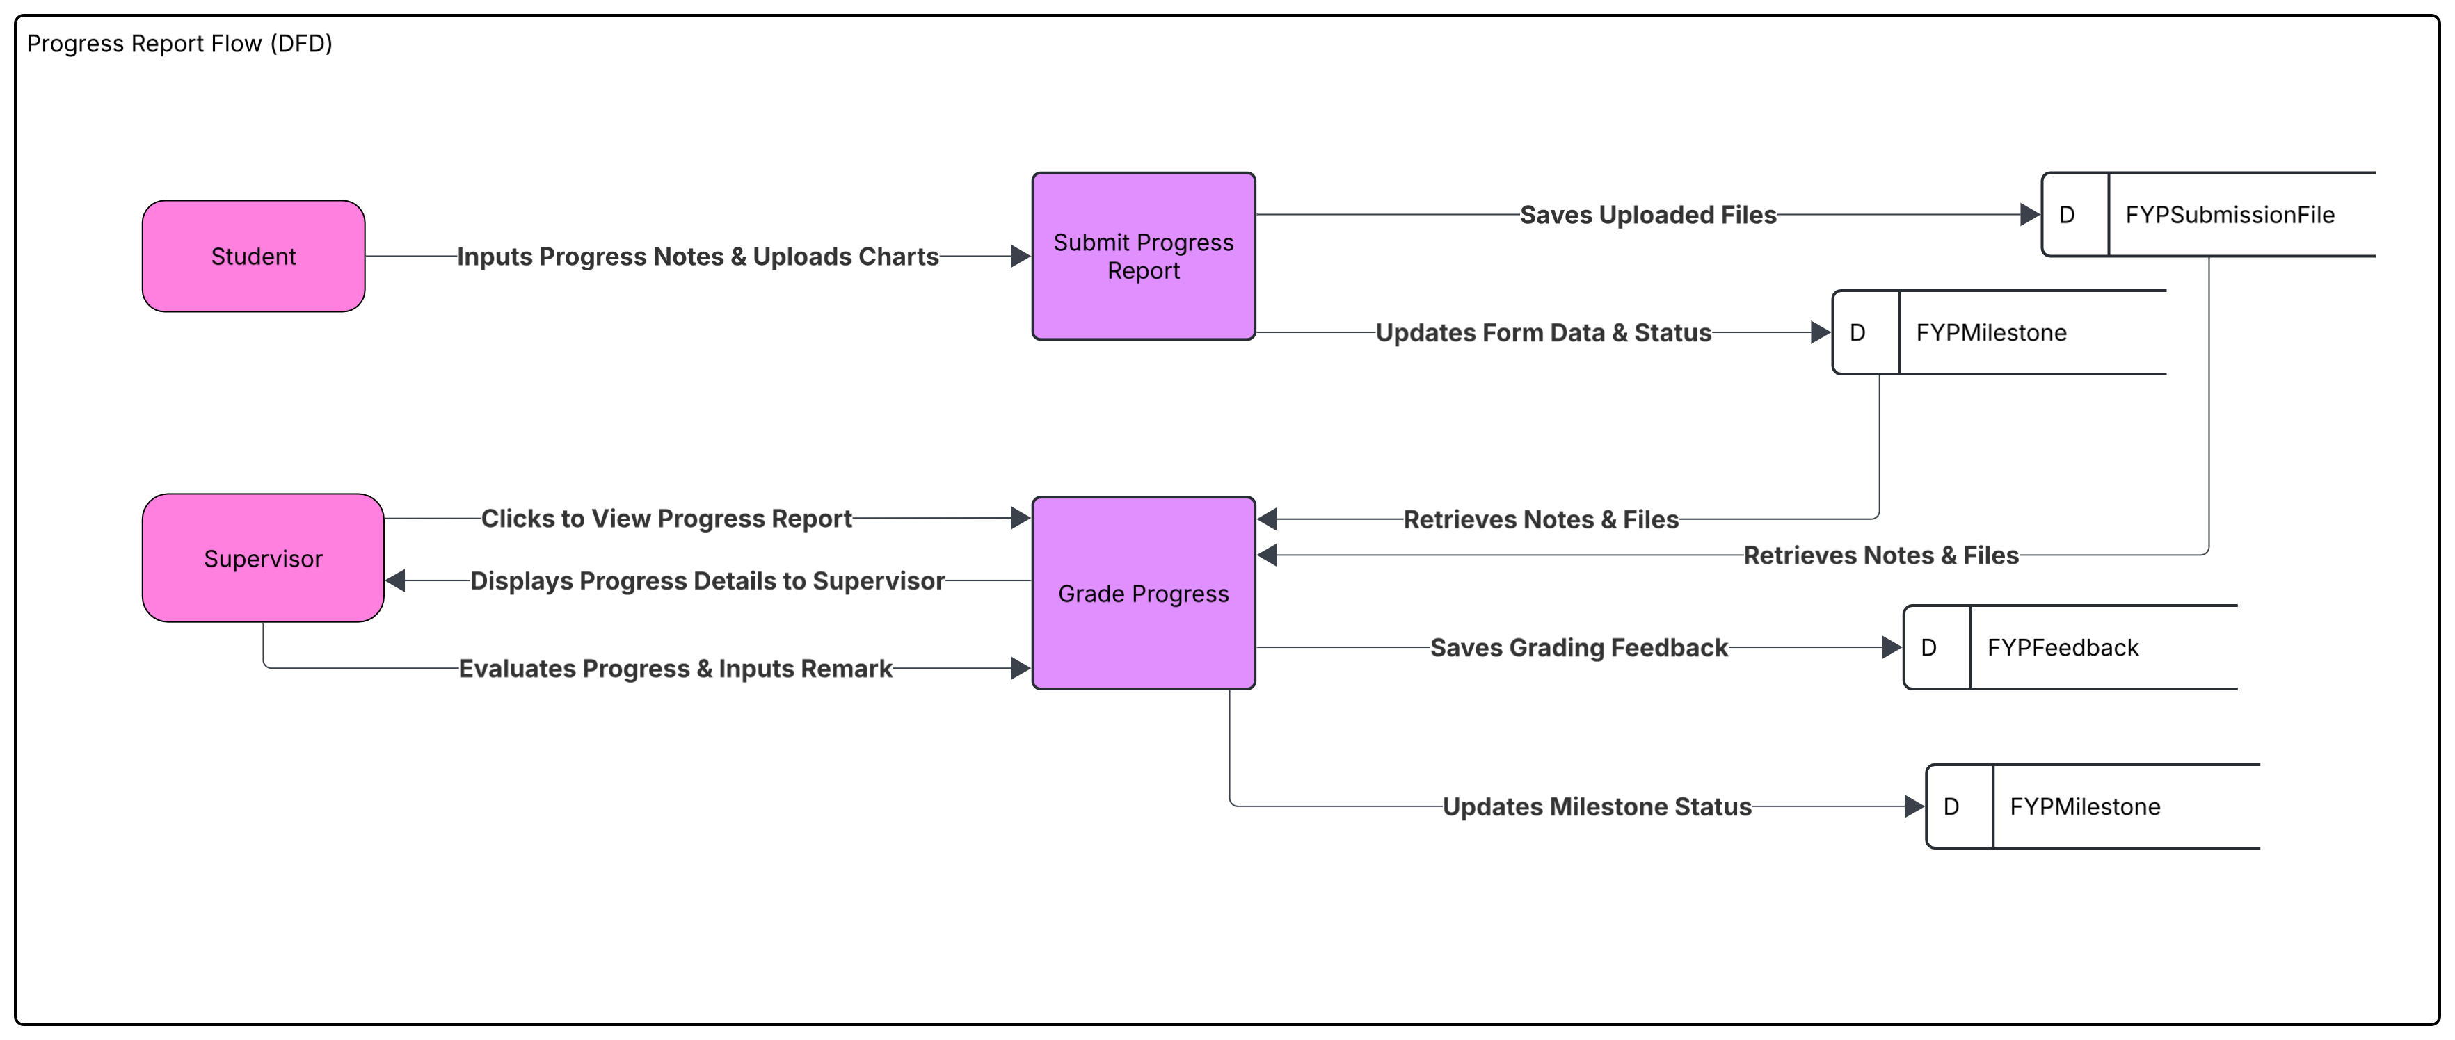

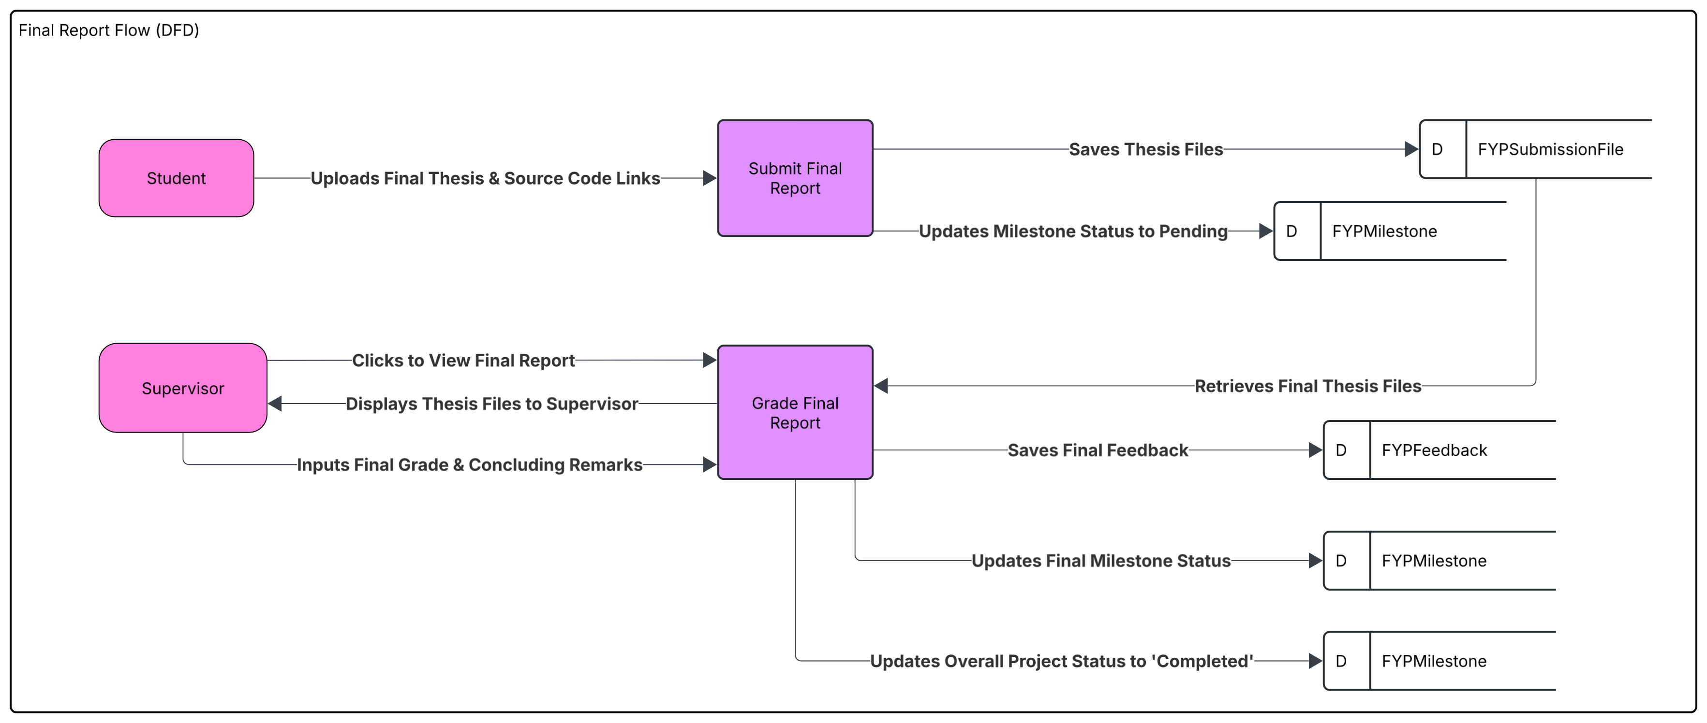

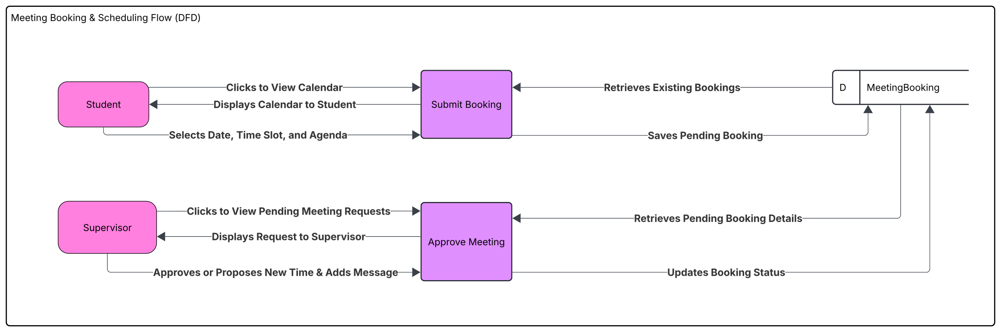
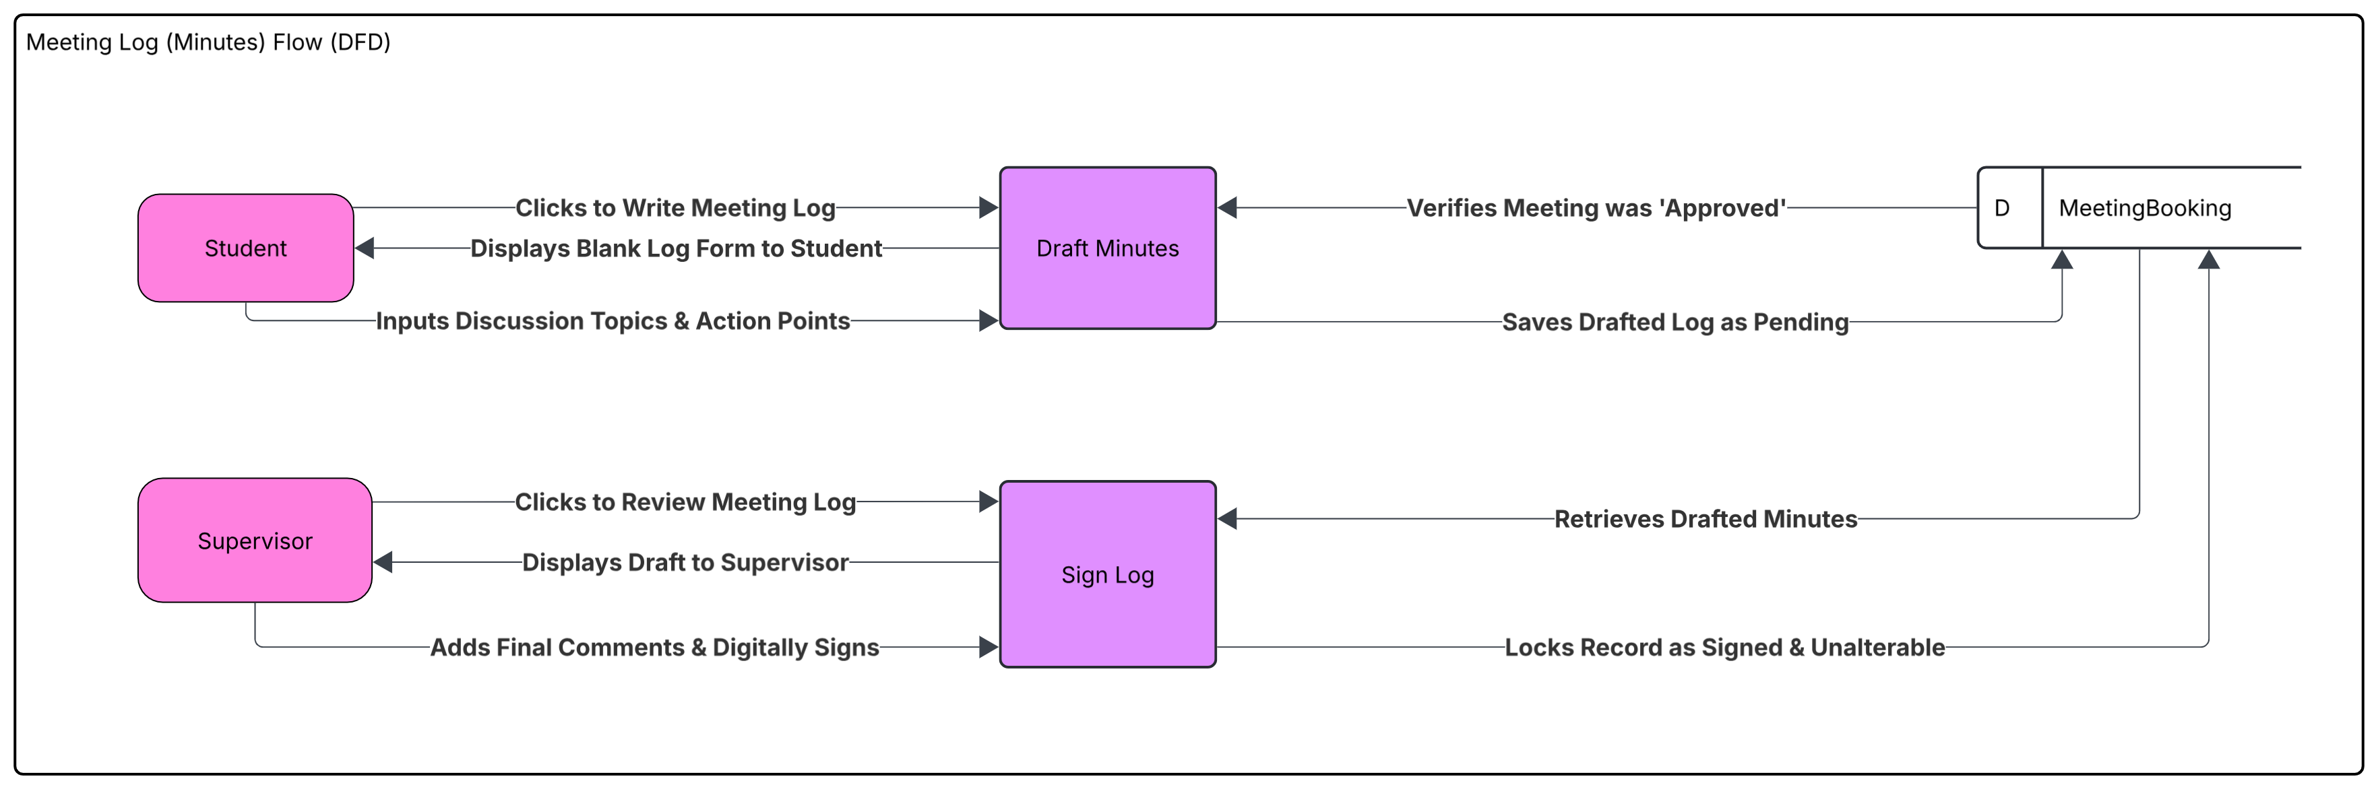

3.6 Entity-Relationship Diagram (ERD)
An Entity Relationship Diagram is a structural blueprint of a database that visually models the organization data assets and the logical associations between them. Built around three core components which represent entities like Students Supervisors or Forms attributes like Email addresses or Quota limits and relationships depicting how data interacts the diagram translates abstract data requirements into an actionable relational database schema. By utilizing precise mathematical notations like crows foot notation to specify cardinality such as a one to many relationship between a supervisor and their assigned students the diagram enforces architectural constraints establishes foreign key structures and ensures structural data integrity before actual coding begins in SQL Server.

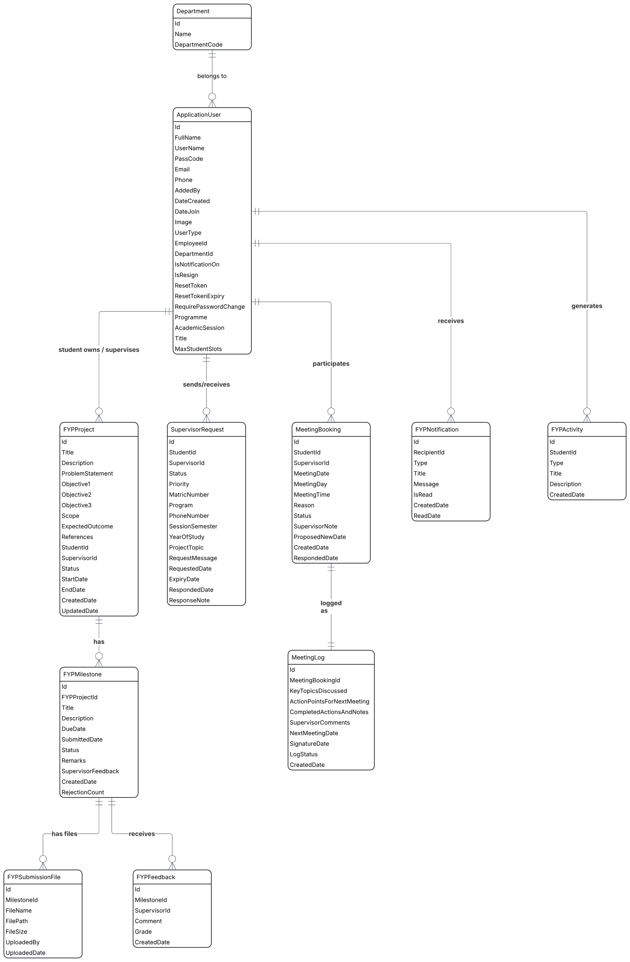
Figure 3.? ERD Diagram

There are eleven entities in the database which are Department, ApplicationUser, FYPProject, SupervisorRequest, MeetingBooking, FYPNotification, FYPActivity, FYPMilestone, MeetingLog, FYPSubmissionFile and FYPFeedback. Each entity has its own attributes with the primary key and foreign keys if any. One department has attributes such as Id primary key, Name and DepartmentCode. One department has a one to many relationship with users as many application users can belong to one department. One application user has attributes such as Id primary key, FullName, UserName, PassCode, Email, Phone, AddedBy, DateCreated, DateJoin, Image, UserType, EmployeeId, DepartmentId, IsNotificationOn, IsResign, ResetToken, ResetTokenExpiry, RequirePasswordChange, Programme, AcademicSession, Title and MaxStudentSlots. It has foreign keys such as DepartmentId. One user acting as a student owns one FYP project while one user acting as a supervisor supervises one to many FYP projects. One user can send or receive one to many supervisor requests. One user can participate in one to many meeting bookings. One user can receive one to many FYP notifications. One user can generate one to many FYP activities.
One FYP project has attributes such as Id primary key, Title, Description, ProblemStatement, Objective1, Objective2, Objective3, Scope, ExpectedOutcome, References, StudentId, SupervisorId, Status, StartDate, EndDate, CreatedDate and UpdatedDate. It has foreign keys such as StudentId and SupervisorId. One FYP project has a one to many relationship with milestones as it logs one to many FYPMilestone entries over the tracking lifecycle. One supervisor request has attributes such as Id primary key, StudentId, SupervisorId, Status, Priority, MatricNumber, Program, PhoneNumber, SessionSemester, YearOfStudy, ProjectTopic, RequestMessage, RequestedDate, ExpiryDate, RespondedDate and ResponseNote. It has foreign keys such as StudentId and SupervisorId. One meeting booking has attributes such as Id primary key, StudentId, SupervisorId, MeetingDate, MeetingDay, MeetingTime, Reason, Status, SupervisorNote, ProposedNewDate, CreatedDate and RespondedDate. It has foreign keys such as StudentId and SupervisorId. One meeting booking has a one to many relationship with meeting logs as one meeting booking receives one to many MeetingLog records. One FYP notification has attributes such as Id primary key, RecipientId, Type, Title, Message, IsRead and CreatedDate. It has foreign keys such as RecipientId. One FYP activity has attributes such as Id primary key, StudentId, Type, Title, Description and CreatedDate. It has foreign keys such as StudentId.
One FYPMilestone has attributes such as Id primary key, FYPProjectId, Title, Description, DueDate, SubmittedDate, Status, Remarks, SupervisorFeedback, CreatedDate and RejectionCount. It has foreign keys such as FYPProjectId. One FYP milestone has a one to many relationship with submission files as it has one to many files attached. One FYP milestone also has a one to many relationship with feedbacks as it receives one to many FYPFeedback logs over multiple review cycles. One MeetingLog has attributes such as Id primary key, MeetingBookingId, KeyTopicsDiscussed, ActionPointsForNextMeeting, CompletedActionsAndNotes, SupervisorComments, NextMeetingDate, SignatureDate, LogStatus and CreatedDate. It has foreign keys such as MeetingBookingId. One FYPSubmissionFile has attributes such as Id primary key, MilestoneId, FileName, FilePath, FileSize, UploadedBy and UploadedDate. It has foreign keys such as MilestoneId. One FYPFeedback has attributes such as Id primary key, MilestoneId, SupervisorId, Comment, Grade and CreatedDate. It has foreign keys such as MilestoneId and SupervisorId.

3.7 Project Database Design
Table 3.1 shows the summary of all database tables implemented in SQL Server Management Studio for the proposed system. There is a total of 14 tables in the system, of which 11 are visualized in the Entity-Relationship Diagram (ERD). However, 3 tables are not included in the ERD as they do not have direct relationships with other entities. These tables are primarily used for logging and record-keeping purposes, such as storing historical data and system activities. The attributes shown in bold represent primary keys, while the attributes in italics represent foreign keys.
Table 3.1 Data Dictionary Table
ApplicationUser
Column Name | Data Type | Description
Id | int | Primary Key
FullName | string? | User's full legal name
UserName | string? | System login username
PassCode | string? | Encrypted password hash
Email | string? | Contact/login email
Phone | string? | Contact number
AddedBy | string? | Admin who created the account
DateCreated | DateTime? | Account creation timestamp
DateJoin | DateTime? | First login timestamp
Image | string? | Avatar file path
UserType | string? | Student, Supervisor, Admin
EmployeeId | string? | Student ID / Matric No.
DepartmentId | int? | Foreign Key
IsNotificationOn | bool | Email notification toggle
IsResign | bool | Account deactivation flag
ResetToken | string? | Password reset token
ResetTokenExpiry | DateTime? | Token expiry time
RequirePasswordChange | bool | Force password reset
Programme | string? | Academic program
AcademicSession | string? | Semester/session
Title | string? | Dr., Mr., Ms.
MaxStudentSlots | int | Supervisor capacity
Department
Column Name | Data Type | Description
Id | int | Primary Key
Name | string | Department name
DepartmentCode | string? | Short code
FYPProject
Column Name | Data Type | Description
Id | int | Primary Key
Title | string | Project title
Description | string? | Project summary
ProblemStatement | string? | Problem definition
Objective1 | string? | First objective
Objective2 | string? | Second objective
Objective3 | string? | Third objective
Scope | string? | Project scope
ExpectedOutcome | string? | Expected results
References | string? | Academic references
StudentId | int | Foreign Key
SupervisorId | int? | Foreign Key
Status | string | Project status
StartDate | DateTime? | Start date
EndDate | DateTime? | End date
CreatedDate | DateTime | Created timestamp
UpdatedDate | DateTime? | Last updated
SupervisorRequest
Column Name | Data Type | Description
Id | int | Primary Key
StudentId | int | Foreign Key
SupervisorId | int | Foreign Key
Status | string | Pending, Accepted, Rejected
Priority | int | Request priority
MatricNumber | string? | Student ID snapshot
Program | string? | Program snapshot
PhoneNumber | string? | Phone snapshot
SessionSemester | string? | Session snapshot
YearOfStudy | string? | Study year
ProjectTopic | string? | Proposed topic
RequestMessage | string? | Message content
RequestedDate | DateTime | Request time
ExpiryDate | DateTime | Deadline
RespondedDate | DateTime? | Response time
ResponseNote | string? | Supervisor reply
MeetingBooking
Column Name | Data Type | Description
Id | int | Primary Key
StudentId | int | Foreign Key
SupervisorId | int | Foreign Key
MeetingDate | DateTime | Requested date
MeetingDay | string? | Day of week
MeetingTime | string? | Time slot
Reason | string? | Meeting purpose
Status | string | Pending, Approved, Rescheduled
SupervisorNote | string? | Supervisor response
ProposedNewDate | DateTime? | Alternative date
CreatedDate | DateTime | Created timestamp
RespondedDate | DateTime? | Response timestamp
FYPNotification
Column Name | Data Type | Description
Id | int | Primary Key
RecipientId | int | Receiver user ID
Type | string | Notification type
Title | string | Notification title
Message | string? | Notification content
IsRead | bool | Read status
CreatedDate | DateTime | Created timestamp
ReadDate | DateTime? | Read timestamp
FYPActivity
Column Name | Data Type | Description
Id | int | Primary Key
StudentId | int | Foreign Key
Type | string | Activity type
Title | string | Activity title
Description | string? | Activity details
CreatedDate | DateTime | Timestamp
FYPMilestone
Column Name | Data Type | Description
Id | int | Primary Key
FYPProjectId | int | Foreign Key
Title | string | Milestone name
Description | string? | Instructions
DueDate | DateTime? | Deadline
SubmittedDate | DateTime? | Submission time
Status | string | Pending, Approved, Revision
Remarks | string? | Student notes
SupervisorFeedback | string? | Supervisor comments
CreatedDate | DateTime | Created timestamp
RejectionCount | int | Number of rejections
MeetingLog
Column Name | Data Type | Description
Id | int | Primary Key
MeetingBookingId | int | Foreign Key
KeyTopicsDiscussed | string | Discussion points
ActionPointsForNextMeeting | string | Next tasks
CompletedActionsAndNotes | string | Progress review
SupervisorComments | string? | Final remarks
NextMeetingDate | DateTime? | Next meeting
SignatureDate | DateTime? | Sign-off time
LogStatus | string | Draft, Finalized
CreatedDate | DateTime | Created timestamp
FYPSubmissionFile
Column Name | Data Type | Description
Id | int | Primary Key
MilestoneId | int | Foreign Key
FileName | string | File name
FilePath | string | Storage path
FileSize | long? | File size
UploadedBy | int? | Uploader ID
UploadedDate | DateTime | Upload timestamp
FYPFeedback
Column Name | Data Type | Description
Id | int | Primary Key
MilestoneId | int | Foreign Key
SupervisorId | int | Foreign Key
Comment | string? | Feedback
Grade | string? | Score/grade
CreatedDate | DateTime | Timestamp

3.8 System Interface Design
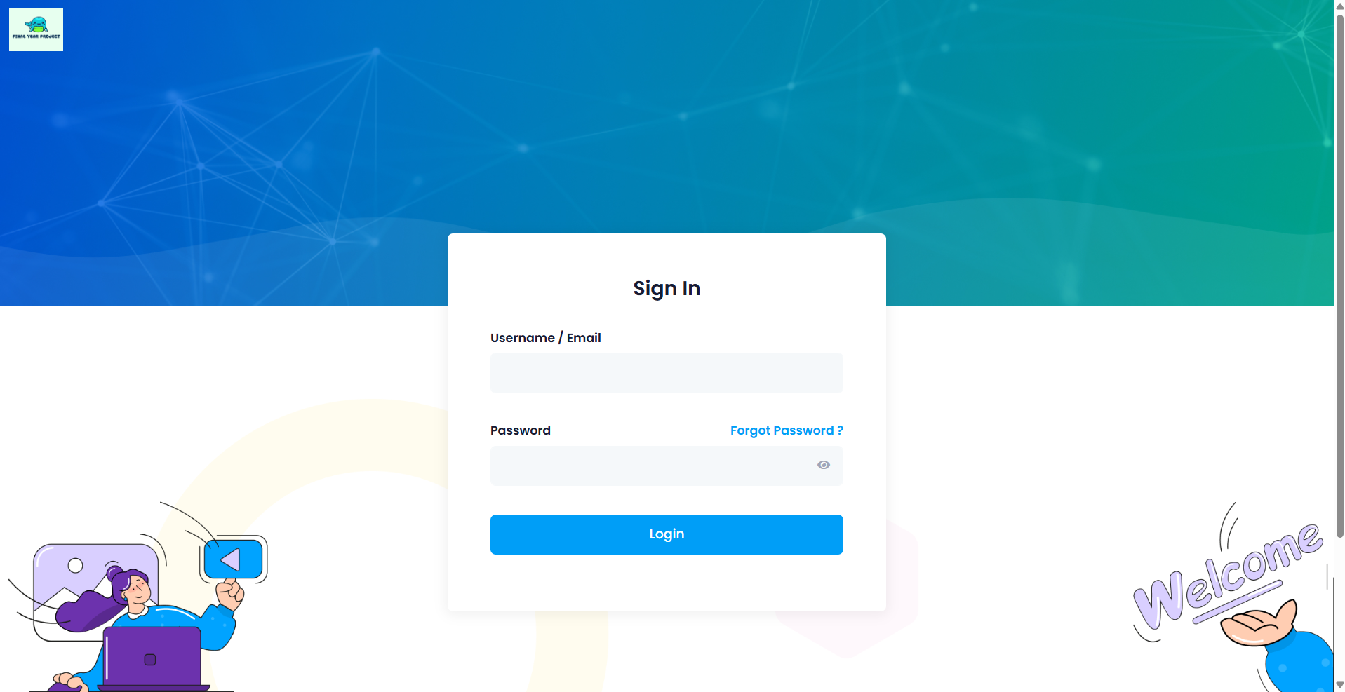Figure 3.8: The Login Page
Figure 3.8 shows the system utilizes a centralized login portal enforcing role-based access control. Users authenticate using their registered Email/ID and password. The system dynamically routes the user to their respective dashboard (Admin, Student, or Supervisor) upon successful validation.
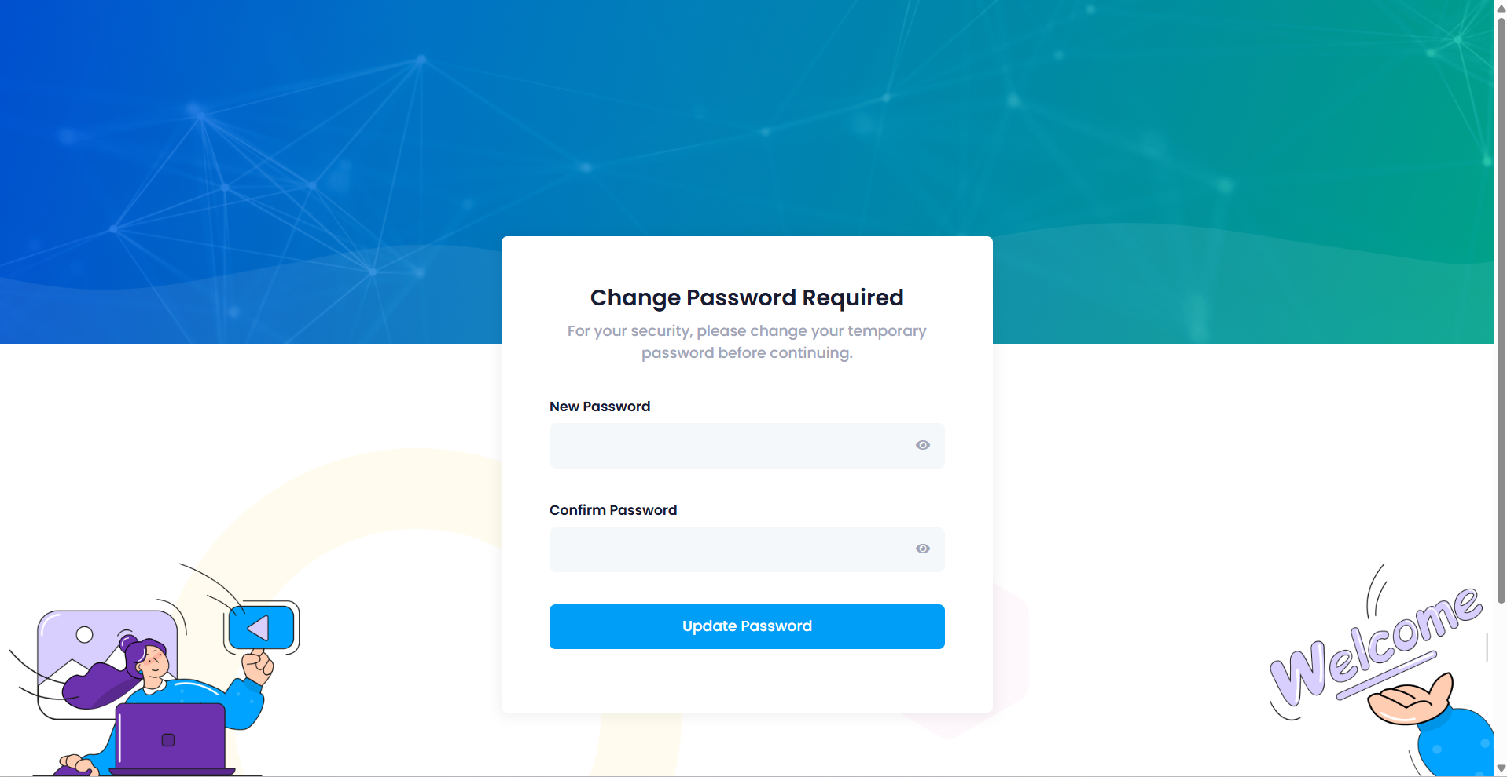
Figure 3.9: Force Password Change Screen
Figure 3.9 shows to enforce strict security protocols, users logging in with an auto-generated temporary password are intercepted by this screen. They are mandated to set a new, secure password before accessing any internal system functionalities.
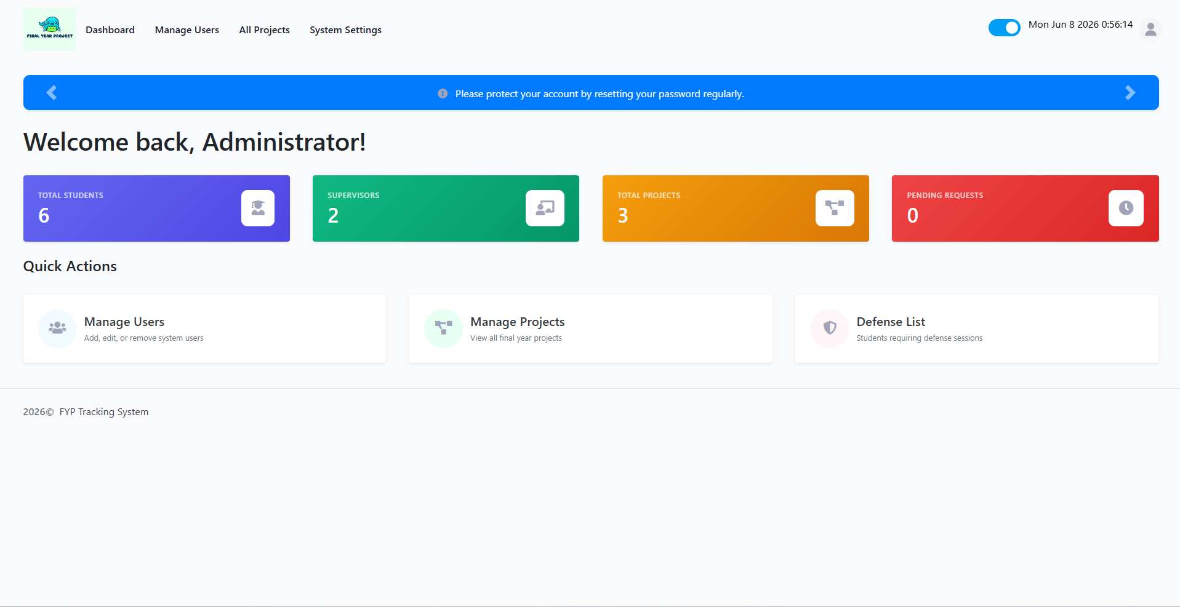
Figure 3.10: Admin Dashboard
Figure 3.10 shows the Administrator Command Center features analytical metric cards providing a real-time snapshot of system health, including the total number of registered students, active projects, and pending supervision requests.

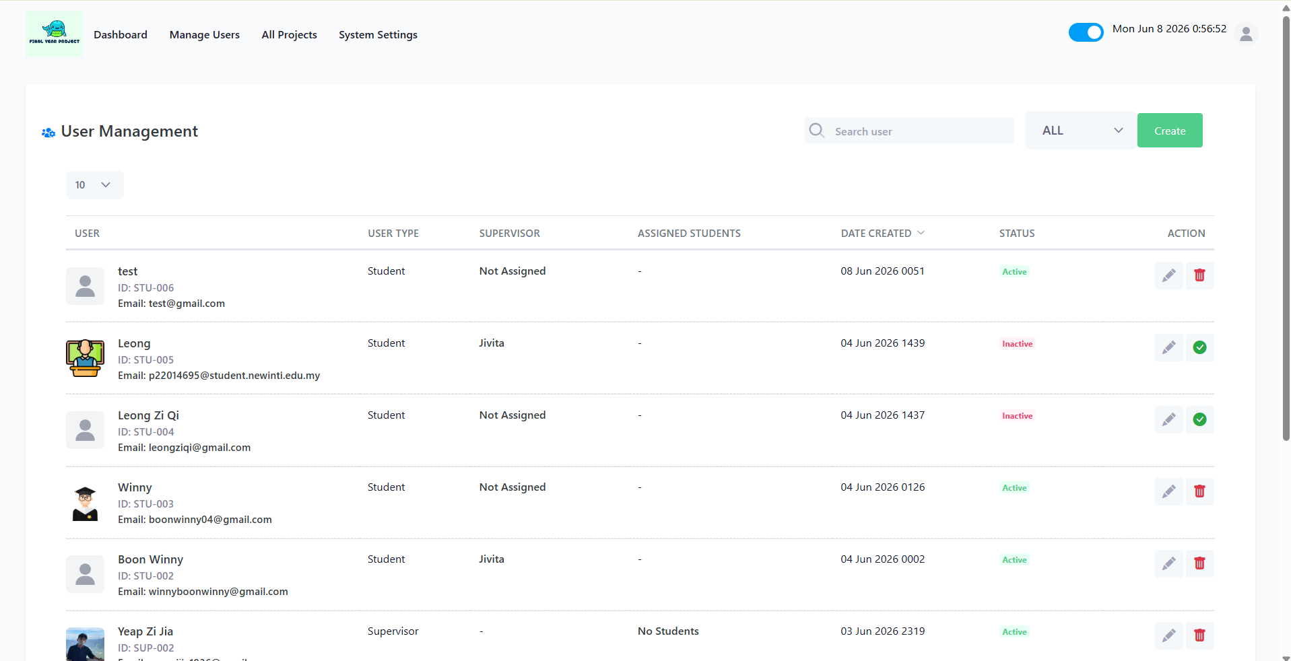
Figure 3.11: User Directory & Management
Figure 3.11 shows this interface allows administrators to oversee all registered accounts. It provides CRUD capabilities, enabling admins to view details, edit typographical errors in profiles, and instantly toggle account activation status to suspend or grant access.
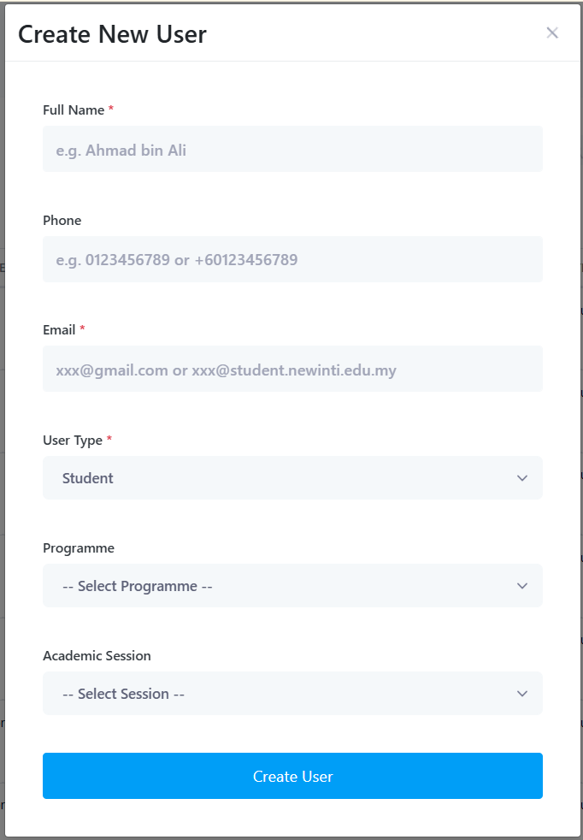 | 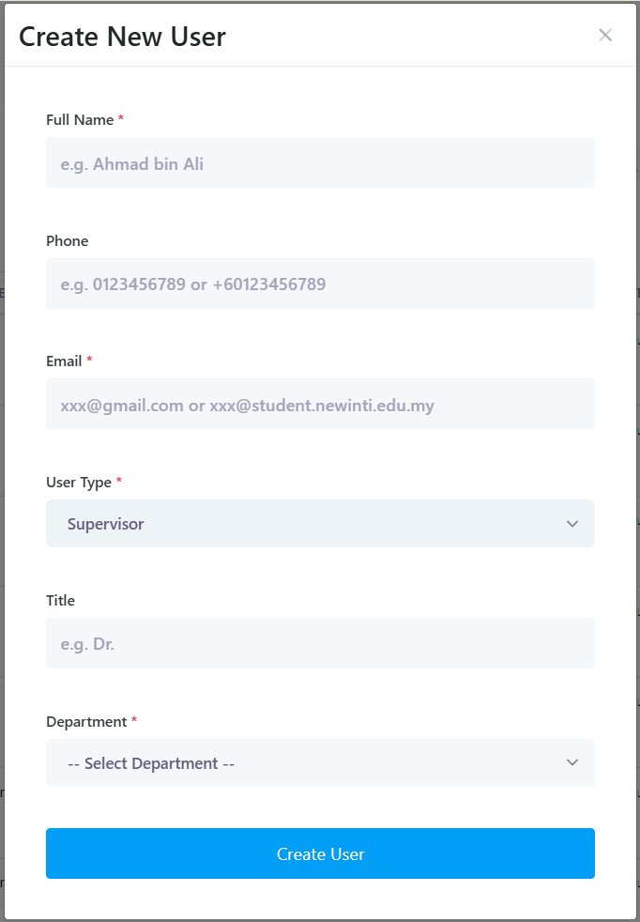
Figure 3.12-13: Create New User Form
Figure 3.12-13 shows the user provisioning form incorporates real-time validation. When an administrator inputs a new university email, the system automatically parses the Student/Staff ID and triggers a background service to generate a secure password and dispatch a welcome email.
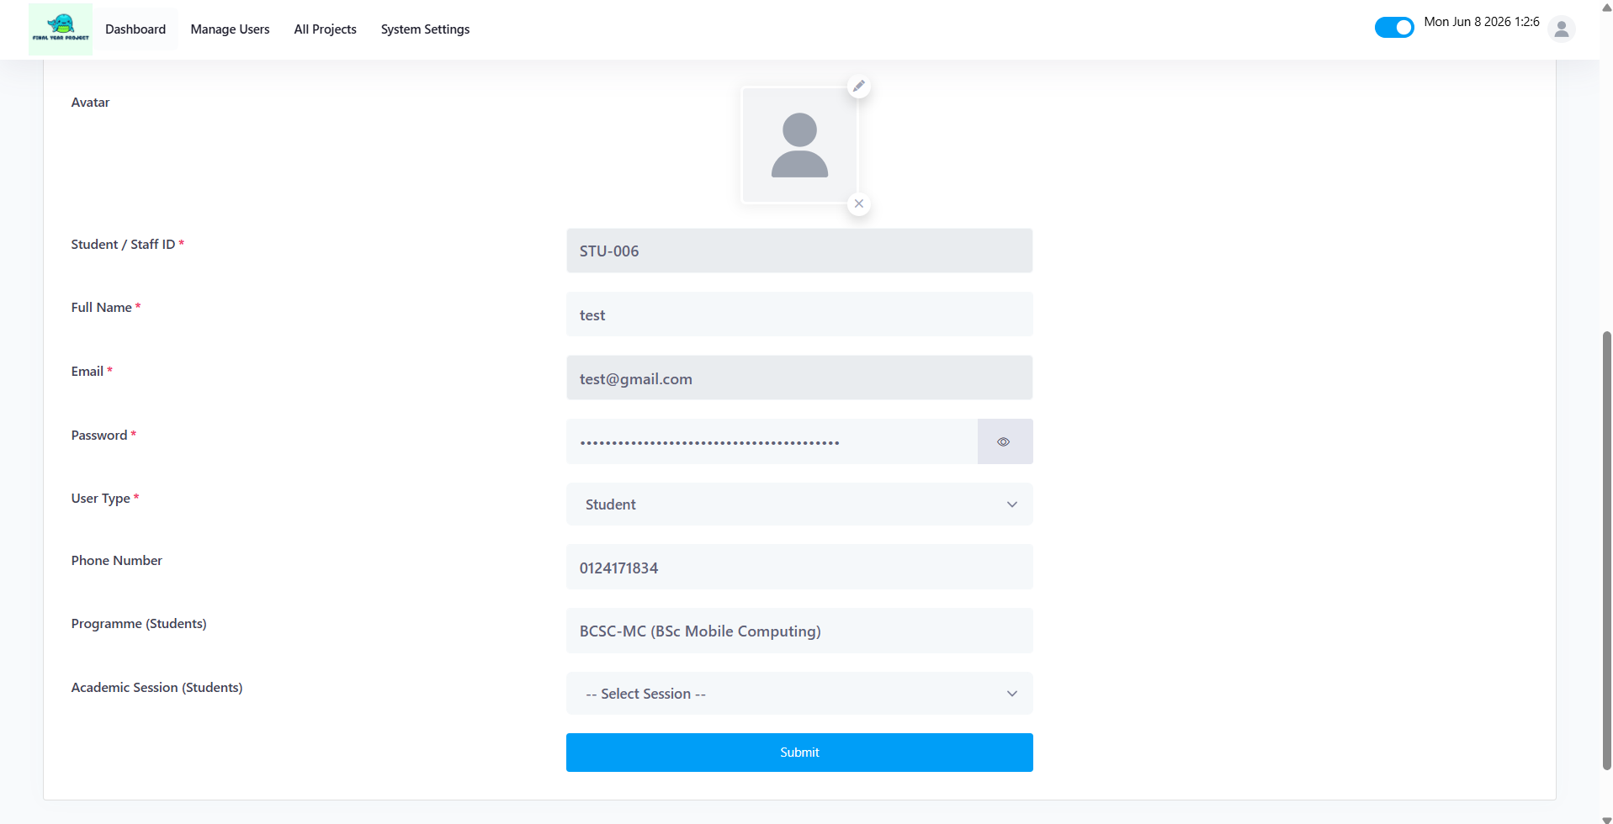
Figure 3.14: Edit User
Figure 3.14 shows the edit user interface provides administrators with a secure, centralized form to modify existing account profiles. Accessed directly from the master user directory, this interface pre-populates with the user's current database records, allowing the administrator to seamlessly correct typographical errors, update contact information, and adjust departmental or academic alignments. The form enforces strict server-side validation to ensure that any modified data conforms to the system's formatting rules and prevents the creation of duplicate email addresses, thereby maintaining total data integrity across the tracking system.
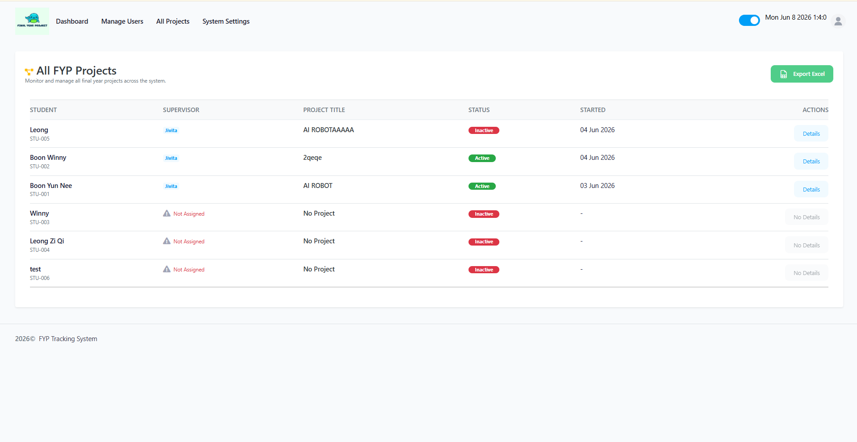
Figure 3.15: Manage Projects Interface
Figure 3.15 shows the manage projects interface serves as a comprehensive, high-level directory that empowers administrators to oversee all Final Year Projects operating within the system. This centralized data table displays critical tracking information, including the formalized project title, the assigned student, the allocated supervisor, and the current academic status of the project. A core feature of this module is the 'Export to Excel' functionality, which allows administrators to instantly generate and download a spreadsheet containing all live project data. This export capability is crucial for archiving, offline auditing, and seamlessly sharing project distributions with higher management or external accreditation boards.

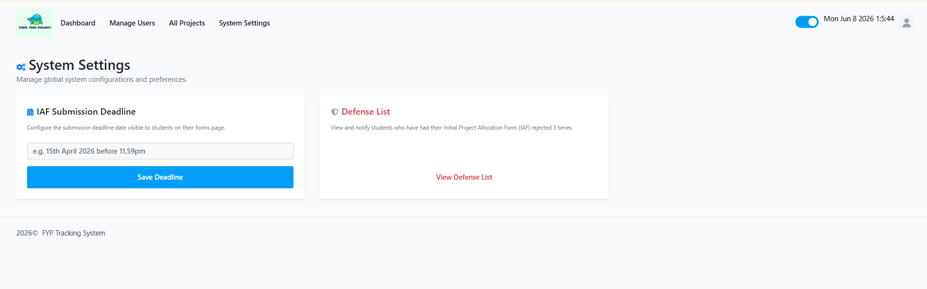
Figure 3.16 System Settings Interface
Figure 3.16 shows the system settings interface serves as the primary configuration hub for critical academic deadlines and exception handling. Firstly, it allows administrators to globally configure the IAF (Initial Project Allocation Form) Submission Deadline. This dynamically updates the countdown and visibility on all student dashboards, ensuring uniform enforcement of university timelines. Secondly, it features the Defense List management tool. This acts as an academic safety net, automatically aggregating a list of students whose IAF submissions have been rejected three times. Administrators can use this view to monitor struggling students and dispatch targeted notifications, prompting them to prepare for an in-person proposal defense.

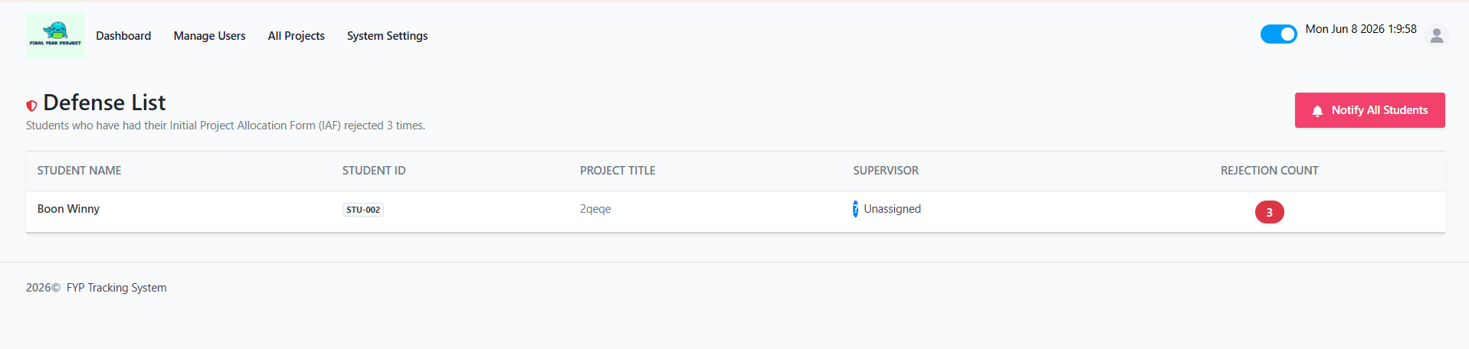
Figure 3.17 Defense List Interface
Figure 3.17 shows the defense list interface serves as a specialized academic safety net within the system. It is designed to automatically isolate and aggregate students who have reached the critical threshold of having their Initial Project Allocation Form (IAF) rejected three consecutive times. By presenting these specific students in a centralized data table, the interface allows administrators to easily identify struggling candidates. Furthermore, it empowers administrators to take direct, immediate action by triggering targeted notifications, officially summoning the students to prepare for a mandatory, in-person proposal defense panel to resolve their project bottlenecks.
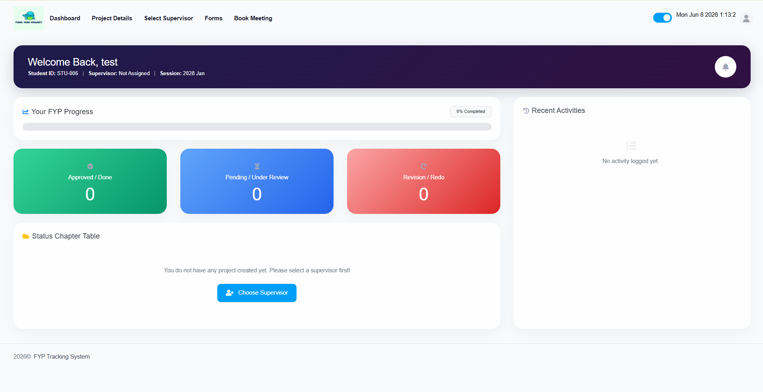
Figure 3.18 Student: Main Dashboard
Figure 3.18 shows the student dashboard acts as the personalized command center for the student's Final Year Project journey. Upon logging in, this interface provides an immediate visual summary of their overarching academic progress. It prominently displays the real-time status of their current project, highlights impending milestone submission deadlines such as the IAF deadline, and features an activity feed or notification panel to ensure the student is instantly aware of any urgent feedback or meeting approvals from their supervisor.
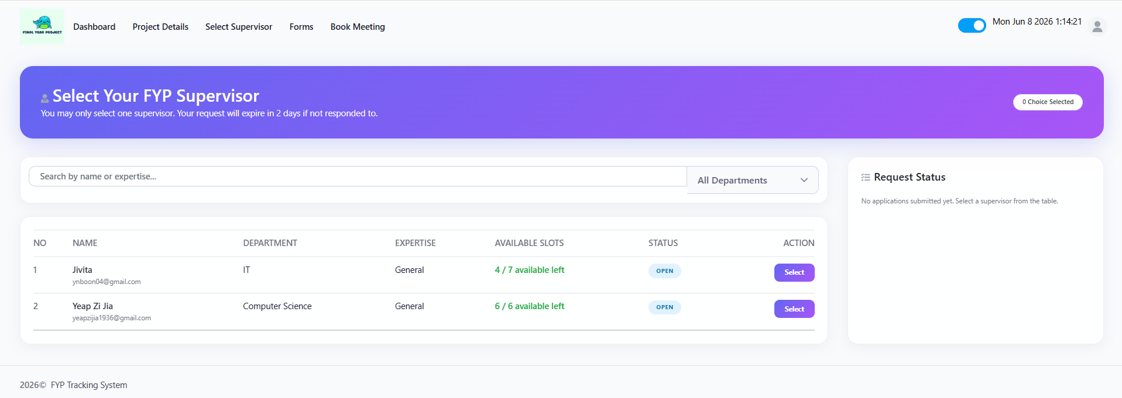
Figure 3.19 Supervisor Directory & Request
Figure 3.19 shows this interface facilitates the crucial pre-allocation phase of the Final Year Project. It presents a comprehensive directory of all faculty members alongside a dynamic counter of their available supervision slots. Students can evaluate potential supervisors based on capacity and academic alignment. Upon selecting an available faculty member, the interface opens a secure submission form where the student must draft and submit a 'Brief Proposal', formally pitching their project idea to initiate a supervision request.
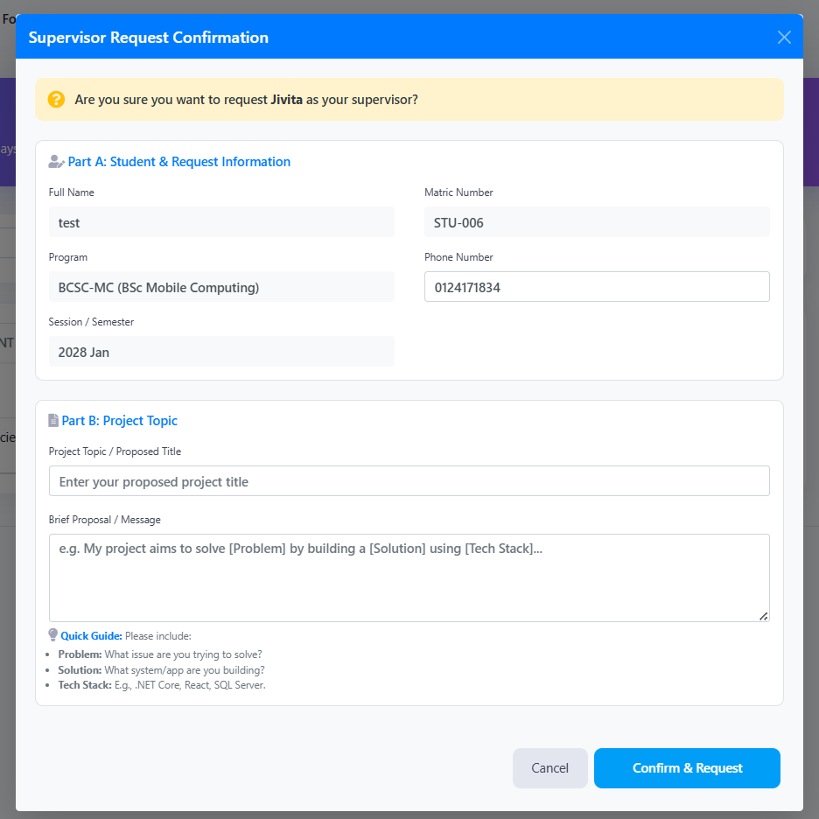
Figure 3.20 Supervisor Directory & Request
Figure 3.20 shows the Supervisor Request Confirmation Modal acts as the formal application gateway connecting students to supervisor. Triggered when a student selects a potential supervisor from the directory, this dynamic popup is divided into two distinct sections. Part A automatically pre-populates with the student's immutable academic data directly from the database, ensuring zero data-entry errors. Part B requires active student input, prompting them to formally declare their proposed Project Topic and draft a 'Brief Proposal'. To ensure high-quality requests, the modal provides integrated UI guidance, explicitly instructing students to outline their Problem Statement, Proposed Solution, and Technical Stack. This structured approach guarantees that the receiving supervisor is provided with a concise, highly informative pitch to base their acceptance decision upon.

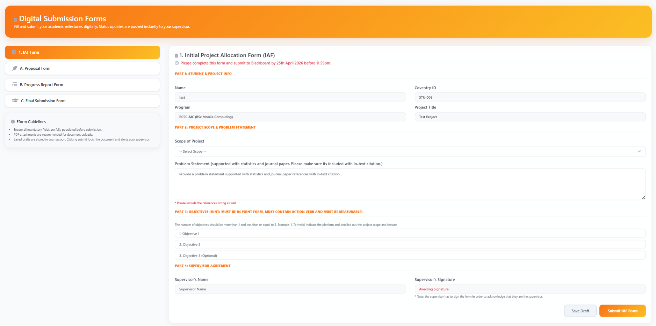
Figure 3.21 Student: Initial Project Allocation Form (IAF) Interface
Figure 3.21 shows the Initial Project Allocation Form (IAF) interface serves as the first critical submission gateway for students after securing a supervisor. This structured digital form mandates the student to formally define their foundational project parameters before any developmental work commences. The interface requires the student to articulate key academic metrics, including the Working Title, Problem Statement, Project Objectives, and proposed Methodology. By forcing this structured data entry, the IAF acts as an initial academic contract. Upon submission, the system automatically locks the form and routes it directly to the assigned supervisor's dashboard for formal evaluation, ensuring the project's scope is strictly aligned with university standards from day one.
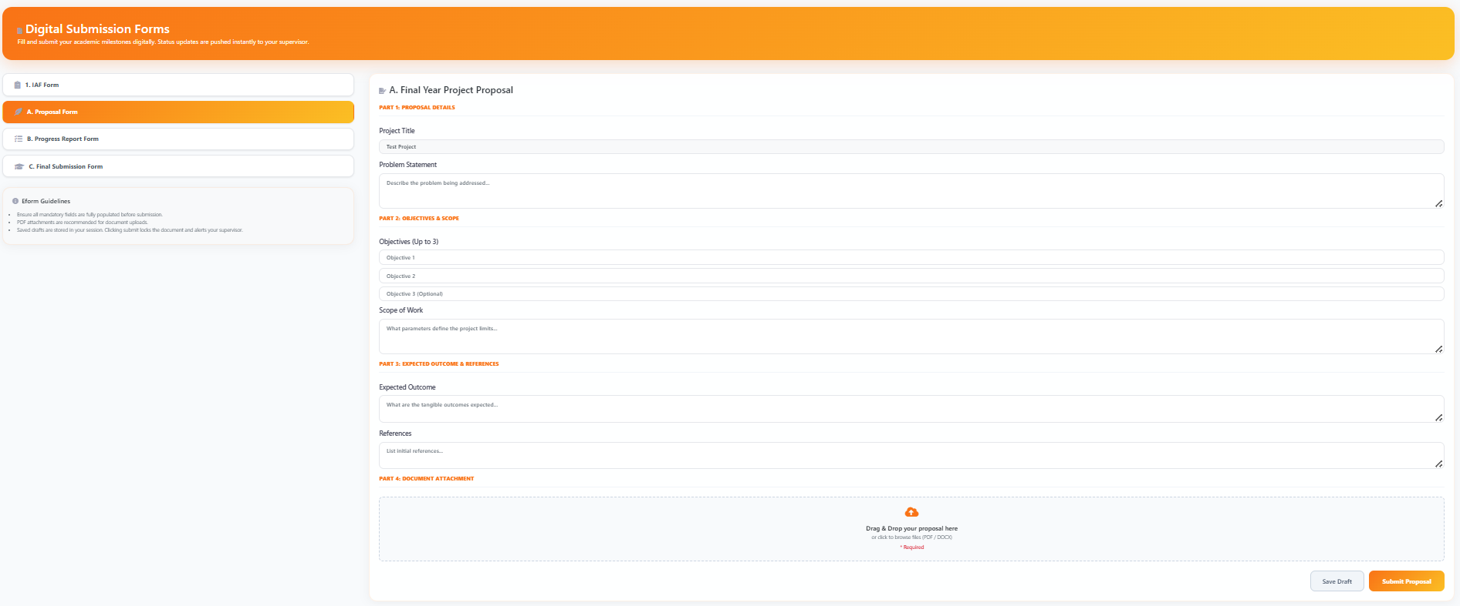
Figure 3.22 Student: Proposal Submission Interface
Figure 3.22 shows following the approval of the initial IAF, the Proposal Submission interface is utilized to formally submit the project's comprehensive architectural and technical design. This interface moves beyond basic scope definitions, requiring the student to upload detailed documentation. By enforcing the upload of these critical technical documents in secure formats (PDF/DOCX), the interface ensures the supervisor has all necessary blueprints to evaluate the technical feasibility of the system before coding begins.
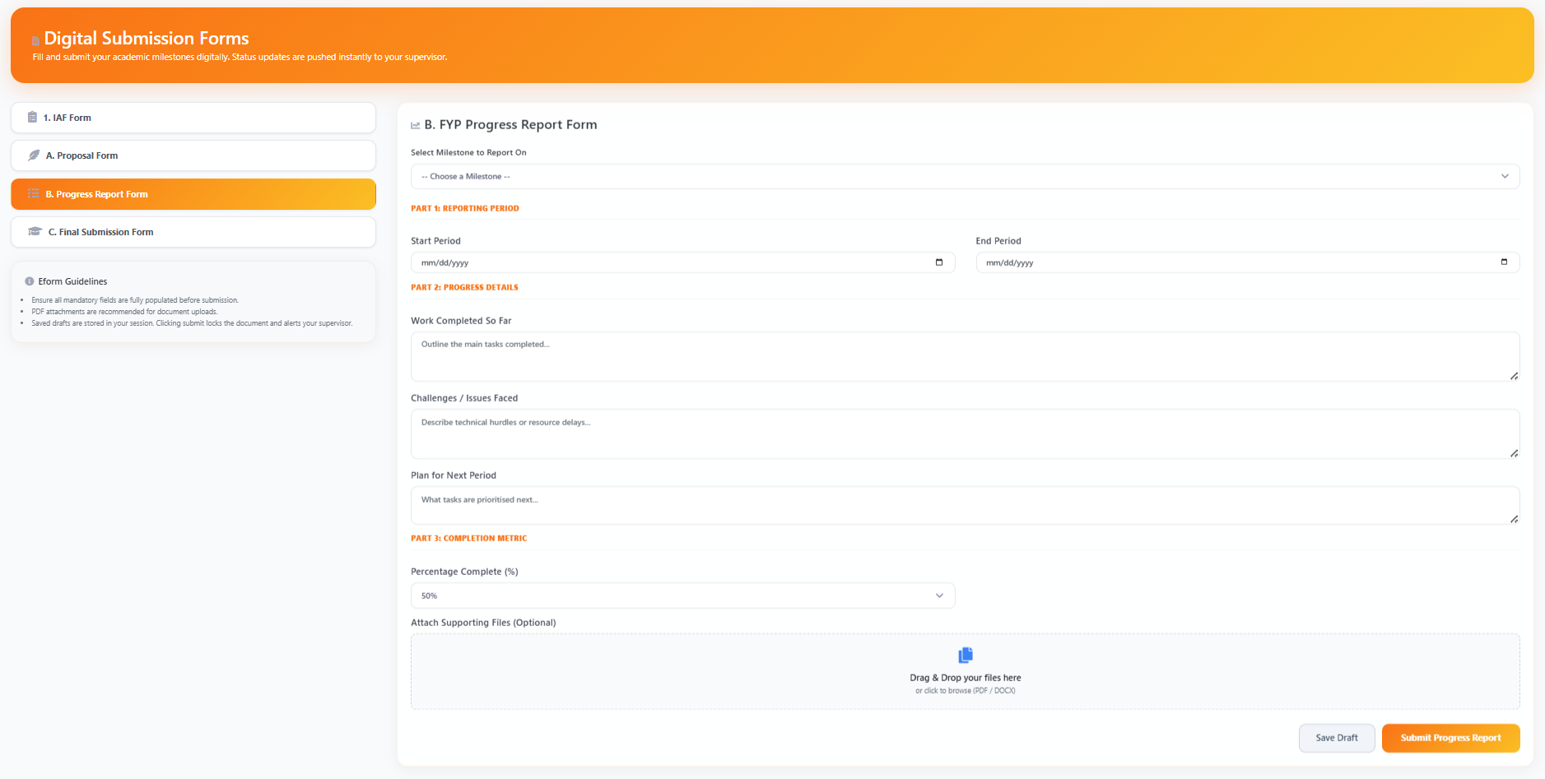
Figure 3.23 Student: Progress Report Interface
Figure 3.23 shows the Progress Report interface is engineered to facilitate mid-development academic check-ins. This UI is designed to capture the dynamic status of the project, requiring students to report on completed development modules, highlight current technical blockers, and submit updated Gantt charts reflecting their timeline adherence. By systematically recording these mid-point deliverables, the interface provides supervisors with measurable data to gauge if the student remains on track for the final deadline, allowing for early intervention if development has stalled.
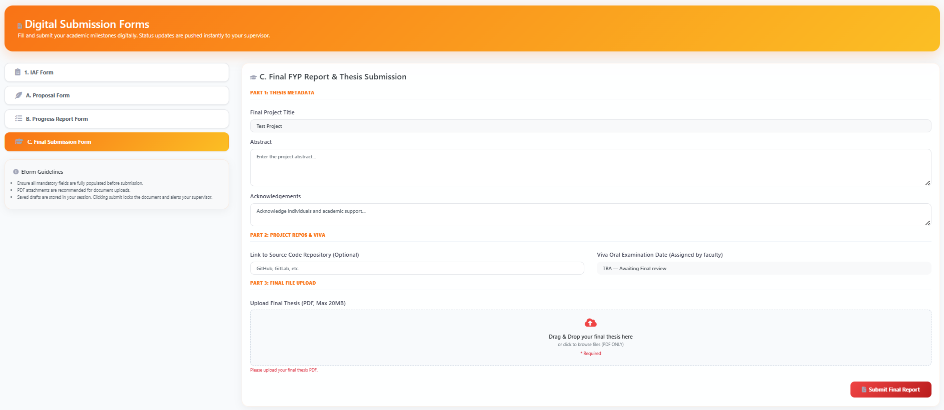
Figure 3.24 Student: Final Report Submission Interface
Figure 3.24 shows the Final Report Submission interface represents the culmination of the Final Year Project tracking lifecycle. This definitive gateway requires the student to submit their exhaustive final thesis, comprehensive user manuals, and the finalized source code repository links. The interface is configured to handle these larger, highly critical file uploads securely. Once submitted through this UI, the project status is transitioned to its final review state, signifying the end of the student's developmental phase and preparing the system for final grading and external moderation.
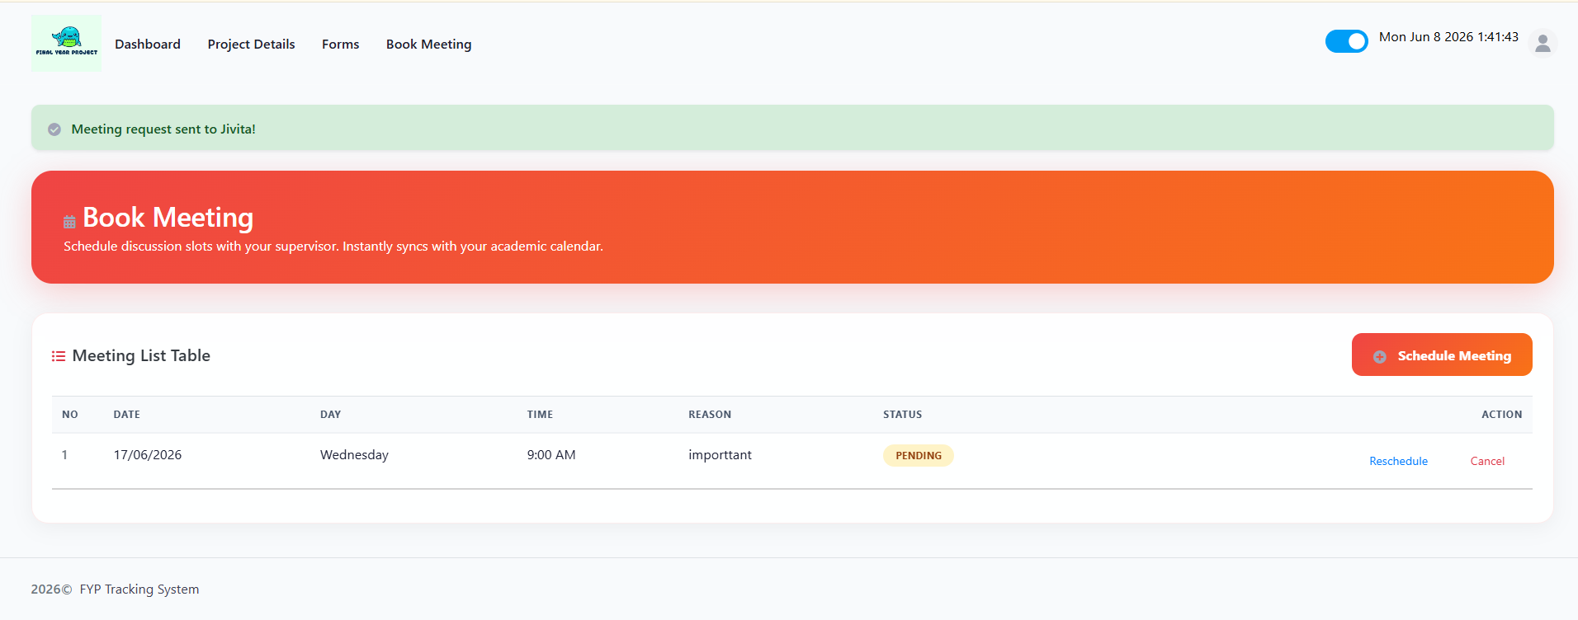
Figure 3.25 Meeting Management & Booking
Figure 3.25 shows the Meeting Management interface provides students with a streamlined scheduling tool to handle consultations. Through this UI, students can request new meeting slots by selecting a proposed date, time, and entering an agenda or reason for the consultation. The interface also acts as a historical ledger, allowing students to view the status of all pending, approved, or rescheduled meeting requests, thereby ensuring transparent and documented communication with their supervisor.
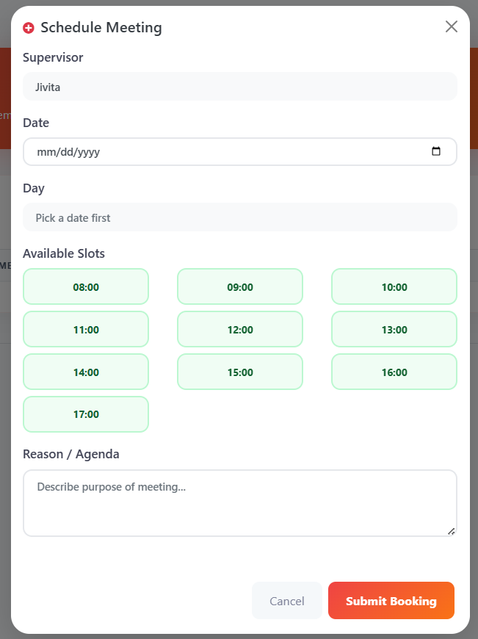
Figure 3.26 Meeting Management & Booking
Figure 3.26 shows the Schedule Meeting Modal serves as an interactive, streamlined booking system designed to facilitate seamless consultation scheduling between the student and their assigned supervisor. Upon opening, the modal dynamically displays a calendar input that automatically resolves the selected date into the corresponding day of the week. To prevent scheduling conflicts, it features a visual 'Available Slots' grid, allowing the student to precisely select a standardized one-hour time block (from 08:00 to 17:00). Furthermore, the interface enforces a mandatory 'Reason / Agenda' field. This crucial feature ensures that every consultation request is submitted with a clear, predefined academic purpose, allowing the supervisor to prepare adequately and optimizing the productivity of the meeting.
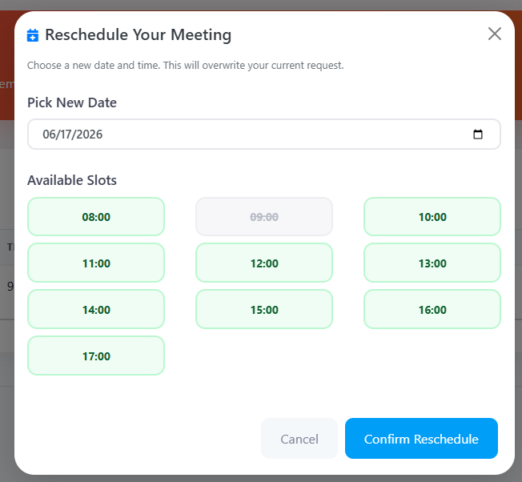
Figure 3.27 Reschedule Meeting Modal Interface
Figure 3.27 shows the Reschedule Meeting Modal is a targeted, secondary interface designed specifically to handle calendar flexibility and conflict resolution. Rather than forcing the student to cancel and completely recreate a meeting request if a scheduling conflict arises, this modal allows them to seamlessly update the proposed date and time of an existing, pending consultation. It retains the original meeting agenda in the database and presents the user with a streamlined date-picker and 'Available Slots' grid. Upon confirmation, the system instantaneously overwrites the previous calendar data with the new parameters, updating the backend records and automatically reflecting the newly proposed schedule on the supervisor's dashboard.
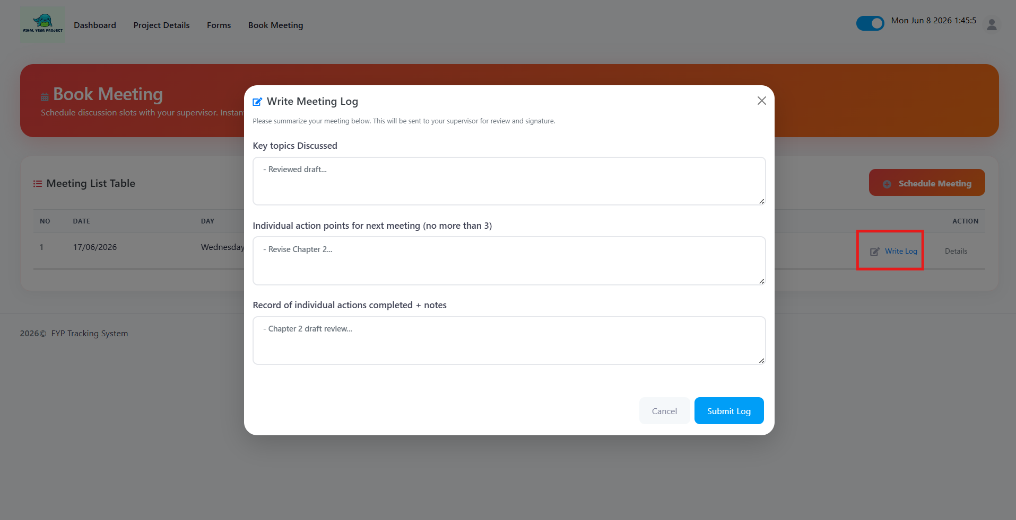
Figure 3.28 Write Meeting Log Interface
Figure 3.28 shows the Write Meeting Log interface functions as the system's official digital minutes-taking mechanism, designed to formally document the outcomes of an academic consultation. Structured to enforce student accountability, the interface requires the user to input data across three critical academic metrics: the 'Key Topics Discussed', specific 'Individual Action Points for the Next Meeting', and a 'Record of Completed Actions'. By segmenting the log in this manner, the system ensures that both past progress and future milestones are explicitly documented. Once the student submits this form, the log is transitioned into a 'Pending Review' state and is routed directly to the supervisor's dashboard for final validation and digital signature.

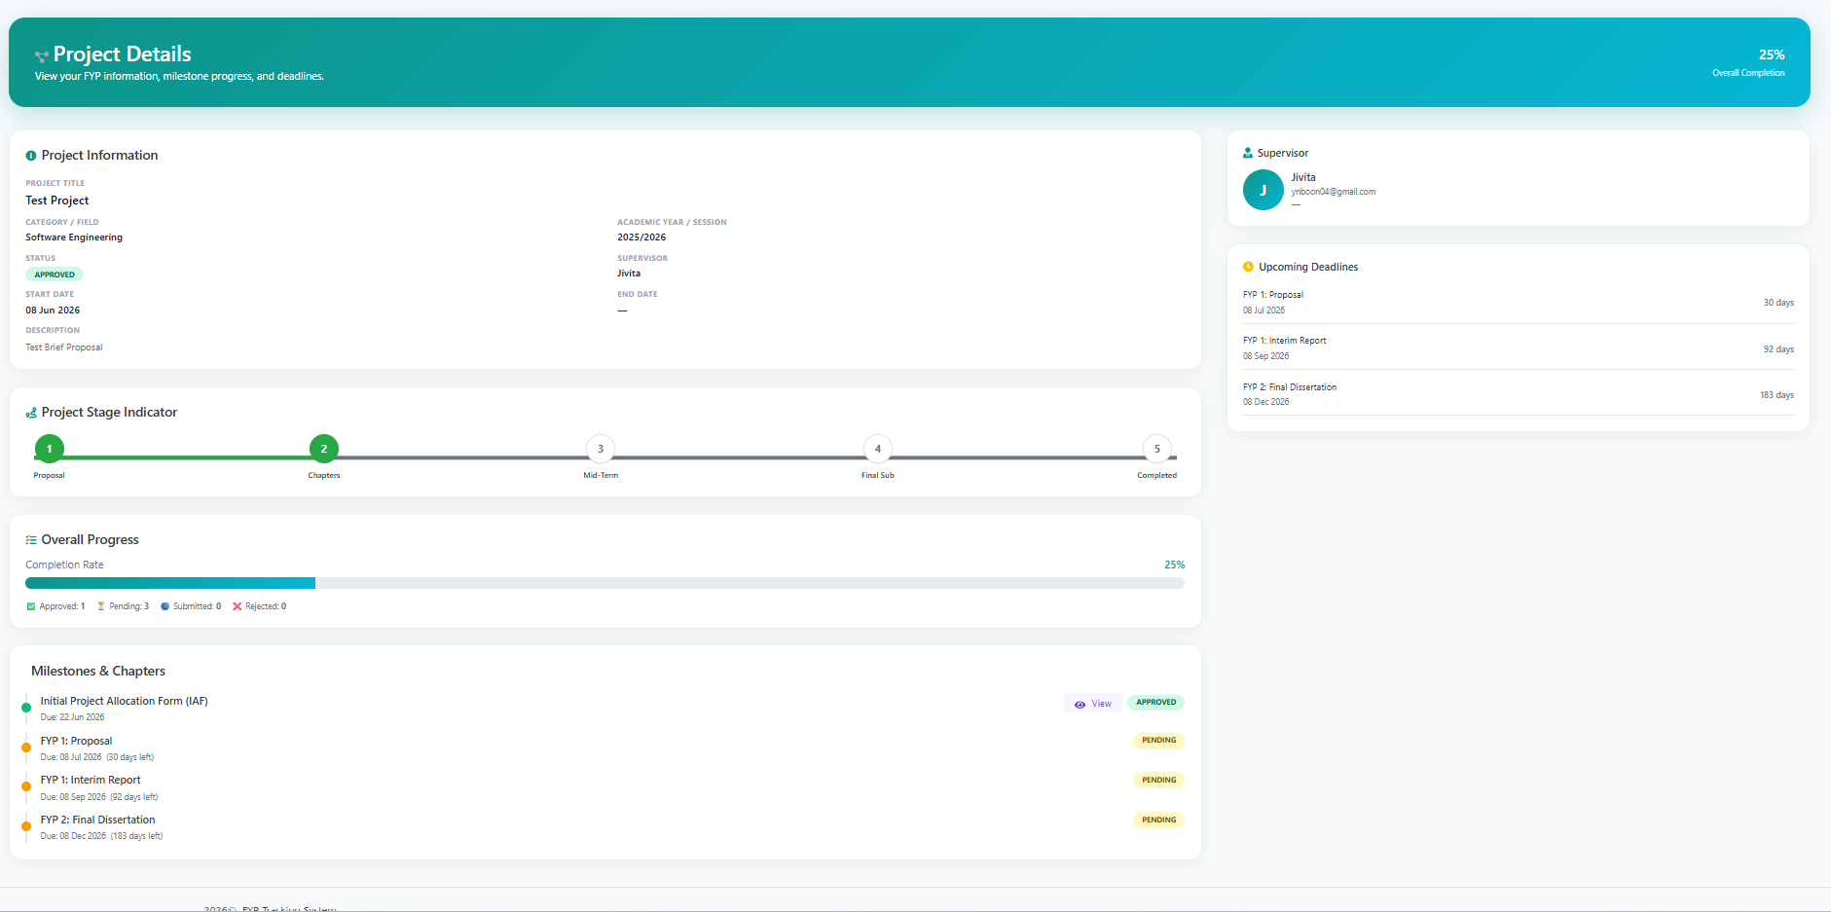
Figure 3.29 Project Details Interface
Figure 3.29 shows the Project Details interface serves as the definitive, read-only 'source of truth' for the student's ongoing Final Year Project. This comprehensive dashboard is designed to aggregate and display all critical project metadata in a single, centralized location. It prominently features the finalized Project Title, the formally assigned Supervisor, the project's commencement date, and its overarching academic status. Furthermore, the interface acts as a historical ledger, providing a complete timeline of all previously submitted milestones, uploaded files, and supervisor feedback. This allows students to effortlessly retrieve historical data, track their overarching development progression, and review past academic critiques without needing to navigate through individual submission forms.

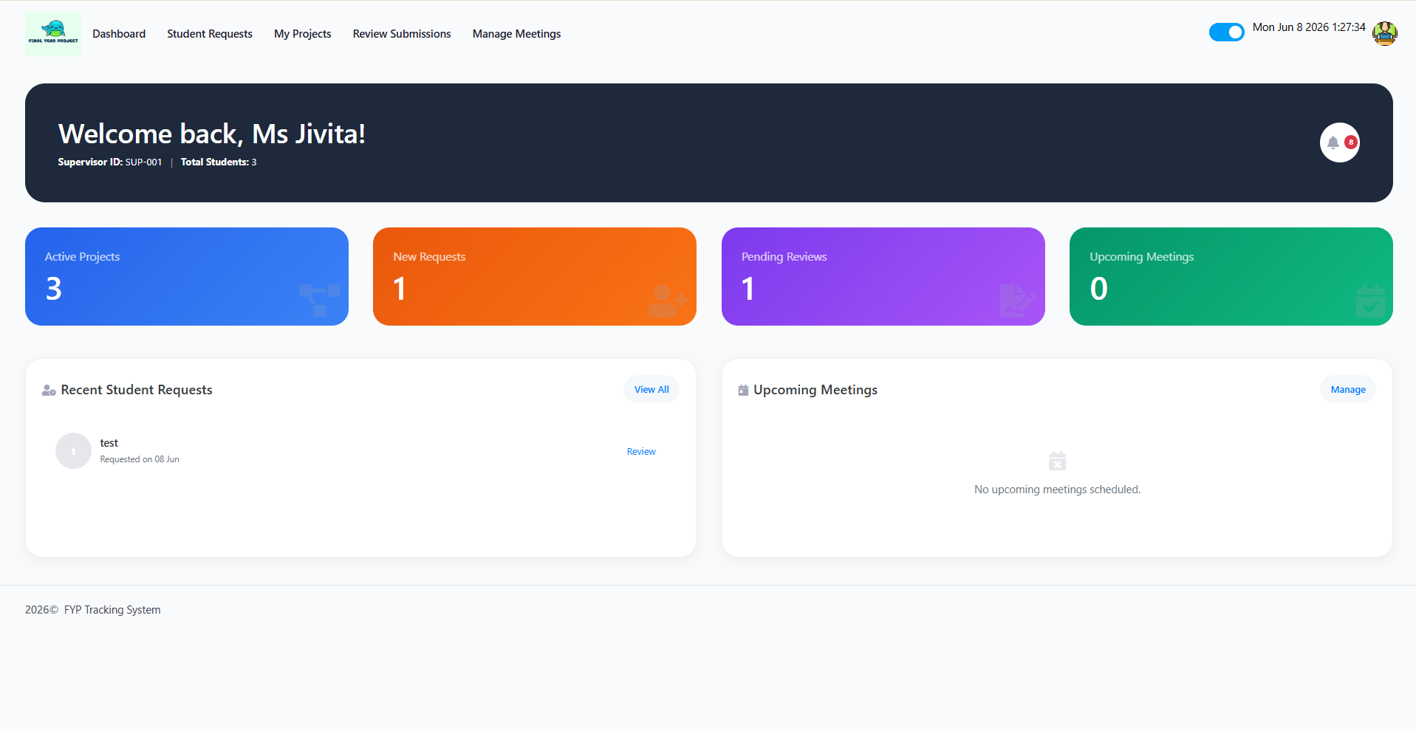
Figure 3.30 Supervisor: Main Dashboard
Figure 3.30 shows the Supervisor Dashboard acts as the primary administrative command center. Upon logging in, the interface provides an immediate analytical overview of the supervisor’s current academic workload. It displays key metrics such as the number of active project slots filled versus remaining availability, pending student supervision requests, and urgent milestone submissions awaiting review. This high-level aggregation of data ensures that the supervisor can efficiently prioritize their academic responsibilities and seamlessly manage multiple student projects simultaneously.
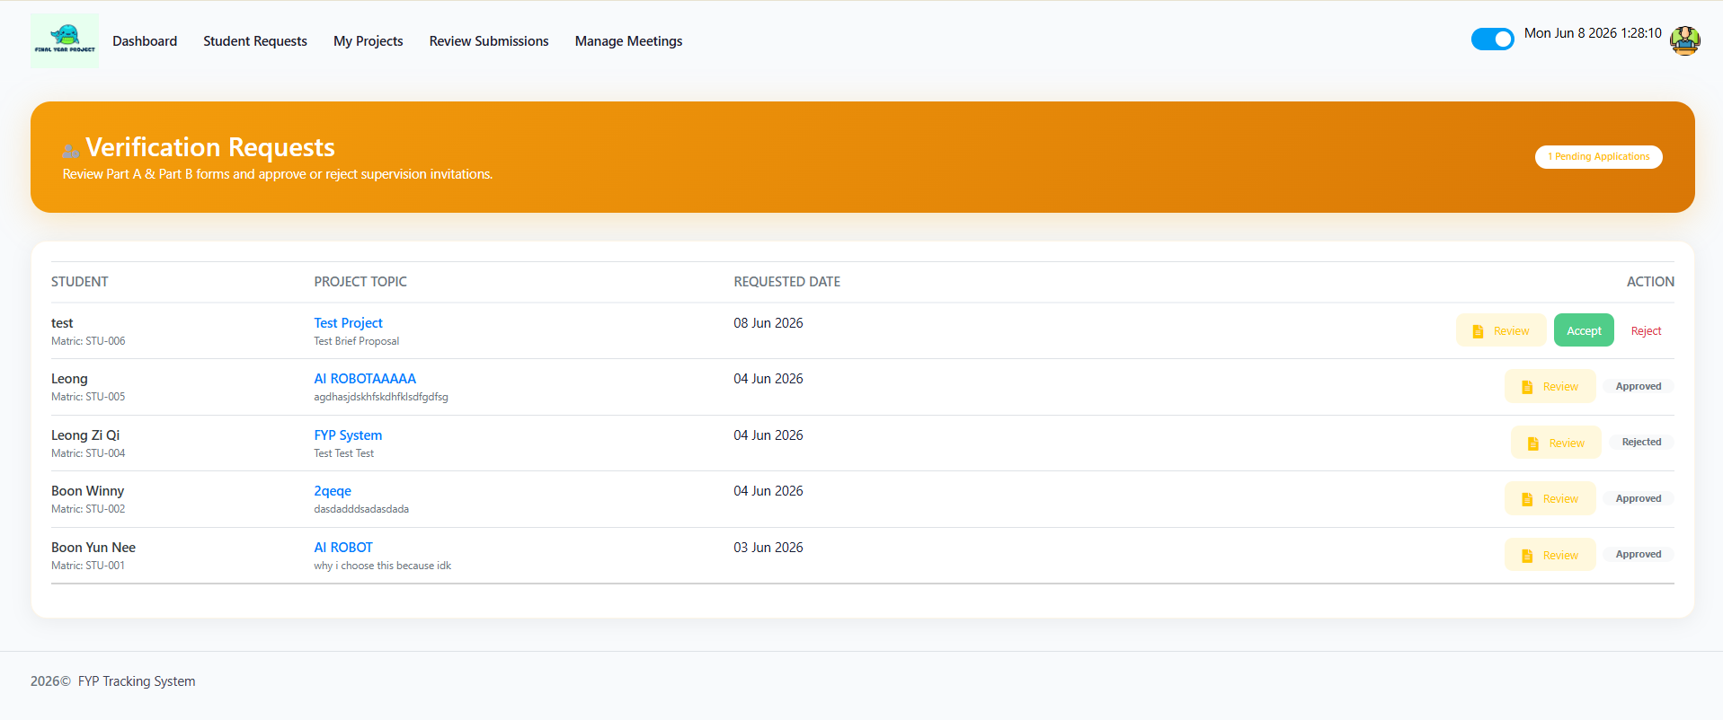
Figure 3.31 Supervisor: Manage Requests
Figure 3.31 shows this interface facilitates the critical evaluation phase of student allocation. It aggregates all incoming 'Brief Proposals' submitted by students seeking supervision. The UI presents the supervisor with the student's academic profile alongside their proposed Project Title, Problem Statement, and Technological Stack. Empowered with this data, the supervisor can make an informed academic decision to either 'Accept' the student thereby initiating a formal project record in the system or 'Reject' the request if the topic does not align with their expertise or current workload capacity.
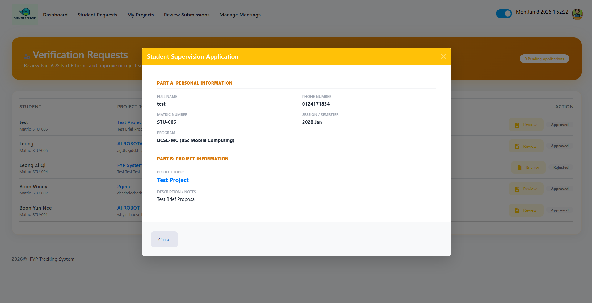
Figure 3.32 Supervisor: Student Supervision Application Modal
Figure 3.32 shows the Student Supervision Application Modal acts as the detailed evaluation window for faculty members assessing incoming project requests. Triggered from the 'Manage Requests' dashboard, this dynamic interface mirrors the data originally submitted by the student, intelligently segmenting it into two distinct logical areas. Part A displays immutable academic metadata and contact information, allowing the supervisor to instantly verify the student's eligibility. Part B presents the core academic pitch, detailing the proposed Project Topic and the student's 'Brief Proposal' notes. By providing this concentrated view, the modal empowers the supervisor to critically evaluate the project's technical feasibility and determine if the research aligns with their own academic expertise before issuing a formal acceptance or rejection.
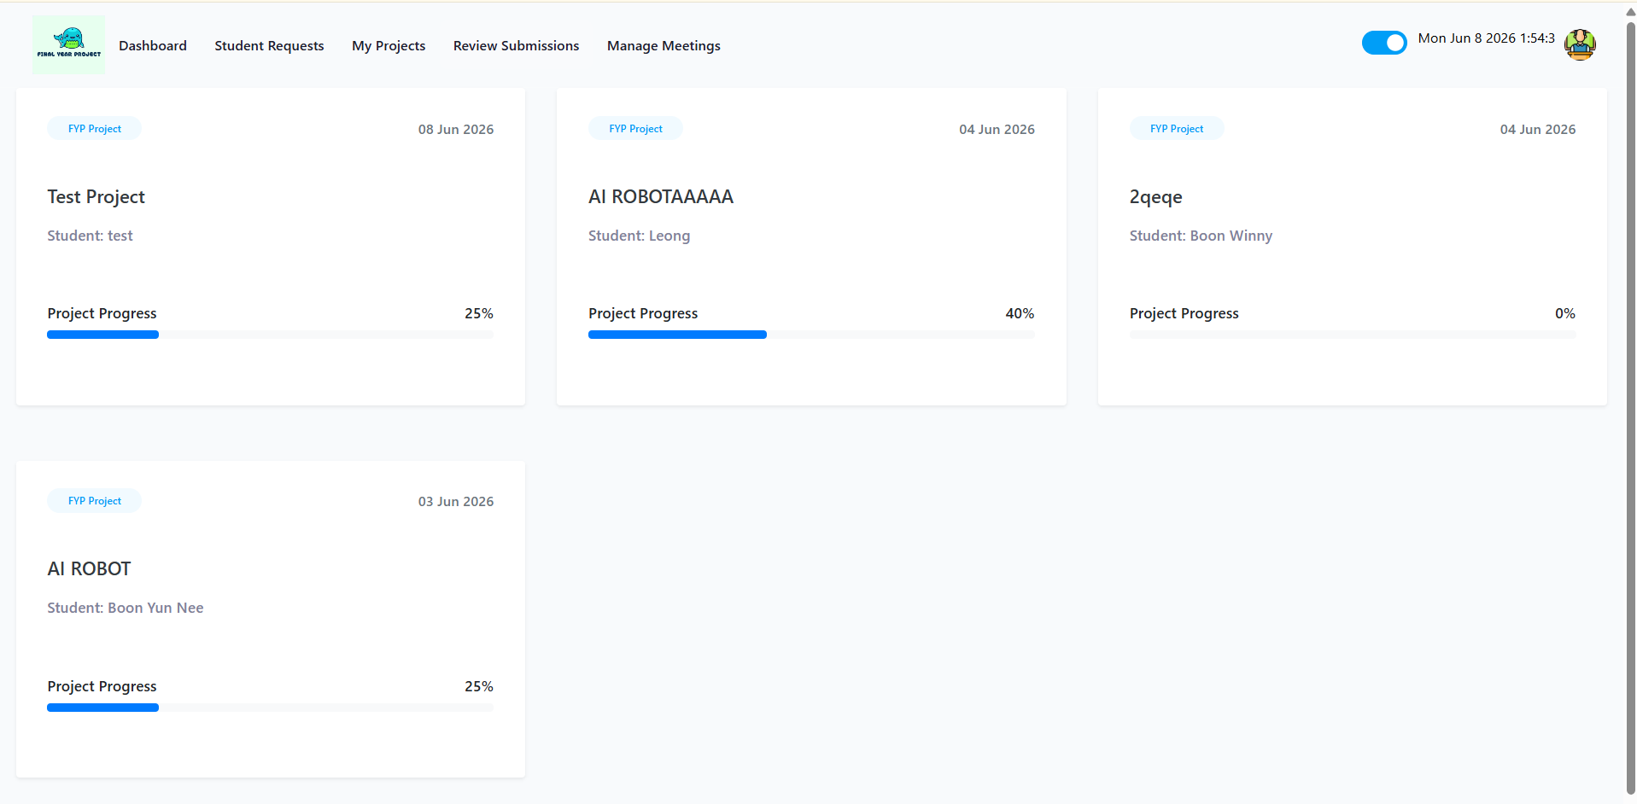
Figure 3.33 Supervisor: Manage Projects & Submissions
Figure 3.33 shows the Manage Projects interface serves as the core evaluation hub for all active Final Year Projects under the supervisor's purview. This interface lists all currently assigned students and provides direct access to their milestone submissions. From this centralized dashboard, the supervisor can download securely attached project documents (PDFs/DOCXs), review the student's technical methodologies, and utilize integrated forms to provide formal academic feedback. Supervisors use this module to either 'Approve' a milestone to progress the project or 'Reject' it, mandating the student to revise and resubmit.
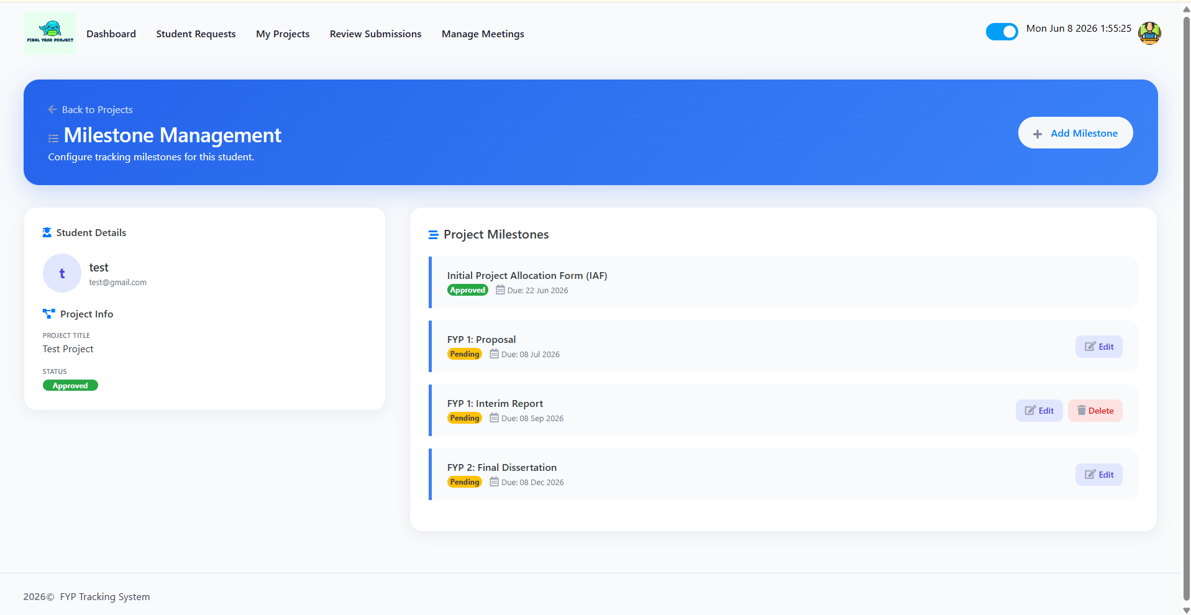
Figure 3.34 Supervisor: Project Milestone Management Interface
Figure 3.34 shows the Specific Project Details interface functions as the primary administrative engine for managing academic deliverables, specifically engineered to handle comprehensive CRUD (Create, Read, Update, Delete) operations for project milestones. Rather than relying on rigid, pre-defined system deadlines, this dynamic dashboard empowers the supervisor to custom-tailor the project timeline for individual students. Through this interface, supervisors can instantly Create new milestone requirements , Read and evaluate submitted files associated with those milestones, Update milestone parameters such as extended deadlines or status changes, and securely Delete obsolete tasks. This CRUD functionality provides unparalleled flexibility, allowing faculty to dynamically adjust the academic roadmap based on the student's real-time developmental pace.
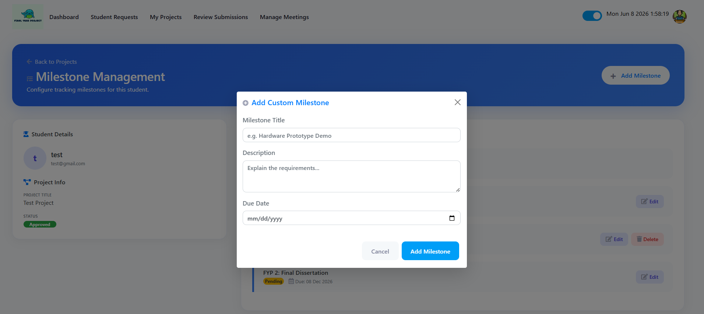
Figure 3.35 Supervisor: Add Custom Milestone Modal Interface
Figure 3.35 shows the Add Custom Milestone Modal is the primary user interface component responsible for executing the 'Create' operation within the milestone CRUD module. This modal allows supervisors to inject highly specialized academic requirements that fall outside the standard university timeline. The structured form mandates three critical data points are a distinct Milestone Title, a comprehensive Description outlining the specific academic expectations, and a strict Due Date. Upon submission, this data is instantly committed to the database, dynamically updating the student's personal dashboard and synchronizing the new deliverables in real-time.

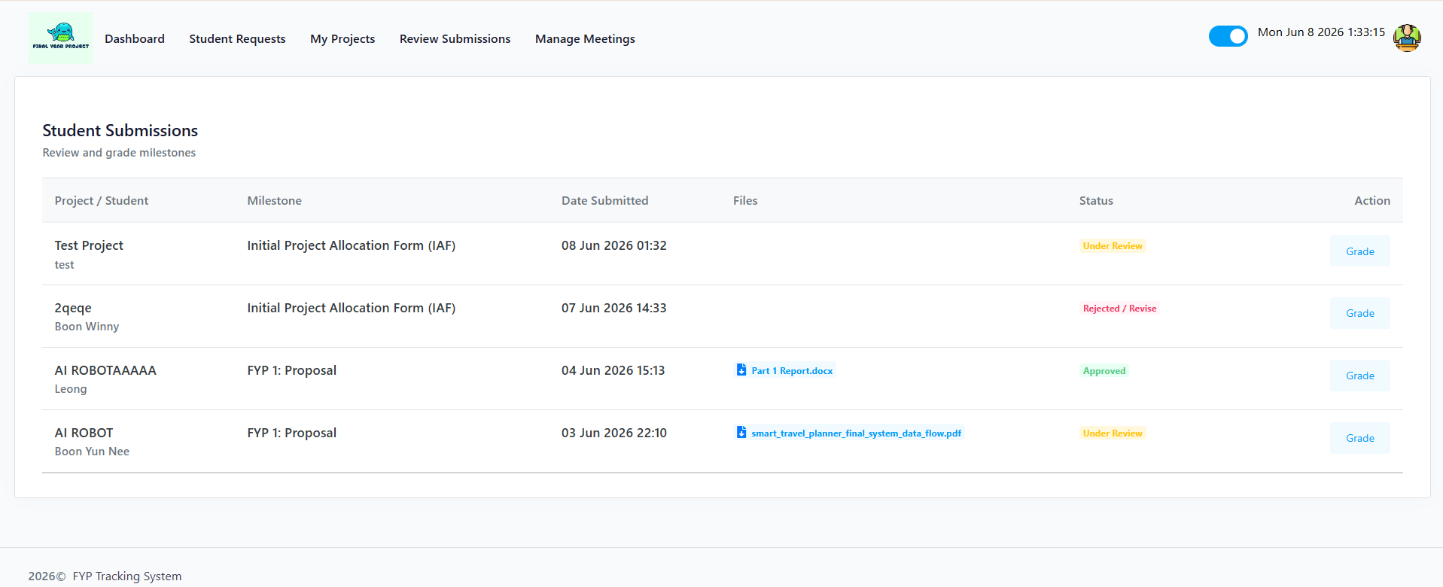
Figure 3.36 Supervisor: Review Submissions Interface
Figure 3.36 shows the Review Submissions interface acts as a dedicated, high-priority dashboard designed to streamline the academic marking process. Rather than forcing the supervisor to manually click through individual student profiles to find pending work, this interface intelligently aggregates all 'Awaiting Review' deliverables across all assigned projects into a single, organized queue. From this centralized hub, supervisors can rapidly identify pressing deadlines, securely download submitted technical documents or source code artifacts, and seamlessly transition into the grading phase to either formally approve the milestone or mandate critical revisions.
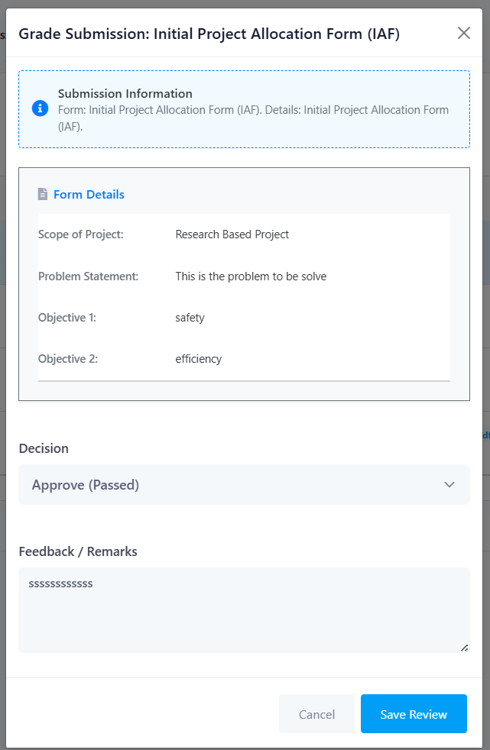
Figure 3.37 Supervisor: Grade Submission Modal Interface
Figure 3.37 shows the Grade Submission Modal functions as the formal academic evaluation interface for supervisors. Designed for maximum efficiency, the modal dynamically retrieves and displays the exact contents of the student's submission directly within the grading window. This prevents the supervisor from having to toggle between different screens to review the work. The interface forces a strict binary academic 'Decision' either formally Approving the work to progress the project timeline, or Rejecting it to mandate revisions. Furthermore, it incorporates a 'Feedback / Remarks' section, ensuring that students always receive constructive, formally documented critiques that justify the supervisor's final grading decision.

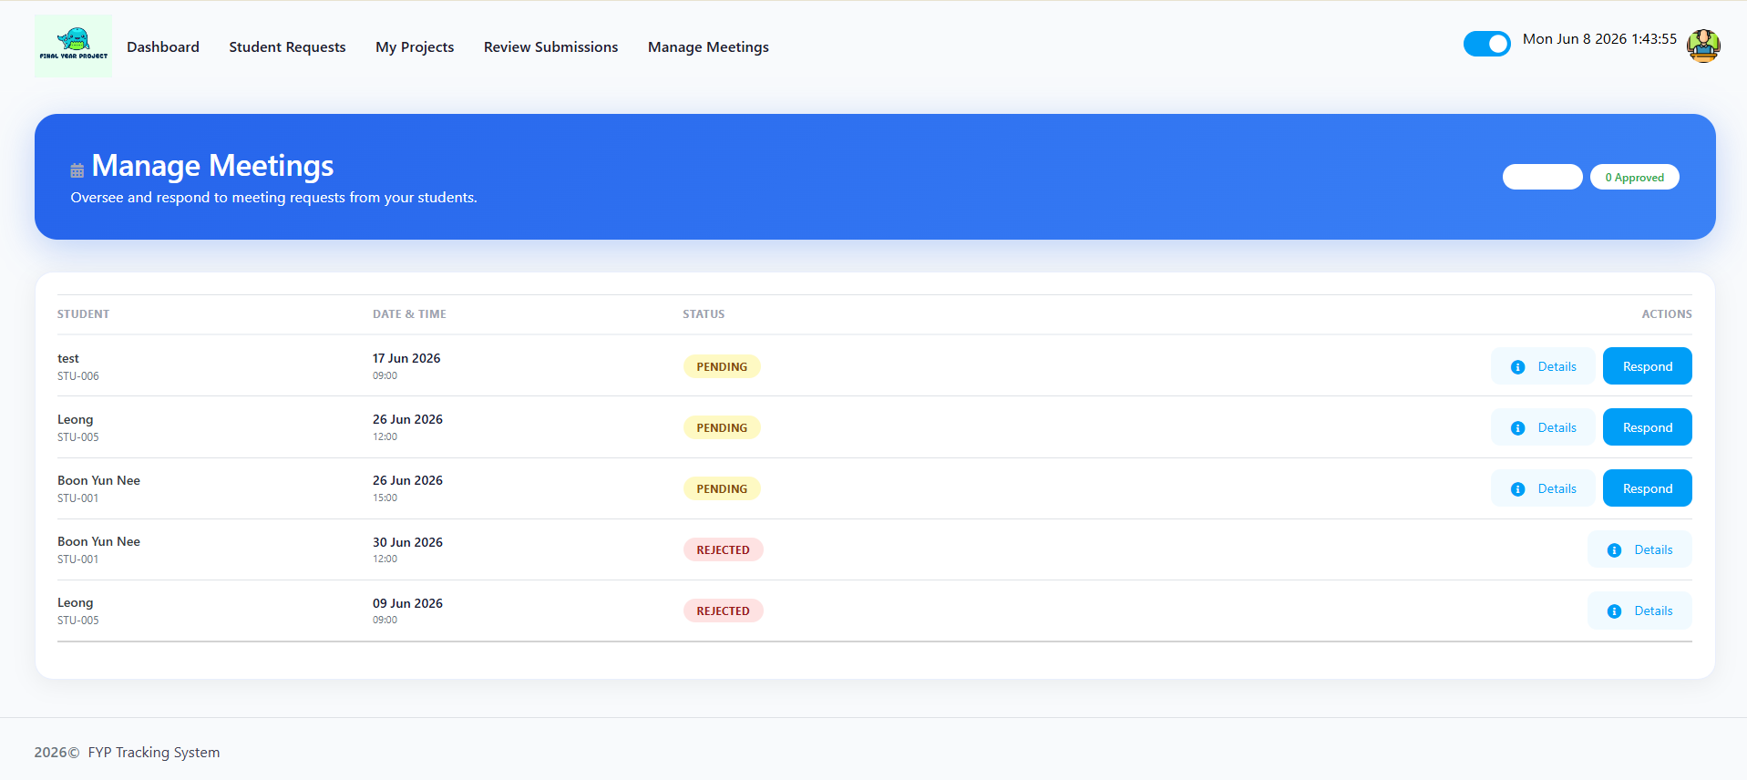
Figure 3.38 Supervisor: Meeting Management
Figure 3.38 shows the Meeting Management interface provides the supervisor with a streamlined digital calendar to manage student consultations. The UI isolates all incoming meeting requests, displaying the proposed date, time slot, and the student's predefined agenda. This allows the supervisor to quickly assess their availability and the meeting's purpose. The interface grants the supervisor the authority to formally 'Approve' the time slot, ensuring the meeting is locked into the system, or independently propose a rescheduled time if a calendar conflict exists.
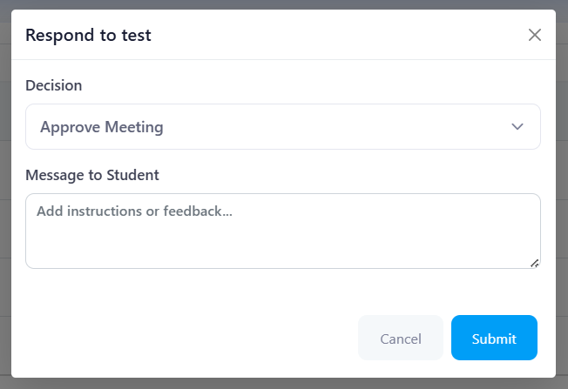
Figure 3.39 Supervisor: Respond to Meeting Request Modal Interface
Figure 3.39 shows the Respond to Meeting Request Modal is a targeted communication interface designed to allow supervisors to rapidly process incoming consultation requests. To streamline calendar management, the modal requires the supervisor to select a definitive 'Decision' regarding the requested time slot. Crucially, the interface includes an integrated 'Message to Student' field. This provides the supervisor with a direct channel to issue pre-meeting instructions or offer context for a scheduling rejection, ensuring that the student is fully prepared and aligned with academic expectations before the consultation takes place.

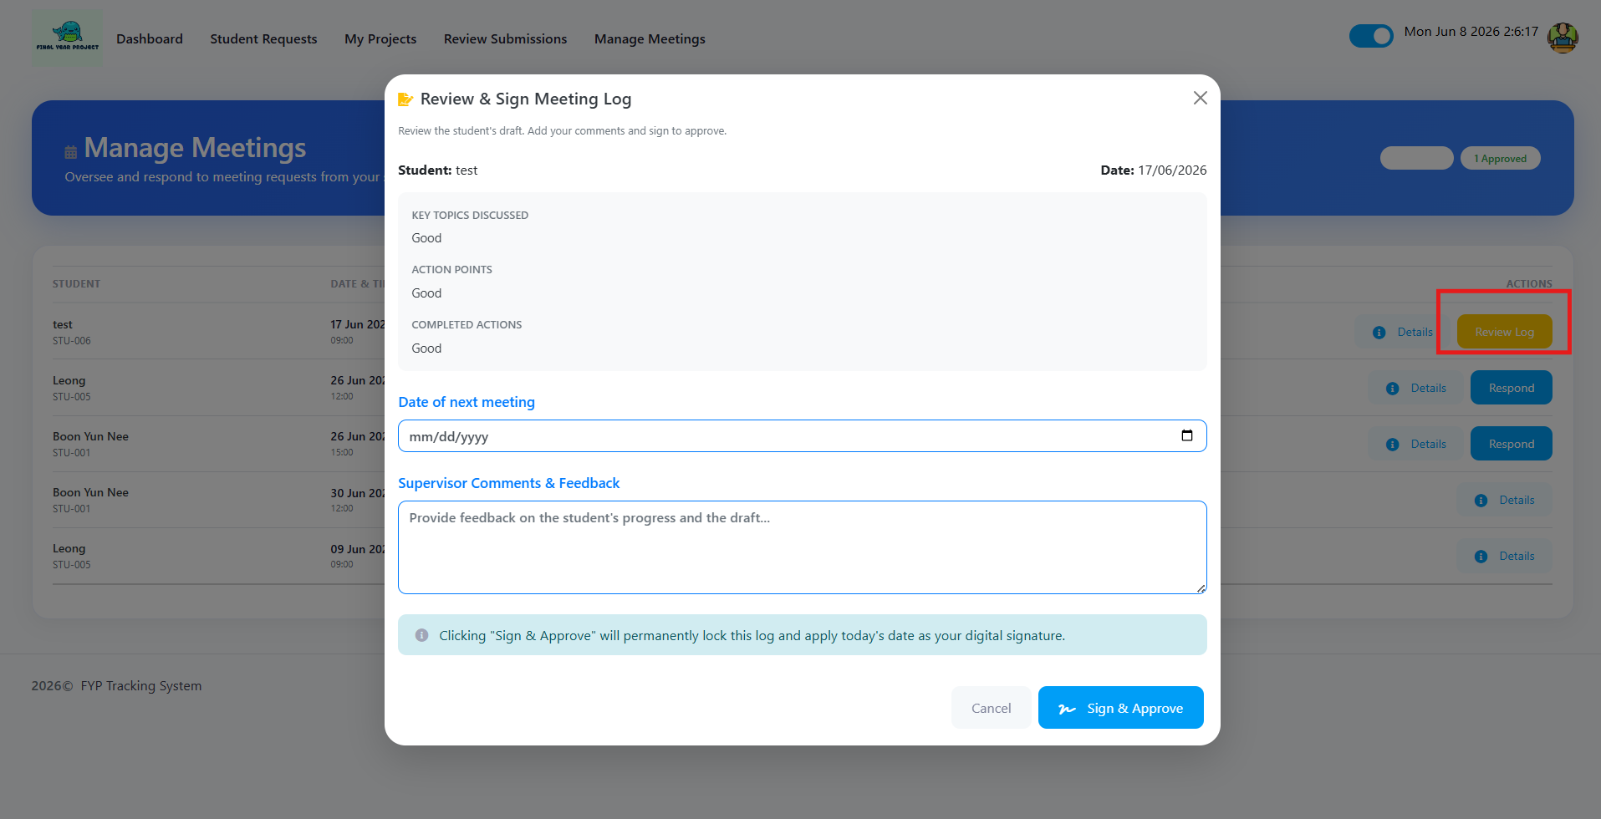
Figure 3.40 Supervisor: Respond to Meeting Request Modal Interface
Figure 3.40 shows the Review & Sign Meeting Log Modal serves as the final validation checkpoint for formal consultation documentation. This interface presents the supervisor with a read-only view of the minutes drafted by the student, allowing the supervisor to thoroughly audit the student's interpretation of the meeting. To maintain project momentum, the interface allows the supervisor to formally schedule the 'Date of next meeting' and input final 'Supervisor Comments & Feedback'. Crucially, clicking the 'Sign & Approve' button applies a timestamped digital signature to the record. This action permanently locks the document against any future modifications by either party, establishing an unalterable, formalized audit trail for university moderation purposes.

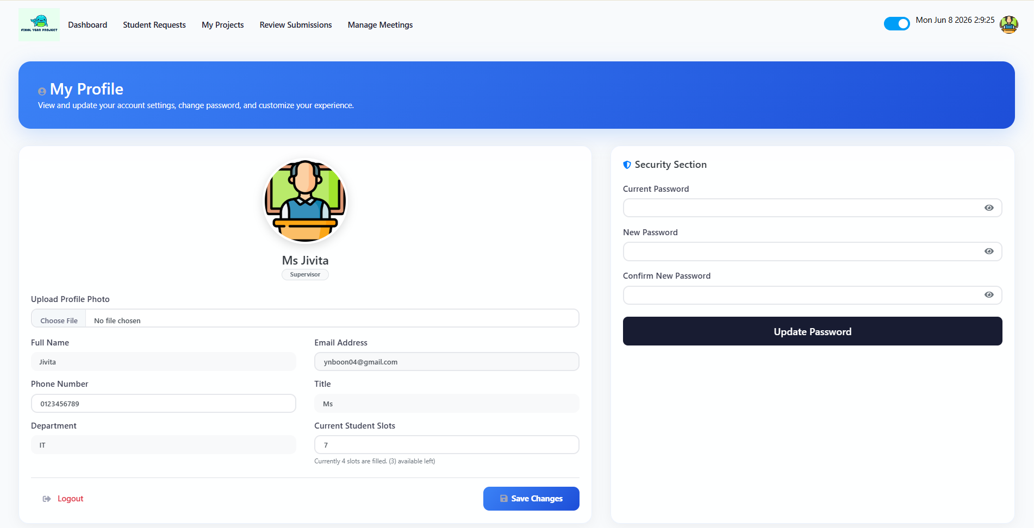
Figure 3.41 Global: Public User Profile Interface
Figure 3.41 shows the User Profile interface serves a dual purpose within the system. When viewing another user's page, it acts as a transparent academic directory displaying public metadata to facilitate networking and supervisor allocation. However, when a user accesses their own profile, the interface transforms into a secure, self-service account management dashboard. From this private view, the user is empowered to update their personal contact information, upload a profile avatar, and most critically, execute Password Changes. By housing the credential management module directly within the profile interface, the system ensures that students, supervisors, and admins can independently maintain their account security without relying on manual IT support requests, thereby enforcing strict data privacy protocols.

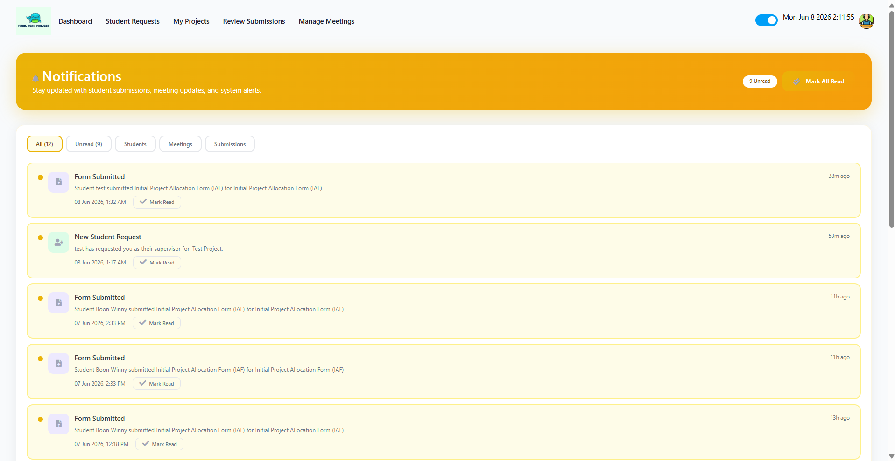
Figure 3.42 Global: System Notifications Interface
Figure 3.42 shows the Notifications interface functions as the real-time alerting engine for the entire application, serving as a globally accessible component for Students, Supervisors, and Administrators alike. This interface centralizes all system-generated alerts into a chronological, highly visible feed. Depending on the user's role, the engine dynamically curates the alerts are notifying Students of meeting approvals or newly graded submissions, while simultaneously alerting Supervisors to incoming project requests or pending milestones requiring evaluation. By providing immediate, actionable links directly within the notification cards, the interface drastically reduces administrative friction and ensures that critical academic deadlines and tasks are never overlooked.

3.9 Project Schedule Planning (Gantt Chart)
To guarantee strict compliance with university grading windows, the software project lifecycle is precisely scheduled across a dedicated development timeline.
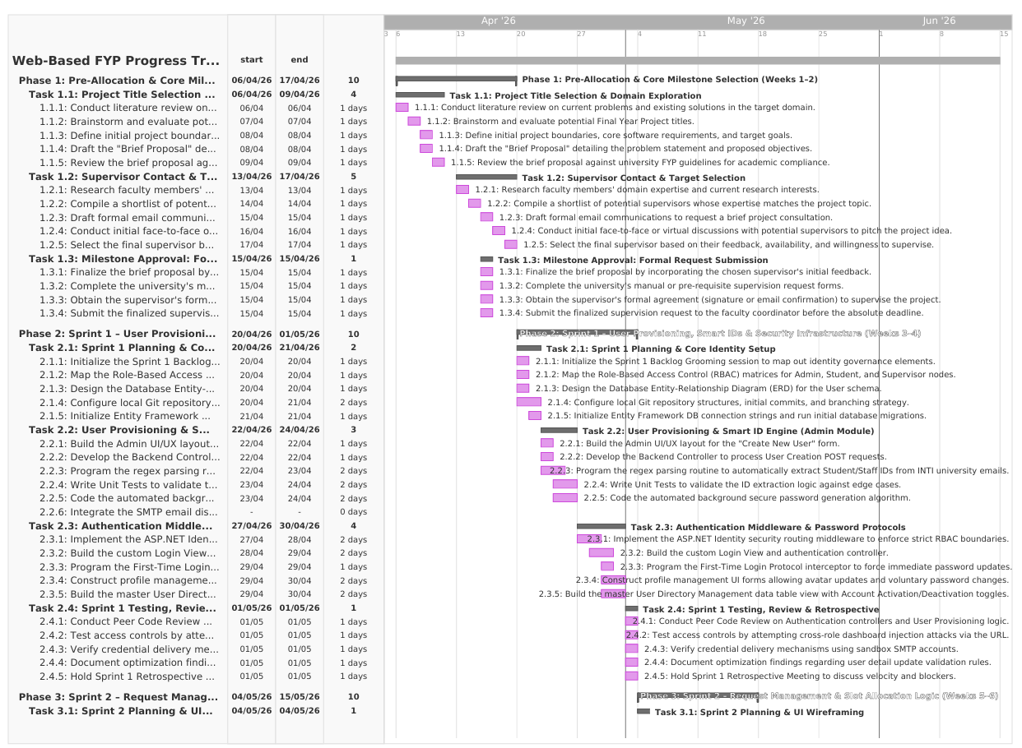
Figure 3.43 Project Gantt Chart 1

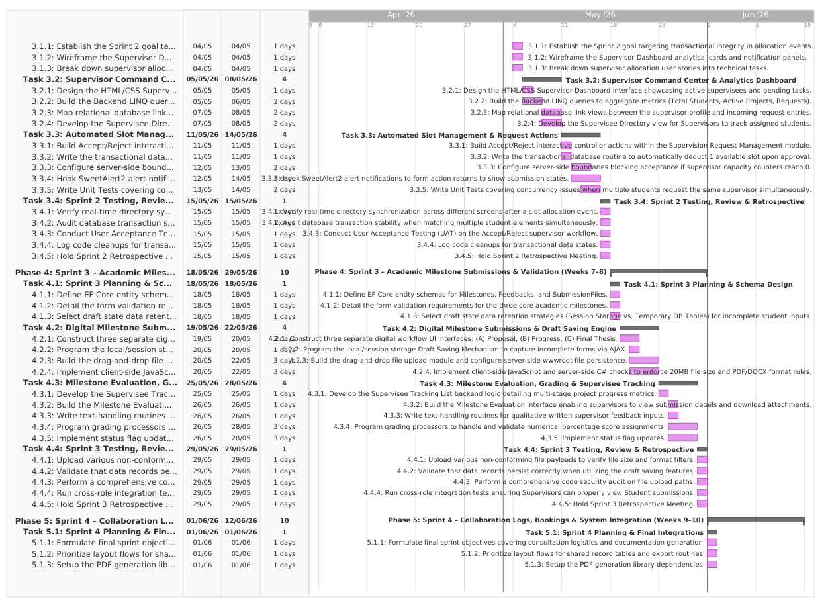
Figure 3.44 Project Gantt Chart 2

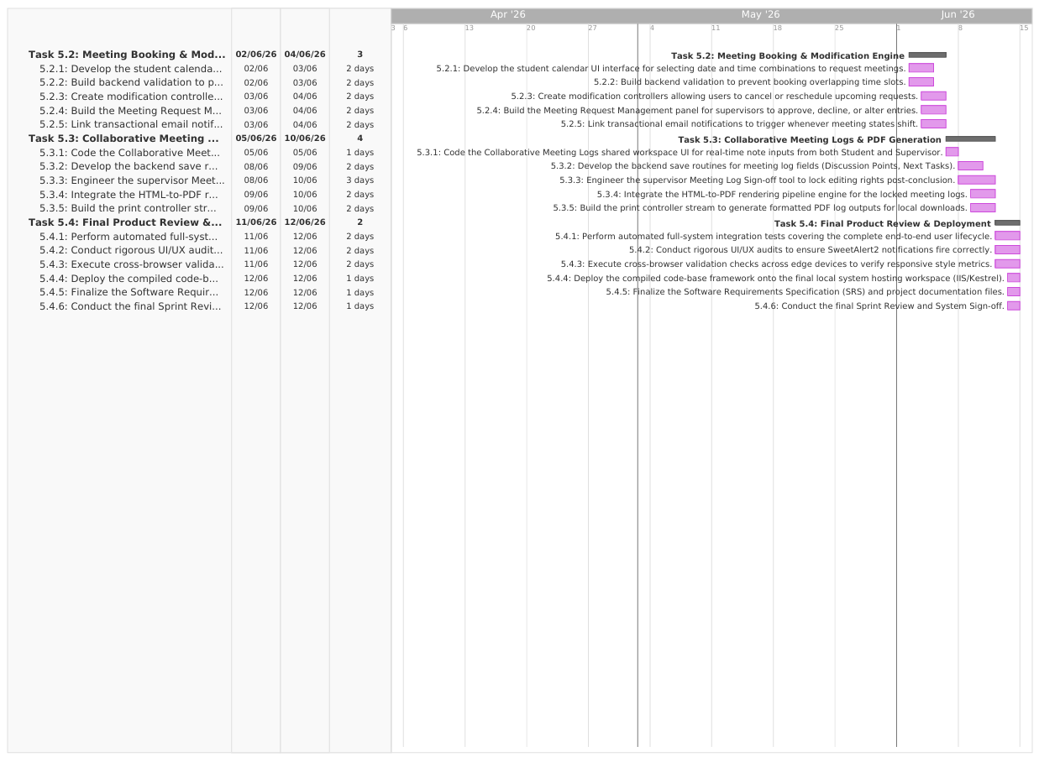
Figure 3.45 Project Gantt Chart 3

3.10 Conclusion
In summary, the Agile Scrum methodology was chosen for its ability to accommodate the fluid nature of academic project management. Through continuous iterative development and active engagement with real institutional stakeholders, the system ensures both technical stability and alignment with user needs. The design artifacts and project Gantt chart provided in this chapter establish the necessary foundation for the implementation phase described in Chapter 4.

REFERENCES
Arumugam, K. and Abd Ishak, N. (2025) ‘Capstoning undergraduate research: a study on PSM supervision workflows’, Journal of Academic Systems, 12(2), pp. 45–62. [Accessed 18 May 2026].
Fatman, A., Rahim, Z. and Hariyanto, D. (2023) ‘Transactional data models in project management: a systematic review’, International Journal of Software Engineering, 9(4), pp. 112–129. [Accessed 20 May 2026].
Fauzi, M. and Alduais, A. (2025) Operational modules for web-based supervision systems. Kuala Lumpur: TechEd Publications. [Accessed 22 May 2026].
Hariyanto, B., Setiawan, A. and Pratama, R. (2025) ‘Digitizing the final project lifecycle: an enterprise approach for STMIK Jayakarta’, Journal of Applied Technology, 14(1), pp. 22–38. [Accessed 21 May 2026].
Horng, L. and Abdullah, S. (2025) ‘Vulnerabilities in legacy web architectures: from PHP to modern frameworks’, Cybersecurity and Education Review, 8(3), pp. 77–90. [Accessed 19 May 2026].
Isa, R., Hamid, F. and Ismail, Z. (2024) ‘Structural deficits in tertiary education tracking systems’, Higher Education Management Today, 19(2), pp. 201–215. [Accessed 22 May 2026].
Jailani, M., Rosli, N. and Bakar, A. (2022) ‘Milestone authorization protocols in engineering capstones’, Journal of Technical Education, 5(2), pp. 55–69. [Accessed 15 May 2026].
Jiang, Y., Li, Q. and Tan, H. (2021) ‘Technical paper integration in mechanical engineering curricula’, Research Methodology Quarterly, 11(4), pp. 33–48. [Accessed 10 May 2026].
Kolade, O., Adeyemi, A. and Thompson, P. (2024) ‘Impact of digital tracking on undergraduate retention: a global analysis’, Academic Performance Studies, 22(1), pp. 10–27. [Accessed 12 May 2026].
Noor, M., Aziz, S. and Rahman, F. (2023) ‘Operational luxury versus structural necessity: the evolution of tracking suites’, Educational Infrastructure Review, 7(3), pp. 88–104. [Accessed 05 May 2026].

Sa, H., Lee, K. and Kim, J. (2021) ‘Modern higher education frameworks: governance of final year projects’, International Journal of Pedagogical Quality, 3(1), pp. 1–15. [Accessed 02 May 2026].
United Nations (2015) Transforming our world: the 2030 Agenda for Sustainable Development. New York: UN Publishing. [Accessed 20 May 2026]
UTM (2021) School of Mechanical Engineering: Final Year Project guide and portal specifications. Johor Bahru: University of Technology Malaysia. [Accessed 10 May 2026].
Yuan, Z., Zhao, Y. and Wang, L. (2024) ‘Student-centered allocation: eliminating institutional failure rates in final year projects’, Journal of Educational Data Analytics, 30(4), pp. 402–418. [Accessed 21 May 2026].
Zaheer, S. and Munir, M. (2020) ‘Collaborative nodes in project management: student-faculty interactions’, Higher Education Theory and Practice, 15(2), pp. 200–219. [Accessed 18 May 2026].

APPENDICES

