

Information Security Systems Design
------------------------------------------
Representation Report
-------------------------------------------------

--------------------------------------------
Prepared by

AYTEN TONBUL - 17030411012
BERKE CAN YAMAN - 16030411062
ENES EYÜBOĞLU - 16030411016

- WHAT IS OSSEC?
OSSEC (Open Source HIDS SECurity) is a free open source host-based intrusion detection system (HIDS). It performs log analysis, Windows registry monitoring, integrity checks, rootkit detection, time-based alerts and proactive responses. It provides intrusion detection for most operating systems, including Linux, OpenBSD, Solaris, FreeBSD, OS X, and Windows. You can use OSSEC for your security needs through its extensive configuration options, adding custom alert rules and writing scripts to take action when alerts occur.
OSSEC has a centralized cross-platform architecture that allows easy monitoring and management of multiple systems. OSSEC has a log analysis engine that can correlate and analyze logs from multiple devices and formats. It is used by almost every large enterprises small businesses to governments agencies as their primary server intrusion detection. In addition to being deployed for server protection, OSSEC, is commonly used strictly as a log analysis tool, monitoring and analyzing firewalls, IDSs, web servers and authentication logs . It detects and alerts on unauthorized file system modification and malicious behavior that could make you non-compliant that helps organizations meet specific compliance requirements.
- HISTORY OF OSSEC
- In June 2008, the OSSEC project and all the copyrights owned by Daniel B. Cid, the project leader, were acquired by Third Brigade, Inc. They promised to continue to contribute to the open source community and to extend commercial support and training to the OSSEC open source community.
- In May 2009, Trend Micro acquired Third Brigade and the OSSEC project, with promises to keep it open source and free.
- In 2018, Trend released the domain name and source code to the OSSEC Foundation.
- The OSSEC project is currently maintained by Atomicorp who stewards the free and open source version and also offers an enhanced commercial version.

- HOW OSSEC WORKS
-Tree modes; Local, client, server.
-Client server model;
-Clients receive configuration from server.
-Clients send logs to server over an encrypted channel.

- KEY BENEFITS
-There are many benefits that ossec has, however I will only talk about key benefits.
-There are 4 key benefits OSSEC has.
-They are Multi platform, Compliance Requirements, Real-time and Configurable Alerts, Centralized management.

Multi platform
-OSSEC lets customers implement a comprehensive host based intrusion detection system with fine grained application/server specific policies across multiple platforms
-such as Linux, Solaris, Windows, and Mac OS X.

Compliance Requirements
-OSSEC helps customers meet specific compliance requirements such as PCI and HIPAA.
-It lets customers detect and alert on unauthorized file system modifications and malicious behavior embedded in the log files of commercial products as well as custom applications.
-For PCI, it covers the sections of file integrity monitoring, log inspection and monitoring and policy enforcement/checking.

Real-time and Configurable Alerts
-OSSEC lets customers configure incidents they want to be alerted on, and lets them focus on raising the priority of critical incidents over the regular noise on any system.
-Integration with smtp, sms, and syslog allows customers to be on top of alerts by sending them to e-mail enabled devices.
-Active response options to block an attack immediately are also available.

Centralized management
-OSSEC provides a simplified centralized management server to manage policies across multiple operating systems.
-Additionally, it also lets customers define server specific overrides for finer grained policies.

- KEY FEATURES
File Integrity checking
-There is one thing in common to any attack to your networks and computers: they change your systems in some way.
-The goal of file integrity checking is to detect these changes and alert you when they happen.
-It can be an attack, or a misuse by an employee or even a typo by an admin, any file, directory or registry change will be alerted to you.

Log Monitoring
-Your operating system wants to speak to you, but do you know how to listen?
-Every operating system, application, and device on your network generate logs (events) to let you know what is happening.
-OSSEC collects, analyzes and correlates these logs to let you know if something suspicious is happening such as attack, misuse or errors.
-Do you want to know when an application is installed on your client box? Or when someone changes a rule in your firewall? By monitoring your logs, OSSEC will notify you.

Rootkit detection
-Criminal hackers want to hide their actions, but using rootkit detection you can be notified when the system is modified in a way common to rootkits.
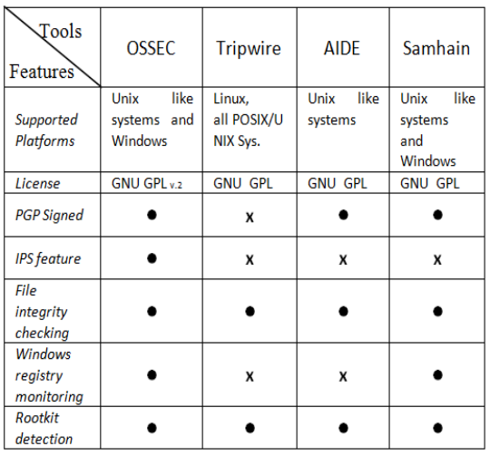
COMPARISON OF OPEN SOURCE HIDS TOOLS

This table compares some of the open source HIDS tools as we can see here OSSEC is superior to Tripware, Aide and Samhain.
- HOW TO INSTALL OSSEC?
Installation types of OSSEC
-Local
-Server
-Agent and Agen-less

OSSEC Install
$ wget https://github.com/ossec/ossec-hids/archive/3.6.0.tar.gz
$ sudo tar -xvzf 3.6.0.tar.gz
$ sudo /home/hgadmin/ossec-hids-3.6.0/install.sh
Provide your preferred input as prompted. For the demo we opted for the below:
The inputs we selected for the demo
Input your server IP Address or hostname
Installing the Web User Interface.
$cd /tmp/
$ sudo git clone https://github.com/ossec/ossec-wui.git
$ sudo mv /tmp/ossec-wui /var/www/html
$ cd /var/www/html/ossec-wui
$ sudo ./setup.sh
When prompted enter your chosen username and password. For the web server
name enter www-data.
Set Permissions

$ sudo chown -R www-data:www-data /var/www/html/ossec-wui/
$ sudo chmod -R 755 /var/www/html/ossec-wui/
Restart Apache and launch Web User Interface
$ sudo systemctl restart apache2
Open browser and navigate to http://your-servers-ip/ossec-wui
Configure WUI port to :8090
One way to change the WUI port is to edit the 000-default.conf file.
vi /etc/apache2/sites-enabled/000-default.conf

Add the following to the file
<VirtualHost *:8090>
DocumentRoot /var/www/html/ossec-wui
</VirtualHost>
Edit the /etc/apache2/ports.conf file and add the port you specified. In our
case 8090.
sudo vi /etc/apache2/ports.conf
Restart apache and test.
sudo systemctl restart apache2
Open your browser to http://your-ip-address:your-port / http://192.168.68.143:8089
Windows Agent Install
Download the OSSEC agent from
– https://updates.atomicorp.com/channels/atomic/windows/ossec-agent-win32-
3.6.0-12032.exe
Open the command prompt and ssh to your ossec server.
ssh hgadmin@192.168.68.123
launch the OSSEC Agent Manager
sudo /var/ossec/bin/manage_agents
Input option (A) to add a new agent. Input your windows machines name when
prompted.
Input the windows machines IP when prompted and confirm adding with responding
(y)
Launch the executable agent file you have downloaded as administrator. Should be
in your downloads folder.
Open the OSSEC agent as administrator that you installed and enter the IP address
of your OSSEC server.
Open the command prompt window that you used to ssh to the OSSEC server.
Extract the Key by inputting option (e) and then the corresponding Agent ID for the
windows machine in the OSSEC Agent Manager that should still be open.
Highlight and copy the key, update the OSSEC Agent. Save the updated info and
start the OSSEC Agent.
Open your web browser and navigate to your OSSEC Servers IP and specific port if
you set one.
—– Setup Guide Ends Here —–

