**Web-based School Canteen Reservation Management System**

An Undergraduate Capstone Project Proposal

Presented to the

Panel of Examiners

Cebu Technological University

TABOGON EXTENSION

Poblacion, Tabogon, Cebu

In Partial Fulfillment

Of the Requirements for the Degree

BACHELOR OF SCIENCE IN INFORMATION TECHNOLOGY

Armenton, Jie Ar

Alagase, Kim Carlo P.

Flores, Arbejie

Inahid, Jonmar B.

Noynay, Aizaneth

Pacaldo, Junrel

Parco, Philip Dave P.

Sulad, Marjun

**CHAPTER I**

**THE PROBLEM AND ITS SCOPE**

**Introduction**

**Rationale**

In the modern education landscape, school canteens play a vital role in providing students with nutritious meals and fostering a sense of community within educational institutions. As the number of students grows and dietary preferences diversify, the need for an efficient and user-friendly Web-based School Canteen Reservation Management System becomes increasingly apparent. This chapter aims to present a comprehensive overview of the problem at hand and outline the scope of our project. By addressing the challenges faced by both students and canteen staff, our system endeavors to streamline the reservation process, enhance food service, and contribute to a seamless and enjoyable dining experience.

The Web-based School Canteen Reservation Management System is designed to alleviate the struggles faced by students when reserving their meals and reduce the workload for canteen personnel. Existing manual reservation methods often result in long queues, time-consuming transactions, and food shortages, leading to frustration among students and staff alike. By implementing a digital reservation system, we aim to eliminate these inconveniences and ensure that students have access to their preferred meals with ease. Additionally, the system will empower canteen administrators with real-time insights and data to optimize food preparation, reduce waste, and cater to the evolving tastes of the student body.

This project aims to achieve several key objectives, centered around improving the overall canteen experience for students and staff. Firstly, the system will offer a user-friendly and intuitive interface that allows students to browse through a diverse menu, make reservations, and select convenient pick-up times. Secondly, it will enable canteen administrators to efficiently manage food inventory, track popular meal choices, and plan menus accordingly. By facilitating a smooth and organized reservation process, the system will foster a positive environment that encourages healthy eating habits and nurtures a sense of community within the school campus.

The scope of this project encompasses the development of a web-based application accessible to students and canteen personnel. The system will be designed to handle various types of meals, dietary preferences, and payment methods to cater to the diverse needs of the school community. While focusing on reservation and food management, the system will not include online payment processing, which will remain a separate module for future expansion. Moreover, data security and user privacy will be prioritized throughout the development process to safeguard sensitive information and ensure a trusted platform for all users.

In conclusion, the Web-based School Canteen Reservation Management System addresses the pressing challenges faced by educational institutions in managing their canteen operations efficiently. By harnessing the power of technology, we aspire to revolutionize the way students reserve and enjoy their meals, while empowering canteen administrators with data-driven insights for improved decision-making. As this chapter sets the context for our project, subsequent sections will delve into the system's design, development process, and implementation, providing a holistic understanding of our endeavor to create a seamless and user-friendly dining experience for the school community.

This chapter presents a comprehensive review of the existing literature on reservation systems and food service management within educational institutions. Scholars have explored various theories and approaches to streamline reservation processes, improve data reporting systems, and enhance overall management efficiency. The studies highlight the significance of secure data handling, open communication channels, and data-driven decision-making in creating a user-friendly and effective canteen reservation system. By synthesizing these findings, our School Canteen Reservation Management System aims to build upon existing knowledge and develop a robust platform that optimizes food service, fosters a vibrant canteen community, and ensures a seamless dining experience for students and staff.

**Review of Related Systems**

**Related Systems**

Web-based Food Ordering Systems have been developed to cater to the increasing demand for efficient and user-friendly reservation management in various industries, including educational institutions. These systems provide a convenient online platform for students and staff to reserve meals from the school canteen. Depending on their preferences and dietary requirements, customers can instantly view the available menu options and select their desired meals. The system's architecture comprises different modules, leveraging technology to streamline the reservation process and enhance the overall dining experience. With a user-centric approach, these platforms allow canteen administrators to manage food inventory more effectively, reduce waiting times, and optimize food preparation. Furthermore, the system empowers customers by enabling them to access the platform from anywhere with an internet connection, providing flexibility and ease of use. By incorporating secure data handling and communication features, web-based school canteen reservation systems ensure that user information remains confidential, fostering a trusted and efficient reservation management process.

**Related Study Projects**

This research project, conducted in Cebu Technological University, aimed to explore the impact of implementing a Web-based School Canteen Reservation Management System on the dining experience and food service efficiency within the educational institution. Guided by user-centric design principles, the study employed a mixed-methods approach to gather data from students, staff, and canteen administrators of Cebu Technological University. Structured questionnaires and interviews were the main data collection tools, ensuring a comprehensive understanding of user preferences and challenges in the current reservation process at the university's canteen. Data analysis included descriptive statistics to examine reservation patterns and qualitative analysis to gain insights into user feedback and expectations. The study revealed that the implementation of the Web-based Reservation System significantly reduced waiting times, improved food inventory management, and empowered users to personalize their meal orders based on dietary preferences. The findings emphasized the importance of data security and privacy, ensuring that user information remains confidential. Overall, the research indicated a positive impact on the dining culture, fostering a vibrant and inclusive canteen community within Cebu Technological University. Based on the study's recommendations, the Web-based School Canteen Reservation Management System promises to enhance the overall dining experience, optimize food service, and cater to the diverse needs of the school community at Cebu Technological University.

**Foreign Study Projects**

* **Title:** Streamlining Dining Services: A Comparative Analysis of Web-based School Canteen Reservation Management Systems in European Universities

**Abstract:**

This cross-sectional study aims to compare and evaluate the implementation of Web-based School Canteen Reservation Management Systems in various European universities. Using a combination of surveys and focus group discussions, data will be collected from students, faculty, and canteen administrators to assess the systems' effectiveness in reducing waiting times, optimizing food service, and meeting the dietary preferences of diverse campus communities. The research seeks to identify best practices and challenges faced by different institutions, providing valuable insights into enhancing the dining experience across European universities.

* **Title:** Improving Campus Food Services: An Investigation of Web-based Canteen Reservation Systems in Australian Educational Institutions
* **Abstract:**

This research project aims to explore the impact of Web-based School Canteen Reservation Management Systems on campus food services in Australian educational institutions. Through qualitative interviews and observations, data will be collected from students, staff, and canteen operators to assess the systems' user-friendliness, efficiency, and ability to accommodate dietary requirements. The study seeks to identify factors that contribute to successful implementation and examine how these systems enhance the overall dining experience in diverse Australian campuses, providing valuable insights for other institutions seeking to upgrade their food service management.

* **Title:** Enhancing Dining Accessibility: A Case Study of Web-based School Canteen Reservation Management System in a Leading North American University
* **Abstract:**

This case study investigates the implementation of a Web-based School Canteen Reservation Management System in a prominent North American university. Combining qualitative surveys and usability testing, the study will gather data from students, faculty, and canteen administrators to evaluate the system's impact on reducing wait times, facilitating dietary customization, and fostering inclusivity in the campus dining experience. The research aims to identify user preferences and areas for improvement, contributing valuable insights for other educational institutions in North America seeking to implement similar systems to enhance their canteen services and student satisfaction.

**Technical Background**

The Web-based School Canteen Reservation Management System is a comprehensive and user-friendly platform designed to efficiently handle day-to-day reservation transactions and provide comprehensive management information for educational institutions. The system is specifically tailored to meet the unique requirements of schools and universities with dining facilities. It facilitates the storage of crucial information for registered users, including students, staff, and canteen administrators. For users, the system allows convenient reservation of meals, enabling them to select from a diverse menu. On the administrator's side, the system offers full control over managing reservation records and food inventory in the database.

The technical implementation of the system involves a logical Database Design for the relational model, ensuring a structured and organized database schema. The Physical Database design is derived by translating the logical data model into a robust and scalable MySQL Database Management system, enabling efficient data storage and retrieval. The system architecture leverages modern web technologies, such as HTML, CSS, and JavaScript, to create a responsive and user-friendly interface accessible from various devices.

**Key functionalities of the Web-based School Canteen Reservation Management System include:**

* **User Registration and Profile Management**

The system enables users to create and maintain their profiles, providing essential information for identification and reservation purposes.

* **Reservation**

Users can access the menu, and make reservations for preferred items within the specified time frames.

* **Inventory Management**

The system helps canteen administrators manage food inventory by tracking the availability of menu items, preventing overbooking or shortages.

* **Data Security and Privacy**

Stringent security measures, such as encryption and access controls, ensure the confidentiality of user information and protect sensitive data from unauthorized access.

Overall, the Web-based School Canteen Reservation Management System offers a seamless and efficient reservation process, promoting a positive dining experience for the school community while providing administrators with effective tools for managing canteen operations and enhancing overall service quality.

**Details of the Technology to be Used:**

* **Hyper-Text Transfer Protocol (HTTP)**

HTTP is a set of rules for transferring files, including text, images, sound, video, and other multimedia files, over the web. It is the underlying protocol used when users open their web browsers to access websites.

* **Apache**

Apache is an open-source web server software that serves as the foundation for hosting websites and applications. It is part of the group of American Indian peoples in the southwestern U.S., but in the context of technology, it refers to the web server software.

* **MySQL**

MySQL is an open-source relational database management system (RDBMS) used to store, manage, and retrieve data. Its name is a combination of "My," the name of co-founder Michael Widenius's daughter, and "SQL," which stands for Structured Query Language.

* **Cascading Style Sheet (CSS)**

CSS is a stylesheet language that defines the presentation of a web document written in HTML or XML. It determines how elements should be rendered on various media, such as screens, paper, or speech.

* **Hypertext Preprocessor (PHP)**

PHP is a scripting language used to create dynamic and interactive HTML web pages. It is executed on the server, processing PHP commands and sending the results to the visitor's browser.

* **JavaScript**

JavaScript is a scripting language primarily used on the web to enhance HTML pages and add interactivity. It is embedded in HTML code and executed by the browser to render web pages dynamically.

* **Hypertext Markup Language (HTML)**

HTML is the fundamental building block of the web. It defines the structure and meaning of web content, while other technologies like CSS and JavaScript handle appearance and functionality, respectively.

**How the project will work**

The Web-based School Canteen Reservation Management System operates through a well-structured and user-centric approach. The project commences with in-depth interviews, observations, and discussions to understand the existing challenges and requirements within the school's canteen management. Through this data gathering process, the researchers identify key issues faced by students, staff, and canteen administrators during the reservation process.

Using the valuable insights from the initial phase, the researchers proceed to design a comprehensive solution in the form of the Web-based School Canteen Reservation Management System. This system is custom-built to cater specifically to the unique needs of the educational institution, ensuring seamless reservation experiences for all users.

The heart of the system lies in its user-friendly interface, which allows students and staff to effortlessly access the canteen's menu, customize their meal choices, and make reservations within specified time frames. On the administrator's side, the system empowers canteen staff with efficient tools for managing food inventory, monitoring reservations, and generating insightful reports on reservation patterns.

To ensure data security and privacy, the system employs robust measures to protect user information and prevent unauthorized access. Throughout the development process, the researchers prioritize iterative user testing and feedback collection to fine-tune the system, making continuous improvements to meet the ever-evolving needs of the school community.

Upon completion, the Web-based School Canteen Reservation Management System aims to revolutionize the dining experience within the educational institution, streamlining operations, reducing waiting times, and fostering an inclusive and vibrant canteen community. The project's success will ultimately be measured by the increased efficiency and overall satisfaction of users, creating a positive impact on the dining culture and enhancing the overall campus experience.

**Purpose and Description of the Project**

Our School Canteen Reservation Management System's main goal is to completely transform meals in educational settings. Our goal is to alleviate the typical difficulties that students and canteen employees encounter while making reservations and overseeing food service by utilizing technology. With a wide selection of options and various pick-up hours, our concept aims to give students a simple, quick way to make lunch reservations. By improving food inventory management, minimizing waste, and gathering useful information to improve menu planning, the technology also aims to lessen the strain on canteen administrators. The ultimate goal of this project is to cultivate a lively and welcoming school community where wholesome meal alternatives are readily available and the canteen.

A web-based program called the School Canteen Reservation Management System was created with the user's experience in mind. Students and staff may browse a sizable menu using an easy-to-use interface, and with the stroke of a button, they can easily reserve their chosen meals. To ensure a flawless and customized dining experience, the technology will let consumers tailor their orders based on dietary preferences and choose suitable pick-up hours. The system will give canteen managers real-time information on the most popular menu items, allowing them to plan and prepare meals more effectively and cut down on food waste and wait times. The initiative will put a strong emphasis on security and privacy, ensuring that user data is kept private and secure. We hope to develop a dynamic and effective system when we adopt this one.

**The Problem**

**Statement of the Problem**

In the contemporary educational landscape, the efficient operation of school canteens plays a pivotal role in providing students with nutritious meals and fostering a sense of community within educational institutions. However, the current methods of managing canteen reservations and operations are fraught with challenges that undermine the overall dining experience for students and hinder the productivity of canteen staff. This study aims to address these issues and contribute to the enhancement of school canteen management through the development of a Web-based School Canteen Reservation Management System.

**Inefficiency in Reservation Processes**

Existing manual reservation systems and paper-based processes are labor-intensive, error-prone, and time-consuming. This results in long queues, delayed transactions, and occasional food shortages, leading to frustration among both students and canteen staff.

**Limited Menu and Inventory Management**

Many canteens struggle with managing menus and inventory effectively. Changes in menu offerings, availability of ingredients, and pricing adjustments are challenging to implement in real time, leading to menu stagnation and potential financial losses.

**Lack of Data-Driven Insights**

The absence of data-driven insights and reporting tools in current canteen management systems inhibits informed decision-making. Canteen administrators often lack access to real-time data on reservation trends, popular meal choices, and inventory levels.

**Security and Privacy Concerns**

As schools collect and store sensitive student and payment information, ensuring data security and user privacy becomes paramount. Manual or outdated systems may not meet the necessary security standards, exposing users to potential data breaches.

**Scalability Challenges**

As student populations grow, the scalability of existing reservation systems becomes a concern. Manual and paper-based systems are ill-equipped to handle the increasing volume of reservations efficiently.

**Objectives**

**General Objectives**

The Web-based School Canteen Reservation Management System's major goal is to improve the dining experience for students and staff at the canteen. The system promises to decrease wait times, get rid of food shortages, and boost overall food service effectiveness by offering a user-friendly platform for meal reservations. The project also aims to equip canteen managers with useful information and data so they can improve menu planning, cut down on food waste, and accommodate the various dietary requirements of the student body. The ultimate goal is to establish a seamless and pleasurable dining environment that encourages wholesome eating habits, encourages social contact, and supports a lively and inclusive school community.

**Specific objectives**

* By establishing a user-friendly web-based application that enables students and staff to rapidly schedule their favorite meals, the reservation process will be streamlined and waiting times will be decreased.
* To increase the effectiveness of the food service by including a real-time inventory management system that gives canteen managers useful information about the most popular meals, allowing for better planning and fewer instances of food shortages.
* To accommodate a variety of dietary requirements by providing a flexible menu system that offers a large selection of wholesome and adequate food options for all students.
* To preserve user information, implement strong encryption and access controls, and abide by any data protection laws in order to maintain data security and privacy.
* By including a feedback tool that enables students and staff to give feedback on their dining experiences, it will be easier to increase communication between canteen personnel and patrons over time.
* By using data-driven analytics to determine consumption trends, allowing for better planning and eliminating surplus food production, it is possible to reduce food waste and maximize resource allocation.

**Scope and Delimitation**

* **Scope**
* To provide a thorough system for managing reservations for school canteens that includes a user-friendly web-based application that is geared toward both students and staff and ensures effective meal reservations and order customization.
* To provide a variety of nutrient-dense food alternatives for the school community through the inclusion of a broad and adaptable menu system that takes into account different dietary preferences.
* To incorporate real-time inventory management, which would help canteen managers prepare food more efficiently, cut down on waste, and guarantee a sufficient supply of meals.
* To place a high priority on data security and privacy, enforcing strong encryption and access controls to secure user information and adhere to the necessary data protection laws.
* To create an interactive feedback method that invites staff and students to share comments on their dining experiences, promoting ongoing canteen service improvement.
* To provide a seamless transition to the digital platform and maximize the efficiency and benefits of the system by providing thorough training to canteen staff and users.
* To assess the effectiveness of the Web-based School Canteen Reservation Management System using performance indicators, user input, and data analytics, identifying opportunities for enhancement and potential growth in the future.
* **Delimitation**
* The Web-based School Canteen Reservation Management System will not include online payment processing. Payment methods will remain separate from the reservation platform.

**Significance of the Study**

The Web-based School Canteen Reservation Management System significantly enhances the dining experience by streamlining reservations, optimizing food service, ensuring data security, and fostering a vibrant canteen community.

* **Efficient Reservation Process:**

The implementation of the Web-based School Canteen Reservation Management System holds significant value in enhancing the efficiency of the reservation process. By providing a user-friendly web-based application, students and staff can conveniently browse through a diverse menu, customize their meal orders, and reserve preferred items effortlessly. This streamlined reservation system reduces waiting times, eliminates long queues, and ensures that every member of the school community can access their desired meals without any hassle.

* **Optimized Food Service:**

The proposed system's real-time inventory management feature offers considerable benefits to canteen administrators. By analyzing data on popular meal choices, the system empowers administrators to make informed decisions about menu planning, ensuring an adequate supply of meals while minimizing food waste. This optimization not only leads to cost savings but also fosters a more sustainable approach to food service within the school.

* **Improved Communication and Feedback:**

The inclusion of an interactive feedback mechanism in the proposed system provides valuable insights for canteen administrators. Students and staff can share their dining experiences, preferences, and suggestions, leading to continuous improvements in the quality of canteen services. This direct line of communication helps administrators adapt to changing preferences, address concerns promptly, and foster a sense of community within the school canteen environment.

* **Enhanced Accessibility and Flexibility:**

The web-based nature of the School Canteen Reservation Management System grants users the flexibility to access the platform from any location with an internet connection. This enhanced accessibility allows students and staff to make reservations at their convenience, even outside the school premises. As a result, the canteen becomes a more dynamic and inclusive space, catering to the varying schedules and preferences of the entire school community.

* **Promotion of Healthy Eating Habits:**

With the system's customizable menu that caters to diverse dietary preferences, the proposed project encourages and promotes healthier eating habits among students and staff. By offering nutritious meal options, the canteen becomes an environment that supports overall well-being and academic performance.

**Methodology**

* **Environment (**optional for non-org specific project**)**
* **Locale**

The Web-based School Canteen Reservation Management System is developed for and targeted at Cebu Technological University. The system is designed to meet the specific needs and requirements of the university's canteen management.

* **Population of the Study**

The primary users of the system are the students, faculty, and staff of Cebu Technological University who utilize the canteen services. The system aims to streamline the reservation process, making it more convenient and efficient for the university community. The anticipated user base includes:

- Students from various courses and academic levels.

- Faculty members who may organize events or reserve spaces for academic purposes.

- Administrative staff involved in canteen management and event coordination.

The system is tailored to accommodate the dynamic and diverse population of Cebu Technological University, providing a user-friendly interface for a seamless canteen reservation experience.

* Organizational Chart/Profile
* **Requirements Specifications**
* Operational Feasibility
* Fishbone Diagram

The operational feasibility of the Web-Based School Canteen Reservation System was meticulously examined using a Fishbone Diagram. This visual representation allowed the research team to identify potential operational challenges and root causes. Major branches included factors such as processes, personnel, equipment, and policies. By analyzing these factors, the team gained insights into the viability of the proposed system from an operational standpoint.

* Functional Decomposition Diagram

To delve deeper into the functional aspects, a Functional Decomposition Diagram was employed. This diagram systematically broke down the system into its constituent functions, illustrating how each component contributed to the overall operation. The Functional Decomposition Diagram facilitated a granular understanding of the necessary functions, ensuring that each operational element was considered in the system's development.

* Technical Feasibility

The technical feasibility assessment focused on the system's compatibility with existing technological infrastructure. This included an evaluation of hardware, software, and network requirements. The research team ensured that the proposed system could seamlessly integrate into the school's IT environment, minimizing disruptions and optimizing performance.

* Schedule Feasibility
* Gantt Chart

Gantt Chart in which a series of horizontal lines shows the amount of work done or production completed in certain periods of time in relation to the amount planned for those periods.

* **Requirements Modeling**

These are requirements that refers to the activity or processes a system’s capability to perform.

* Input-Process-Output Diagram

**Inputs**

The system is capable of accepting the following inputs:

* Log in
* Email
* Password
* Customer’s Information
* User type
* Year and Section (If student in user type)
* Teacher’s Position (If teacher in user type)
* First name
* Middle name
* Last name
* Suffix
* DOB
* Age
* Gender
* Civil Status
* Email
* Contact
* Address
* Password
* Category
* Category Name
* Description
* Income
* Reservation
* Log History
* User
* Login time
* Logout time
* Product
* Category Id
* Product name
* Product description
* Price
* Stock
* Ingredients
* Nutritional info
* Preparation time
* Product image
* Reservation
* Customer Id
* Product Id
* Quantity
* Status
* User
* First name
* Middle name
* Last name
* Suffix
* DOB
* Age
* Email
* Contact
* Birthplace
* Gender
* Civil Status
* Occupation
* Religion
* House No
* Street name
* Purok
* Zone
* Barangay
* Municipality
* Province
* Region
* Image
* Password
* User type (Staff or Admin)

**Processes**

The system is also capable of performing the following:

* The system can login/register users.
* The system can save the customer’s information.
* The system can add customer’s information.
* The system can add income reports.
* The system can add product information.
* The system can add category information.
* The system allows customer to reserve foods
* The system can also perform the following features:
* Update information
* Search information
* View information
* Delete information

**Outputs**

The system displays the following information:

* List of customers
* List of Income
* List of Reservation
* List of Category
* List of Products
* List of System Users
* Total number of customers
* Total number of system users
* Total number of reservations
* Total number of products
* Total number of categories
* Either of the following two (2), whichever is applicable:
* Data and Process Modeling
* Context Diagram
* Data Flow Diagram
* 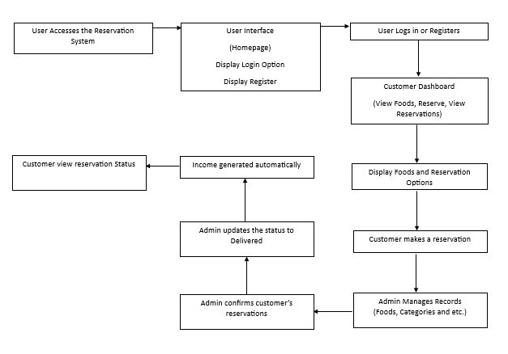System Flowchart
* Program Flowchart (highlights only)
* Class Diagram
* Sequence Diagram
* Activity Diagram
* **Analysis**
* Cost and Benefit Analysis (for projects that entails monetary costs)

This chapter focuses on the analysis of the cost and its benefits in investing in a new system.

The development cost was established through a personal interview with the administration and staff of Medellin National High School.

**Development Cost of the System**

|  |  |
| --- | --- |
| **HARDWARE** | |
| Laptop | Php 23, 000.00 |
| Printer Unit (Epson) with scanner | Php 7, 945.00 |
| Total | **Php 30, 945.00** |
| **SOFTWARE** | |
| OS (Windows 10) | Php 1, 500.00 |
| SmadAv (Anti-virus) 2019 | Php 1, 400.00 |
| Sublime Text | Php 2,500.00 |
| **Total Software Cost** | **Php 5, 400.00** |
| **Total Development Cost** | **Php 31, 400.00** |

* Cost Recovery Scheme (for projects that entails monetary costs)

The development and implementation of the Web-Based School Canteen Reservation System entail monetary costs, and a robust cost recovery scheme was devised to ensure financial sustainability. The scheme involved a combination of revenue-generating strategies and careful expense management.

**User Fees**:

Introduce reasonable user fees for specific premium features or services within the reservation system. This approach allows the system to generate revenue directly from users who opt for enhanced functionalities.

**Partnerships and Sponsorships:**

Explore potential partnerships with local businesses or food suppliers interested in gaining visibility through the canteen system. Sponsorship agreements can provide financial support or in-kind contributions to offset development and maintenance costs.

**Subscription Models:**

Implement subscription-based models for certain user groups or premium services. Regular subscription fees can contribute to the ongoing maintenance and improvement of the reservation system.

**Integration with School Finances:**

Collaborate with the school administration to allocate a portion of the canteen profits or budget towards the maintenance and development of the web-based reservation system.

**Grants and Funding:**

Explore opportunities for obtaining grants or funding from educational or technological initiatives. This external financial support can contribute to the initial investment required for system development.

* Risk Assessment/Analysis

The risk assessment for the Web-Based School Canteen Reservation System involved a thorough analysis of potential challenges and uncertainties. Key elements of the risk assessment included:

**Identifying Risks:**

A comprehensive identification of potential risks, such as technical challenges, user adoption issues, financial constraints, or external factors impacting system performance.

**Probability and Impact Analysis:**

Evaluating the likelihood of each identified risk occurring and the potential impact on the project. This analysis informed prioritization and mitigation strategies.

**Mitigation Strategies**:

Developing proactive measures to mitigate or minimize identified risks. These strategies could include contingency plans, resource allocation adjustments, or alternative approaches to problem-solving.

**Monitoring and Adaptation:**

Implementing a continuous monitoring system to track the evolving risk landscape. Regular reviews and adaptations of risk mitigation strategies ensured that the project remained resilient to unforeseen challenges.

**Communication Plan:**

Establishing a robust communication plan to keep stakeholders informed about potential risks, mitigation efforts, and changes in the risk landscape. Transparent communication fosters collaboration and awareness among project participants.

* **Design**
* Outputs and User-Interface Design
* Forms
* 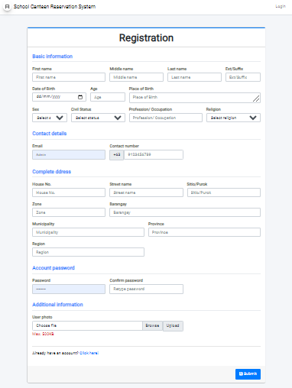User Registration - To access the system, students will have to register to create their accounts.
* Reports
* 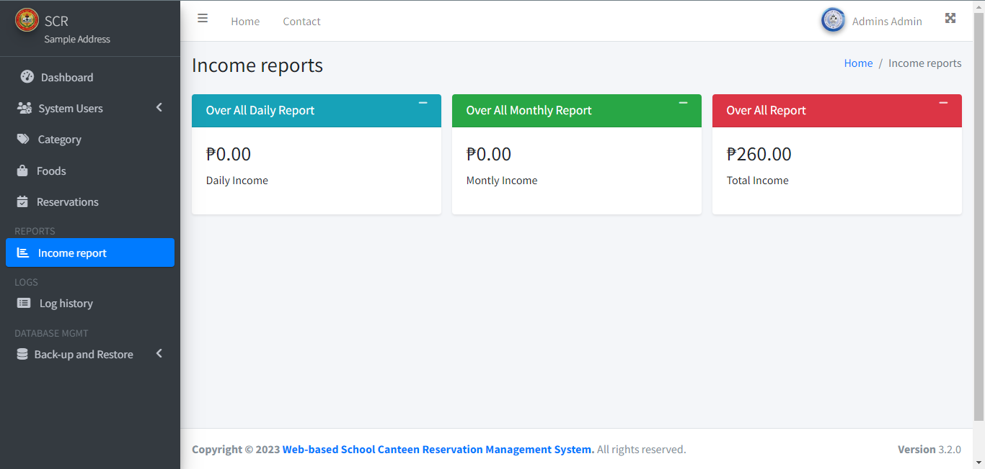Income reports - Delve into the financial data surrounding delivered reservations with our comprehensive income reports. Gain real-time insights into your revenue stream on a daily, weekly, and monthly basis, helping you make informed decisions and track the financial health of your business.
* 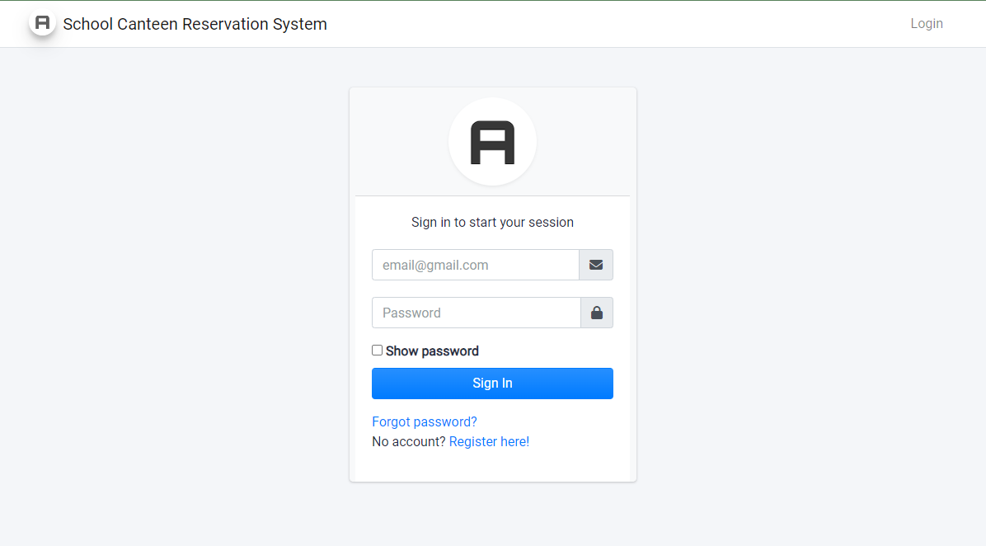Login page - This is the log-in page wherein the users of the system will log-in using their own credentials such as their email and password in order to access the system.

* 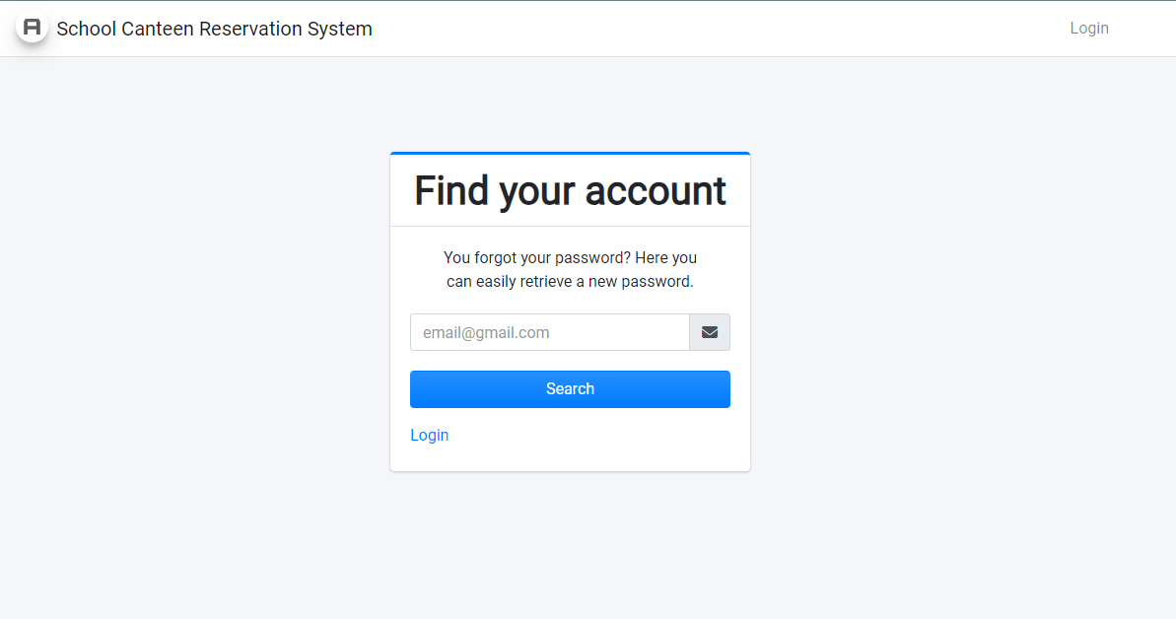Forgot password page - To search for an email of the user who forgets his/her password.
* Dashboard - The dashboard displays the number of records of the users, administrators and other necessary records.

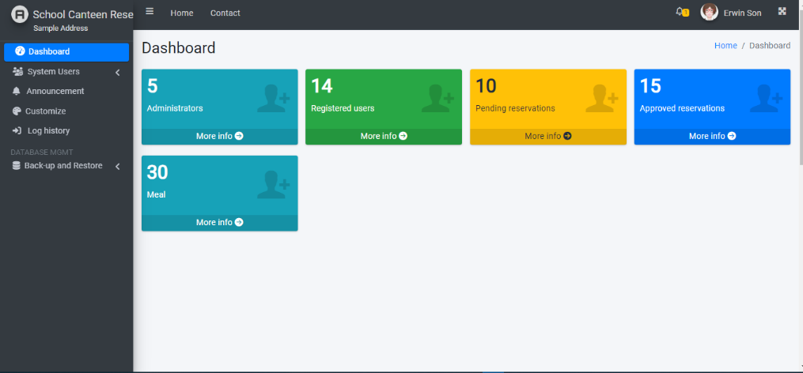

* 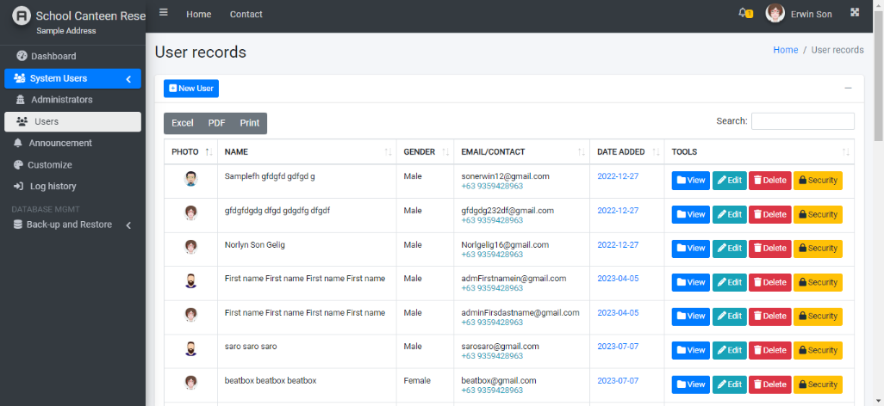User records - This page shows all the user/students/teachers records who registered into the system.
* 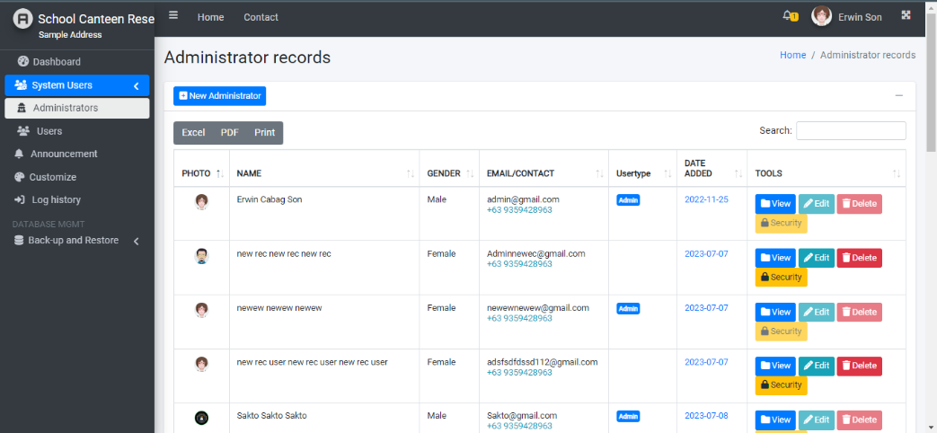Administrator records - This page shows all the system administrators that controls the system information.
* 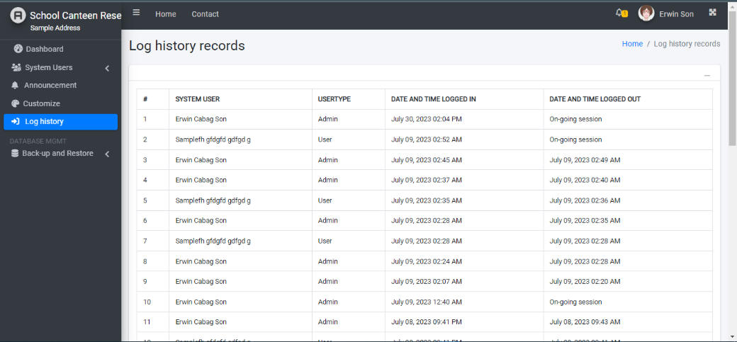Log history - In this page, the logged in user can see his/her log history.
* 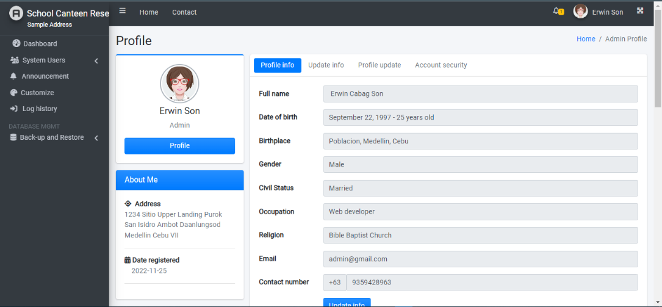Profile - The logged in user can view and update his/her information in the system. He/she can also change his/her password for better security.
* 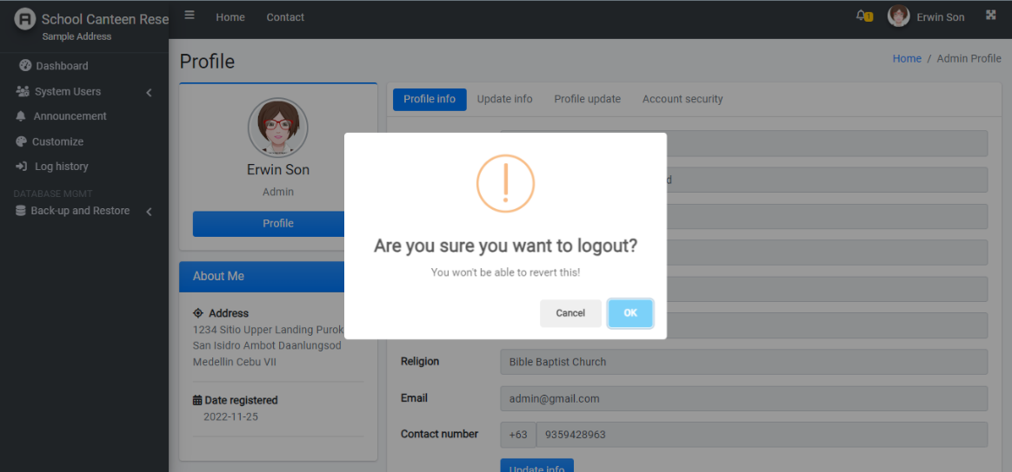Logout - This modal will only show up when the logged in user wants to exit from the system.
* Data Design
* Entity Relationship Diagram (use MS Access Relationships but not preferable for implementation)
* Data Dictionary
* System Architecture

The System Architecture of the Web-based School Canteen Reservation Management System was developed based on the requirements gathered from interviews, observations, and discussion groups. The architecture encompasses various components, with a primary focus on the database, which plays a crucial role in storing and managing information about users who apply for reservations. The system efficiently cross-checks for repetitions and creates a comprehensive summary of the reservation data for each user.

The architectural design follows a systematic approach, starting from the fundamental level of entities and their attributes, then establishing relationships between entities, leading to the creation of an entity relationship diagram (ERD). The ERD serves as a blueprint for the logical Database Design, outlining the structure and organization of the relational model.

For the physical implementation, the logical data model is translated into the MySQL Database Management system, which offers robust and scalable data storage capabilities. MySQL ensures efficient data management, enabling seamless data retrieval and manipulation for smooth reservation processes.

The prototype of the system was meticulously designed to meet the basic requirements of the users. Throughout the development process, user feedback was incorporated, ensuring the prototype aligned with their needs and preferences. As a result, the working system successfully met the fundamental user requirements, providing a user-friendly and efficient platform for reserving meals at the school canteen.

In conclusion, the System Architecture of the Web-based School Canteen Reservation Management System is well-structured, utilizing a logical and relational data model, and implemented on the MySQL Database Management system. This ensures the system's reliability, performance, and scalability, providing a seamless and effective reservation experience for the school community.

* **Network Model**

The network model for the Web-Based School Canteen Reservation System is designed to ensure seamless communication and data exchange among the various components of the system. Given the distributed nature of the reservation system, a client-server network model is a fitting choice. In this model, users (clients) interact with the central server, which manages the reservation database, processes requests, and coordinates communication.

**Client-Side:**

Users access the reservation system through web browsers, acting as clients.

The client-side includes user interfaces for placing orders, viewing menus, and managing reservations.

**Server-Side:**

The central server hosts the reservation system's database, managing data related to menus, orders, and user information.

The server processes user requests, validates reservations, and communicates with external systems (e.g., payment gateways).

* **Network Topology**

The network topology for the Web-Based School Canteen Reservation System is carefully structured to ensure reliability, scalability, and efficient data flow. A hybrid topology is implemented to combine the benefits of different structures:

**Star Topology:**

The central server acts as the focal point, connecting to all client devices. This ensures a centralized and efficient flow of information.

**Bus Topology:**

In the context of client devices, a bus topology is employed, where each device is connected to a central communication channel. This simplifies connectivity, and additions to the network are straightforward.

* **Security**

Ensuring the security of the Web-Based School Canteen Reservation System is of paramount importance to protect user data, financial transactions, and system integrity. The security measures encompass various layers:

**Data Encryption:**

Utilize SSL/TLS protocols to encrypt data transmission between clients and the server, safeguarding sensitive information during online transactions.

**Authentication and Authorization**:

Implement robust user authentication mechanisms to verify the identity of users. Authorization protocols ensure that users have appropriate access levels based on their roles.

**Firewall Protection:**

Deploy firewalls to monitor and control incoming and outgoing network traffic. This helps prevent unauthorized access and protects against potential cyber threats.

**Secure Socket Layer (SSL) Certificates:**

Integrate SSL certificates to establish a secure connection between the user's browser and the server. This encryption ensures the confidentiality and integrity of data during communication.

**Regular Security Audits:**

Conduct regular security audits to identify vulnerabilities and address potential risks promptly. Regular updates and patches help fortify the system against emerging threats.

* **Development**
* Software Specification

|  |  |
| --- | --- |
| **Software** | **Specification** |
| Operating System | Windows or Linux |
| Software | XAMPP, Text Editors, Browsers |
| Database | MySQL |

* Hardware Specification

**1. Server Hardware:**

Processor (CPU): A multi-core CPU with sufficient processing power to handle incoming requests and database operations efficiently. The specific requirements depend on the expected traffic and load on the system.

Memory (RAM): Adequate RAM is essential for handling multiple simultaneous user connections and managing application data. The required amount of RAM depends on the application's complexity and expected usage patterns.

Storage: Storage requirements depend on the volume of data your system will handle. Consider using SSDs for faster data retrieval and improved overall system performance.

**2. Network Infrastructure:**

Network Bandwidth: Sufficient bandwidth to handle incoming and outgoing data traffic. The exact requirements depend on the number of users and data transfer rates. A high-speed, reliable internet connection is crucial.

**3. Database Server:**

If your system is designed to handle a large number of reservations and users, you might need a dedicated database server with its own set of hardware specifications.

* Program Specification

This program specification provides a high-level overview of your project, detailing the key features, technologies, and tools you'll use. It can serve as a roadmap to guide your development process and communicate your project's scope to stakeholders. You can expand on each section as needed and adapt it to the specific requirements of your School Canteen Reservation Management System.

**1. Introduction:** The Web-based School Canteen Reservation Management System is designed to streamline the reservation and management of school canteen orders. It allows students and staff to reserve meals and provides administrators with tools to manage reservations efficiently.

**2. System Components:**

**Front End:**

HTML: Responsible for page structure and content.

CSS (Bootstrap): Used for styling and responsive design.

JavaScript (jQuery): Enhances interactivity and user experience.

**Back End:**

PHP: Handles server-side logic, user authentication, and database interactions.

MySQL: Stores reservation data, user information, and canteen menu details.

**3. Key Features:**

**User Registration and Authentication:**

Customers and staff can register and log in to the system.

**Reservation Management:**

Users can select menu items and reserve meals for specific dates and times.

Administrators can view, modify, and confirm reservations.

Menu Management:

Administrators can add, edit, or remove menu items.

Reporting:

Generate income reports on a daily, weekly, and monthly basis.

User Profile Management:

Users can update their profiles, including contact information.

**4. Development Tools:**

**Text Editor:** Sublime Text

**Local Development Environment:** XAMPP (Apache, MySQL, PHP, phpMyAdmin)

**Web Browser for Testing:** Google Chrome

**5. Security:**

Implement user authentication and authorization to protect user data and access.

Use secure coding practices to prevent SQL injection and other vulnerabilities.

**6. Deployment:**

Deploy the system on a web server for production use, ensuring it's accessible to users.

**7. Testing:**

Perform thorough testing, including unit testing, integration testing, and user acceptance testing to ensure the system functions as expected.

**8. Documentation:**

Provide user documentation for how to use the system. Document the codebase for future maintenance and updates.

**9. Future Enhancements:**

Consider potential enhancements like mobile compatibility, integration with payment gateways, and user feedback mechanisms.

**10. Timeline:**

Set project milestones and a timeline for development, testing, and deployment.

**11. Maintenance and Support:**

Plan for ongoing maintenance and support to address issues, updates, and improvements after deployment.

**12. Compliance:**

Ensure the system complies with any relevant data protection and privacy regulations.

* Programming Environment

**Sublime Text:** Sublime Text is a popular text editor used for coding. It provides features for code editing, syntax highlighting, and extensions/plugins to enhance your development workflow.

**XAMPP:** XAMPP is a software package that provides an environment for developing and testing web applications locally. It includes Apache (web server), MySQL (database server), PHP, and phpMyAdmin (for database management). This allows you to develop and test your application on your local machine before deploying it to a web server.

**Google Chrome:** Google Chrome is a web browser that you can use to test and debug your web application. It has developer tools that are useful for inspecting and troubleshooting your code.

* Front End

**HTML:** This is used for structuring the web pages and defining the content.

**CSS (Bootstrap):** CSS is used for styling your web pages, and Bootstrap is a popular CSS framework that makes it easier to create responsive and visually appealing designs.

**JavaScript (jQuery):** JavaScript is a scripting language that enhances the interactivity and functionality of your web pages. jQuery is a JavaScript library that simplifies DOM manipulation and event handling, making it easier to develop dynamic web applications.

* Back End

**PHP:** PHP is a server-side scripting language that is widely used for web development. It's responsible for handling server-side logic, processing user requests, and interacting with the database.

**MySQL:** MySQL is a relational database management system (RDBMS) that stores and manages data. It's essential for storing canteen reservations and related information.

Development Environment:

* **Deployment Diagram**

The Deployment Diagram visually represents the distribution of software components and hardware nodes in the Web-Based School Canteen Reservation System. It outlines the physical arrangement and communication pathways between different elements, providing an overview of how the system is deployed in a real-world environment.

Components:

**Client Devices:**

Users access the reservation system through various client devices, including laptops, desktops, tablets, and smartphones.

These devices host web browsers that enable users to interact with the system's user interfaces.

**Web Server:**

The web server hosts the web application that serves as the interface between clients and the server-side logic.

It handles user requests, processes reservation transactions, and communicates with the central server.

**Database Server:**

The database server stores and manages data related to menus, orders, reservations, and user information.

It interacts with the web server to facilitate seamless data exchange between the client-side and server-side components.

**Payment Gateway:**

If applicable, the payment gateway securely handles online transactions, ensuring the integrity and confidentiality of financial information.

**Communication Paths:**

**Client to Web Server**: Communication occurs through standard HTTP/HTTPS protocols, and users interact with the reservation system's interfaces via web browsers.

**Web Server to Database Server:** The web server communicates with the database server to retrieve and store data, ensuring data consistency and integrity.

* **Test Plan**

Web-Based School Canteen Reservation System. The plan encompasses different testing levels and scenarios to cover a wide range of functionalities.

**Objectives**:

**Verify System Functionality:** Ensure that all features, from menu browsing to order placement and reservation management, function as intended.

**Assess Usability:** Evaluate the user interfaces for intuitiveness, responsiveness, and overall user experience.

**Validate Security Measures:** Confirm that security protocols, including data encryption and user authentication, effectively protect user data and transactions.

**Check Performance:** Assess the system's performance under various loads, ensuring optimal responsiveness and reliability.

**Testing Levels:**

**Unit Testing:**

**Scope**: Individual components, functions, and modules.

**Tools**: Testing frameworks and tools for automated unit tests.

**Focus**: Functionality, data processing, and logic.

**Integration Testing:**

**Scope**: Interactions between system components.

**Tools**: Integration testing frameworks, simulated environments.

**Focus**: Communication pathways, data flow, and module integration.

**System Testing:**

**Scope**: End-to-end testing of the entire system.

**Tools**: Testing environments that replicate real-world scenarios.

**Focus**: Complete user workflows, performance under normal and stress conditions.

**Security Testing:**

**Scope**: Identifying vulnerabilities in data protection and authentication.

**Tools**: Security testing tools, penetration testing.

**Focus**: Encryption, secure communication, and protection against common security threats.

**Testing Scenarios:**

**User Registration and Authentication:**

Verify that user registration and login processes function correctly.

**Menu Browsing and Selection:**

Test the system's ability to display menus, allow users to browse, and select items.

**Reservation Workflow:**

Validate the end-to-end reservation process, including checking availability, selecting time slots, and receiving confirmation.

**Performance under Load:**

Conduct stress testing scenarios to evaluate system performance under heavy user loads.

**Test Environment:**

**Hardware**:

Client devices (laptops, desktops, tablets, smartphones).

Web server and database server infrastructure.

**Software**:

Web browsers (Chrome, Firefox, Safari).

Web server software (e.g., Apache, Nginx).

Database management system (e.g., MySQL, PostgreSQL).

**Test Schedule:**

Unit Testing: Weeks 1-2

Integration Testing: Weeks 3-4

System Testing: Weeks 5-6

Security Testing: Weeks 7-8

Performance Testing: Weeks 9-10

**Responsibilities:**

**Testing Team:**

Conduct all testing activities as per the defined test plan.

Document and report test results, issues, and resolutions.

**Development Team:**

Address and resolve issues identified during testing.

Collaborate with the testing team for continuous improvement.

* **Testing**
* **Unit Testing**

**Objective**:

Unit testing for the Web-Based School Canteen Reservation System is focused on validating the functionality of individual components or modules in isolation. This ensures that each unit of the system performs as expected.

**Key Aspects:**

**User Interfaces:** Test the user interfaces of the reservation system, including order placement, menu browsing, and reservation management.

**Database Operations:** Verify that database operations, such as data retrieval and storage, are functioning correctly for individual components.

**Reservation Logic:** Evaluate the logic behind reservation processes, including checking available slots, validating user inputs, and updating reservation status.

* **Integration Testing**

**Objective**:

Integration testing aims to validate the interactions and collaboration between different modules or components within the Web-Based School Canteen Reservation System. This ensures that integrated units function seamlessly as a unified system.

**Key Aspects**:

**Communication between Components:** Verify that data is accurately passed between different components, such as the client-side interfaces and the server-side logic.

**Order and Reservation Workflow**: Test the end-to-end workflow, including the user placing an order, making a reservation, and receiving confirmation.

**Data Consistency**: Ensure that data consistency is maintained across the entire system, especially during simultaneous user interactions.

**Error Handling**: Validate the system's response to errors, ensuring that it gracefully handles unexpected scenarios without compromising the user experience.

* **System/Alpha Testing**

**Objective:**

System or Alpha testing involves assessing the entire Web-Based School Canteen Reservation System as a cohesive unit. The primary goal is to evaluate the system's overall functionality, usability, and performance.

**Key Aspects:**

End-to-End Testing: Conduct end-to-end tests to simulate real-world scenarios, covering the complete user journey from logging in to placing an order and receiving confirmation.

**Usability and User Experience**: Evaluate the system's usability, ensuring that interfaces are intuitive, and users can easily navigate through the reservation process.

**Performance Testing:** Assess the system's performance under different loads to ensure it can handle concurrent user interactions without degradation

**Security Assessment:** Perform security assessments to identify and address vulnerabilities, ensuring the protection of user data and system integrity.

**Stress Testing:** Evaluate the system's resilience by subjecting it to stress testing scenarios, such as a sudden surge in user traffic.

* Acceptance Testing (must be done after the final oral defense)

**Definition of Terms**

* **Web-based School Canteen Reservation Management System (WSCRM)** The comprehensive digital solution designed to facilitate the efficient management of school canteen operations, including reservation processes, menu management, and data analytics, accessible through a web-based interface
* **Reservation System**

A subsystem of the WSCRM that allows students to book and manage their canteen meal reservations online, specifying their preferred menu items and pickup times.

* **Menu Management**

The feature within the WSCRM responsible for the creation, modification, and organization of the school canteen's menu items, including their descriptions, prices, and availability status.

* **Canteen Administrator**

An authorized user with administrative privileges in the WSCRM, responsible for overseeing menu updates, inventory management, and system configuration.

* **User Authentication**

The process of verifying the identity of users accessing the WSCRM, typically involving the submission of a username and password to gain access.

* **Role-Based Access Control (RBAC)**

A security model within the WSCRM that defines and enforces access permissions based on the roles and responsibilities of users (e.g., student, canteen staff, administrator).

* **Database Management System (DBMS)**

A software system used in the backend of the WSCRM to manage the storage, retrieval, and manipulation of data, including user profiles, reservations, and menu details.

* **Real-time Updates**

The feature in the WSCRM that provides instant and current information to users, ensuring they have the latest data on menu availability, reservation status, and other relevant information.

* **Inventory Management**

The functionality within the WSCRM dedicated to monitoring and controlling the stock of ingredients and food items available in the canteen, helping prevent shortages and waste.

* **Data Analytics**

The process of examining and interpreting data collected by the WSCRM to gain insights into reservation trends, popular menu choices, and other key performance indicators, enabling informed decision-making.

* **Data Security**

The set of measures and protocols implemented within the WSCRM to safeguard sensitive information, ensuring it remains confidential and protected from unauthorized access or breaches.

* **User Privacy**

The protection of personal and sensitive user information within the WSCRM, ensuring that data is collected, stored, and used in accordance with privacy regulations and user consent.

* **Scalability**

The ability of the WSCRM to accommodate an increasing number of users, reservations, and transactions without significant degradation in performance or functionality.

* **Online Payment Processing (Future Expansion)**

A potential module of the WSCRM that enables users to make payments for canteen reservations and purchases online, enhancing convenience and streamlining transactions.

* **Responsive Design**

The design approach applied to the user interface of the WSCRM, ensuring it adapts and functions effectively across various devices and screen sizes, including desktop computers, tablets, and smartphones.

* **User Interface (UI)**

The visual and interactive elements of the WSCRM that users interact with, including menus, buttons, forms, and displays.

* **Backend Framework**

The software framework used in the server-side development of the WSCRM, responsible for handling business logic, data processing, and interactions with the database.

**CHAPTER II  
PRESENTATION, ANALYSIS AND INTERPRETATION OF DATA**

* **Questionnaire (**How data is gathered, analyzed and interpreted**)**

**Data Gathering:**

The research team embarked on a comprehensive investigation aimed at understanding student perspectives on the potential implementation of a Web-Based School Canteen Reservation System. To facilitate this, a meticulously crafted questionnaire was designed, focusing on aspects crucial to the development and success of such a system.

The questionnaire, distributed among 291 students, incorporated both closed-ended questions with predefined response options and open-ended queries to capture a holistic view of student opinions. The distribution channels included both online platforms and traditional in-person methods to ensure a diverse and representative sample.

**Data Analysis**:

Quantitative analysis formed the backbone of the study. The research team meticulously processed the received responses, calculating frequencies and percentages for each response option. Through this statistical lens, they gained insights into the prevailing sentiments among the student population.

In-depth cross-tabulation allowed the researchers to explore relationships between variables, such as responses based on different demographics. This method unveiled nuanced patterns and divergences in preferences, providing a more comprehensive understanding of the potential users of the Web-Based School Canteen Reservation System.

**Data Interpretation**:

Interpreting the data within the context of their research theme, the team identified pronounced patterns that indicated a significant interest among students for a web-based reservation system. These patterns were discerned not only from the quantitative data but also by weaving in qualitative insights garnered from open-ended questions and additional comments.

The researchers paid particular attention to the expectations and concerns voiced by the students, recognizing the importance of aligning the proposed system with their preferences and needs.

**Recommendations**:

Drawing on the interpreted data, the researchers crafted recommendations tailored to the theme of a Web-Based School Canteen Reservation System. These recommendations included features such as a user-friendly interface, secure payment options, and delivery choices. The researchers underscored the significance of incorporating student feedback into the system's design and emphasized the need for continuous improvement.

**Continuous Improvement for Web-Based School Canteen Reservation System Research**:

Acknowledging the dynamic nature of technology and user preferences, the research team proposed a feedback loop for continuous improvement. This iterative approach aimed to refine the Web-Based School Canteen Reservation System based on ongoing feedback, ensuring its adaptability and relevance to the evolving needs of the student community.

In summary, the research on the "Web-Based School Canteen Reservation System" employed a systematic approach to data gathering, analysis, and interpretation, culminating in recommendations geared towards enhancing the canteen experience through innovative technological solutions.

* **Analysis (**How, Tables, only**)**

This chapter focuses on the presentation, analysis and interpretation of data. The following are the answers of the survey conducted to the students of CTU Tabogon Extension Campus.

**RESULTS PERCENTAGE FROM THE RESEARCH RESPONDENTS**

N=286

**Table 1**

**Importance of School Canteen**

The majority of students consider the School Canteen as a significant aspect of their student life, with 70.8% expressing that it is crucial for providing meals and services.

|  |  |  |
| --- | --- | --- |
| Question: How important is the School Canteen for you as a student? | f | **%** |
| Provide meal and services | 206 | 70.8 |
| Have a comfortable place to eat | 139 | 47.7 |
| Convenience and accessibility | 151 | 51.9 |
| Aids in time management | 88 | 30.2 |
| Provide nutritious food | 73 | 25.6 |
| Others | 6 | 2.1 |
| **Total** | **291** | **100** |

Additionally, 47.7% value having a comfortable place to eat, while 51.9% emphasize the importance of convenience and accessibility. A notable portion of students, 30.2%, views the School Canteen as a factor that aids in time management. Moreover, 25.6% of students appreciate the canteen for providing nutritious food. Although a smaller percentage, 2.1% of students mentioned other reasons contributing to the importance of the School Canteen. Overall, the data suggests that the School Canteen holds a significant role in the student community, catering to various needs and preferences.

**Table 2**

**Challenges and Problems in the School Canteen**

|  |  |  |
| --- | --- | --- |
| Question: What aspects of the school canteen do you find challenging or problematic? | f | % |
| Long Line | 153 | 53.3 |
| Time Consuming | 136 | 47.7 |
| Not Spacious Area | 97 | 34 |
| Problem of paying bill | 46 | 16.1 |
| Limited Menu | 94 | 33 |
| Others | 7 | 2.4 |
| **Total** | **291** | **100** |

A significant number of students have identified several challenges and problems related to the school canteen. The most prevalent issue, noted by 53.3% of respondents, is the long waiting lines. Additionally, 47.7% find the canteen experience time-consuming. The limited space in the canteen is a concern for 34.0% of students, while 16.1% face difficulties with the payment process. A considerable portion, 33.0%, express dissatisfaction with the limited menu options. Lastly, 2.4% of students mentioned other challenges not specified in the provided categories. This data highlights the need for improvements in managing lines, reducing waiting times, addressing space constraints, streamlining the payment process, and diversifying the menu to enhance the overall experience of the school canteen.

**Table 3**

**Satisfaction with the Manual Ordering System**

|  |  |  |
| --- | --- | --- |
| Question: Based on your experience, how satisfied are you with the manual Ordering System? | f | % |
| Very Satisfied | 48 | 16.5 |
| Satisfied | 159 | 54.6 |
| Neutral | 77 | 26.5 |
| Not Satisfied | 7 | 2.4 |
| **Total** | **291** | **100** |

The majority of respondents, constituting 71.1%, express overall satisfaction with the manual Ordering System. Specifically, 16.5% indicate being very satisfied, while a larger portion, 54.6%, report being satisfied. A notable proportion, 26.5%, maintains a neutral stance regarding their satisfaction level. In contrast, a small percentage, 2.4%, express dissatisfaction with the manual Ordering System. These results suggest that the current manual system is generally well-received, with a significant number of students either satisfied or very satisfied. However, the existence of a neutral response and a small dissatisfied segment implies that there may be room for improvements or adjustments based on individual preferences and experiences.

**Table 4**

**Experience with Web-Based Ordering System**

|  |  |  |
| --- | --- | --- |
| Question: Have you ever experienced using a web-based ordering system? | **f** | **%** |
| YES | 113 | 38.8 |
| NO | 178 | 61.2 |
| **Total** | **291** | **100** |

A significant portion of respondents, 38.8%, indicates that they have experienced using a web-based ordering system, while 61.2% have not had such an experience. These results suggest that a considerable number of students have familiarity with web-based ordering systems, potentially indicating a level of technological awareness or exposure among the surveyed population. The majority, however, has not encountered such systems, highlighting the need for considerations and training if there is a transition from manual to web-based ordering systems in the future.

**Table 5**

**Interest in Using a Web-Based Ordering System**

|  |  |  |
| --- | --- | --- |
| Question: How are you interested in using a web-based ordering system from the school canteen? | **f** | **%** |
| Very Satisfied | 89 | 30.6 |
| Satisfied | 153 | 52.6 |
| Somewhat Interested | 42 | 14.4 |
| Not Satisfied | 7 | 2.4 |
| **Total** | **291** | **100** |

A significant portion of respondents expresses interest in using a web-based ordering system from the school canteen. Specifically, 83.2% of students are either very satisfied or satisfied with the idea. Among them, 30.6% are very satisfied, and 52.6% are satisfied. Another 14.4% are somewhat interested, indicating a moderate level of interest. A small proportion, 2.4%, expresses dissatisfaction with the concept of a web-based ordering system.

Overall, the data suggests a positive inclination toward adopting a web-based ordering system, with the majority of students open to the idea and a smaller segment expressing a more reserved or negative stance. Further exploration of preferences and concerns could provide insights into how to tailor and implement such a system effectively.

**Table 6**

**Reasons for Interest in a Web-Based Ordering System**

|  |  |  |
| --- | --- | --- |
| Question:  Why are you interested using a Web-based Ordering System from the school canteen? | **f** | **%** |
| It has student friendly price | 112 | 38.5 |
| Makes the ordering process easier | 153 | 52.6 |
| Gives the customer the freedom and choice to place an order anytime | 141 | 48.8 |
| Saves time and effort | 168 | 57.9 |
| Can browse a digital menu | 57 | 20 |
| **Total** | **291** | **100** |

Several reasons contribute to students' interest in using a web-based ordering system from the school canteen. The most prominent factors include:

* Student-friendly prices: 38.5% of respondents are interested because they believe the web-based system offers prices that are friendly to students.
* Makes the ordering process easier: A majority of 52.6% express interest in the system because it simplifies the ordering process.
* Freedom and choice to place an order anytime: 48.8% appreciate the convenience of being able to place an order at any time that suits them.
* Saves time and effort: The efficiency of a web-based system in saving time and effort is a significant factor for 57.9% of respondents.
* Can browse a digital menu: 20.0% express interest in the system because it allows them to browse a digital menu, potentially providing more information and choices.

These insights provide a comprehensive understanding of the specific aspects that appeal to students and could guide the development and implementation of a web-based ordering system tailored to their preferences and needs.

**Table 7**

**Preferred Features for a Web-Based Ordering System**

|  |  |  |
| --- | --- | --- |
| Question: What features would you like to see in a web-based ordering system for the school canteen? | **f** | **%** |
| User-friendly Interface | 177 | 61.2 |
| Secure payment option | 139 | 48.1 |
| Order Customization | 117 | 40.2 |
| Order tracking | 98 | 33.9 |
| Reviews and rating for food items | 85 | 29.2 |
| **Total** | **291** | **100** |

When considering features for a web-based ordering system, students express a strong preference for:

* User-friendly Interface: The majority, 61.2%, values a system with a user-friendly interface, emphasizing the importance of ease of use and navigation
* Secure Payment Option: Nearly half, 48.1%, prioritize the inclusion of a secure payment option, highlighting the significance of data security in online transactions.
* Order Customization: 40.2% express interest in a system that allows them to customize their orders, indicating a desire for personalized food choices.
* Order Tracking: 33.9% would like a feature that enables them to track the status of their orders, providing transparency and awareness.
* Reviews and Rating for Food Items: 29.2% are interested in a system that incorporates reviews and ratings for food items, suggesting a desire for feedback and recommendations from peers.

These insights offer valuable guidance for the development of a web-based ordering system tailored to meet the preferences and expectations of students.

**Table 8**

|  |
| --- |
| **Recommendations** |
| If possible, there should be a delivery inside the school premise only. The web-based order system must also include choices like deliver, pick-up and others for the convenience of the students. |
| Have different types of food cook for breakfast, lunch, snacks and dinner. |
| I recommend to have Support and Training so that it can offer comprehensive support and training for cafeteria staff, and students to ensure that they can use the system effectively. |
| It would be great if this web-based canteen ordering system would be realized because it is very convenient for us students to not consume our time by just buying a food in the canteen |
| It’s good to sell only nutritious foods, and for the beverages, I suggest "no coke, sprite, royal" just water, and energizers like cobra drinks. Thanks. I hope I had help. |
| I only want a budget friendly meal and also I suggest that maybe if it's ok in our canteen we can also buy something(sanitary pads, pen , paper,etc.) |
| I recommended school canteen to save times of the students. |
| Affordable and various range of snacks and lunch to choose from that can be ordered from an efficient web-based school canteen ordering system. |
| for me it would be nice to have an app instead of website |
| Dapat naa jud tay canteen solud sa school campus para dool nalang ta inig palit dili nata mo gawas² |

**Recommendations Summary:**

* Delivery Options: Consider implementing a delivery service within the school premises, providing choices like delivery, pick-up, and others for the convenience of students.
* Diverse Food Options: Offer different types of food for breakfast, lunch, snacks, and dinner to cater to diverse preferences and nutritional needs.
* Support and Training: Provide comprehensive support and training for cafeteria staff and students to ensure effective use of the web-based ordering system.
* Convenience and Time-saving: Emphasize the convenience of the web-based canteen ordering system to save time for students, making the process more efficient.
* Nutritious Food Selection: Focus on selling only nutritious foods, limiting beverage options to water and energizers, promoting healthier choices.
* Budget-Friendly Options: Prioritize budget-friendly meals and consider expanding the canteen's offerings to include non-food items like sanitary pads, pens, and paper.
* Time-Saving Measures: Implement measures to save time for students, potentially through an efficient web-based ordering system.
* Affordable and Varied Snack Options: Offer a range of affordable snacks and lunch choices through the web-based ordering system to cater to different preferences.
* Mobile App: Consider developing a mobile app for the web-based canteen ordering system for added convenience and accessibility.
* On-Campus Canteen: Explore the possibility of having a canteen within the school campus for easy access and convenience, reducing the need for students to go outside.

These recommendations reflect the diverse preferences and needs of the student population, aiming to enhance the overall canteen experience and make it more efficient, convenient, and supportive of a healthy lifestyle.

**Table 9**

|  |
| --- |
| **Additional Comments** |
| if ever web na siya, dili na kami ang mo duol sa order or if ever man ang ang nag tinda nya kulang sa tawo basin malisod nya |
| Long line because of the population of the students also time wasting |
| A less time consuming method in comparison to personally buying outside the gates. |
| school canteens play indispensable roles in the life and functioning of schools. |
| Pero dapat dakug space ang canteen |
| I recommend that the price in the web based canteen is very affordable |
| I hope it would be implemented as on as possible |
| Since it is their duty and not the customers', I am expecting that the canteen staff members will have accommodative attitudes and always have coins ready for change. |
| Hopefully the coming school canteen can provide nutritious foods, and also worthy price for student. |
| I think this system is a helpful one for those students that wants accessible system for ordering their food |

**Additional Comments Summary:**

* Remote Ordering: Emphasize the convenience of a web-based system, highlighting that students won't need to approach the counter for orders, especially in situations where there might be a shortage of staff.
* Long Lines and Time-Wasting: Address concerns about long lines and time-wasting, possibly caused by the high student population or the current manual system.
* Efficiency and Time-Saving: Acknowledge the need for a less time-consuming method compared to purchasing outside the school gates.
* Importance of School Canteens: Recognize the indispensable role school canteens play in the life and functioning of schools.
* Need for Adequate Space: Highlight the recommendation for a spacious canteen to accommodate the student population effectively.
* Affordable Pricing: Emphasize the importance of keeping prices in the web-based canteen affordable for students.
* Implementation Urgency: Express the hope for the swift implementation of the web-based canteen ordering system.
* Expectations from Staff: Expect accommodating attitudes and the readiness of canteen staff to handle transactions effectively.
* Nutritious Foods at Worthy Prices: Encourage the provision of nutritious foods at reasonable prices for the benefit of students.
* Helpful System: Recognize the web-based ordering system as a helpful and accessible solution for students seeking a convenient way to order their food.

These additional comments provide valuable insights into specific concerns, expectations, and hopes related to the proposed web-based canteen ordering system. Addressing these points can contribute to the successful implementation and satisfaction of the student community.

* **Cost and Benefit Analysis (**for projects that entails monetary costs**)**
* **Cost Recovery Scheme (**for projects that entails monetary costs**)**
* **Risk Assessment/Analysis**
* **Acceptance Testing (**must be done after oral defense**)**

**Chapter III**

**SUMMARY OF FINDINGS, CONCLUSION AND RECOMMENDATIONS**

* **Summary of Findings**
* **Analysis (Results only)**
* **Cost and Benefit Analysis (**for projects that entails monetary costs**)**
* **Cost Recovery Scheme (**for projects that entails monetary costs**)**
* **Risk Assessment**
* **Testing (Results only)**
* **Unit Testing**
* **Integration Testing**
* **System Testing**
* **Acceptance Testing (**must be done after oral defense**)**
* **Conclusions**
* **Recommendations**
* **Implementation Plan**
* **BIBLIOGRAPHY**
* **APPENDICES**
* **Relevant Source Code**
* **Evaluation Tool**
* **Sample Input/Output/Reports**
* **User Guide**
* **Other Relevant Documents**
* **Project Working Title Form**
* **Signed Transmittal Letter**
* **Project Adviser Appointment Form**
* **Grammarian’s Certification (optional)**
* **Curriculum vitae**
* **Testing (How, Tables only)**
* **Unit Testing**
* **Integration Testing**
* **System Testing**