**Testing Requirement**

1. Unit testing on the socket connection

Files echoServer.c and echoClient.c are use for this testing

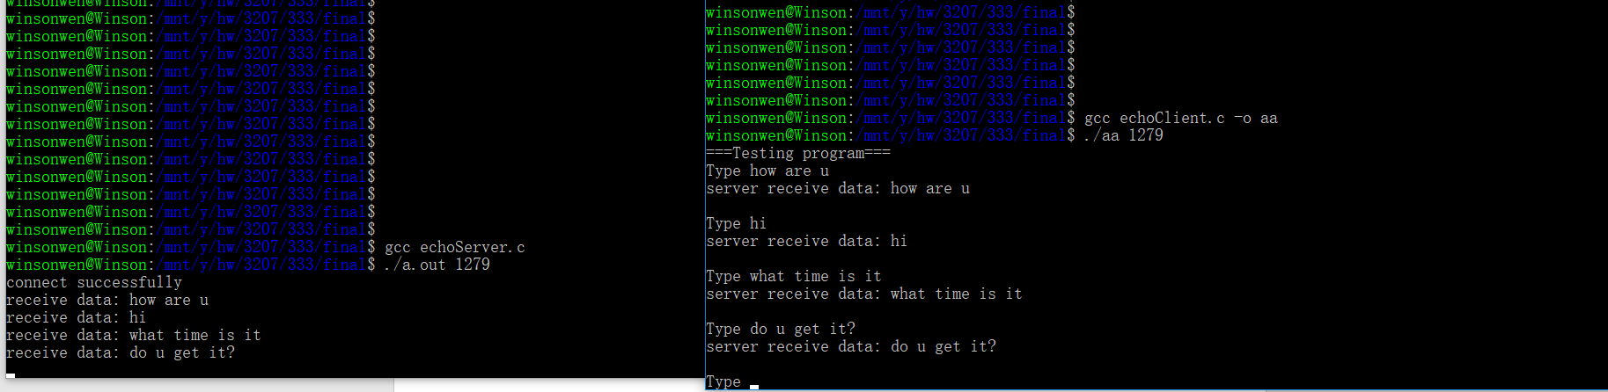

Server Client

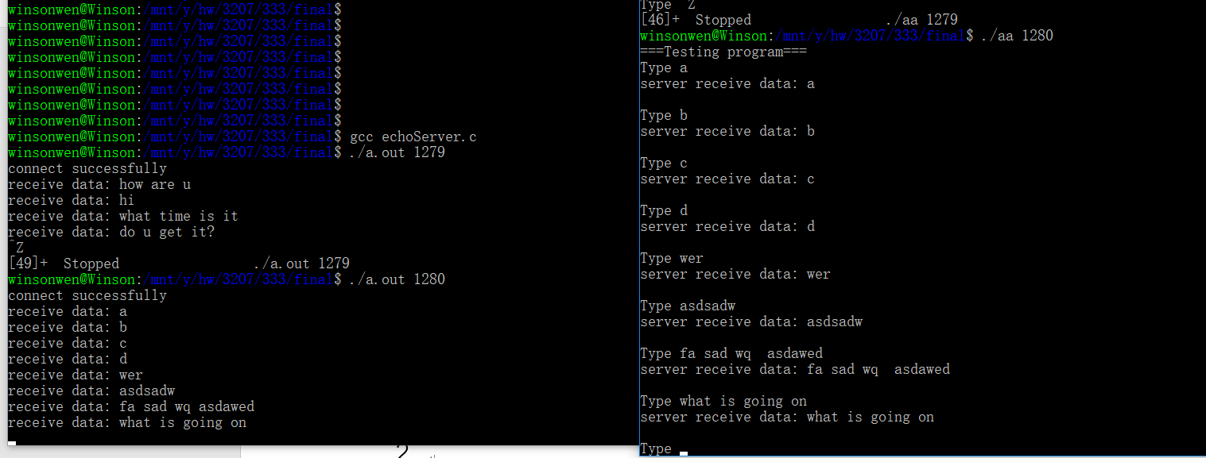

Type anything in client, server will return whatever received back to the client.

1. Modular test on new thread creation



We can set any number of workers which >=1.

For 4 workers,

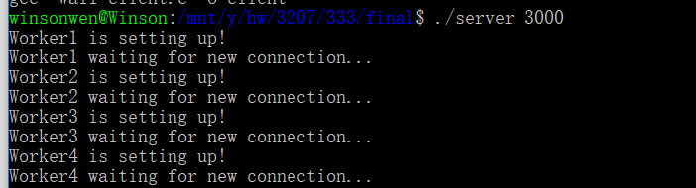

Before run client

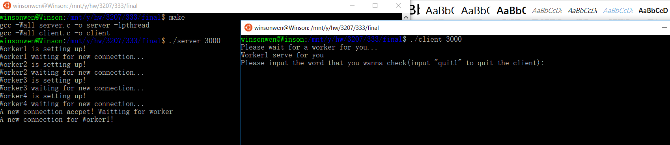

Run 1 client

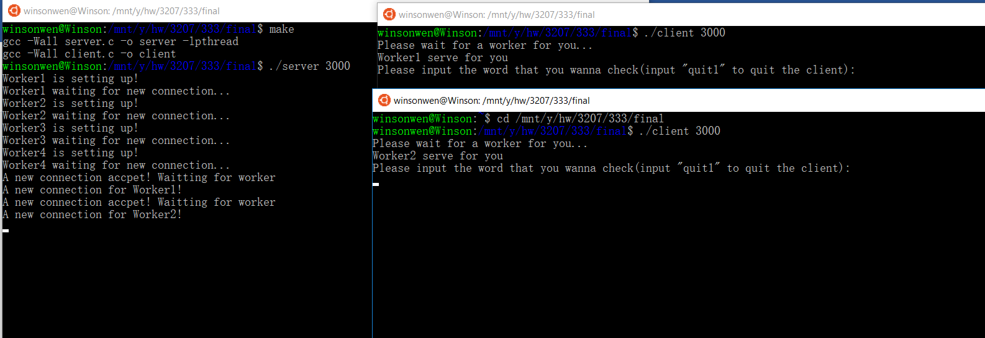

Run 2 client

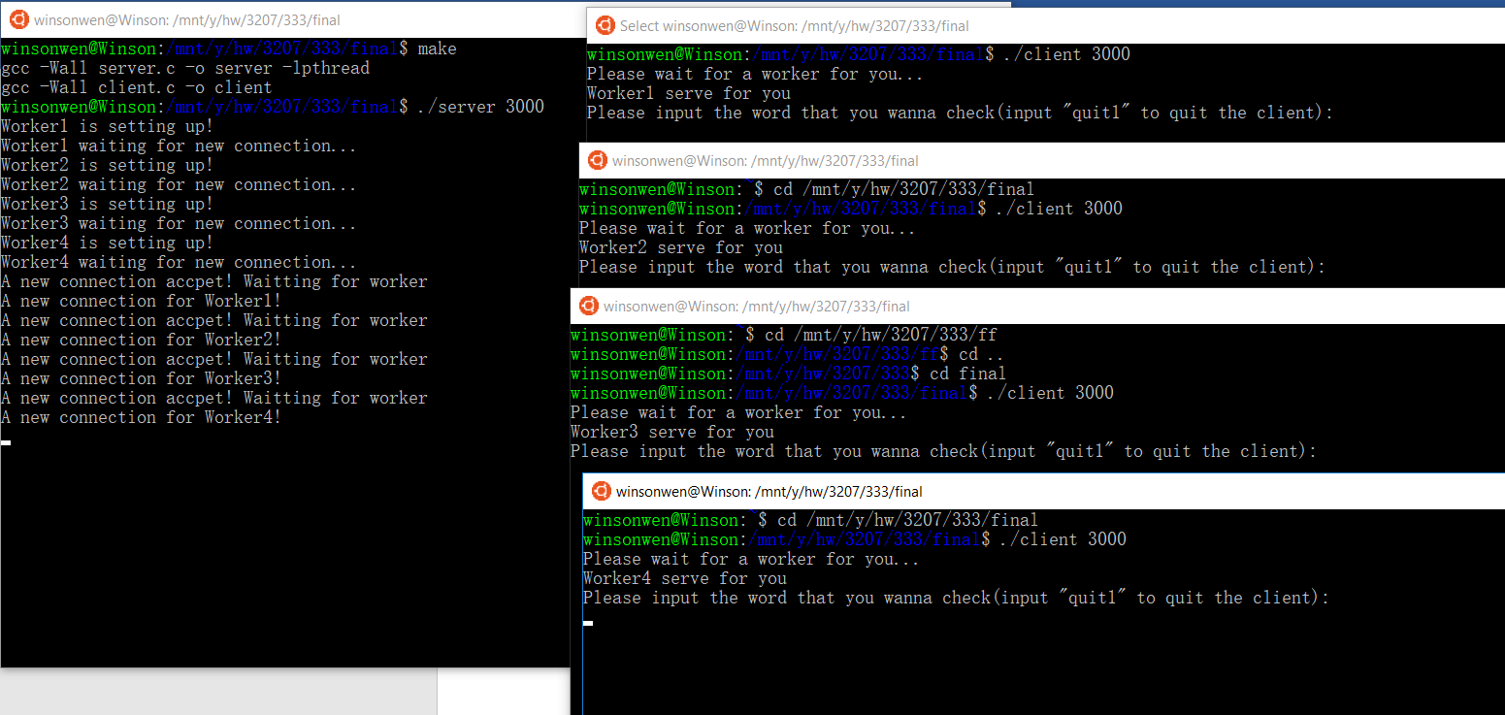

Run 4 client

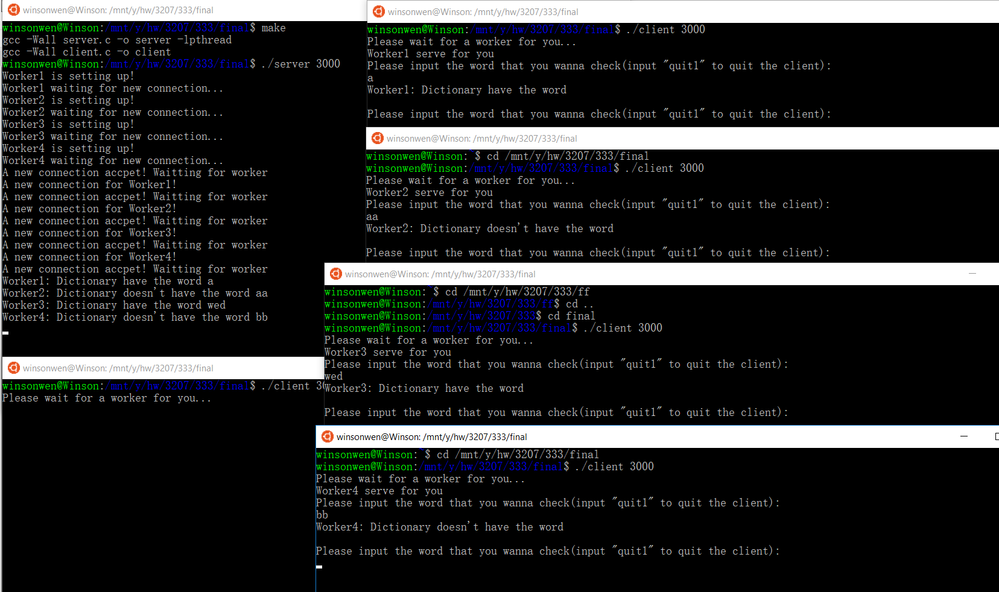

After type one command.

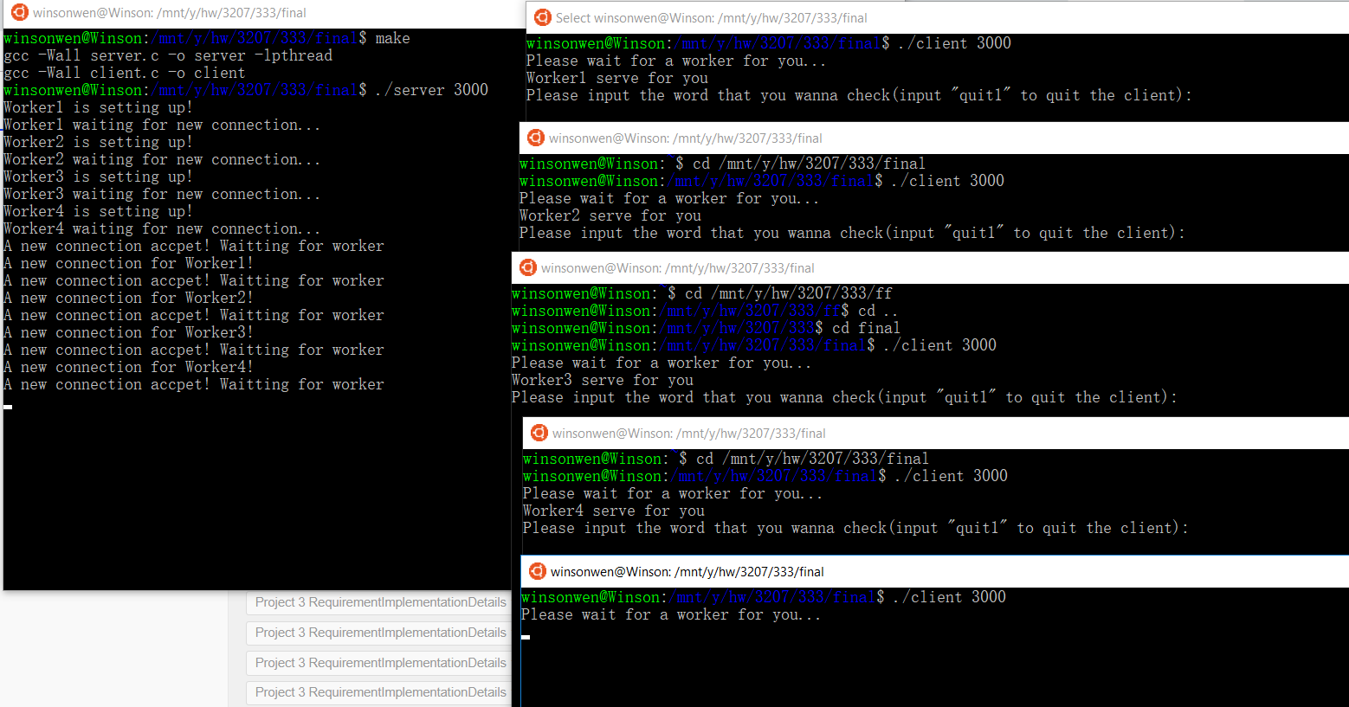

Run 5 client.

1. Modular test on the enqueue and dequeue from the shared buffer

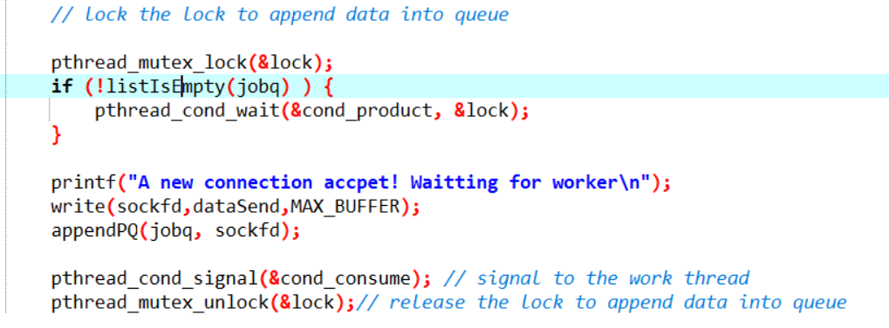 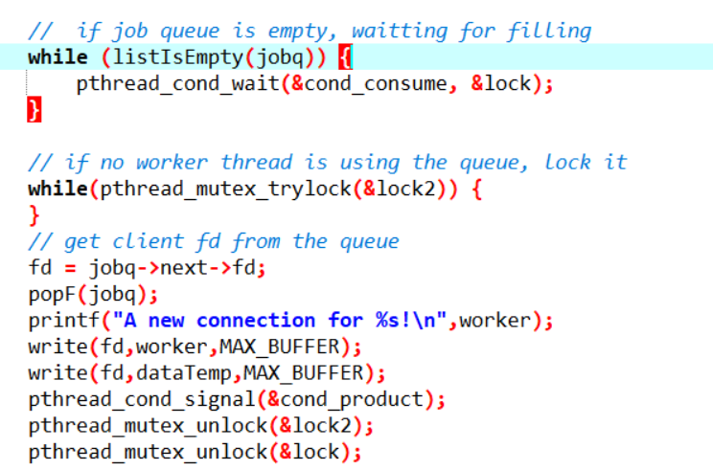

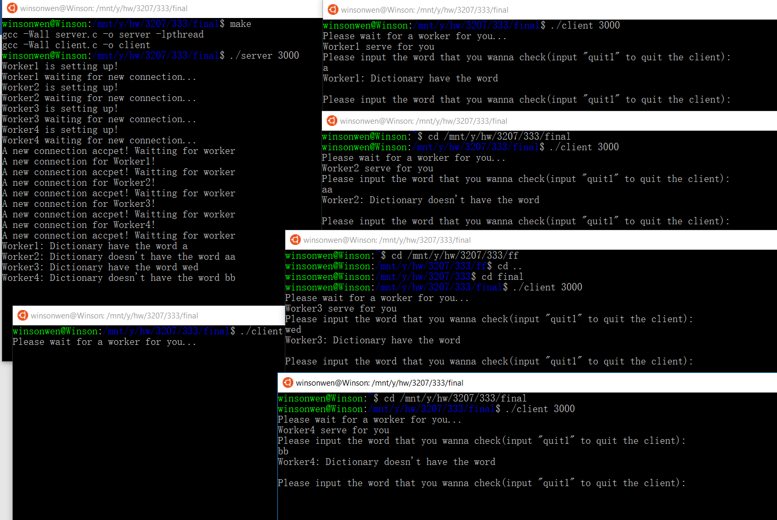

This is the situation that worker is all busy, the fifth client (lower left quarter) is waiting for next worker who is available.

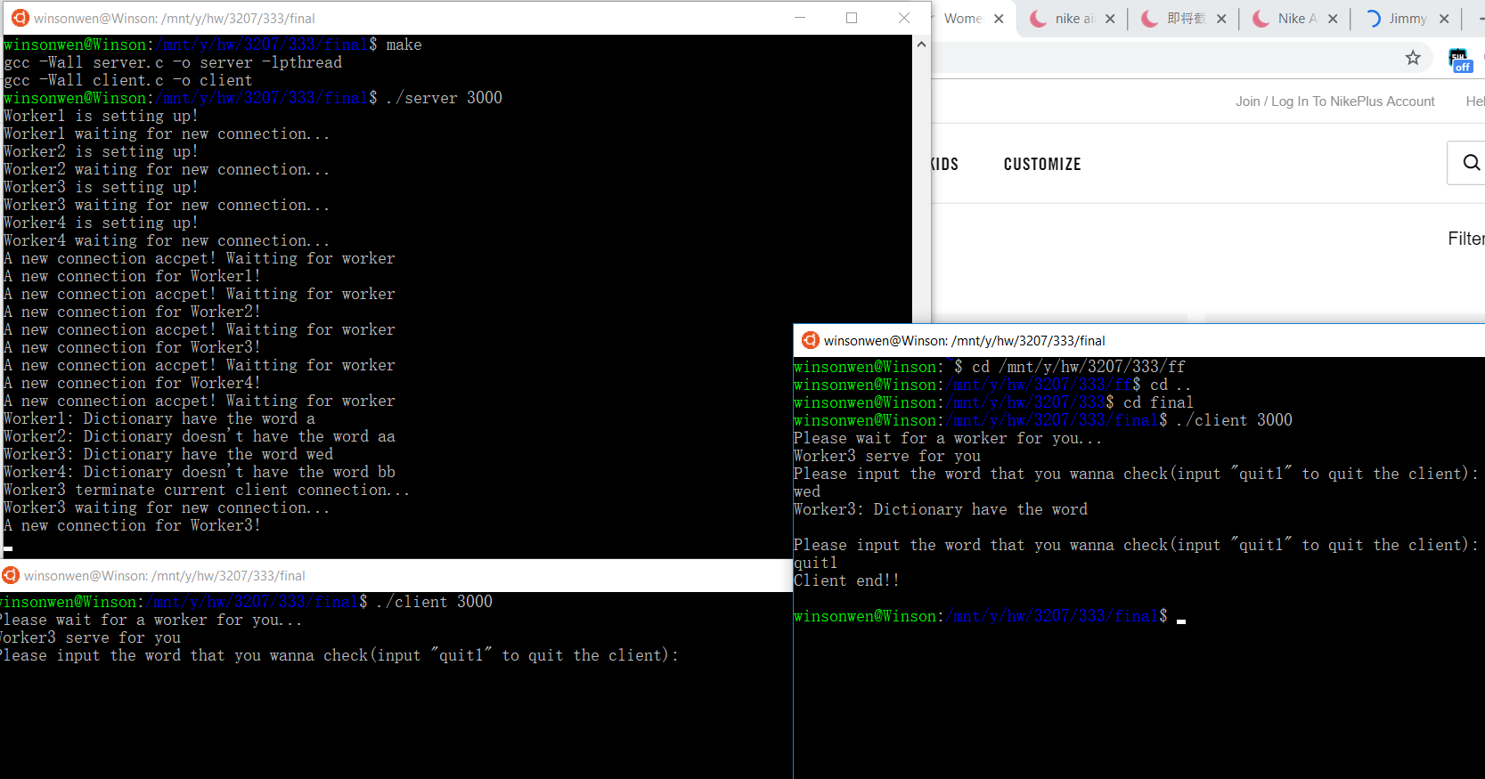

When one of the client is turn off. A worker is work with the fifth client.

1. Modular test of spell checking

testCharSeek.c is used for test.

Type a word and see the result.

