**Junxiang Wen**

**The structure of File System**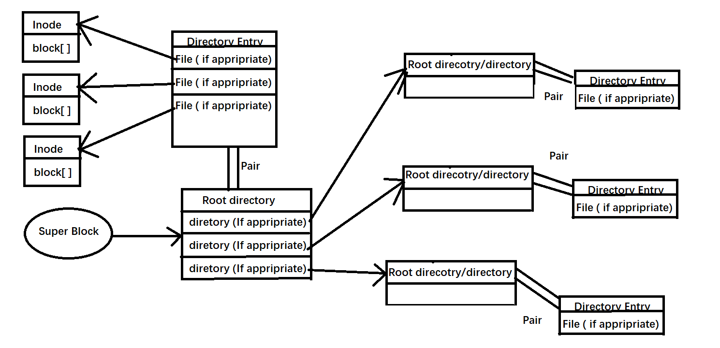

1. **List of finished function modules**

You should explicitly specify which functions are realized by you and which are not

|  |  |
| --- | --- |
| Opening and loading the virtual disk file | project provided |
| Locating and retrieving the superblock, FAT, and root directory | Yes |
| Listing files under the root directory | Yes |
| Retrieving the metadata of a specified file | Yes |
| Creating and allocating a block for an empty file | Not need |
| Opening a file and generating independent file descriptors for it | Yes |
| Using the file descriptor to read and write the file | Yes |
| Making all modifications persistent | Yes |
| Retrieving previously saved content when reopening the virtual disk | Yes |
| Deleting file | Yes |
| Creating subdirectory and deleting an empty directory | Yes |

1. **Design descriptions**
2. What kind of implementation is your using (FAT/ Inode)?

Inode

1. Are you using mmap() to access the virtual disk?

No

1. What’s your partition of the virtual disk file

Block 0: super block

Block 1-2: nodeBlock

Block 1-2: dataBlock

Block 5-516: DIRECTORY

Block 600 – 111: DIRECTORY ENTRY

Block 6912 – 8191: Inode

Block 8192 – last: File data

1. How and where do you store directory entries

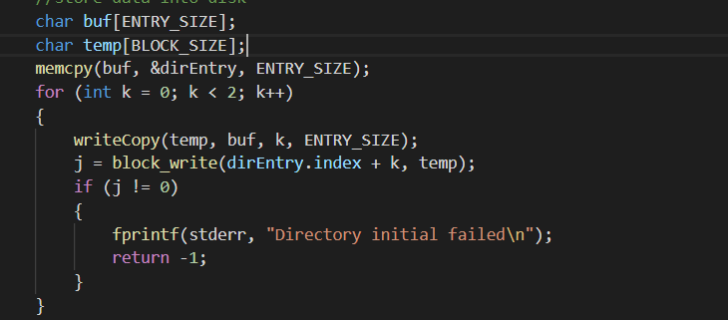

Using memcpy to transfer directory entries into a string, then store it into block.

Block 600 – 111: DIRECTORY ENTRY

1. What’s your struct of the directory entry and file descriptor.

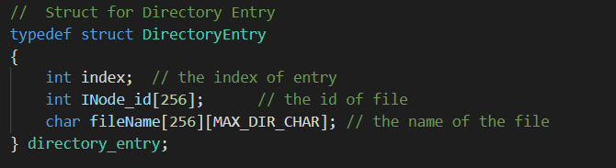

file descriptor is just an interger 

that from 0-63 and the index of 0-63 store the index of Inode.

f. How do you find the location to insert the new directory entry when you create a

new file in a subdirectory

I have an array for files for specified directory. When we created a new file, we will file an undefined index in that array. Then store the index of file into array

1. How do you find an available block when you creating a new file?

dataBlock and nodeBlock is help to check a block is available or not. 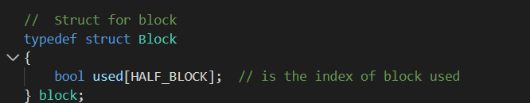

When we create a new file, it will check which block is used=false. Then system will operate that block. Finally, marking that block into used = true.

h. How do you reclaim the space when you delete a file

**clear all the block that it used and clear the file information in located directory.**