**Junxiang Wen**

**When we use command ‘quit’, it will close file and unmount the file system automatic**

**System start and instruction:**

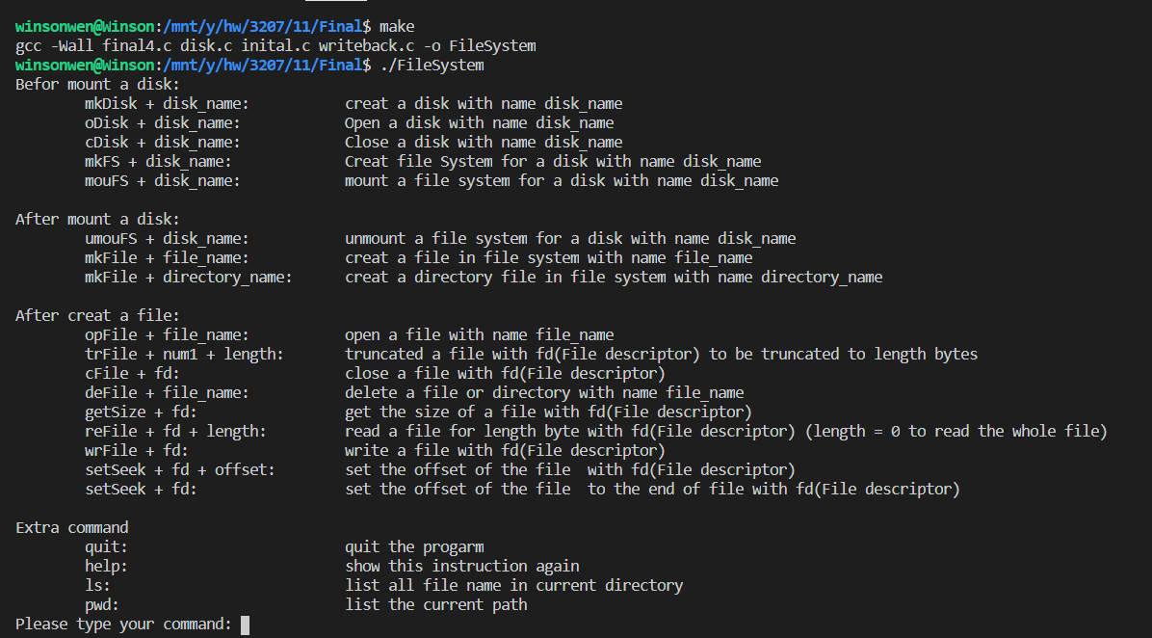

**Test for providing command**

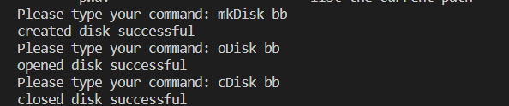

**First time to create file system (int make_fs(char *disk_name);) :**

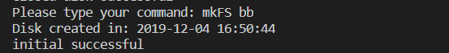

**Again:**

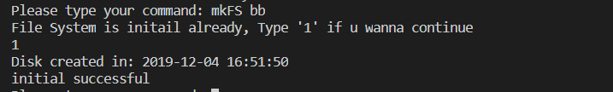

**Mount the file system ( int mount_fs(char *disk_name))**

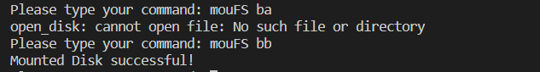

**When created a file( int fs_close(int fildes);) or a directory(int fs_mkdir(char *name);):**

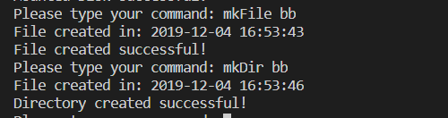

**When we open a file, the metadata will print out and we got the file descriptor.**

**int fs_open(char *name);**

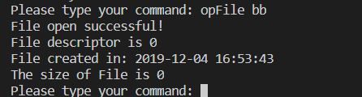**n**

**Write a file:**

**int fs_write(int fildes, void *buf, size_t nbyte);**



**Before read the file, set the offset first:**

**int fs_lseek(int fildes, off_t offset);**

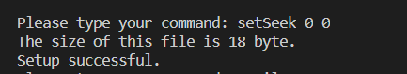

**Read the whole file:**

**int fs_read(int fildes, void *buf, size_t nbyte);**

**Read the part of file:**

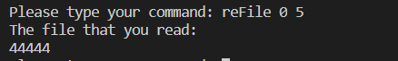

**Set the offset of file at the end of file:**

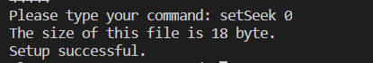

**Write the file again, we can write what we read before:**



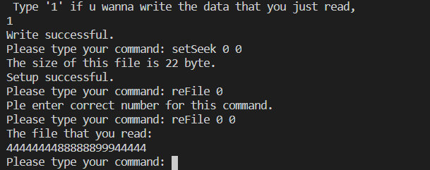

**Close the program:**

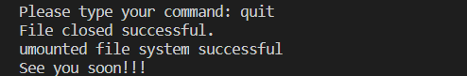

**Reopen:**



**Do the same thing, data in the file still here:**

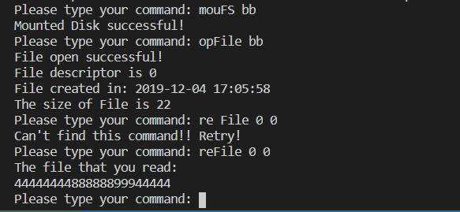

**Check the size:**

**int fs_get_filesize(int fildes);**



**Close File:**

**int fs_close(int fildes);**



**Truncated the file:**

**int fs_truncate(int fildes, off_t length);**

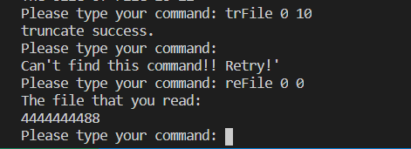

**File in located directory:**

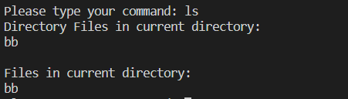

**Delete file first if we have the same name with directory or file.**

**int fs_delete(char *name);**

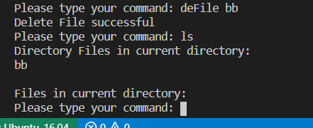

**The second time, it deletes the directory**

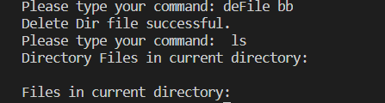

**Unmount the file system:**

**int umount_fs(char *disk_name);**

