Name: Junxiang Wen

Last Edited: 09/011/2019

Topic: Project 1: Giorgio's Discrete Event Simulator

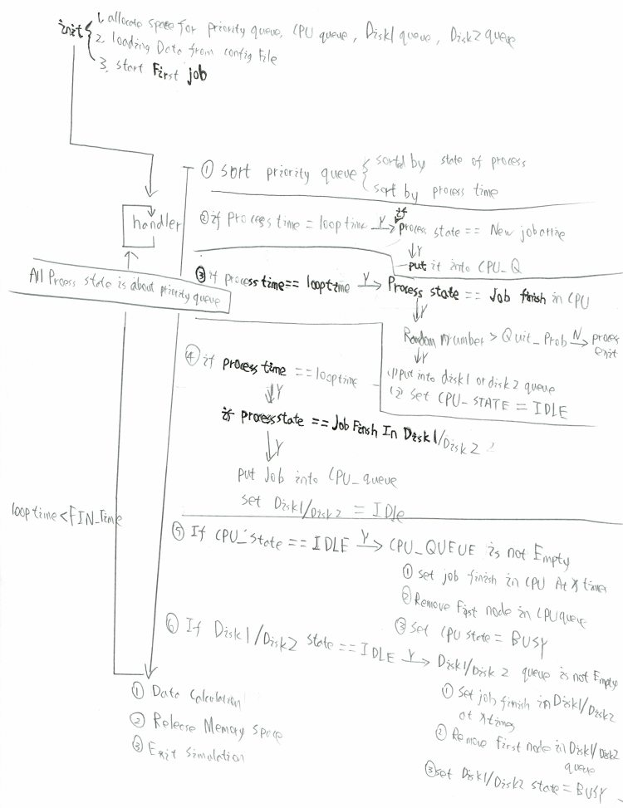\

In this project, we will test about simulation operation of Giorgio's Discrete Event. the programs that we execute require different services from our machines at different times: sometimes they're crunching numbers using the CPU. Sometimes, they read from a device or network device. In this simulation, we will have internal input value, a CPU and two disk.

**Program architecture:**

I combined all the data in one file, so it’s only 1 source file and 4header file. All header files are supposed from C languate.

Main function will only call Simulation function. Simulation function will call all the function for executing program.

Two struct supported for the program:

Struct node: it’s singly linked list that use for storing data in queue.

The function supposed to struct node: initQueue(Node**q1),

loading(int arr[], char arr2[][13]);

Destroy_List(Node* head), printListInfor(Node* q);

appendPQ(Node *q, int pid, int ps,int pt, job arr[]);

Size_List(Node* head), listIsEmpty(Node* q)

PrintList(struct JOB arr[] ), ListSort(Node* head);

TransferQ(Node *pq, Node *q), popF(Node* head).

struct JOB: used for collecting data for each Job, but the project program doesn’t

require. (can be remove)

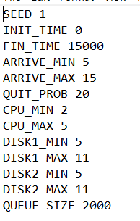 For each times of loop, I decided to run all the events in priority queue first. Then, if the state of CPU or DISK is idle, that would be the last part of the loop.

**How to run your program?**

1, setting basic parameters in config file.

2. a) In Ubuntu or Liunx system, going into the directory that all file locates.

b) Compiler and run file Project1. c.

Or you can type make in the directory under Ubuntu or Linux system. It would compiler and run automatic. (But don’t forget to type “clean” to remove .o file)

**Testing:**

Random number:



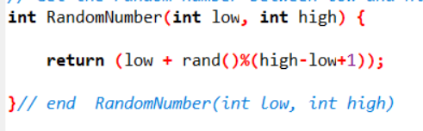

Testing -- for 0-100

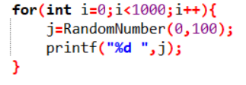

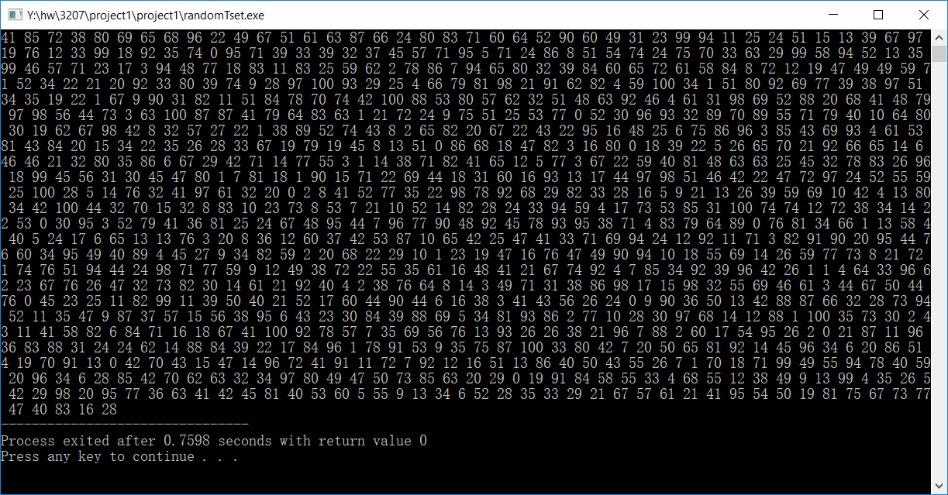

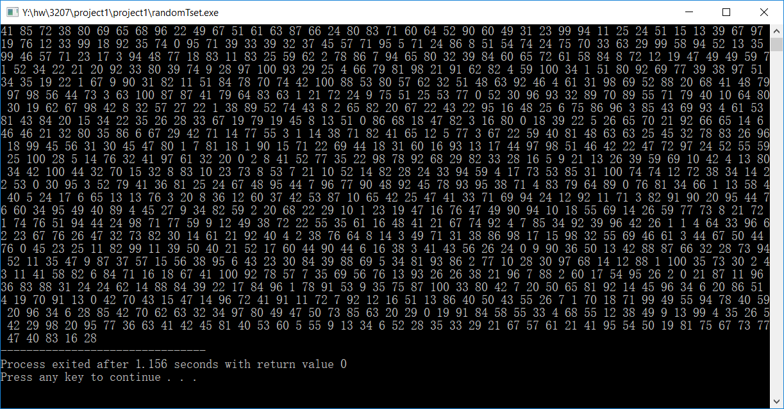

Priority queue or FIFO queue:

Each line is for each loop. processID- processSate- processTime is the information for each node in the priority queue. Because it’s sorted list, we can see all the node is order in priority queue. The priority queue is also FIFO queue.

Because it is impossible two different event have the same event state, we only need to sort the queue orderly in the single linked list.

